July Wellman

CS 470: Full Stack Development II

Southern New Hampshire University

October 12, 2025

**Project One**

1. API URL / Endpoint: Backend of the project running.

*Deployed API*

1. S3 URL / Endpoint: Frontend of the project hosted on S3.

*Frontend running with questions*

Frontend running with answer

1. Screenshots for Each Part/Section:

Correspond to different parts/sections in the Project One Guide (Evidence of S3 setup, IAM security, Lambda functions, CORS configurations, etc.)

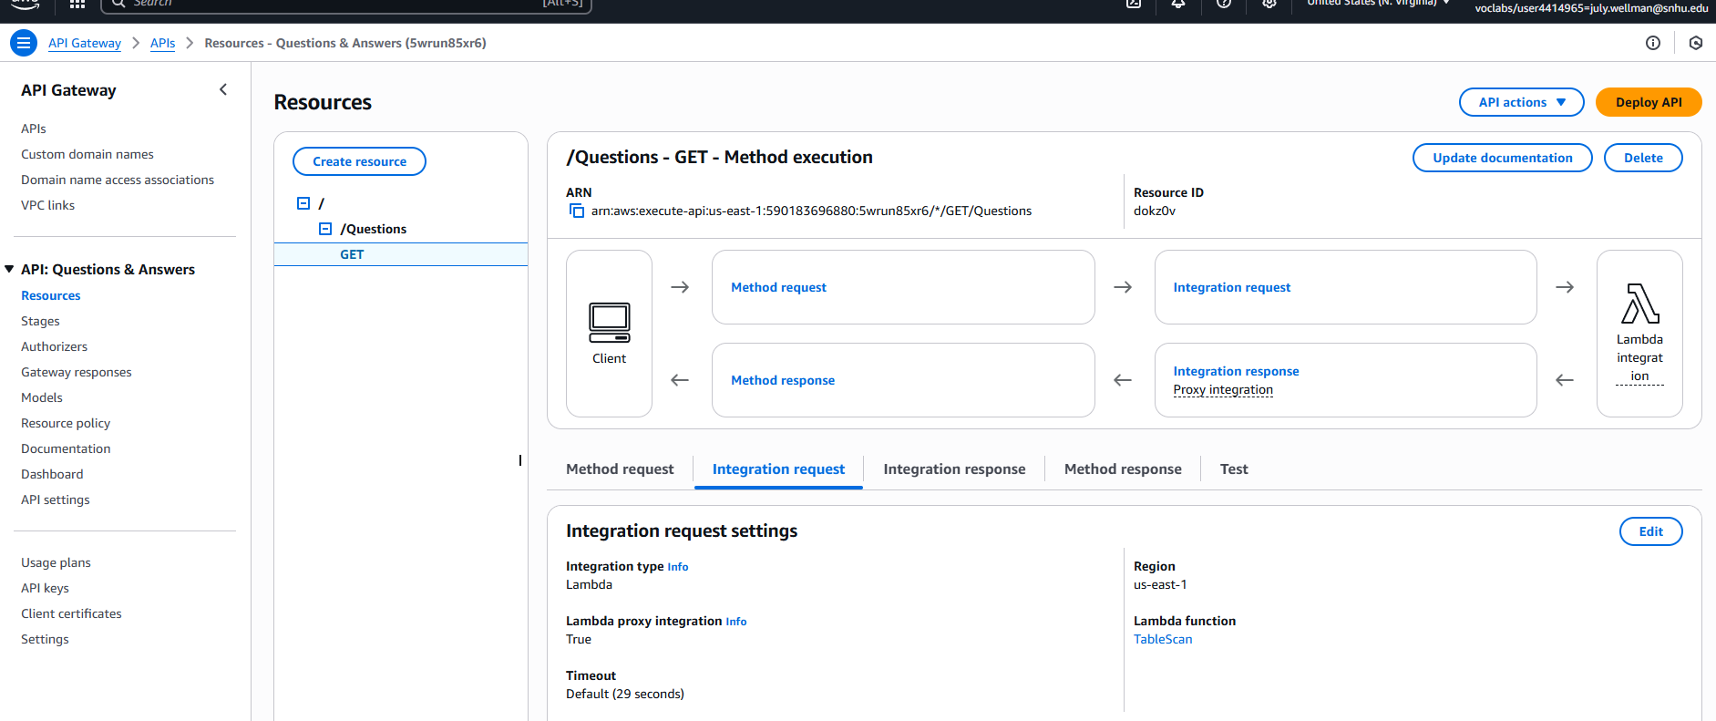

*Created the Questions resource with get method from using TableScan function*

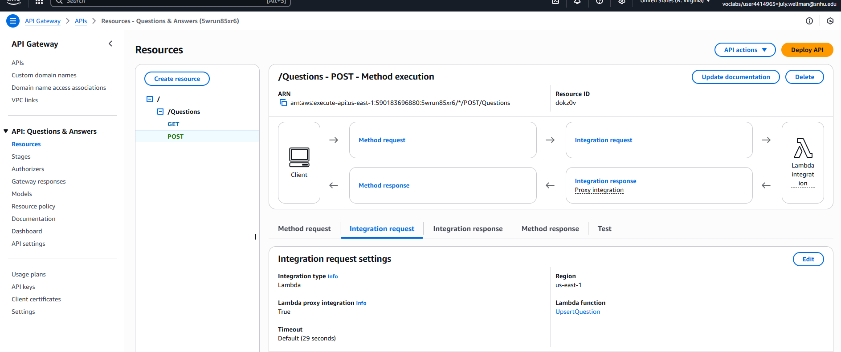

*Created Post method using UpsertQuestion function in Questions resource*

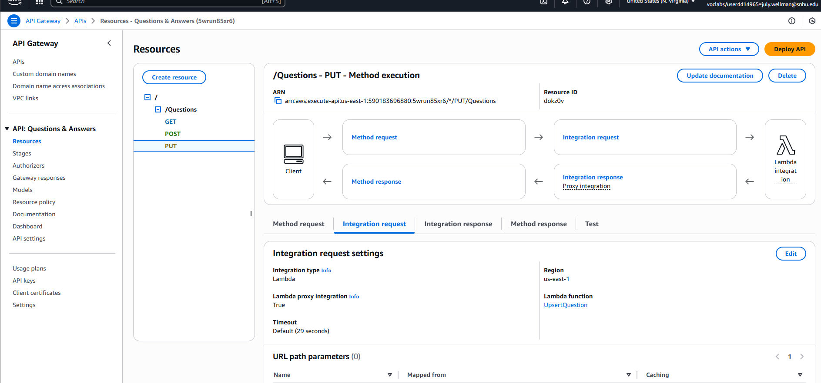

*Created Put method using UpsertQuestion in Questions resource*

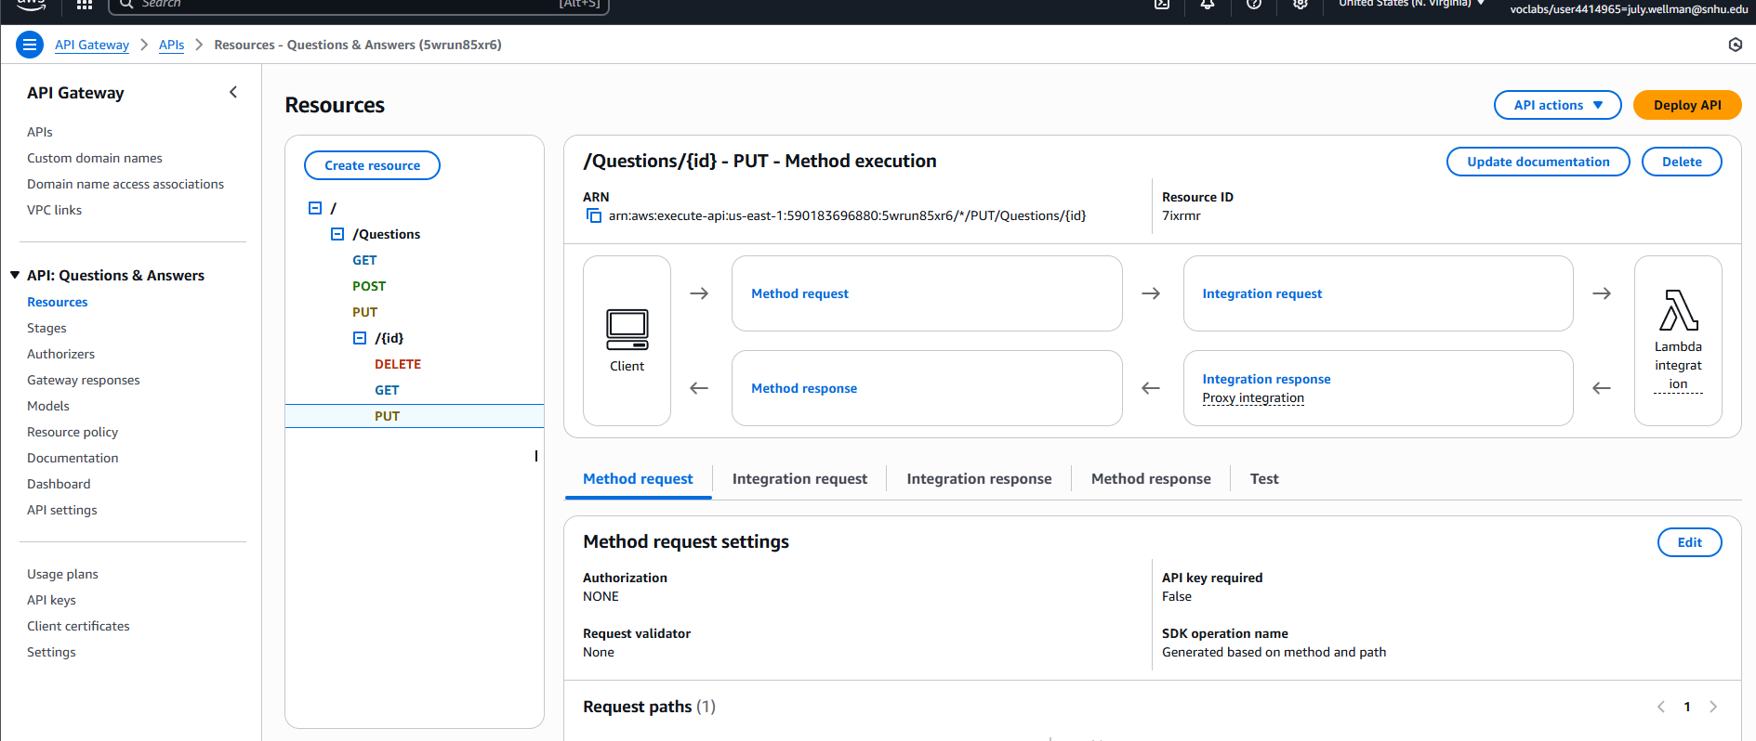

*Created {id} sub resource with delete, get, and put methods*

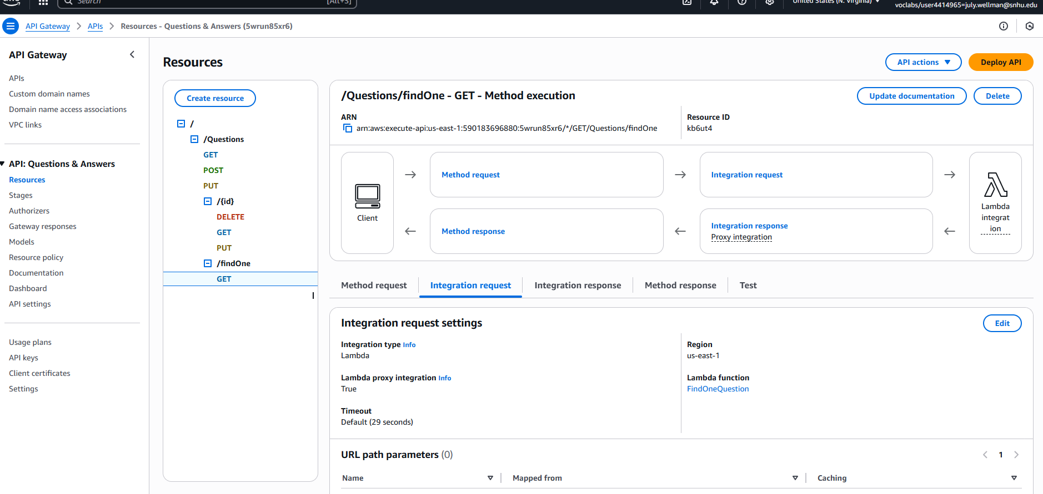

*Created findOne sub resource with a get method using findOneQuestion function*

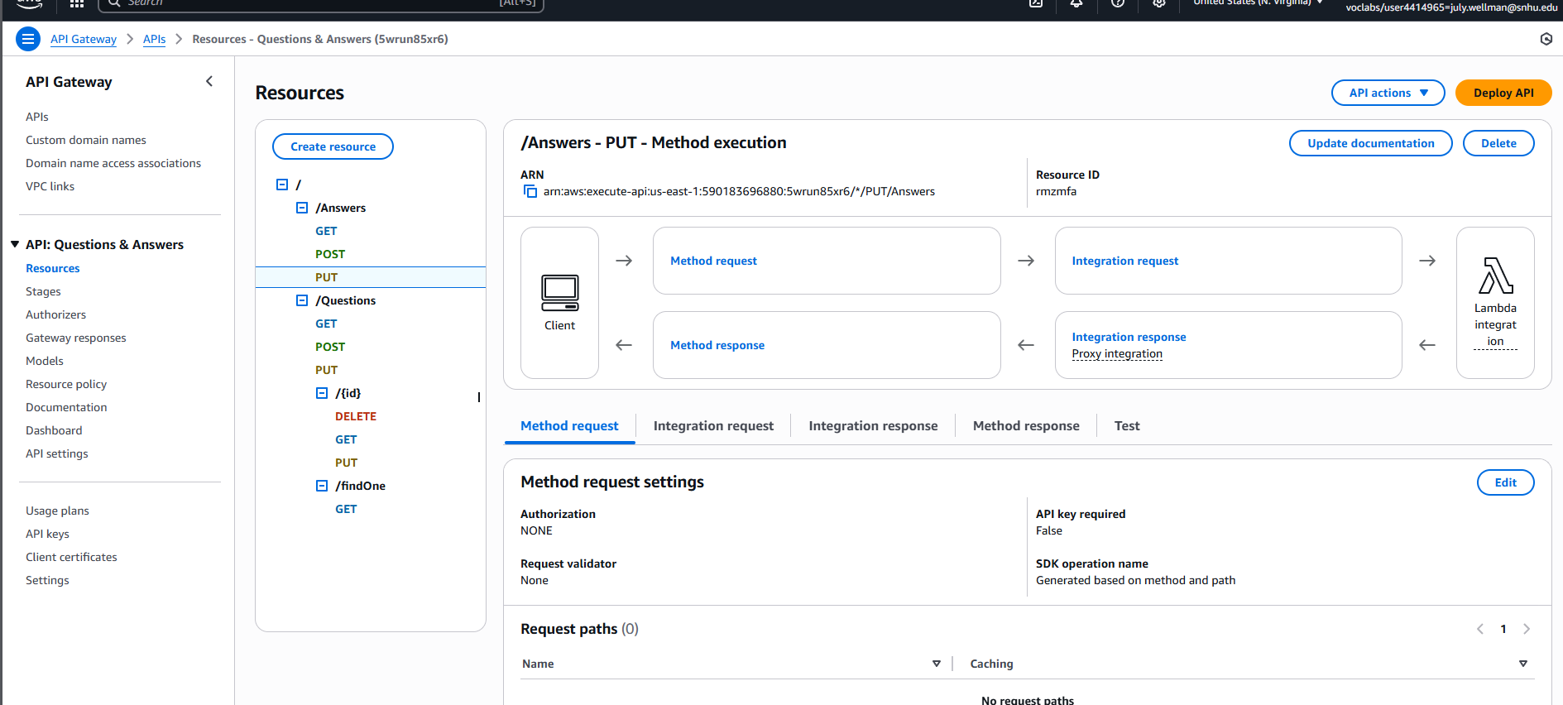

*Created Answer resource with get, post, and put methods*

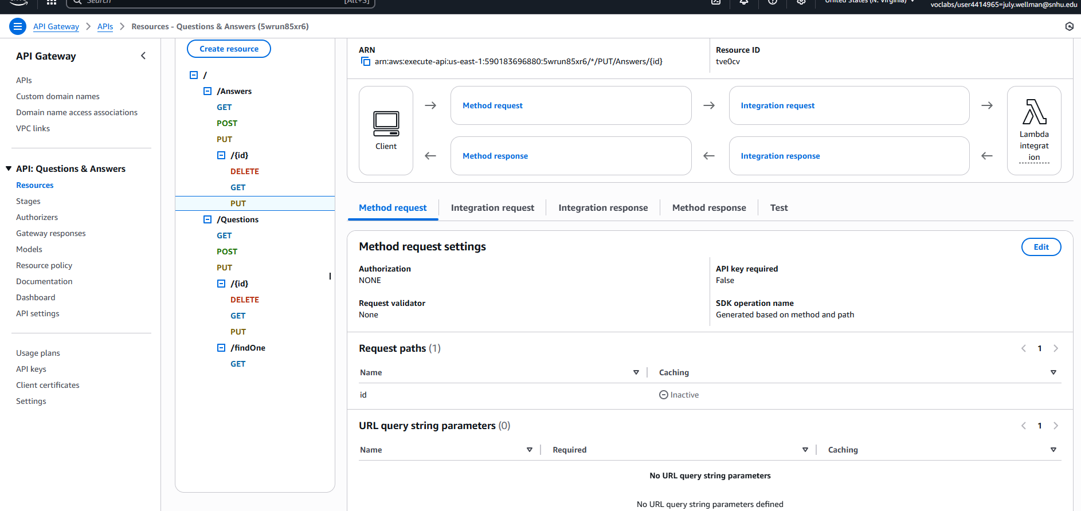

*Created {id} sub resource in Answer resource with delete, get, and put methods*

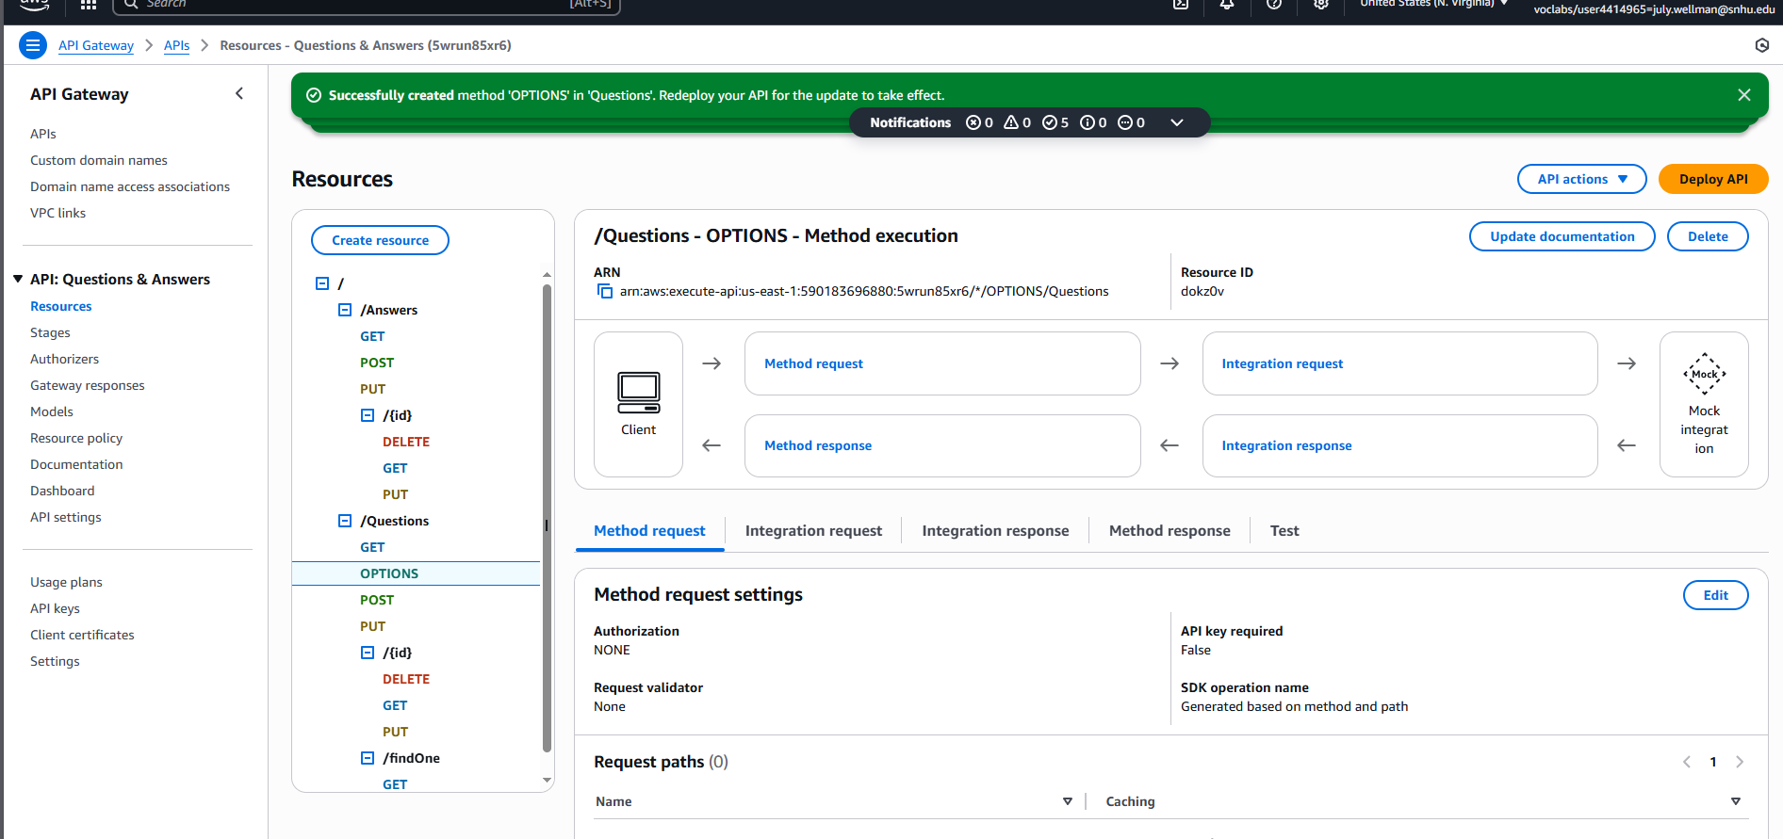

*Created CORS to Questions Resource*

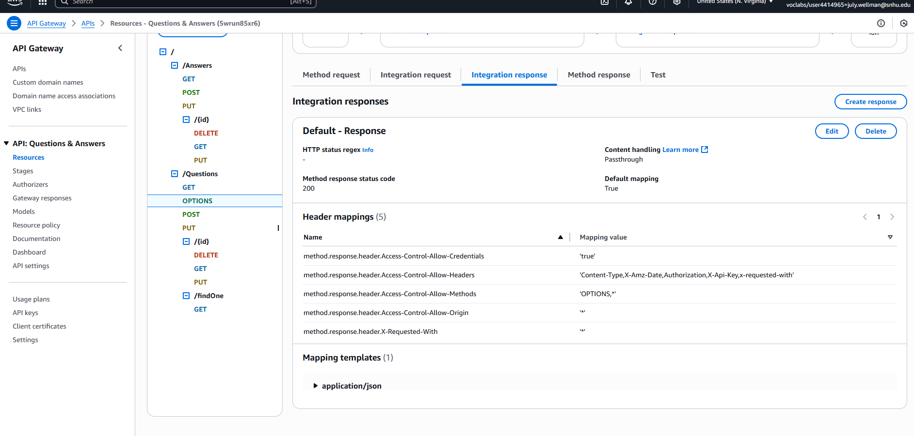

*Created Integration response for Questions resource*

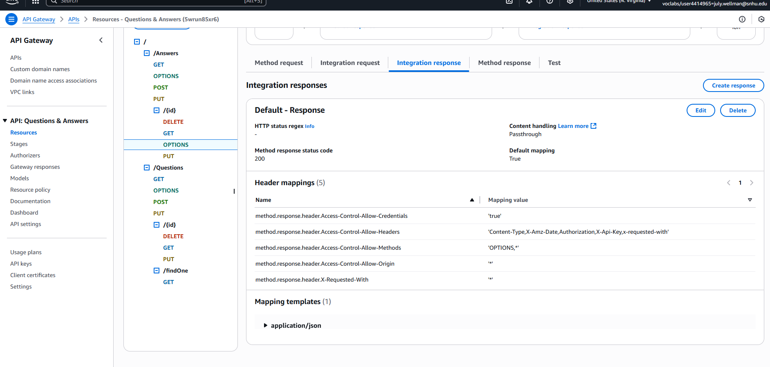

*Created Options method with CORS for Answers and Answers {id} sub resource*

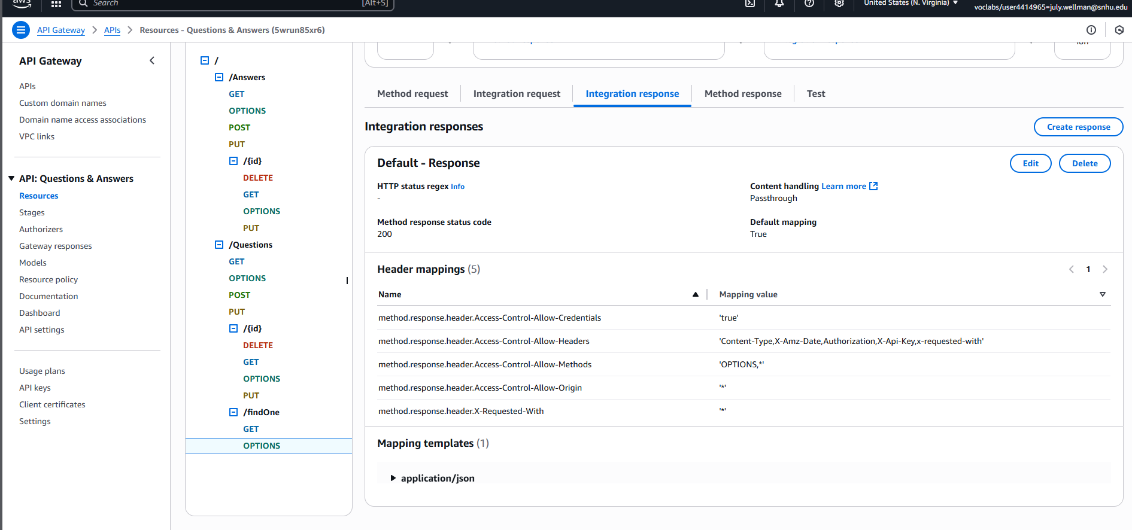

*Created Options method with CORS for Questions [Id} and findOne sub resource*

*Modifying Main.ts to filter on URL*

*Modifying environment.prod.ts to redirect to my URL*

*Rebuilding angular files*