# Grazioso Salvare

## About the Project/Project Title

Grazioso Salvare is an international rescue-animal training company. They are looking for a software application that can pull existing data from animal shelters in the Austin, Texas area to categorize available dogs for rescue training. The first half of the project is to develop a Python module enabling the use of CRUD functionality for MongoDB. The other half is to create the dashboard and the interface logic for MongoDB functionality.

## Motivation

The motivation behind this project is for Grazioso Salvare to be able to find specific breeds needed for rescue training.

## Getting Started

To get started, you should have a user account already created in MongoDB through the AAC database. MongoDB is a popular database especially when interfacing with Python. One of the reasons why MongoDB is popular is that the database stores data in flexible JSON-like documents allowing the data structure to be changed over time. If you are not familiar with how to set up a user account, refer to the MongoDB website for additional help. To create a user account, you should use the admin account. You will also need to import the aac_shelter_outcomes.csv file to the database to be created in MongoDB. Access to Jupyter Notebook will be needed to make the Python file for creating the CRUD methods. A test .ipynb file will also be created to run the Python file and test the CRUD code to ensure functionality. Once your CRUD code is functioning, you will move on to create the dashboard file that will make up the website. The dash framework uses a Model-View-Controller(MVC) architecture. The model holds the data structure, the view is the HTML components of the application and the controller is the logic in the form of callbacks. The dashboard will interact with the CRUD Python file created to pull for specific queries if everything is coded correctly and error-free.

## Installation

Tools needed will be Jupyter Notebook, Python, Linux, and MongoDB. Refer to each respective website for how to download and install each program.

### MongoDB CRUD

*Importing CSV files into MongoDB*

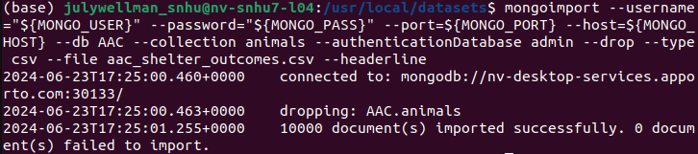

*Animal_shelter.py*

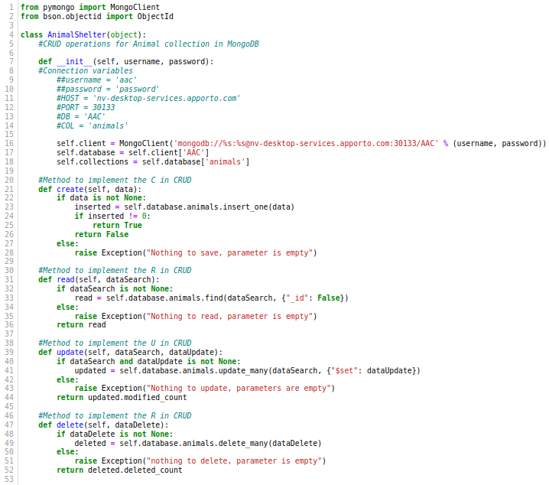

*Test.ipynb to test CRUD functionality*

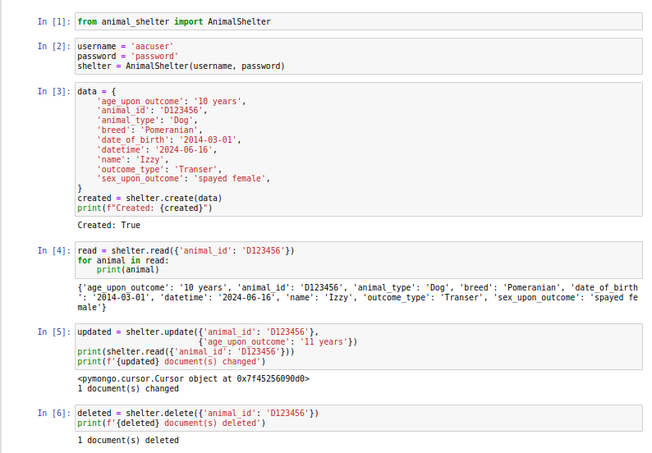

**Dashboard**

*Main Dashboard(Reset All)*

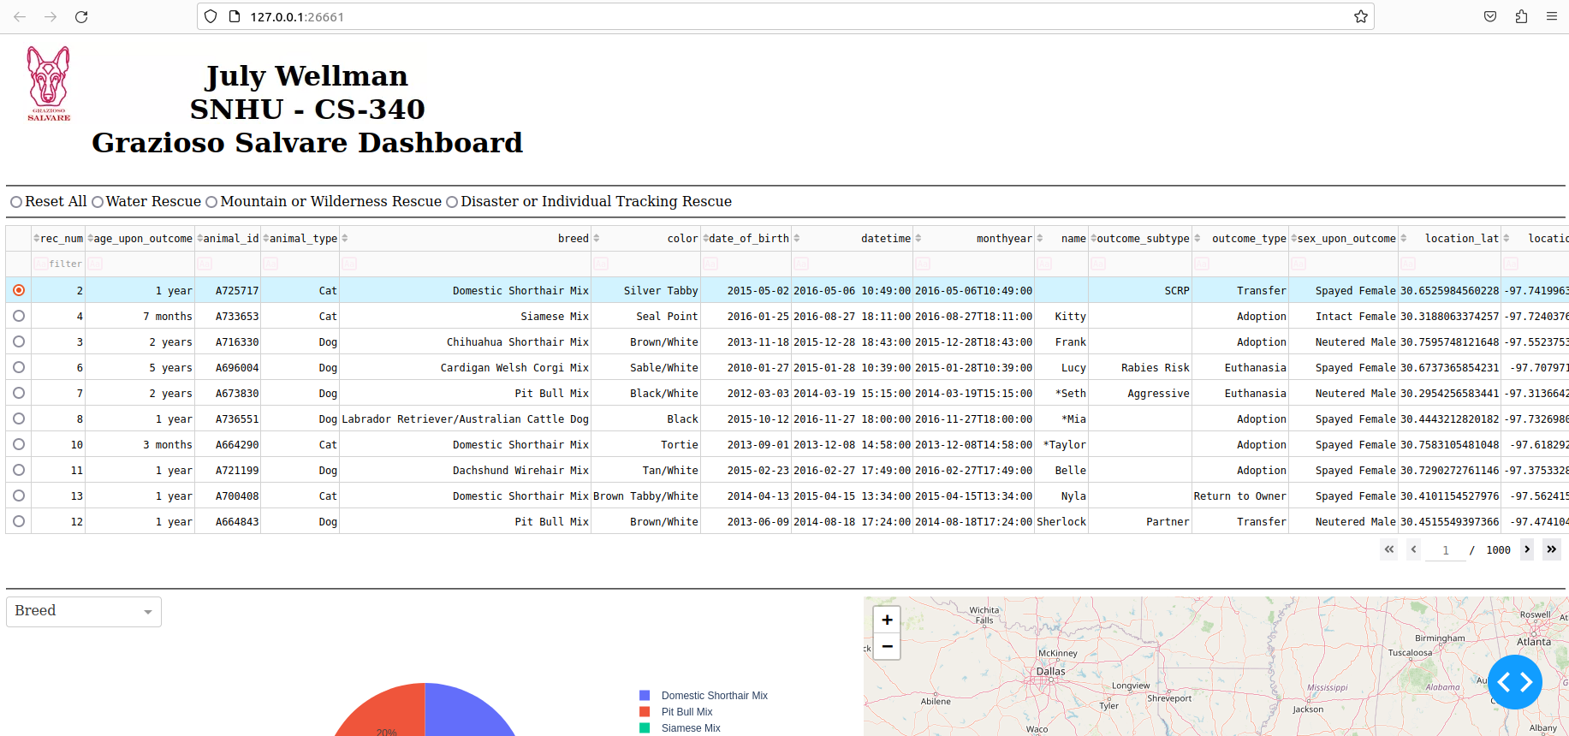

*Water Rescue*

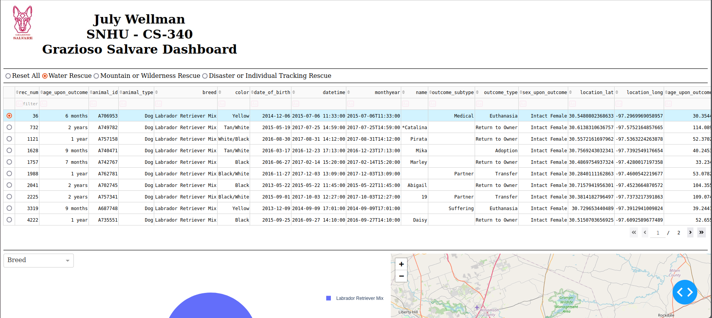

*Mountain or Wilderness Rescue*

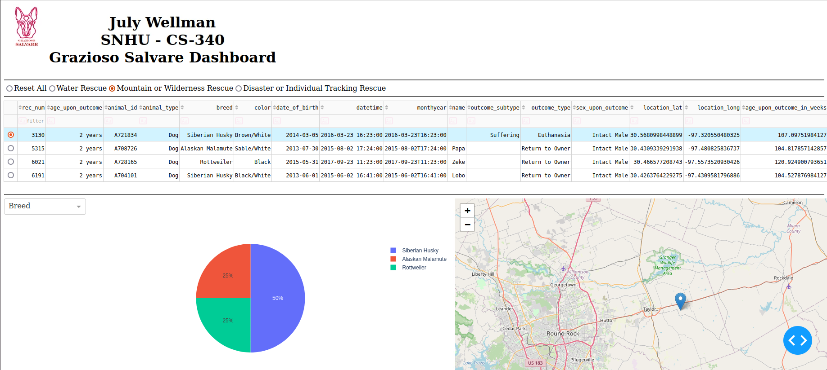

*Disaster or Individual Tracking Rescue*

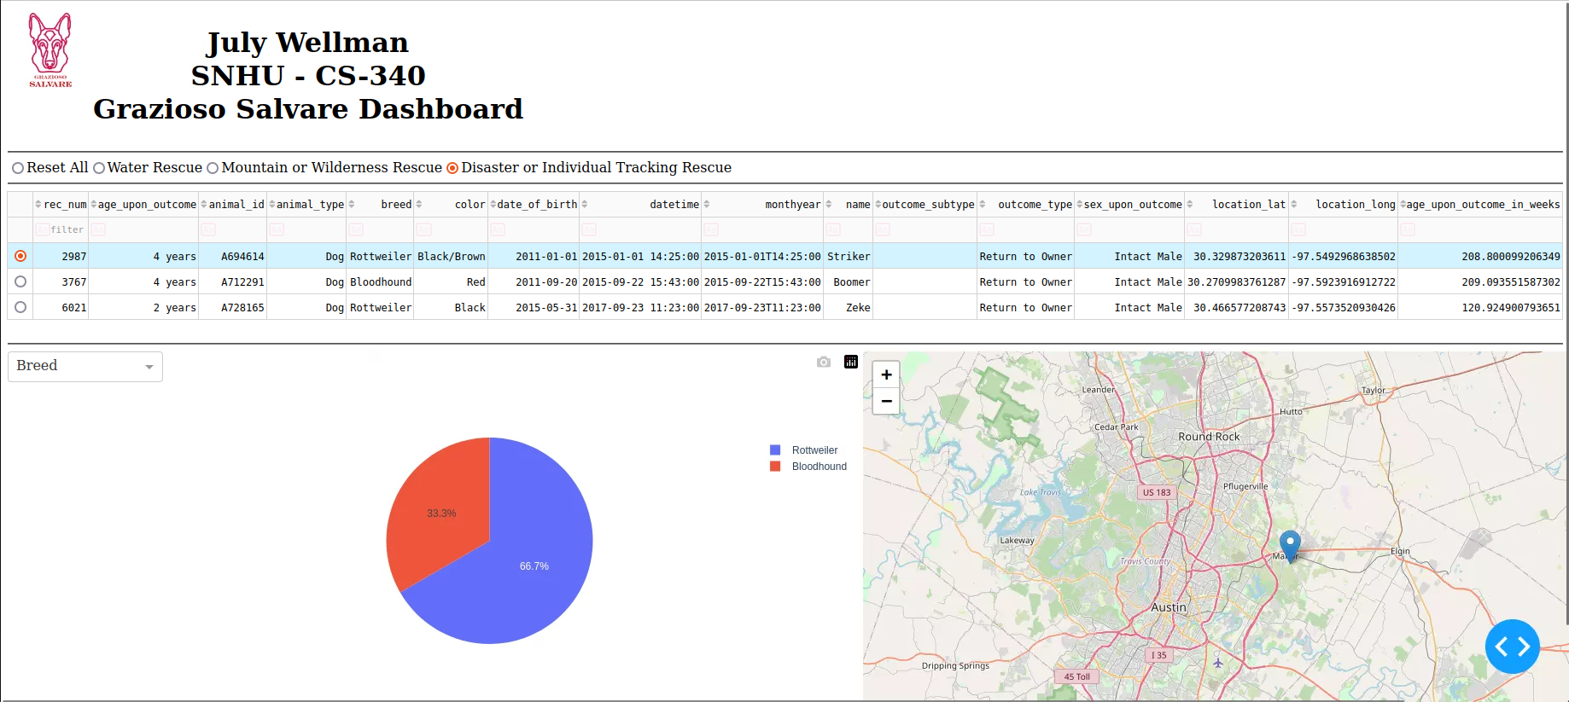

## Roadmap/Features (Optional)

## Contact

Your name: July Wellman