Telco

John Wensink

MIS445 - Statistics in Business Analytics

Colorado State University-Global Campus

Dr. Alin Tomoiaga

October 18, 2020

Telco

After downloading, uploading, and importing the Telco data, we were able to make some interesting conclusions about how salary depends on age or the lack of dependence thereof.

**Scatter Plot for Age vs Income**

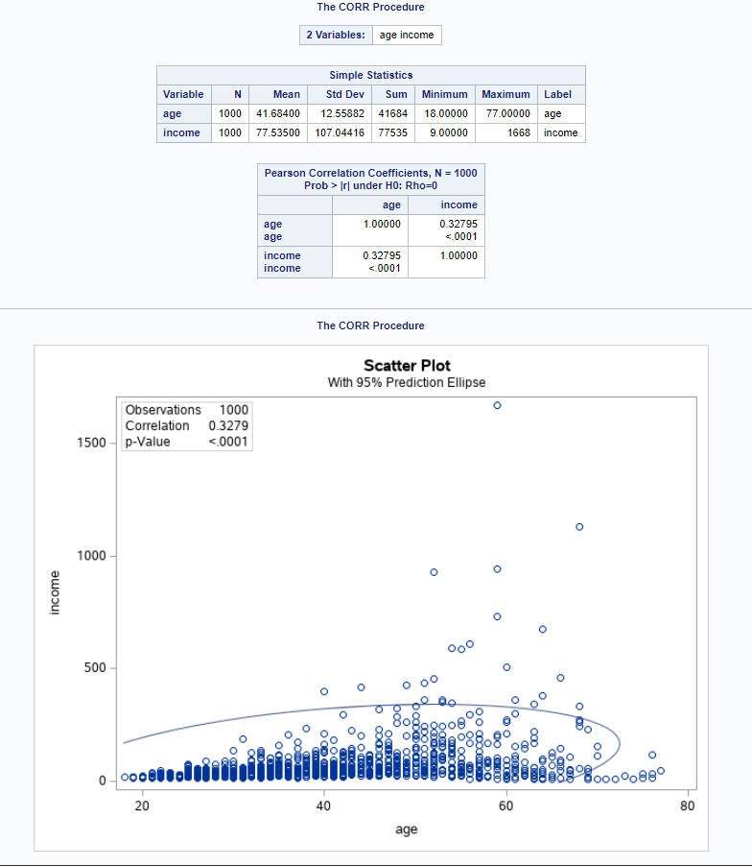

**Linear Regression**

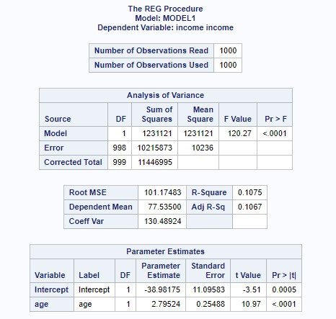

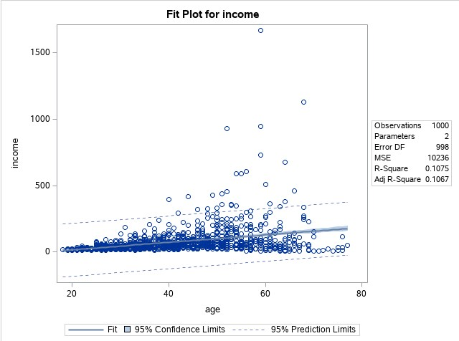

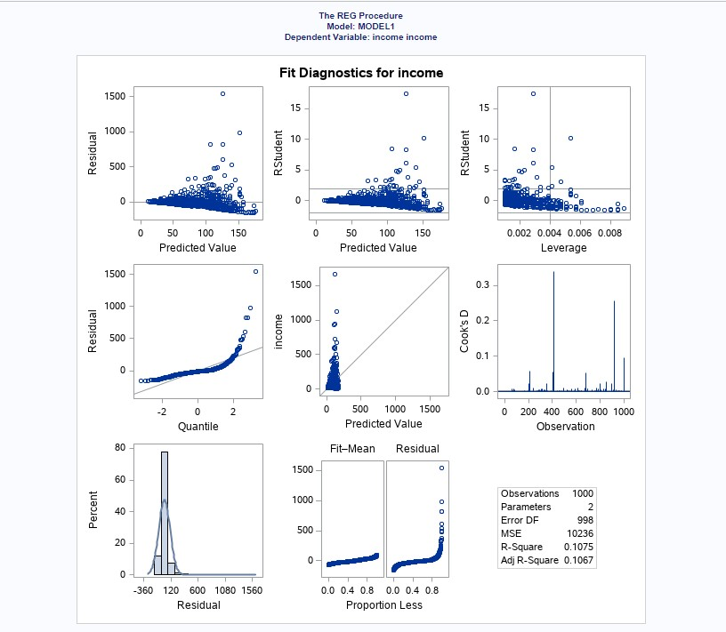

**Quality of Fit**

In this analysis, we examined the correlation between age as it relates to an individual’s mean income. The idea that as one gets older he or she will earn a higher income will be examined using several metrics including Pearson correlation, R2, and the F statistic.

Let us set H0 to = 0.

Let us set H1 to != 0.

In this analysis, the F-statistic of 120.27 is much higher than the critical value corresponding to Fisher’s distribution of 5.039082, as 120.27>5.039082, this causes us to accept the null hypothesis. Income is somewhat dependant on age. To determine how much, we can examine Pearson’s correlation of P=.32795, which indicates the regression model does not fit the data well. Age is not a perfect predictor of income, but there is a moderately positive correlation, as age increases income increases in some instances.

**Predicted Income for a 27-Year-Old**

Now that we have validated the model we can use it to make predictions. We will make use of the intercept (b0) and the slope (b1) of our regression model. In this example b0= -38.98175 and b1= 2.79524. We will use the equation

income = -38.98175+2.79524(27)

x=36,489.73

A 27-year-old can reasonably expect to make about $36,500 as calculated by this moderately correlated model. There are likely other factors in play that could help us derive a more accurate estimate.