1. What I learned in the lab…  
   I ran into some difficulties in the, it seems as thought the code was not able to read my nbaallelo_slr.csv as it was giving me errors that related to not being able to read the pts column. I am not sure why it is making an error. I tried multiple times to resolve the error, even to the point I deleted the main.py file and tried re-creating the file, and that did not help, the instructor (Micheal Bird) tried to ‘reset’ the file, and it did not seem successful. I followed along with the live instruction recording and still was not successful. My professor does a great job with the live instructions for the lab, very easy to follow along and I like when we run into errors because troubleshooting helps me by being able to resolve codding issues through the errors. However, in these labs I was unable to resolve this issue. I hope he may be able review my code to help see if there is an issue with the code or if it may be an issue with zybooks.
2. The chart created from starter file…  
   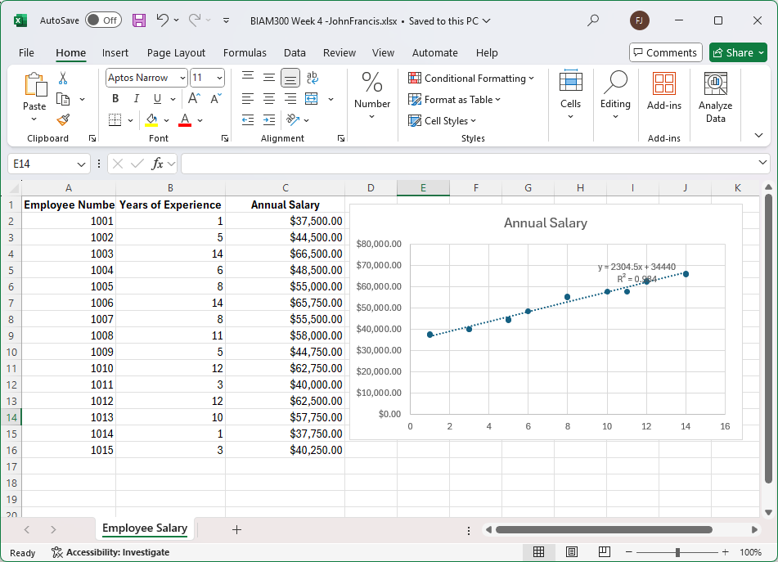
3. Paragraph explaining the regression equation and R-squared, Analysis of what the regression line reveals.

The regression line used in the graph above indicates that as the number of years of experience increases salaries will increase. As an example, employee 1001 has one year of experience and will result in a $37.5K salary and employee 1002 has 5 years of experience and has a $44.5K salary but falls below the linear average, while employee 1005 has 8 years of experience and an annual salary of $55k is slightly above the linear average. Overall the chart shows where the employees fall in terms of salary and years of experience. It is a statistical measure of how well the regression line approximates the actual data