Finding Application Artifacts in Windows
Jon Nagy

Table of Contents
Introduction 3
RegRipper 4
Shimcache 9
Prefetch 12
Userassist 14
MUICache 15
Conclusion 16

Introduction
This is a tutorial on finding artifacts in a Windows system related to applications. There’s so much more than just looking at installed programs. As a forensic analyst, you’ll need to be aware of these different sources. Information from multiple sources will strengthen your investigation.
I’ve avoided directly answering the questions listed in the Data Leakage Case because I want people to try them on their own. This tutorial aims to help them understand the concepts of these sources of artifacts, how to understand the output, and includes some quick tips about how to think during an investigation.

RegRipper
Reading:
- https://github.com/keydet89/RegRipper3.0
RegRipper is one of the most useful tools you’ll use in forensics, designed by Harlan Carvey. It makes it easy to extract data from the Windows registry. There are ways to manually parse the registry, but this requires researching the specific keys you need, which gets slow and boring very quickly. RegRipper takes all of that out of the equation. Let’s dive in.
Before running anything, let’s take a look at the options:
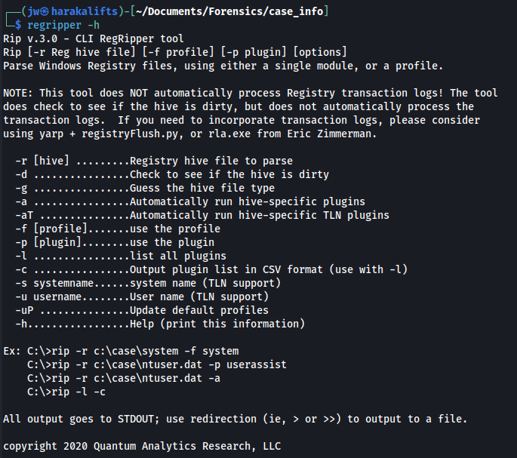
For this tutorial, we’re mostly interested in the -r and -p options.
To get a list of all supported plugins, run regripper -l.
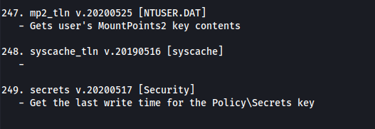
That’s 249 plugins it supports. How do you find which plugins you need?
Pro tip: save the plugin list to a file so you can search it later.
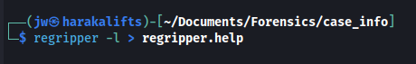
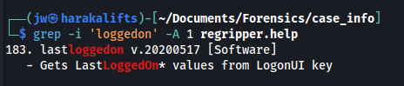
Every plugin lists the registry hive that it operates on. You need to supply the full path to the hive. With just a little research, you’ll find these hives in a few different locations. To find them on my system, I used locate:
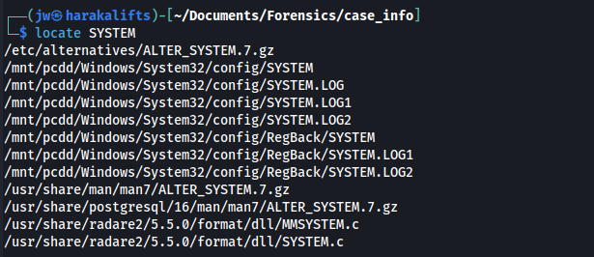
You can manually copy or write the path out, but because I want to impress people who use Linux, I used a fun trick with awk:
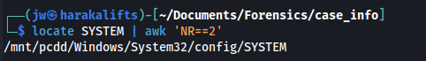Figure 1: NR = Number of Record.

Once you have the path to the registry hive and the desired plugin, running RegRipper looks like this:
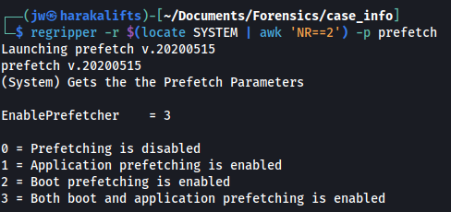
After confirming the output, I saved it to a file. Regripper can also output in TLN format, or timeline format. This will be useful later for crafting a timeline.
The Data Leakage Case asks you to find a list of installed programs. Let’s start by searching through our help file for possible plugins.
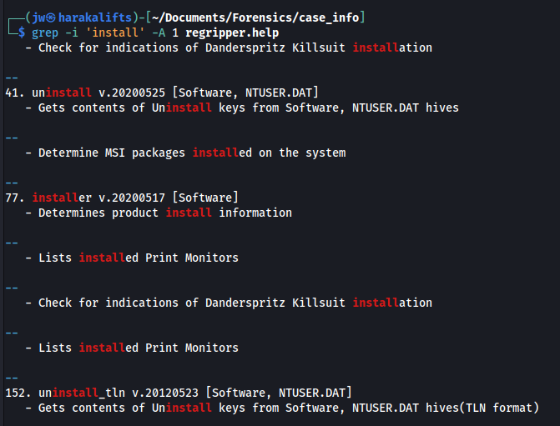
Two plugins immediately stand out: uninstall, and its TLN variant.
I like to count the lines before parsing just to see if I should redirect it to a file later. With wc -l, we find only 64 lines, which is very easy to parse directly on the command line:
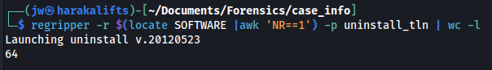
There’s one very notable entry I want to direct your attention to:
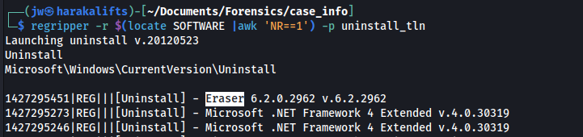
A quick web search for Eraser brings up this:
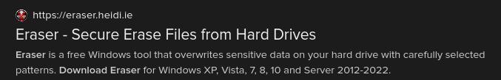
Remember the context of this exercise. We are investigating an employee for leaking company information. Eraser isn’t a program installed by default on every Windows system, and most people won’t need to securely erase every file they want to delete. The presence of this program may be a clue for the investigation.
However, this is not definitive evidence. This is only a list of installed programs on the system, nothing more. Keep this application in mind as you continue the exercise.

Shimcache
Reading:
- https://cloud.google.com/blog/topics/threat-intelligence/caching-out-the-val/
So we found a suspicious file on the target machine. How do we prove it was actually used? Windows’ shimcache is a solid answer. Essentially, it stores information related to file execution. In fact, a simple web search brings up a ton of forensic articles. Knowing how to extract data from the shimcache is a vital skill.
RegRipper provides a shimcache plugin. I’ve noticed the TLN output may be missing some key information. Notice the difference between the following two screenshots:
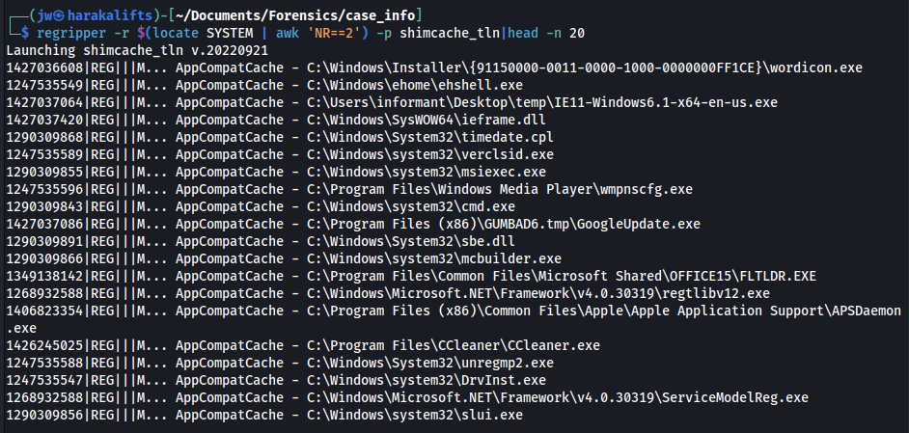
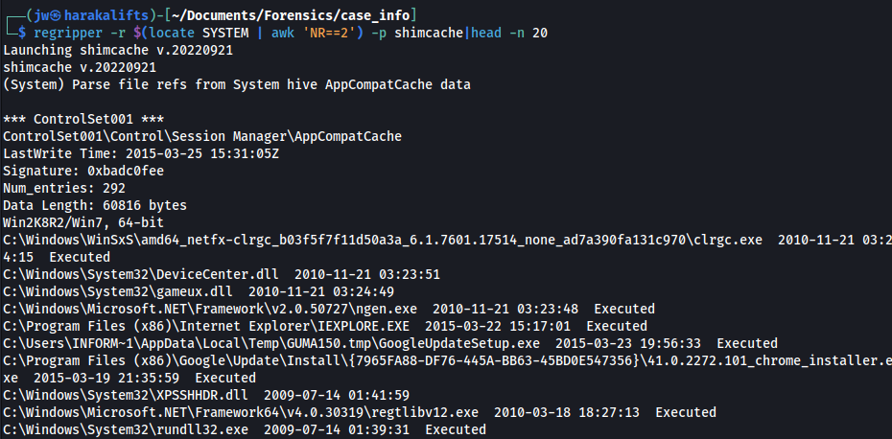
In the second screenshot, some of the entries are appended with “Executed”. This is a very important distinction the shimcache records. It records files that either execute or edit system configuration. Not all files are executable, but knowing which ones did execute is important. I’m going to focus on the non-TLN output for this writeup.
The output is formatted with full paths, execution time and whether or not the file was executed:
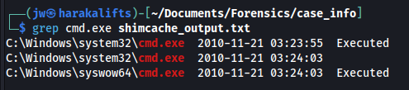
I’m not sure why, but some of the directories aren’t properly named. System32 can be found both capitalized and not. You may want to keep this in mind while parsing this output.
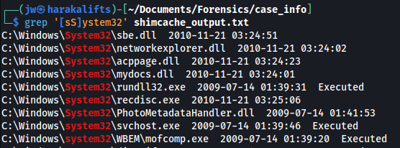
Regardless, the actual files seem to be organized properly. Windows stores critical files under the System32 and SysWOW64 directories. It would be very unusual for an ordinary user to store personal files in these directories, so I’ll filter them out. Let’s look under the Program Files folders.
Almost immediately we find an unusual file:
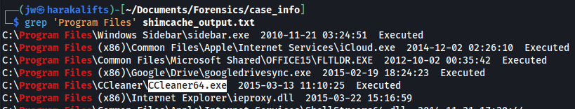
Just like with Eraser, if you search it up, you’ll find CCleaner is a legitimate program to securely delete files. It’s presence isn’t inherently inculpatory, but now we have a time and date for the execution of this program.
If you search for CCleaner in the shimcache output, you’ll also find an uninstaller. This is why it didn’t show up in the earlier example. I later saved all executed programs to another file.
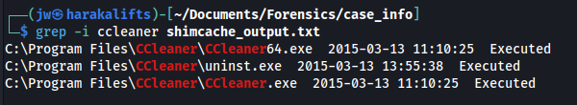
Speaking of Eraser, it also shows up in the shimcache:
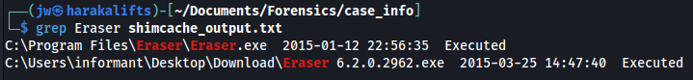

Prefetch
Reading:
- https://forensics.wiki/prefetch/
- https://github.com/no-sec/prefetchkit
Prefetch files are used by Windows to improve performance. They are common (and valuable) artifacts left over whenever an application runs. Notably, they keep track of how many times an application was run.
Let’s start by looking for prefetch files on the Windows system;
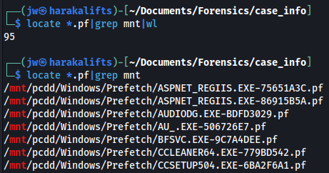
For this section, I’m using a tool called prefetchkit, available on GitHub and as a Rust package. This is a remarkably simple tool. All you need to do is supply the prefetch file:
Figure 2: Since I use 'wc -l' so much, I made an alias for it.
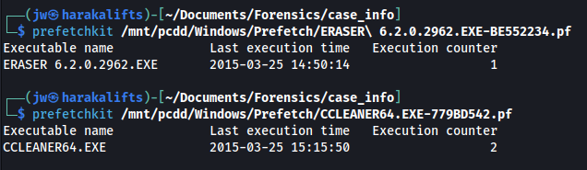
The only caveats are that it only takes one prefetch file at a time, and redirection is a little unusual:
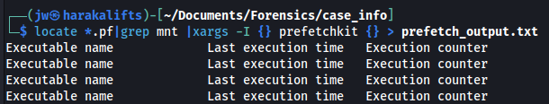
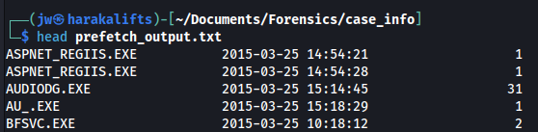
So we know of two applications that are, or were, present on the target machine—Eraser and CCleaner. Let’s try searching for them in the output:
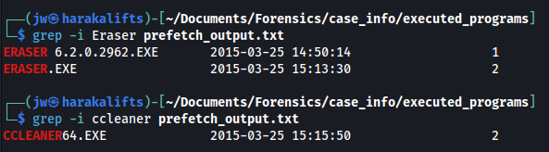
Now we have two suspicious applications, their last execution time and how many times they executed on the target machine. In your final report, you’ll want to exclude unnecessary findings. DLLHOST.EXE appears multiple times in the prefetch output, but will usually be a legitimate entry (unless you are specifically searching for malicious DLLHOST entries, of course).

Userassist
Reading:
- https://blog.didierstevens.com/programs/userassist/

In addition to prefetch files, Windows also uses the UserAssist registry keys to track execution time/count of applications. Conceptually, the two are very similar.
You’ll find a UserAssist plugin with RegRipper. If we run it:
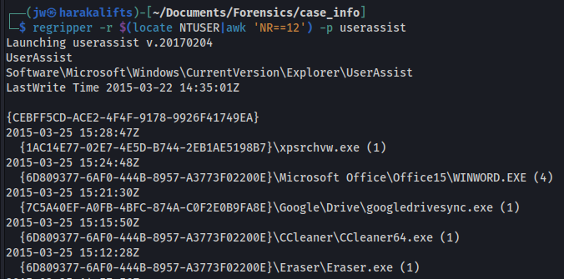
Again we find Eraser and CCleaner with execution times and counts, but notice the count on CCleaner. The prefetch output counted two instances of CCleaner, but here we see only one. If we try searching for it:
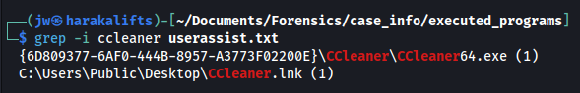
That .lnk file is a shortcut on Windows systems. You won’t find it in the prefetch output. This is a unique distinction of the UserAssist keys.

MUICache
Reading:
- https://learn.microsoft.com/en-us/windows/win32/intl/overview-of-mui
- https://www.magnetforensics.com/blog/forensic-analysis-of-muicache-files-in-windows/
- https://www.howtogeek.com/148499/what-is-an-xps-file-and-why-does-windows-want-me-to-print-to-one/
The MUICache, or Multilingual User Interface service, assists Windows with localization issues. As a forensic analyst, this doesn’t have a ton of information, but can still be helpful. The MUICache stores a little bit of information about application use.
With the RegRipper plugin:
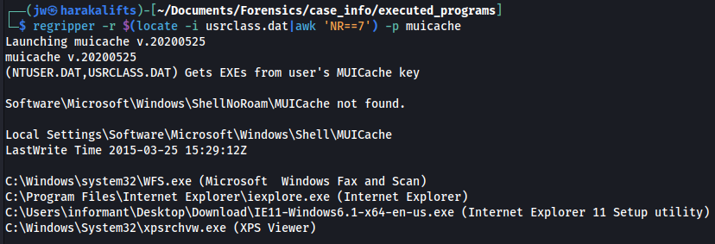
There are only four entries. What this tells us is the subject of investigation used these applications around a certain time. The most notable entries are the Windows Fax and Scan and the XPS Viewer programs. An XPS file is a printable file format, kind of like PDFs. With the Fax and Scan program, this may indicate the subject intended to send a file via fax. This is not conclusive evidence, however. This is just something to keep in mind throughout the rest of the investigation.

Conclusion
This tutorial covered several locations of executable artifacts in a Windows system and how to extract information from them. The shimcache, prefetch files and UserAssist registry keys provide lots of valuable information about applications. The MUICache provides much less information, but may be contextually useful later. RegRipper is an extremely useful tool, but if it doesn’t have a plugin to parse something, you can quickly find another tool to accomplish that task. As a forensic analyst, you need to know how to find evidence in these locations and how to make sense of it.

