# GUI

1. Widgets



1. Widget Description



# Sequences

## Sequence Branching

1. Sequence Branching



There are 4 sequences shown in Figure 3, Init, xTalkAdj, measBase and runTime. Each of these is driven by timers. Only one is active at a time (baton passing). Upon successful completion they branch to the next item until runTime is operational. This path is shown in **green** in the figure. Each of them may need to branch to a previous item if any fault conditions are detected. The branch back paths are shown in **red**.

The Init should only be run once on 1st startup. If a power fault is detected during operation it should be used to reset the device.

## Sequence: runTime

1. Sequence: runTime



The runTime sequence is the most important and complicated of the group of sequences. A “flow chart” of this sequence is shown in Figure 4. This sequence, like the others is polled. Normal flow is from top to bottom on the left of the diagram, along the **green** paths. Branching to other sequences is along the **red** paths with the exit point also shown in red. The individual decision points are detailed below:

1. Prox Done? / Power Fault?  
     
   Purpose: Checks status register  
     
   Read *STATUS once* (it clears on read). Exit if the conversion is not complete. Reinitialize if the supply flag is set (power fault has occurred). Otherwise continue.   
   1. **IF** [ STATUS:PROX_DONE (0x6:B2) == 0 ] **EXIT**
   2. **ELSE**
      1. **IF** [ STATUS:SUPPLY_FLAG (0x6:B4) == 1 ] **Init** // power fault
      2. **ELSE** Drift?
2. Drift?  
     
   Purpose compensates for long term drift.  
     
   Once per *user defined* (default = 60 seconds) re-measure the baseline provided the proximity value is NEAR.
3. Wash?  
     
   Purpose: prevent self rise, if IR is detected for proximity value to 0, FAR  
     
   if PROX_WASH > minimum value detected +1 then proximity=0, go to Near/Far?  
   if minimum value detected > PROX_WASH then minimum value detected = PROX_WASH
4. Offset?  
     
   Purpose: Make sure minimum proximity detected > 0  
     
   After *user defined* (default = 3 cycles) persistence of proximity < 0  
   1. Decrement LUT index by 1 (once), go to measBase
   2. If decrement done (4.a) then go to measXtalk
5. <Baseline?  
     
   Purpose: correct for incorrect Far level (baseline)  
     
   After *user defined* (default = 3 cycles) persistence of proximity < baseline go to measBase
6. Near/Far?  
     
   Purpose: return Near/Far result   
     
   If proximity < threshLo return FAR  
   If proximity > threshHi return NEAR  
   Else return last state
7. VB6 Code

Private Sub tmrRunTime_Timer()

Dim prox As Double, wash As Byte, offset As Long, pFlag As Boolean, np As Byte, pram As Long

Static nearFar As Byte, lastProx As Double, lastBase As Double, lPflag As Boolean

Static offsetReduce As Boolean ' done already, remeasure xTalk

Static offsetReductionCount As Long

Static baseLinePersistCount As Long

Static driftCounter As Long

'

' This routine contains 3 possible state changes

' 1) Init: if "brown out" detected (initNeeded)

' 2) measBase: if prox = 0 for consecutive offsetPersist cycles (offsetReductionCount)

' 3) xTalkAdj: is offset has been adjusted already but is still 0

Static primed As Boolean ' start on 2nd call

If primed Then

If als.GetProximity(prox) Then ' PROX_DONE

prox = Int(prox * 255)

' ===========================================================

' occasionally remeasure the baseline to compensate for drift

' ===========================================================

driftCounter = driftCounter + 1

If driftCounter > 1000 * measBaseTime / (tmrRunTime.Interval) And prox < threshLo + baseline Then

primed = False: gotoState state.stMeasBase

End If

Else

' =====================

' check for power fault

' =====================

If als.getInitNeeded Then ' reset sequence (brown out)

primed = False: gotoState state.stInit

End If

Exit Sub

End If

' ==================================================

' monitor the 2/3 pulse bit (for debug/testing only)

als.readField BF.XPLS_, np

lblSeq.caption = "RUNTIME:" & Str(np)

' ==================================================

pFlag = als.getPflag

If pFlag <> lPflag Then

lPflag = pFlag ' break here for flag change

End If

If pFlag Or 1 Then ' Poll/Interupt And:Use Interrupt; Or:Poll

' XXXXXXXXXXXXXXXXXXXXXXXXXXXXX

dataValid = True ' unless offset too high REMOVE

' XXXXXXXXXXXXXXXXXXXXXXXXXXXXX

' ===========================

' washout detection/ tracking

'als.GetProximity prox: prox = Int(prox * 255)

als.readField BF.WASH_, wash

If washThresh > wash Then washThresh = wash ' new washout detect value

If wash > washThresh + 1 Then ' guardband threshold by 1 LSB

prox = 0 ' bright light detected, force to zero

nearFar = 0

lblLight.caption = "BRIGHT"

' ===========================

Else

lblLight.caption = "DIM"

' ================================================================

' check if offset is too high, drop value by 1, remeasure baseline

' if has already been reduced once, readjust offset [PC]

If prox = 0 Then

offsetReductionCount = offsetReductionCount + 1

Else

offsetReductionCount = 0

offsetReduce = False

End If

If offsetReductionCount >= offsetPersist Then

If offsetReduce Then ' if drop by 1 didn't work, readjust offset

primed = False: gotoState state.stXtalkAdj

Else ' drop by offset by 1, remeasure baseline

offsetReduce = True

drv.dGetProxOffset pram 'returns LUT index in pram

If pram > 0 Then pram = pram - 1

drv.dSetProxOffset pram ' pram sets LUT index, returns offset in LSBs

primed = False: gotoState state.stMeasBase

End If

' ================================================================

Else

' =============================

' check for baseline level [PC]

prox = prox - baseline

If prox < 0 Then

baseLinePersistCount = baseLinePersistCount + 1

prox = 0

If baseLinePersistCount >= baseLinePersist Then

baseLinePersistCount = 0

primed = False: gotoState state.stMeasBase ' remeasure baseline

Else

baseLinePersistCount = 0

End If

End If

' ========================

' ==================

' determine Near/Far

If 0 Then ' Near/Far 0: use prox value; 1: use Prox Int Flag

nearFar = pFlag

Else ' set to 1 for Motorola Logic

If prox > threshHi Then

nearFar = 1 ' Near

Else

If prox < threshLo Then

nearFar = 0 ' Far

Else

'in hysterisis band, use last value

End If

End If

End If

' ==================

End If

End If ' wash/not

updateProx prox, nearFar

End If ' interrupt/poll loop

Else

driftCounter = 0

primed = True

End If

End Sub

# Test Procedure

## Functional (Black Box)

### Initialization

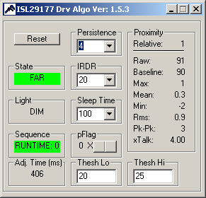Start Driver with no object present:

Observe for > 1 minute:

1. State = FAR
2. 10 < Baseline < 100
3. Proximity (relative) < 10
4. 10 < Baseline < 90

### Near/Far

1. 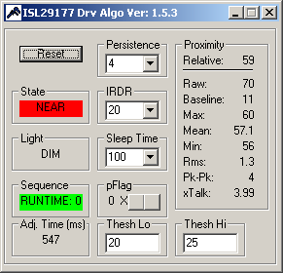Place flat object (i.e. paper) ~3cm from sensor
2. 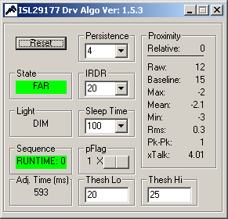Verify NEAR state: Proximity (relative) > Threshold High (default=25)
3. 10 < Baseline < 90
4. Remove object
5. Verify FAR state: Proximity (relative) < 10
6. 10 < Baseline < 90

### False Offset recovery

1. 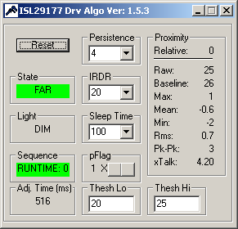Place flat object (i.e. paper) ~3cm from sensor
2. Reset driver
3. Verify FAR state: Proximity (relative) < 10
4. 10 < Baseline < 90
5. 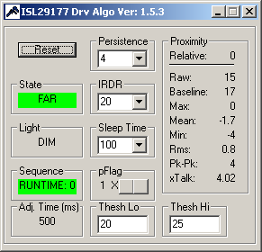Remove Object
6. Verify FAR state: Proximity (relative) < 10
7. 10 < Baseline < 90
8. 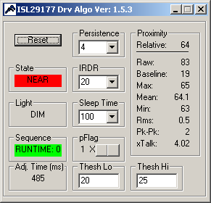Return Object
9. Verify NEAR state: Proximity (relative) > Threshold
10. 10 < Baseline < 90