**ISL29125 Evaluation Board Calibration Procedure**

**1. Connect ISL29125 evaluation board to the PC/Laptop via microUSB cable**

**2. Launch "Chroma meter"**

**a. Open EEprom GUI by clicking on "CCM" on the left top corner**

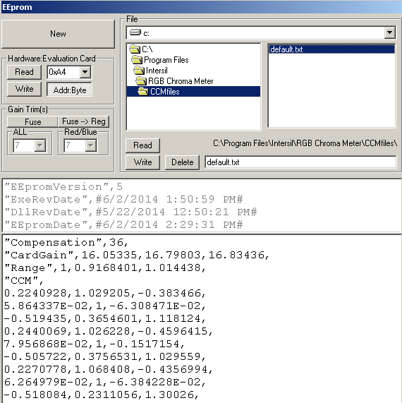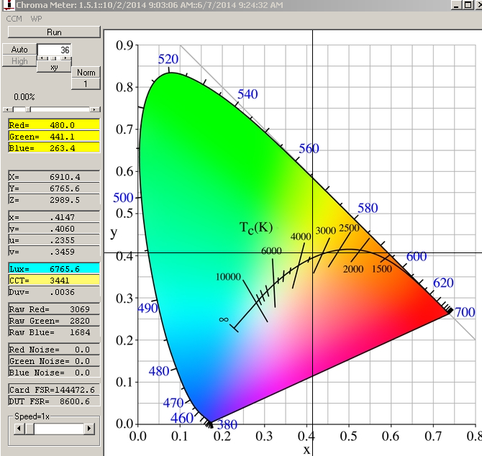

***Figure 1. Chroma Meter GUI and related EEprom GU***I

**b.** **Set I2C address to 0xA4 for Evaluation card as shown in Figure 1**

**c.** **Click on "Read" to read out the calibration data from EEprom**. The latest EEprom calibration data version should be 5. If not, import the calibration header text from “default.txt” as shown in the rightmost panel under installation directory by pressing Read button

“C:\Program Files\Intersil\RGB Chroma Meter\CCMfiles”.

Note above directory may be changed depending on the installation directory of Chroma meter

d. **Click on 'Run' button so that it changes to 'hold' before Calibration in excel**

3**. Launch "simple.ALS.drv.xlsm" (see below inserted excel file)**

Go to Tab “EVB CCT Cal”. Hit "Reset" button in cell"K6" to clear the historical calibration data including the calibration data section (green part), IR compensation and Measured XYZ values (yellow sections).

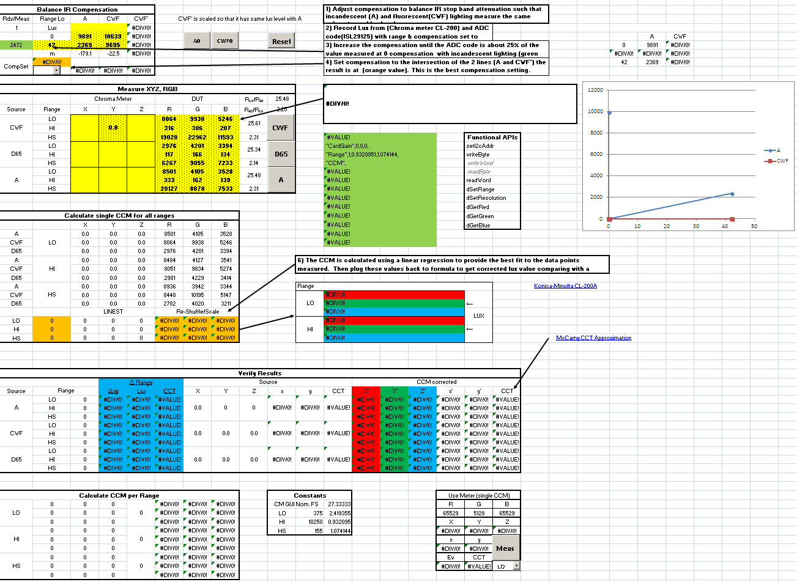

***Figure 2. Calibration Spreadsheet***



**4.** **Perform IR compensation calibration**

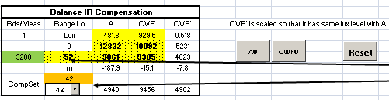

***Figure 3 IR compensation section***

a**. Measure A illuminance lux (EV value)**

1) Turn on 3200K/8000 lux light source (Quartz Tungsten Halogen (QTH) lamps).

2) Place the color conversion filter (D30 to A) between the QTH light source and the

Integrated sphere to generate the A illuminant (CCT~2800K)

3) Input the chroma meter reading of A illuminant light level (lux) value into

Cell “D4” in tab “EVB CCT Cal”

4) Press the button “A0” in Cell “H5”

b**. Measure CWF illuminance lux (EV value)**

1) Turn on 3200K/8000 lux light source (Quartz Tungsten Halogen (QTH) lamps).

2) Place the color filter (D30 to CWF) between the light source and the integrated sphere to

generate CWF illuminant (CCT ~4000K)

3) Input the chroma meter reading of CWF illuminant light level (lux) value into

Cell “E4” in tab “EVB CCT Cal”

4) Press the button “CWF0” in Cell “H5”

The IR compensation values can be found in cell “C8” on the right side of CompSet.

**5**. **Perform CCM calibration**

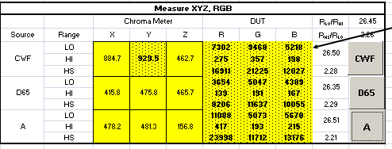

***Figure 4 XYZ calibration section***

a. **Measure CWF illuminant tristimulus values (XYZ)**

1) Turn on 3200K/8000 lux light source (Quartz Tungsten Halogen (QTH) lamps).

2) Place the color filter (D30 to CWF) between the light source and the integrated

Sphere to generate the CWF illuminant (CCT 4000K)

3) Input the chroma meter reading of XYZ values into Cells “D14: F14” in tab

“EVB CCT Cal” and Press button “CWF”

b. **Measure D65 illuminant tristimulus values (XYZ)**

1) Turn on 3200K/8000 lux light source (Quartz Tungsten Halogen (QTH) lamps).

2) Place the color filter (D30 to D65) between the light source and the integrated

Sphere to generate the CWF illuminant (CCT 6500K)

3) Input the chrome meter reading of XYZ values into Cells “D17: F17” in tab

“EVB CCT Cal and Press button “D65”

c. **Measure A illuminant tristimulus values (XYZ)**

1) Turn on 3200K/8000 lux light source (Quartz Tungsten Halogen (QTH) lamps).

2) Place the color filter (D30 to A) between the light source and the integrated

Sphere to generate the CWF illuminant (CCT~2800K)

3) Input the chrome meter reading of XYZ values into Cells “D20:F20” in tab

“EVB CCT Cal” and Press button “A”.

**6.** **Copy the generated CCM calibration value, CardGain, CCM and Range in range “M16: M28” (green cells) and paste it into Chroma meter EEprom data region (as shown below) and press “Write” button in the upper left corner.**

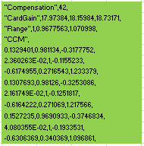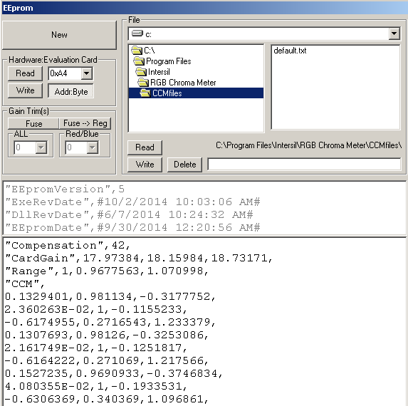

***Figure 5 Final Calibration Write into EEprom***