1. Quick recap of project & changes in scope
Our project focuses on predicting house prices using the Kaggle House Prices: Advanced Regression Techniques dataset, with the goal of understanding how different modeling approaches—linear, nonlinear, and combined—affect prediction performance. Initially, the project was a standard comparison of regression models such as Ridge, Lasso, and nonlinear methods. However, after feedback, we refined our direction to a more analytical question: when are linear models insufficient, and does combining models improve performance? Our hypothesis is that ensemble methods (hybrid and stacking) can improve prediction accuracy by combining strengths of different models, especially when models capture complementary information. To test this, we implemented both a hybrid model and a stacking model, shifting the project into a study of model complementarity and ensemble effectiveness.

2. Algorithms and baselines implemented
We implemented a full pipeline including preprocessing and multiple models. Preprocessing includes median imputation, categorical handling with “Missing”, one-hot encoding, and ordinal mapping for quality features. We also applied a log transformation:
$$y=log⁡(1+\text{SalePrice})$$
to reduce skewness, and converted predictions back using:
$$\hat{y}=exp⁡(\hat{y})-1$$
We implemented:
- Ridge Regression:
$$min⁡∣∣y-Xw∣∣^{2}+λ∣∣w∣∣^{2}$$
- Lasso Regression:
$$min⁡∣∣y-Xw∣∣^{2}+λ∣∣w∣∣_{1}$$
- Gradient Boosting (GB):
$$F_{m}(x)=F_{m-1}(x)+γ_{m}h_{m}(x)$$
We also explored:
- Hybrid model:
$${\hat{y}}_{hybrid}=α{\hat{y}}_{ridge}+(1-α){\hat{y}}_{GB}$$
- Stacking model:
$$\hat{y}=f({\hat{y}}_{ridge},{\hat{y}}_{GB})$$
All models were evaluated using 5-fold cross-validation and RMSE:
$$RMSE=\sqrt{\frac{1}{n}∑(y-\hat{y})^{2}}$$

3. Preliminary results and analysis (with graphs)
Our results show:
Ridge: ~51k RMSE
Lasso: ~57k RMSE
GB: ~29k RMSE
Hybrid: ~29k RMSE
Stack: ~30k RMSE
From the Model Comparison graph, we clearly observe that Gradient Boosting significantly outperforms linear models, confirming that the problem is highly nonlinear.
Based on our hypothesis, we expected stacking to outperform the hybrid model because it learns optimal combinations. However, both Hybrid and Stacking perform similarly to GB and do not improve performance, indicating that the base models are not sufficiently complementary.

🔹 Graph Interpretation

1. RMSE Across Folds
- GB is consistently lower across folds
- Ridge and Lasso show large spikes (especially one fold with very high error)
👉 This indicates linear models are unstable and underfit 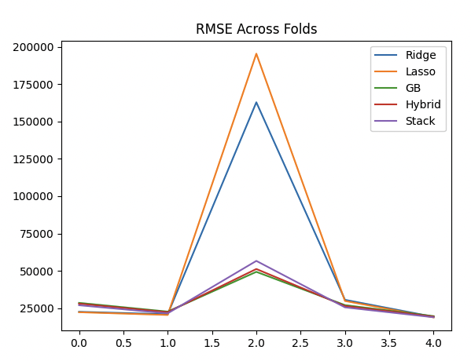

2. Actual vs Predicted (GB)
- Points align closely along the diagonal
👉 Model predictions are accurate overall
- Slight spread for higher prices
👉 Larger error for expensive houses 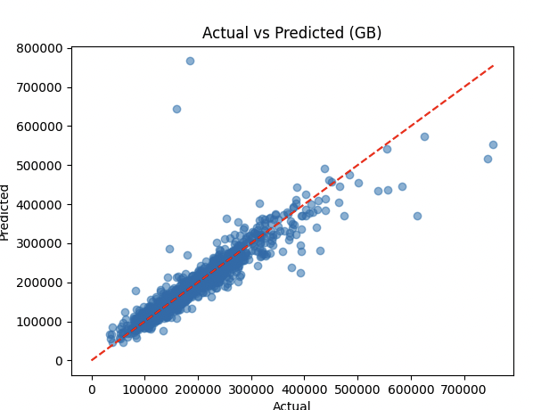

3. Residual Distribution
- Centered around 0 → model is unbiased
- Most residuals within ±30k
👉 Confirms RMSE ≈ 29k
- Some large outliers → increase RMSE 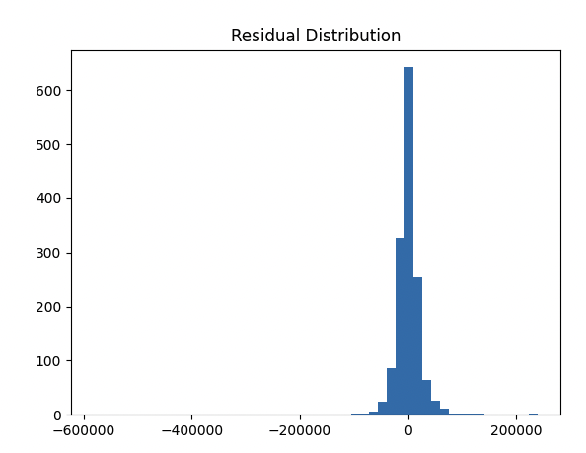

4. Error vs Price
- Clear pattern:
Higher price → larger error
👉 Model struggles more with expensive houses
👉 Suggests heteroscedasticity (error grows with price)
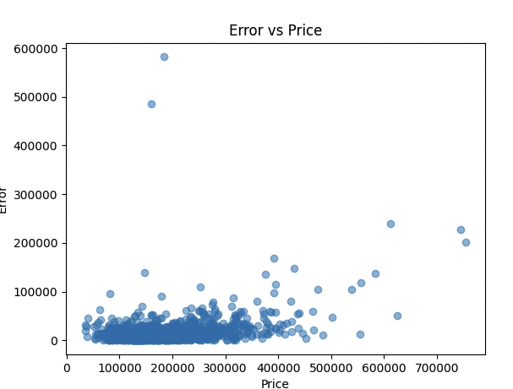

5. Top Features
- Most important features:
OverallQual, GrLivArea, TotalBsmtSF
👉 Matches real-world intuition
👉 Confirms model is learning meaningful patterns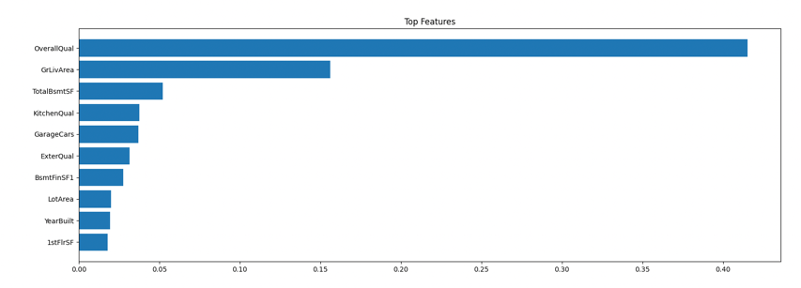

🔥 Key Insight
Although we hypothesized that combining models would improve performance:
Hybrid ≈ GB
Stack ≈ GB
👉 This shows:
Gradient Boosting already captures both linear and nonlinear relationships, leaving little additional signal for other models to contribute.

4. Challenges encountered and solutions
We encountered several challenges:
- Initial scope too simple → expanded to hybrid + stacking
- Complex preprocessing → handled via structured pipeline
- Linear models underperformed → introduced GB
- Initial hybrid (residual-based) failed → switched to weighted hybrid
- Potential data leakage → avoided tuning α dynamically
- Stacking did not improve → revealed lack of model complementarity
Additionally, analysis of graphs revealed larger errors for expensive houses, highlighting limitations in modeling extreme values.

5. Final report plan & additional experiments
For the final report, we will:
- Finalize comparisons across all models
- Improve explanation of hybrid and stacking
- Strengthen interpretation using graphs
- Clearly connect results to hypothesis
If time permits, we will:
- Explore LightGBM / XGBoost
- Improve stacking with more diverse models
- Perform feature engineering
- Analyze errors across price ranges

