FUA Delivery Report

FUA: NL505L1 |  | Maastricht
PRODUCT TYPE | FUA2006
FILE ID | No_Data
PRODUCT TYPE | FUA2012
FILE ID | NL505L1_MAASTRICHT_UA2012.shp
PRODUCT TYPE | CHANGE 2006-2012
FILE ID | No_Data

GENERAL INFORMATION
FUA Area in 2006 (km²) | No_Data km² | Photo-interpretation started on | 2013/08/13
FUA Area in 2012 (km²) | 203 km² | SIRS Quality Control made on | 2013/08/20
Format | geodatabase esri | IGNFI Quality Assessment on | 2013/10/01
Projection | ETRS_1989_LAEA | SIRS Final Validation made on | 2015/12/16
 |  | by: | Lionel Méquignon
SOIL SEALING
Validation date | 2013/08/22
COTS |  | Coordinate system reference | Projection: ETRS 1989 LAEA
Validation date | 2013/08/09 | EPSG | 3035
GEOGRAPHIC COORDINATES | SYSTEM | (Lambert Azimuthal Equal Area) | Central Meridian: 10°
 | GCS_ETRS_1989 |  | Latitude of Origin: 52°
Datum | D_ETRS_1989 |  | False Easting: 4321000,00
Main Meridian | Greenwich |  | False Northing: 3210000,00
Angular Unit | Degree |  | Ellipsoid: WGS84

IMAGE data used
Satellite & Sensor Image List used in the FUA processing
RemarksGoogleProduction dateematic data, satellite images, aerial photos, city maps)\\192.168.1.236\\ua2012\\Lien_vers_hd6\\CHEMINS_IMAGES2012\\NL505L1_Maastricht_images_list.txt
Scale
(spatial detail)
(y/m/d)
Id.
Data source/typeStreet viewGoogle EarthCity mapWeb mapMaastricht2013http://www.plattegronden.nl/maastricht/
CAPI/ DIGITAL CLASSIFICATION

Photointerpreter(s) for the REVISION OF 2006 FUA

Name/surname | interpretation
Name/surname | start (y/m/d) | end (y/m/d) | Remarks

Photointerpreter(s) for the CHANGES BETWEEN 2006 and 2012

Name/surname | interpretation
Name/surname | start (y/m/d) | end (y/m/d) | Remarks

Photointerpreter(s) for the NEW FUA (2012)

Name/surname | interpretation
Name/surname | start (y/m/d) | end (y/m/d) | Remarks
Vasse Thibaut  Stroppa Lionel | 2013/08/13  2013/08/27 | 2013/08/19  2013/08/28

Internal quality control
Internal quality check | Date of control  (y/m/d) | Result | Remarks (errors, corrections, etc.)
Crépin anne | 2013/08/20 | OK | 0

Quality assessment
Internal quality check | Date of control  (y/m/d) | Result | Remarks (errors, corrections, etc.)
IGNFI | 2013/10/01 | OK

Internal quality check | Date of control  (y/m/d) | Result | Remark (errors, corrections, etc.)
SIRS / Lionel Méquignon | 2015/12/16 | OK

TOPOLOGICAL QUALITY CHECK

The topological quality check of all of the FUAs is based on the following rules (see diagramme).
- Thematic QC on the CAPI phase;
- Creation of Arcinfo’s Topology;
- Geometric check and validation of Geodatabase’s Topology.
SIRS created a 5 km size grid on all FUA, which split road large polygons into smaller ones, in order to ease ingestion of such polygons by users.
Only the 12220 code roads are split using this method.

CONFUSION MATRIX

Urban strata accuracy calculation

The sample population is that of the entire FUA and non urban classes are aggregated in class 600.
The main advantage of this method is to provide both omission and commission errors on the urban strata (omission - commission class 1xx / class 600).

CONFUSION MATRIX (URBAN):
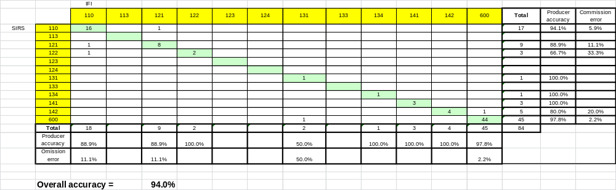

CONFUSION MATRIX (RURAL):
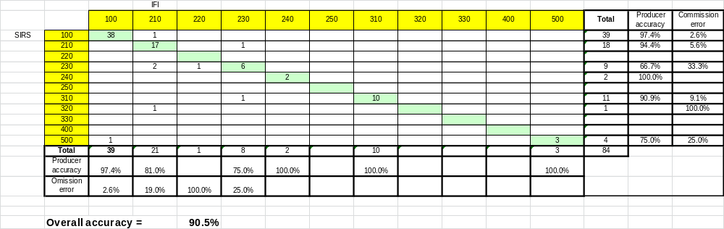

CONFUSION MATRIX (OVERALL):
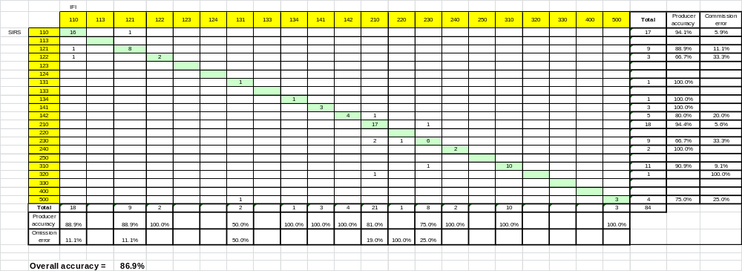

Title
(if relevant)

