John Whaley
Dr. Christopher Harris
Computer Arch. and Design
Feb. 19, 2020

CPU Design pt.2

Register Level Block Diagram:

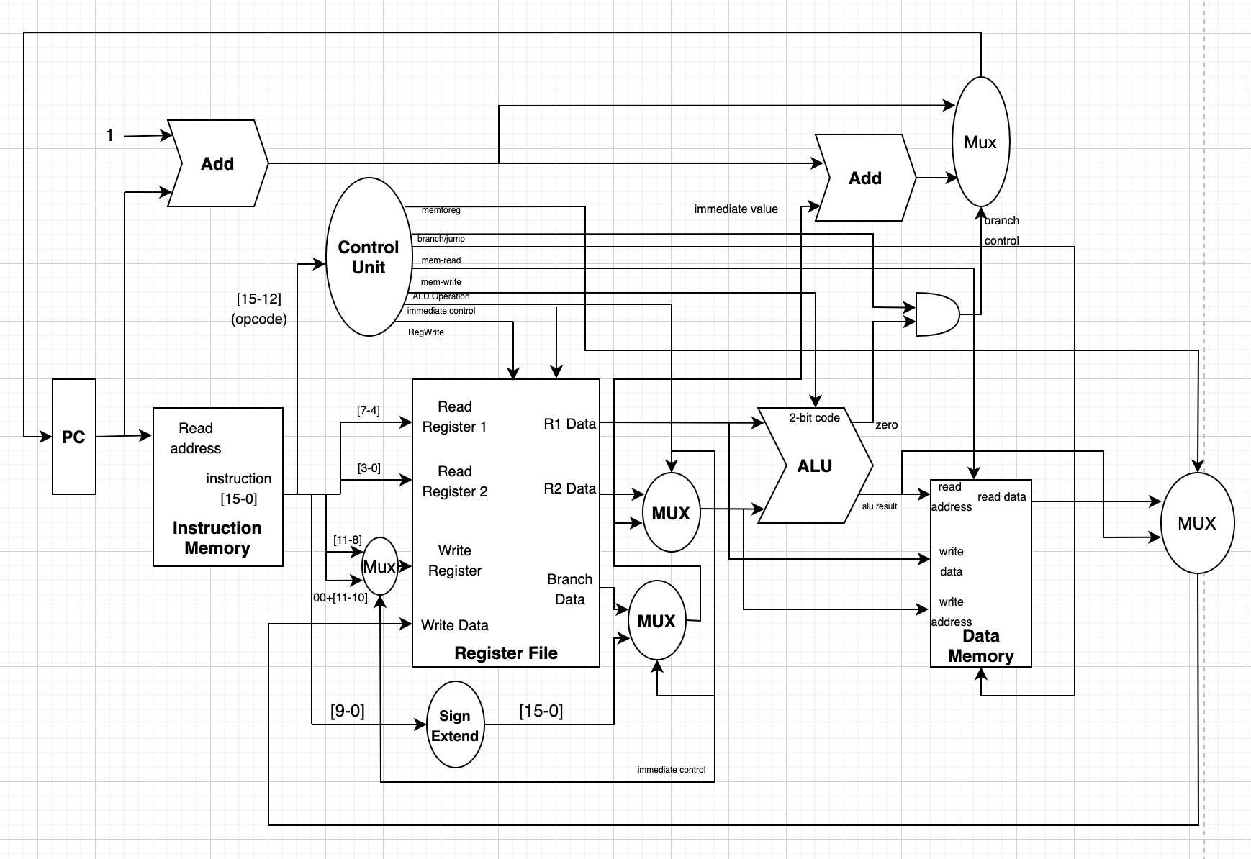

Hardware Design

Description of Components:

PC: This is a register that holds the current instruction location. It outputs a 16 bit read address and takes in a 16 bit address.

Instruction/Data Memory: My system uses Harvard Architecture, which means that the CPU has separate memory for instructions and data.
- Instruction Memory has a 16 bit read address input and 16 bit instruction output.
- Data Memory has read address, write data, and write address inputs (all 16 bits) as well as two control signals: mem_read and mem_write. It also has a read data output for instructions that are asking to read in something for memory.

Register File: This will hold the registers that will be used for the operations in programs. This system uses a 2 read and 1 write register file functionality. A register will be written to if the regwrite control signal is high.
- Inputs: Read_Register1, Read_Register2, Write_Register, write_address, Write_Data, and reg_write
- Outputs: R1 Data, R2 Data, Branch Data
There is a Mux connected to the output of the R2 data which will be used to load in immediate values for instructions that use immediates.
In the event of a stor instruction, the contents stored in the R1 Data output will be passed through to write_data in the data memory.

Control Unit: This is my control functionality that turns on certain parts of the CPU based on which opcode has been supplied.
- Input: Op Code supplied by the instruction memory
- Output: memtoreg, branch/jump, mem_read, mem_write, ALU operation, immediate control, regWrite.
The control unit will decide which of these turn on based on the opcode supplied. (more of this in detail later).

Add: These take in two numbers and add them together
There are a couple of adders used for determining the next value of the PC. My design makes the common case fast (add 1 to the PC).

ALU: This is the Arithmetic Logic Unit. It will be used for and, or, add, and subtract operations.
- Inputs: R1 Data, and Mux output, ALU Operation Control (3-bit operation)
- Outputs: ALU Result, Zero Flag

MUX: These are used to select a certain channel to be passed to the output based on a control signal.
- The MUXes in this design are there to help the system decide whether data should be written/or read from the Data Memory based on the instruction given. There is another MUX used to decide whether the PC should be incremented by 1 or if the PC should jump to another location specified by the output of the sign extend.

Sign Extend: The Sign extend takes in a positive or negative number and extends it to 16 bits so that the PC can be updated appropriately.

Instruction Set Register Transfers:

- Halt: Sets the PC to 0 and jumps to the address in register 0 which holds the 0 value. So the operations and controls performed are: read address with halt instruction, send halt opcode to the control structure. Read r0, r0 into registers 1 and 2 in the register file turn on the add immediate control and branch control, that way the program continues to point at the halt instruction in perpetuity.

- Add r3, r2, r1: this instruction reads the address of the instruction, reads in the registers r2 and r1 as the outputs of the r1 and r2 data. The RegWrite control is flipped high. Mem for reg is flipped low immediate control is low. ALU Operation control is 000 for add. Then the result of the r2 + r1 from the ALU is then forwarded back to the write data input of the register file and the contents of the addition is stored in r3.

- Sub r3, r2, r1: This instruction has all the same control values and performs the same register operations as add, except the 2-bit ALU operation control is 001 for subtract.

- Load r3, A: for load instruction, this system only has the ability to write to 3 registers because it uses 2 bits to determine the register # these options are: r1,r2,and r3. The system does this by throwing the immediate value, regwrite, memforreg to high. Operation sends the address specified in load to the data memory and sends out the data stored in that memory address and stores it into the specified register.

- There will be added logic in my register file to

- Stor r2, r3: This instruction stores the contents of R3 into the memory address located in R2. The data transfer happens as follows: the two registers are read in as usual, and R1 data holds the data we write to the memory address coming out of R2 data. Memwrite control is thrown high so that the write address and write data are done.

- And r3, r2, r1: Has the same control operations as add/subtract with the ALU Operation control having a value of 010.

- Or r3, r2, r1: Has the same control operations and register transfers as add/subtract with ALU Operation control value 011.

- Beq r3, r2, r1: immediate control is low, regWrite is high, Branch/jump is high ALU Operation is subtract or 001, if zero flag is set then branch instruction will run

- Bne r3, r2, r1: same controls as beq are set except for ALU operation, which is set to 100 which will be a subtract function that sets my zero flag to 1 if the subtraction does not end in zero.

- Bgt r3, r2, r1: same controls as beq except for ALU operation (101) which will perform a subtraction and set the zero flag high if the result ends in a positive number

- Bge r3, r2, r1: same controls as beq except for ALU operation (110) which will perform a subtraction and set the zero flag high if the result ends in zero or a positive number.

- Blt r3, r2, r1: same controls as beq except for ALU operation (111) which will perform a subtraction and set the zero flag high if the result ends in a number less than zero.

- Ldi r3, i: this instruction places the 10 bit immediate value into the 2-bit r3 register (r1,r2,r3 are possible values). Immediate control is set high, Regwrite is set high, memtoreg is low. When immediate control is high the Register file sends in r0 through r1 data output

- JUMP A: this function takes in an immediate address and jumps to it by throwing branch/jump high, immediate high. For this operation ALU operation is set to (bne) so that it will branch if the immediate given in A of the operation is not 0. If it is zero then we are jumping to the same location and the operation should fail anyways because it would be continuously jumping to itself.

- Push r2: this essentially works like a stor instruction with the stack pointer register being the address passed in. This instruction should be paired with an add instruction to increment the stack pointer by 1.

- Pop r2: This works very similar to the load instruction, with the stack pointer passed in as the read value, and r2 being the destination.

Truth Table of Control Signals:

Instr. # | memtoreg | Branch/jump | Mem-read | Mem-write | ALU Operation | Immediate | RegWrite
1 | 0 | 1 | 0 | 0 | 001 | 1 | 0
2 | 1 | 0 | 0 | 0 | 000 | 0 | 1
3 | 1 | 0 | 0 | 0 | 001 | 0 | 1
4 | 1 | 0 | 1 | 0 | 000 | 1 | 1
5 | 0 | 0 | 0 | 1 | 000 | 0 | 0
6 | 1 | 0 | 0 | 0 | 010 | 0 | 1
7 | 1 | 0 | 0 | 0 | 011 | 0 | 1
8 | 0 | 1 | 0 | 0 | 001 | 0 | 1
9 | 0 | 1 | 0 | 0 | 100 | 0 | 1
10 | 0 | 1 | 0 | 0 | 101 | 0 | 1
11 | 0 | 1 | 0 | 0 | 110 | 0 | 1
12 | 0 | 1 | 0 | 0 | 111 | 0 | 1
13 | 0 | 0 | 0 | 0 | 001 | 1 | 1
14 | 0 | 1 | 0 | 0 | 100 | 1 | 0
15 | 0 | 0 | 0 | 1 | 000 | 0 | 0
16 | 1 | 0 | 1 | 0 | 000 | 1 | 1

Discussion of tradeoffs:

Cost vs speed tradeoffs considered:
I chose a single cycle design for the ease of design. This means that the speed of my CPU isn’t as good as it could be, however it should be easier to debug and fix if there are any issues. In terms of cost, I’m assuming that cost means power consumption of my CPU. I do have a lot of extra components besides just the ALU, Register File, Data Memory, and Program Memory. However I think that adding these components such as the muxes and adders allowed me to come to a design that works for the instructions that I need.

Single Cycle Design:
As mentioned in the above paragraph, I chose a single cycle design for the ease with which I could design my CPU. It may not be as fast as a Multi Cycle design for certain types of instructions, however it was easier for me to understand how a single cycle datapath works because that is what we have focused on mostly in this class.

Decisions related to shared/dedicated components:
I tried to include as many shared components as possible so that I could save power consumption in my datapath. For example, adding the branch data output allows me to send in 3 registers to the reg file so that I could branch to a memory location stored in r3 in the example of beq r3, r2, r1. This allows the system to save some time in computing where to branch if the two registers are equal.

Selection of Edge-Triggered vs latching registers:
Most of the registers in my design are going to be edge triggered. Meaning that they can only be changed when a clock cycle is high. This way any unwanted data wont be stored and sent through the system if bouncing occurs.

Other Decisions considered:
I designed this CPU with simplicity in mind since I will most likely need to go back and change some stuff around if things don’t work how I originally envisioned them. Most of the decisions I made were done to make things work as logically as possible rather than as quickly as possible.

