John Whaley
Dr. Christopher Harris
Computer Architecture and Design
March 23rd, 2020
CPU Design Pt. 3

I used a combination of a text editor, GHDL, and Scansion to analyze and debug my CPU for this portion of the project. Each component is working by itself, and it will be interesting to try and piece them together with a top level component in part 4.

Control Unit:
The first component discussed in this paper is the control unit. The control unit is a behavioral file that produces certain outputs based on an opcode and was implemented by following the truth table in table 1 below.

Instr. # | memtoreg | Branch/jump | Mem-read | Mem-write | ALU Operation | Immediate | RegWrite
1 | 0 | 1 | 0 | 0 | 001 | 1 | 0
2 | 1 | 0 | 0 | 0 | 000 | 0 | 1
3 | 1 | 0 | 0 | 0 | 001 | 0 | 1
4 | 1 | 0 | 1 | 0 | 000 | 1 | 1
5 | 0 | 0 | 0 | 1 | 000 | 0 | 0
6 | 1 | 0 | 0 | 0 | 010 | 0 | 1
7 | 1 | 0 | 0 | 0 | 011 | 0 | 1
8 | 0 | 1 | 0 | 0 | 001 | 0 | 1
9 | 0 | 1 | 0 | 0 | 100 | 0 | 1
10 | 0 | 1 | 0 | 0 | 101 | 0 | 1
11 | 0 | 1 | 0 | 0 | 110 | 0 | 1
12 | 0 | 1 | 0 | 0 | 111 | 0 | 1
13 | 0 | 0 | 0 | 0 | 001 | 1 | 1
14 | 0 | 1 | 0 | 0 | 100 | 1 | 0
15 | 0 | 0 | 0 | 1 | 000 | 0 | 0
16 | 1 | 0 | 1 | 0 | 000 | 1 | 1
Table 1: Control Unit Truth Table

The VHDL code was verified using a test-bench and supplying all 16 of the different opcodes as input sequentially going up. The design matches the truth table as can be seen in the waveforms plot in Figure 1 below.
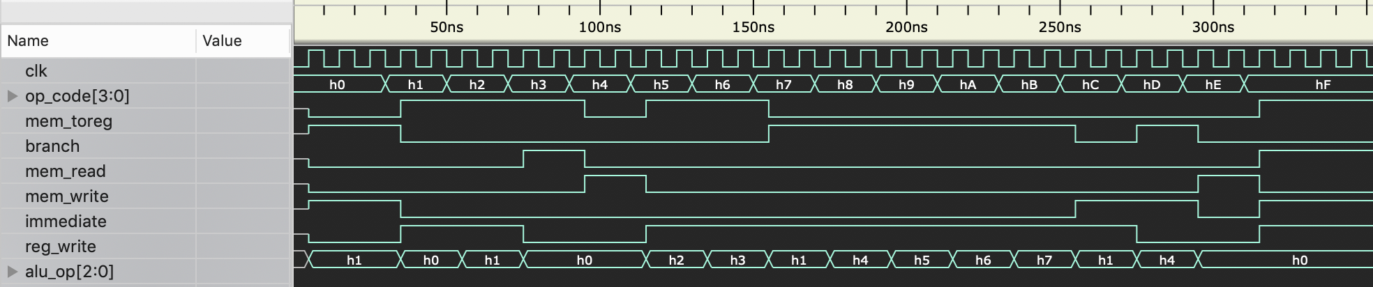
Figure 1: Control Unit Test-bench Output

Arithmetic Logic Unit (ALU):
The ALU has a total of 8 different operations it performs. The following screenshots break up the different operations into chunks so that it is easier to see what is going on.

Addition and Subtraction: ALU_OP: (000, 001)
The first two operations in the ALU are add and subtract. Subtract is a very important operation because it is not only used for mathematical purposes. There is a zero flag which is associated with the subtract operation for branch instructions. The screenshot shown below in figure 2 shows correct operation of the addition and subtraction both when subtraction doesn’t equal zero and when it does. H0 is the addition operation and H1 is the subtraction operation.

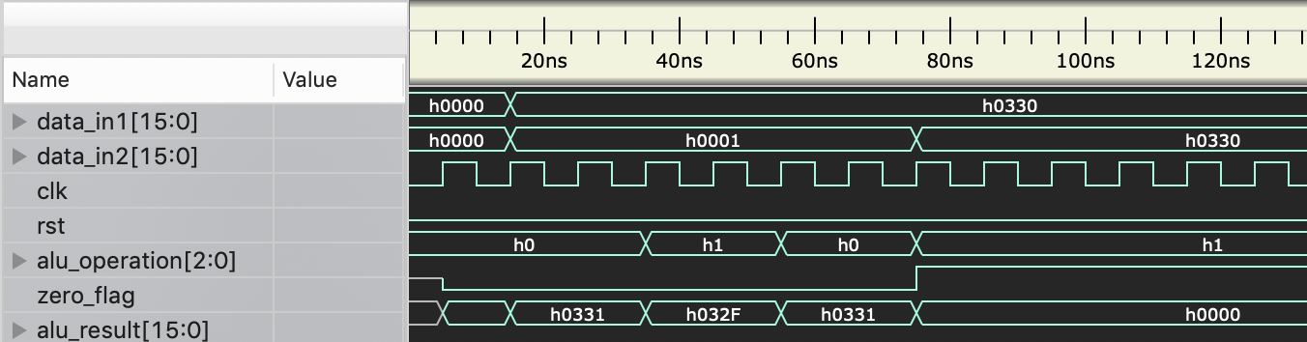
Figure 2: ALU Operation for Addition and Subtraction

AND and OR: ALU_OP: (010, 011)
The next two operations are AND and OR operations. As can be seen from the screenshot in figure 3 below these are working. These are extremely easy operations to implement in VHDL.
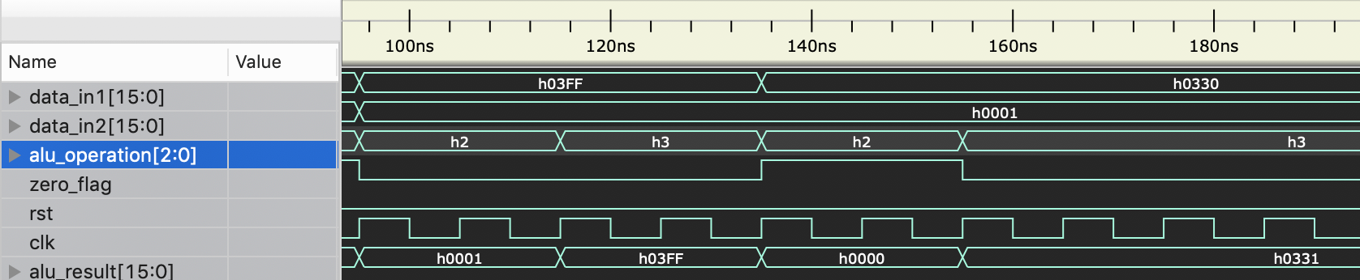
Figure 3: ALU Operation for AND and OR
BNE and BGT: ALU_OP: (100,101)
The Branch if not equal is basically the same thing as BEQ with the if-else statement flipped. The BGT is an interesting one because the zero flag is flipped only when it is greater than. As can be seen in figure 4 below all 3 cases of the BGT operation has been tested. If data_1 is less than data_2 the zero flag is low, if data_1 is equal to data_2 the zero flag is low, and if data_1 is greater than data_2 the zero flag is high.
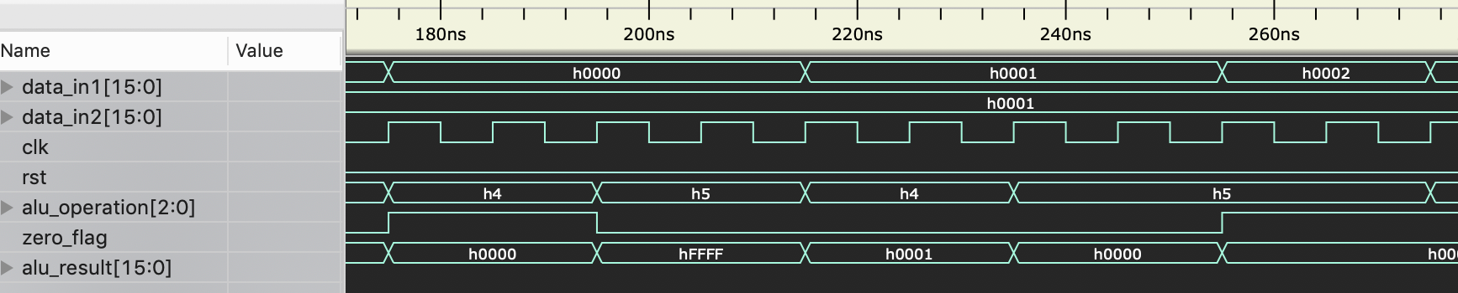
Figure 4: ALU Operation for BNE and BGT

BGE and BLT: ALU_OP: (110,111)
These operations are very similar to BGT with slight variations: BGE now sets the zero flag high when data_1 equals data_2. BLT is the same operation as BGT with data_1 and data_2 flipped. Both of these operations have the correct output as can be seen in Figure 5 below.

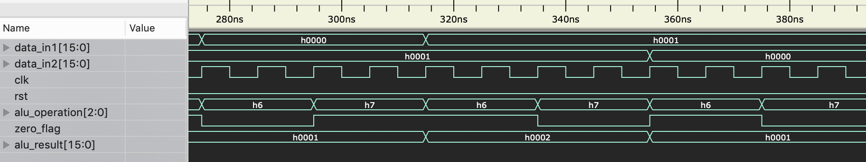
Figure 5: ALU Operation for BGE and BLT

BLE will be implemented by using the BGE ALU Operation and flipping the data inputs at the compiler level. If this is not a sufficient solution then I will get rid of the stack operations, which are unnecessary for the purposes of this class and replace them with a BLE and some other operation.

Register File:
For this CPU the register file will hold 16 registers which can be read from or written to depending on the operation of the CPU. This is a 2 port read 1 port write register file which means that the file is capable of outputting 2 registers for basic read operations and only capable of writing to one register per instruction.

The register file I use also has some added complexity to help deal with the branch functionality of the CPU. The register file outputs the full input data which in some cases may hold a direct address for the system to branch to. As can be seen from Figure 6 below the register file has the correct operation for all the different enable and read inputs.

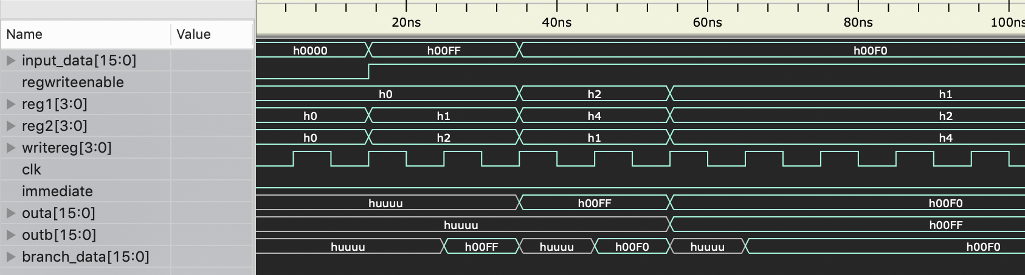
Figure 6: Register File operation

RAM:
For part 3 I have created one memory module even though this CPU uses Harvard architecture which has separate memory for Instructions and Data. The basic operation is to give the RAM a 10 bit read and write address (for 1K of memory), a 16-bit data input, and a write enable input. The operation is that it only outputs data if the write enable is low and will only write data to the memory if write enable is high. As can be seen from Figure 7 below, the RAM follows this logic.

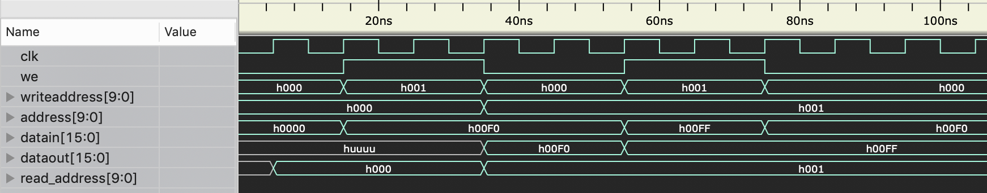
Figure 7: RAM Operation

16 Bit Adder:
For this CPU there are 2 simple 16 bit adders used to branch and load in the current value of the address of the instruction the CPU is currently on. This component has a very simple operation that is similar to the addition done in the ALU.

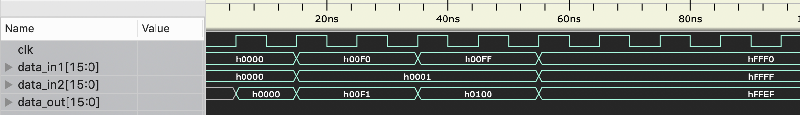
Figure 7: 16 Bit Adder Operation

Sign Extend:
The Sign extend component in this CPU is used to load immediate values into both the register file and the Data memory depending on the instruction being performed. It takes in a 10 bit value and extends it to 16 bits. The way this CPU deals with the extension is by adding 1’s to the beginning if the MSB of the input is a 1 and adding 0’s to the beginning if the MSB is 0.

As can be seen from Figure 8 below this component is working correctly based on those specifications.

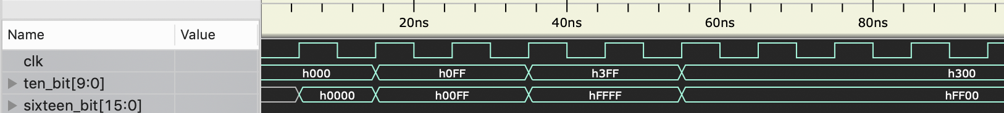
Figure 8: Sign Extend Operation

MUX:
The Mux component is very simple. The mux chooses which signal to propagate through based on a control signal. Since there are muxes with different input values such as a 4 bit mux signals and 16 bit mux signals I have made this a parameterized component so that the vector length can be specified each time a MUX is created in the top level design. I specified it to act on a clock pulse for testing purposes; however, this may need to be taken out in the actual design for speed concerns, or a faster internal clock may be used to make sure nothing is held up by the mux operation since there are so many of them.

