Report of results with sample output.

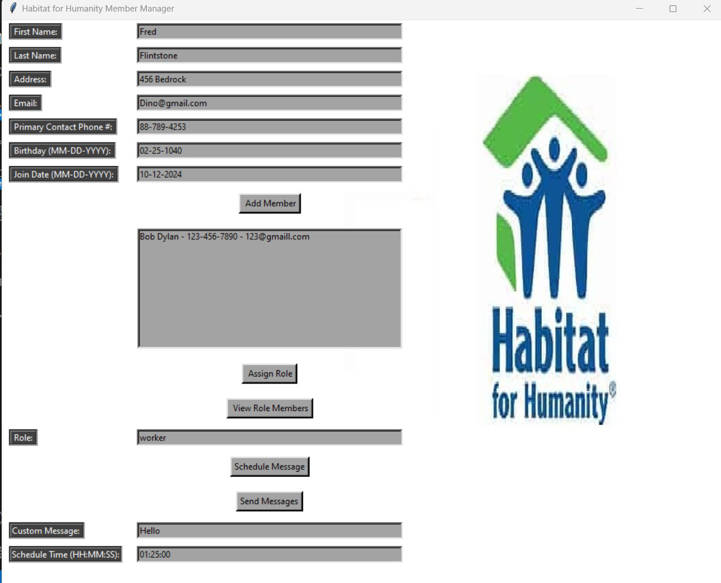

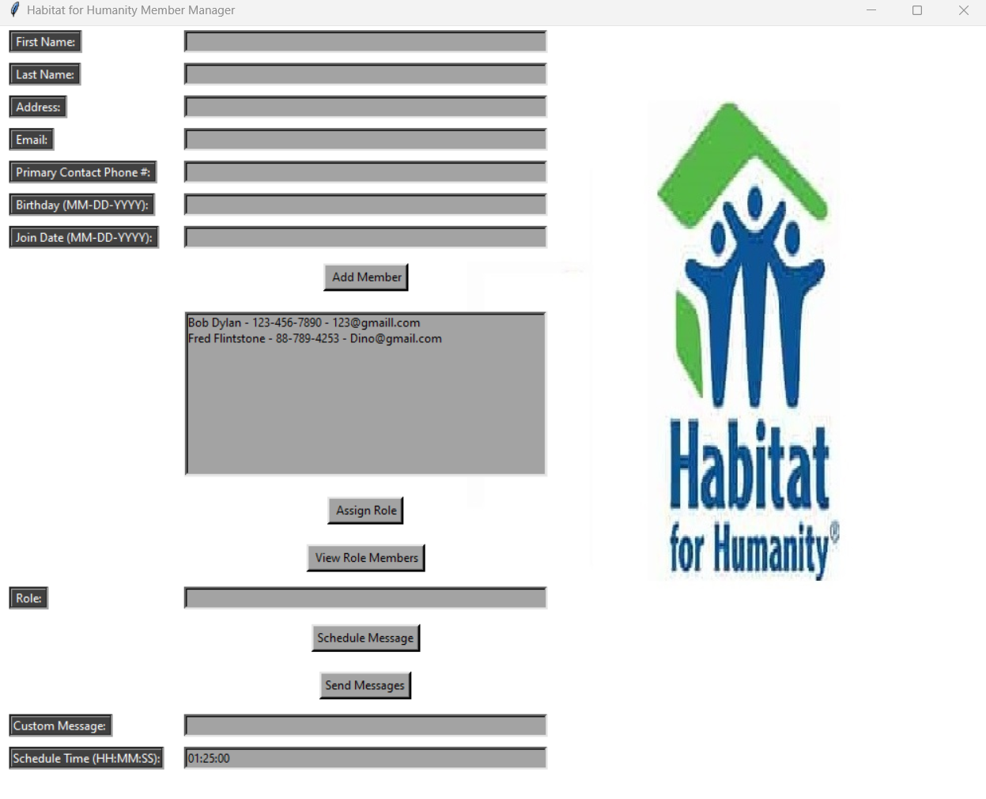
The program functions as expected. Upon filling out the fields you click add member and the member is added. You can then assign them a position and it has a pop up box that assures you the task was completed. Two different members where added. Each was sent a message at a specified time successfully. Roles were assigned to each and was successful as well.

