Exercise 1 Screenshot:
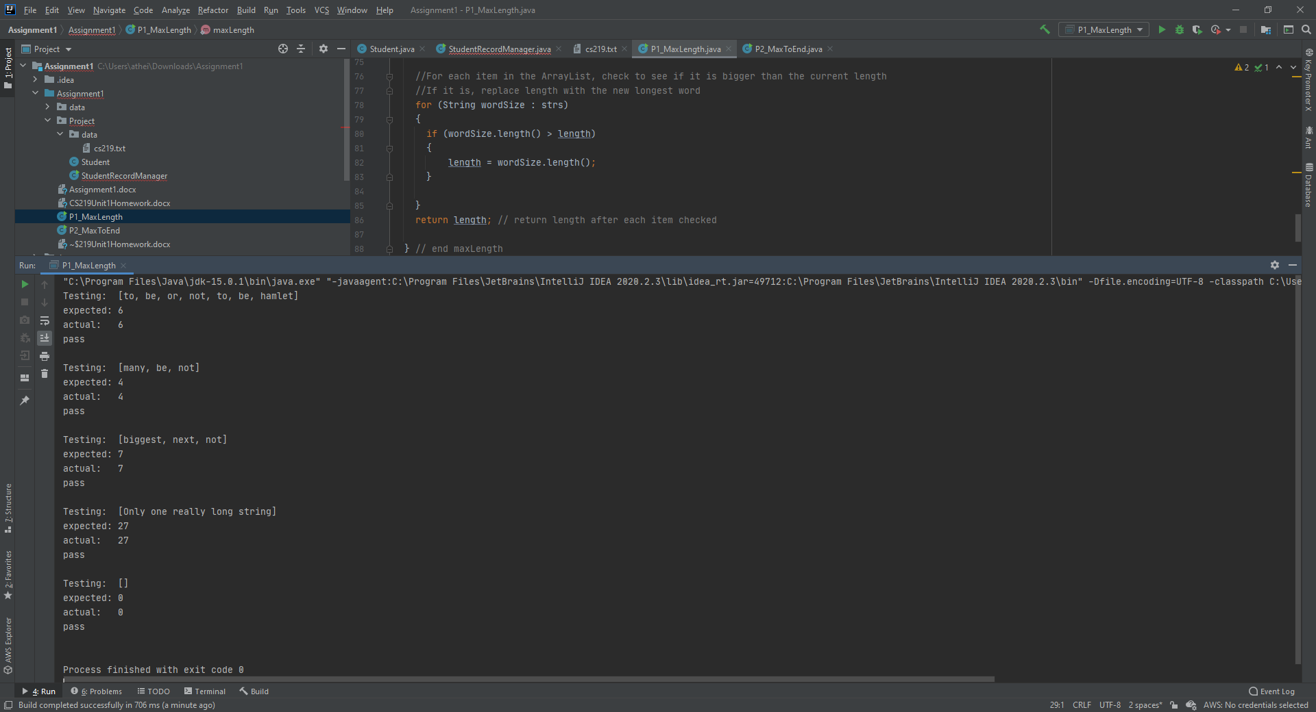
Exercise 2 Screenshot:
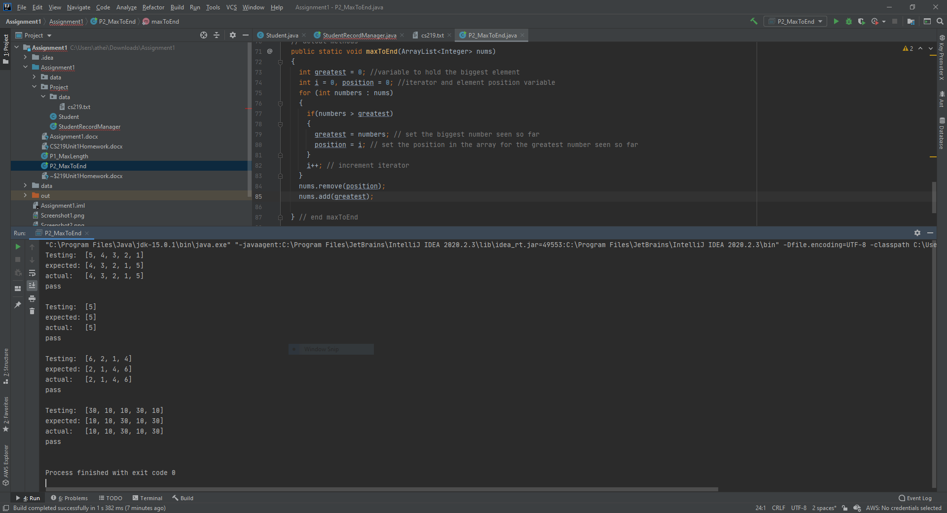

Exercise 3 Reflection:
I think the hardest part for me is still wrapping my head around custom objects and using them in other objects. I understand the Student class and its methods and how to use a Student object, and I understand ArrayLists and how to iterate over them. It took me far longer than I care to admit to understand combining the two and having an ArrayList of Student objects, but in the end I got there.
If I had a time machine and I could go back to Monday, I would not have procrastinated so much on doing the reading and I would have spent more time reviewing my notes from CS151 before jumping into the assignment.
Project Step 2:
Project Screenshot1:
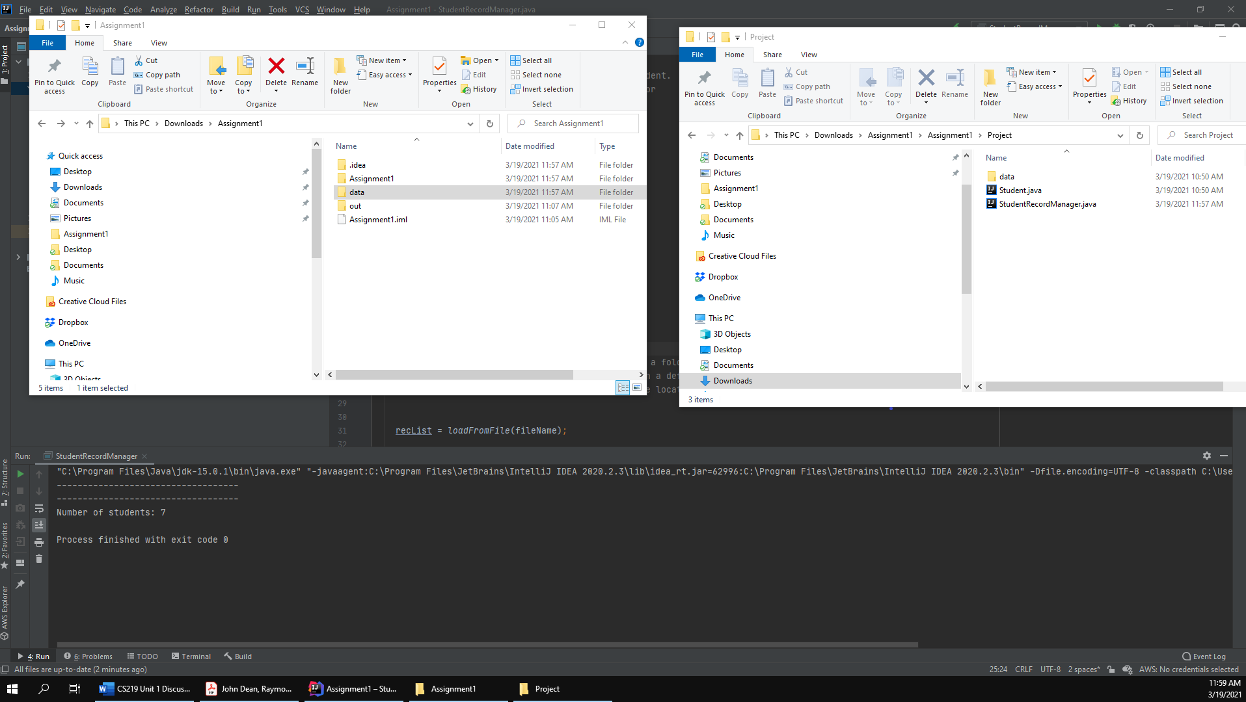

Project Screenshot2:
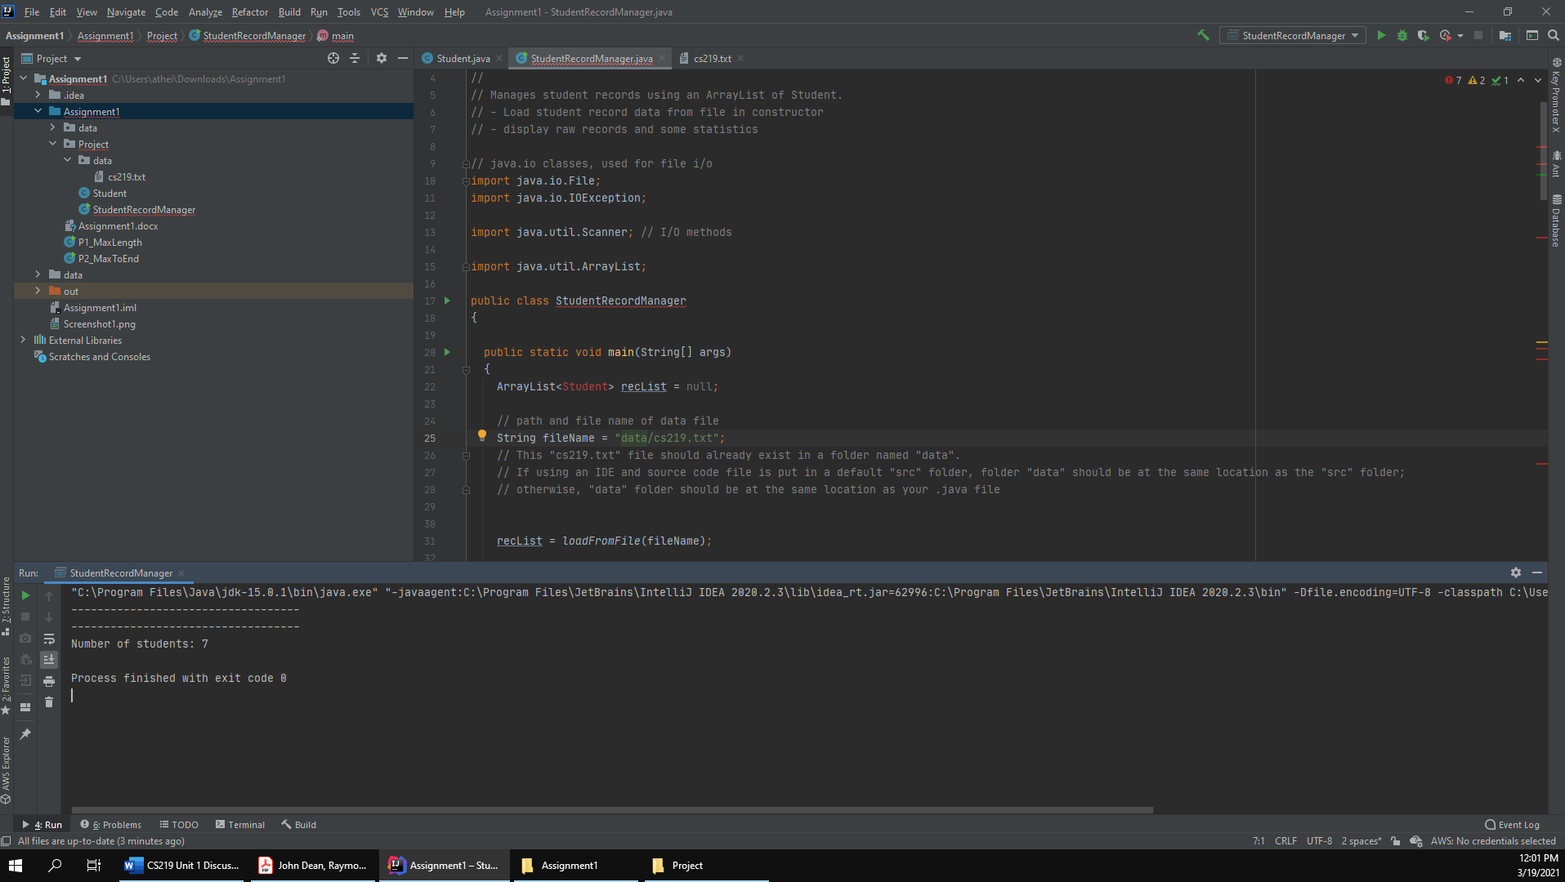
The main() method of StudentRecordManager class
- Describe what the main method does by explaining each line of code.
- Create an empty arraylist called recList
- Create a variable fileName to hold the location of our records file
- Populate our arraylist with the returned output of loadFromFile(fileName)
- Provide our arraylist to the displayRecords function to do what it does
  - Before edits prints “Empty class. No data to show.” If we can’t open/read the file or if the arraylist is empty and exits the function with an empty return statement.
  - If the arraylist is populated, prints two lines of -----------------------------------
- Print “Number of students: 7” to screen.
The loadFromFile()method of StudentRecordManagerclass
- What is the parameter of the loadFromFile() method (type and content)?
  - The parameter is a String containing the filename of the records file.
- What is returned from this method (type and content)?
  - An ArrayList containing student objects.
- Identify the line where the name and absence count information is used to create a new Student object and added into the ArrayList object named records
  - Line 108 in StudentRecordManager.java
    - records.add(new Student(name, absenceCount));

Project Ouput Screenshot:
