STAT 613 - Homework 5

Jacob Henkels

3/4/2021

#### An investor sued his broker for lack of diversification. Below are the rates of return (in percent) for the investor’s portfolio over 39 months (data from Moore, McCabe, and Craig (2017)). The average of the S&P 500 stock index for the same period was 0.95%. Does the broker perform worse than average?

Stockreturns <- c(-8.36, 1.63, -2.27, -2.93, -2.70,   
 -2.93, -9.14, -2.64, 6.82, -2.35,   
 -3.58, 6.13, 7.00, -15.25, -8.66,  
 -1.03, -9.16, -1.25, -1.22, -10.27,  
 -5.11, -0.80, -1.44, 1.28, -0.65,  
 4.34, 12.22, -7.21, -0.09, 7.34,   
 5.04, -7.24, -2.14, -1.01, -1.41,   
 12.03, -2.53, 4.33, 1.35)  
 Stockreturns

## [1] -8.36 1.63 -2.27 -2.93 -2.70 -2.93 -9.14 -2.64 6.82 -2.35  
## [11] -3.58 6.13 7.00 -15.25 -8.66 -1.03 -9.16 -1.25 -1.22 -10.27  
## [21] -5.11 -0.80 -1.44 1.28 -0.65 4.34 12.22 -7.21 -0.09 7.34  
## [31] 5.04 -7.24 -2.14 -1.01 -1.41 12.03 -2.53 4.33 1.35

# 1. Use and show R code to find the mean of the sample data.

mean(Stockreturns)

## [1] -1.124615

# 2. Use and show R code to find the standard deviation of the sample data

sd(Stockreturns)

## [1] 5.977673

# 3. Assuming a normal distribution, use and show R code to find the proportion of returns that are less than -1.5.

pnorm(q = -1.5, mean = -1.124615, sd = 5.977673)

## [1] 0.4749637

# 4. Assuming a normal distribution, use and show R code to find return value that is above 70% of the returns

s <- qnorm(p = 0.70, mean = -1.124615, sd = 5.977673)  
1 - s

## [1] -1.01008

# 5. Use and show R code to find Q1 for the data.

qnorm(p = 0.25, mean = -1.124615, sd = 5.977673)

## [1] -5.156494

# 6. Explore the data by producing and examining a boxplot and checking for normality.

boxplot(Stockreturns)

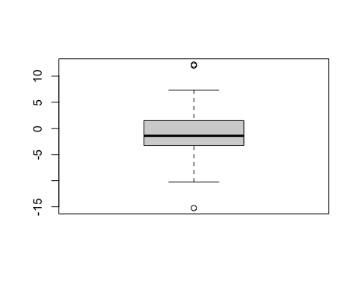

qqnorm(Stockreturns)  
qqline(Stockreturns)

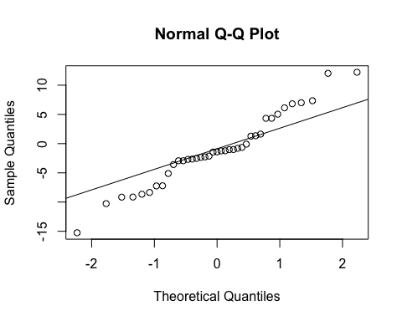

The data does not seem to be completely normal as it does not follow the diagnoal line. It looks like the distribution has a higher frequency on the positive end than the lower end.

# 7. State the appropriate null and alternative hypothesis required for the appropriate t test.

H(0) : true mean = 0.95 H(A) : true mean is less than 0.95

# 8. Use and show R code that will output the needed p value and confidence interval to determine if the null hypothesis should be rejected.

t.test(Stockreturns , mu=0.95, alternative = "less", conf.level = .95)

##   
## One Sample t-test  
##   
## data: Stockreturns  
## t = -2.1674, df = 38, p-value = 0.01827  
## alternative hypothesis: true mean is less than 0.95  
## 95 percent confidence interval:  
## -Inf 0.4891698  
## sample estimates:  
## mean of x   
## -1.124615

# 9. Now answer the question originally stated. Does the broker perform worse than average? (Explain or justify in two or three sentences)

The broker performed worse than average. We reject the null hypothesis as the p-value (0.01827) is less than 0.05. Therefore, the broker performed worse than the average of 0.95%.