Shifting and RPM Meter

Jeffrey Whissen

Extra Credit Project

ECE 351

Project Overview:

The goal of this project is to give the feel of a shifting mechanism that could be used in a car with a continuously variable transmission to simulate a manual or automatic transmission. For this demonstration the program only limits the change in RPM (rotations per minute) of the motor based on the simulated gear.

If set to Automatic transmission mode, when the RPMs get high it will automatically shift to a higher gear, and vice versa. This allows for a complex system of gear ratio adjustment without any user required interaction.

Implementation:

Buttons on the Nano will represent the Accelerator and Brake pedals.

Switches will represent Gears with any combination outside of a one up setting being Neutral.

LED’s would represent the simulated RPM not the real RPM

The top level module represents everything on the Nano that we will be using. I then split the lower level modules into two sections, displayRPM and determineRPM. I then split out the transmission code in determineRPM into its own module.

Display RPM:

Displaying the RPM is pretty simple and just requires the RPM values be connected to the LED outputs.

Determine RPM:

Determining the RPM requires setting values to the gears. Then we reverse the numbers into the ratio used to change the speed at which the RPM’s increase.

Transmission:

Determines the gear ratio and handles the state transition of the automatic transmission option

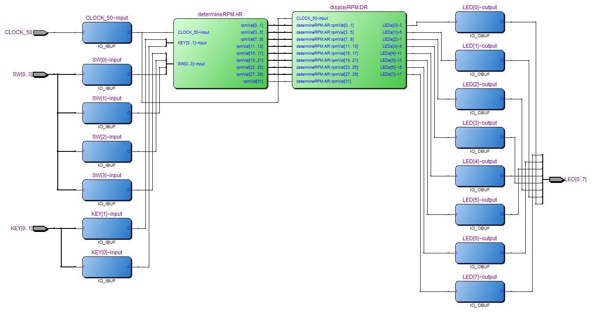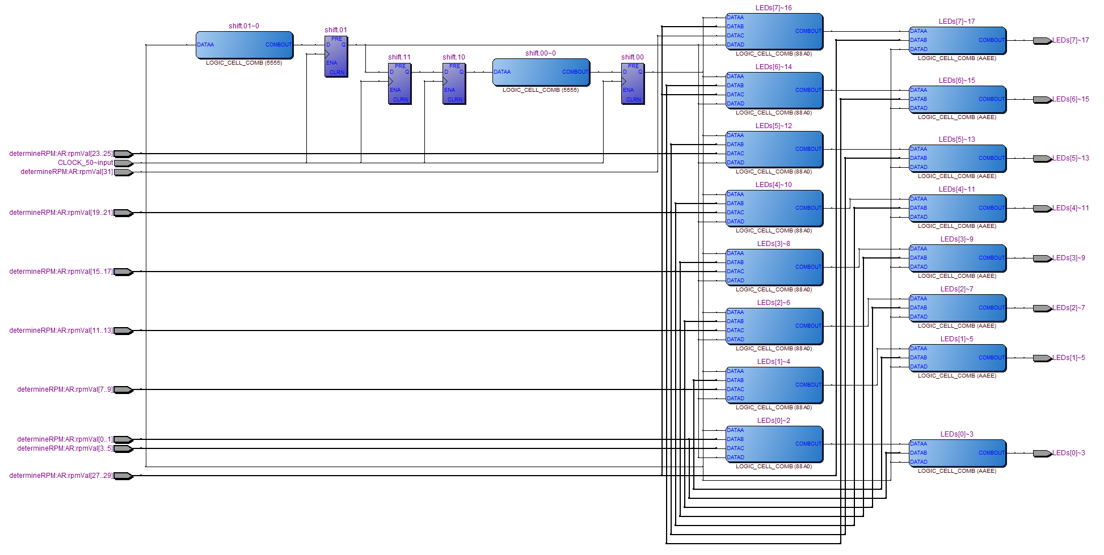

Conclusion:

This setup could potentially be useful in any system that you wish to simulate a transmission for. Even in situations where extra torque from down shifting isn’t available, it is possible that by adjusting the acceleration rate you would be able to get a slight increase in friction application between shifts. The larges limitation in the simulation provided was a lack of applied calculations of the gear ratios. My ratios were simple for the simulation but it might be possibly beneficial to adjust them either to match a real engine or for any applied purpose.

.