Jacob Whitlow

CSCI117

7 May 2021

**Exam Creation Assignment**

**FB (Fill Blank)**

1. A ____ function generates values not when it is applied, but when the result is needed.

Answer: lazy

1. Concurrent programming uses independent statement sequences called ____ in which the program will not necessarily execute lines of code in sequential order.

Answer: threads

1. Syntactic ____ is used to make programs easier to read and eliminates the verbosity found in kernel syntax.

Answer: sugar

1. A(n) ____ is an indexed collection which combines the benefits of a Mutable Array and a Record by allowing non-numeric indexes that can be updated.

Answer: Dictionary **or** Associative Array

**M (Matching) correct answer is written to the right of the dash for each word**

1. Match each item to its primary characteristic

|  |  |
| --- | --- |
| Items  Stream - a  Buffer - b  Transducer - c  Consumer - d | Characteristics  a) list of values which has a possibly unbound length  b) list of values that have been created by a Producer but are yet  c) process that filters values from a given stream into a new stream  d) process that uses input values generated by a Producer  e) process that filters values from a given stream into that same stream  f) process that uses input values generated by a Consumer  g) list of values which always has a predetermined length |

1. Match each data structure to its primary characteristic

|  |  |
| --- | --- |
| Data Structures  Tuple - a  Record - a  Array - b  Dictionary - b | Characteristic  a) contents cannot be changed  b) contents can be changed  c) contents can be changed once from one value to another  d) contents can sometimes be changed  e) contents are inaccessible  f) contents must be strings |

**MA (Multiple Answer)**

Code:

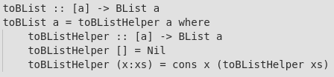

1. Which of the following accurately describes the above function 'toBList' in Haskell?
   1. correct: Iterative
   2. correct: Declarative
   3. correct: Lazy
   4. correct: Recursive
   5. Imperative
   6. Concurrent
2. A function which which returns 0 the first time it is externally called, 1 the second time, 2 the third time, and so on must make use of:
   1. correct:State
   2. Accumulators
   3. Recursion
   4. Randomness
   5. Threads

Code:



1. The above Prolog program is an example of:
   1. correct: Logic programming
   2. correct: Constraint programming
   3. Imperative programming
   4. Concurrent programming

Code:

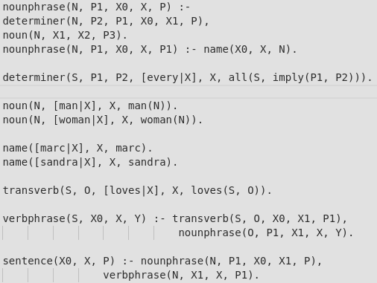

1. Which phrases follow the above grammar rules written in Prolog?
   1. correct: every man loves sandra
   2. correct: sandra loves every man
   3. correct: sandra loves marc
   4. marc loves
   5. all man loves sandra

**MC (Multiple Choice)**

1. What data type/data structure are Cells in Oz most comparable to in other languages?
   1. correct:Pointers
   2. Objects
   3. Arrays
   4. Vectors
   5. Dictionaries

Code:

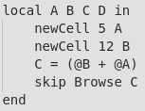

1. How many different names would appear in the Mutable Store as a result of the above Oz program?
   1. correct: 2
   2. 0
   3. 1
   4. 3
   5. 4

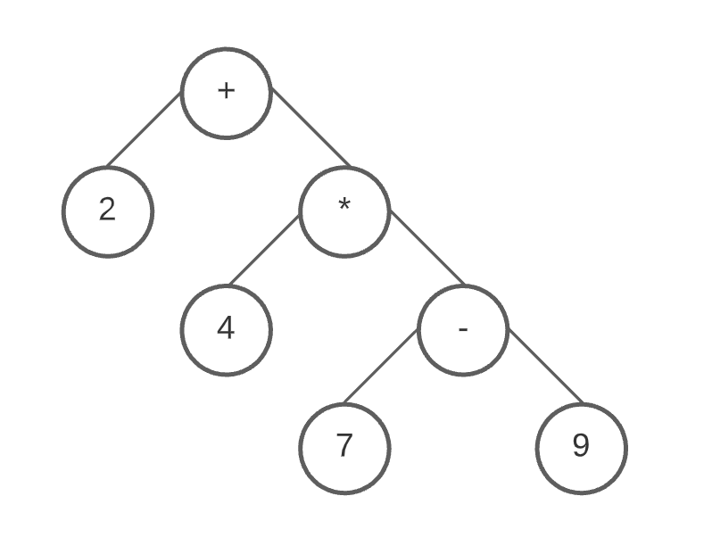

1. What would be the result of the operation shown in the above parse tree?
   1. correct: -6
   2. 10
   3. -12
   4. 12
   5. -16
2. The Hamming Problem is solved using:
   1. correct: Demand-driven concurrency
   2. Supply-driven concurrency
   3. Recursive backtracking
   4. Logic programming

**MD (Multiple Dropdown)**

1. Garbage collection prevents ____ by automatically reclaiming memory during which the program ____.

|  |  |
| --- | --- |
| First Blank | Second Blank |
| correct: Memory leaks  Memory mishandling  Loss of data  Data Corruption | correct: halts temporarily  releases all of its memory  saves all of the released memory  halts for a predetermined amount of time |

1. An ADT can provide security for its variables using a(n) ____ for values going into the ADT and a(n) ____ for values going out of the ADT. correct: Unwrapper

|  |  |
| --- | --- |
| First Blank | Second Blank |
| correct: Wrapper  Unwrapper  Encoder  Decoder | correct: Unwrapper  Wrapper  Encoder  Decoder |