**Lab 12: Ideal Gas Law**

1. **Testable Questions:**
2. How is volume (V, ml) related to pressure (P, kPa)?
3. How is temperature (T, °C) related to pressure (P, kPa)?
4. **Hypothesis:**
5. As volume (V, ml) increases, pressure (P, kPa) will decrease because molecules have more space.
6. As temperature (T, °C) increases, pressure (P, kPa) will increase due to the molecules becoming more excited.
7. **Variables:**
8. **Controls: Gas constant (R); Number of moles (n, mol); Temperature = constant (T, °C); Tube Volume = 2.14 (mL**)

**Independent:** Volume

**Dependent:** Pressure

1. **Controls: Gas constant (R); Number of moles (n, mol); Volume = constant (V, ml)**

**Independent:** Temperature (T, °C)

**Dependent:** Pressure (kPa)

1. **Table Design:**

**A Controls: Gas constant (R); Number of moles (n, mol); Temperature = constant (T, °C); Tube Volume = 2.14 (mL**)

|  |  |  |  |
| --- | --- | --- | --- |
| i | V (mL) | V-1 (mL-1) | P (kPA) |
| 1–8 |  |  |  |

**B Controls: Gas constant (R); Number of moles (n, mol); Volume = constant (V, ml)**

|  |  |  |
| --- | --- | --- |
| i | T (oC) | P (kPa) |
| 1–8 |  |  |

1. **Materials:**

* Pressure Sensor
* GLX Explorer
* Hot Plate
* Beaker
* Tube w/Syringe
* Temperature Sensor
* Sample Container w/Tube
* Meter Stick

1. **Procedures:**

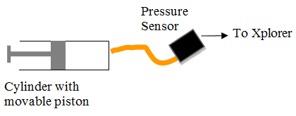

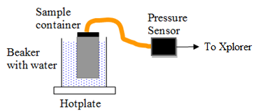

* Measure the length of the tube w/syringe to calculate the tube volume using a meter stick.
* Connect GLX Explorer to the pressure sensor and that to the tube w/syringe.
* Begin the experiment by starting at 20mL on the syringe and collect the data using the GLX. Continue pushing pressure into the syringe every 2mL until you collect 8 data points
* After this, begin the next experiment by placing your beaker on the hot plate. Then put water, the sample container w/tube, and the temperature sensor in the beaker.
* Turn the hot plate on and set it to 540 ℃, then begin taking your first data point.
* Continue taking data points until 8 points are taken, then input all data information into Excel for data analysis.

**Equation being investigated:**

$$PV=nRT$$

1. **Data:**

**A Controls: Gas constant (R); Number of moles (n, mol); Temperature = constant (T, °C); Tube Volume = 2.14 (mL**)

|  |  |  |  |
| --- | --- | --- | --- |
| i | V (mL) | V-1 (mL-1) | P (kPA) |
| 1 | 22.1 | 0.0450 | 97.0 |
| 2 | 20.1 | 0.0500 | 107.0 |
| 3 | 18.1 | 0.0550 | 119.0 |
| 4 | 16.1 | 0.0620 | 133.0 |
| 5 | 14.1 | 0.0710 | 150.0 |
| 6 | 12.1 | 0.0820 | 172.0 |
| 7 | 10.1 | 0.0990 | 204.0 |
| 8 | 8.1 | 0.123 | 246.0 |

**B Controls: Gas constant (R); Number of moles (n, mol); Volume = constant (V, ml)**

|  |  |  |
| --- | --- | --- |
| i | T (oC) | P (kPa) |
| 1 | 22.7 | 96.0 |
| 2 | 27.7 | 98.0 |
| 3 | 32.7 | 100.0 |
| 4 | 37.7 | 101.0 |
| 5 | 42.7 | 103.0 |
| 6 | 47.7 | 104.0 |
| 7 | 52.7 | 106.0 |
| 8 | 57.7 | 107.0 |

**Analysis:**

Part A:

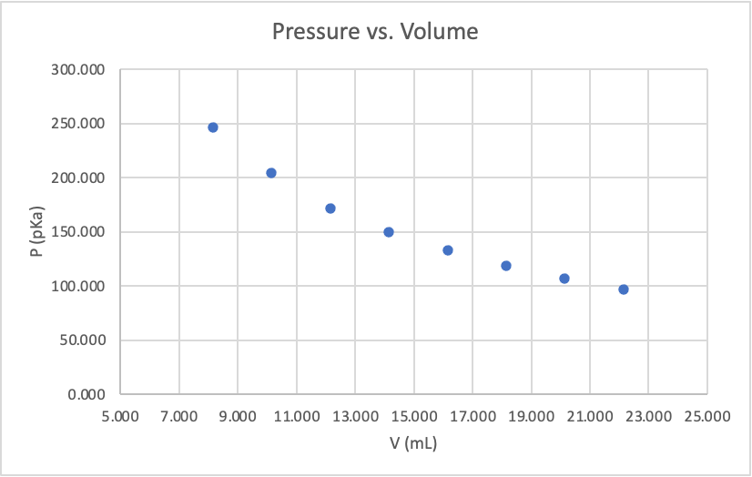

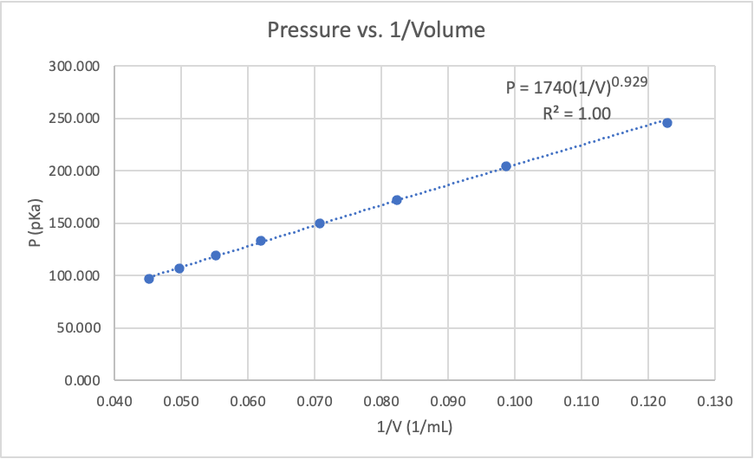

Part B:

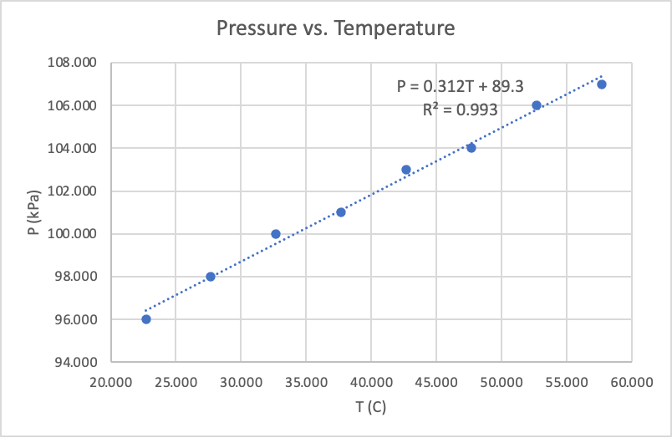

$${TP}_{A}=1.0$$

$MP_{A}=$ 0.929

$\%Error=\frac{\left|1.0-0.929\right|}{1.0}⋅100=7.1\%$

$${TT}_{B}=-273℃$$

$MT_{B}= -(\frac{b}{m})=-286℃$

$$\%Error_{}= \frac{\left|-273-(-286)\right|}{-273}⋅100=4.76\%$$

1. **Conclusion:**
2. Pressure (P, kPa) was found to be linear to the inverse of volume (V, ml) as shown by our found equation: P = 1740(1/V)0.929
3. Pressure (P, kPa) was found to be linear to temperature (T, °C) as shown by our found equation: P = 0.312T + 89.3.
4. **Evaluation:**

Our hypothesis was supported by our findings. We found that as volume increased, pressure decreased, and that as temperature increased, so did pressure. For part A, this is because the molecules have more space to move. For part B, this is due to the molecules becoming more excited.

Our percent of accuracy was good, with part A being 7.10% and part B being 4.76%. We did not run into much systematic error, but some sources of it could include starting without neutral pressure in the syringe for part A, and for part B it could be letting the temperature gauge touch the bottom of the glass.

Our R2 values were good, being 1.00 and 0.993 for parts A and B respectively. We as a group did not have much random error, but some sources could be skipping a measurement point on the syringe for part A, and misreading a measurement of temperature on part B.