Justin Whooley
3/3/2024
Project Two
Inclusion of Grazioso Logo as well unique identifier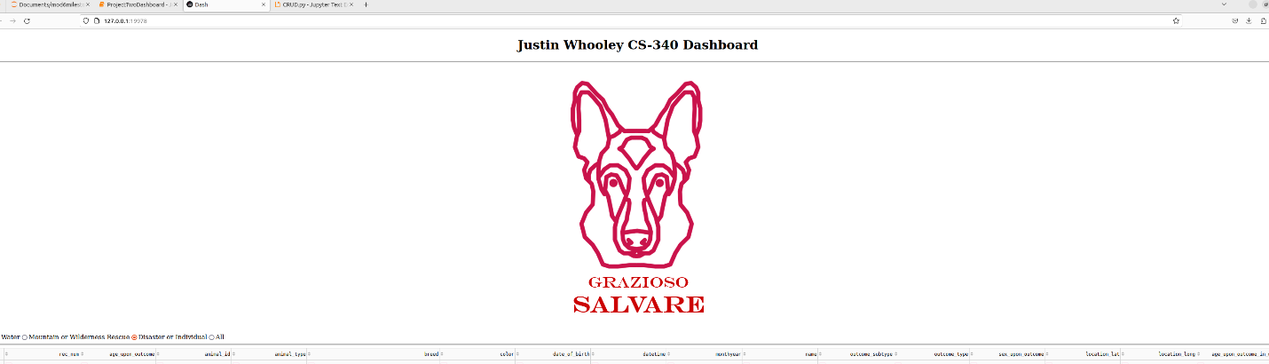
Data table with unfiltered view
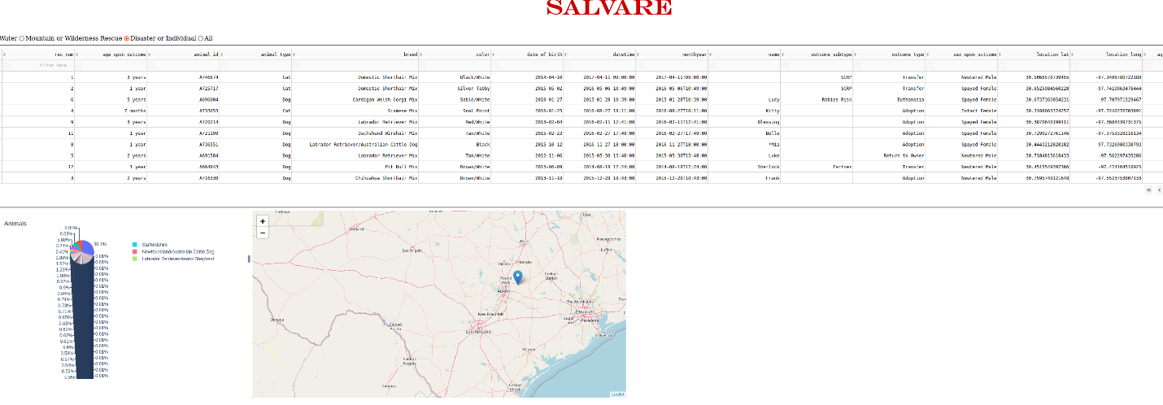

The filter is done through radio buttons. And the map is updated based on the animal chosen.

