CS 340 README Template

Use this template to complete your README file. When completing the template, keep the headings as they are so that your document has a clear organization. Remove the italicized prompt text after you have completed each section for a polished final document.

About the Project/Project Title
The purpose of this project is to import a csv file of animal shelter cases along with all of the included data into mongodb. The goal is to be able to find and access old cases as well as create and update old cases and deleting cases no longer needed.

Motivation

Getting Started
You must upload your data, in this case a .csv file into MongoDB as shown below:
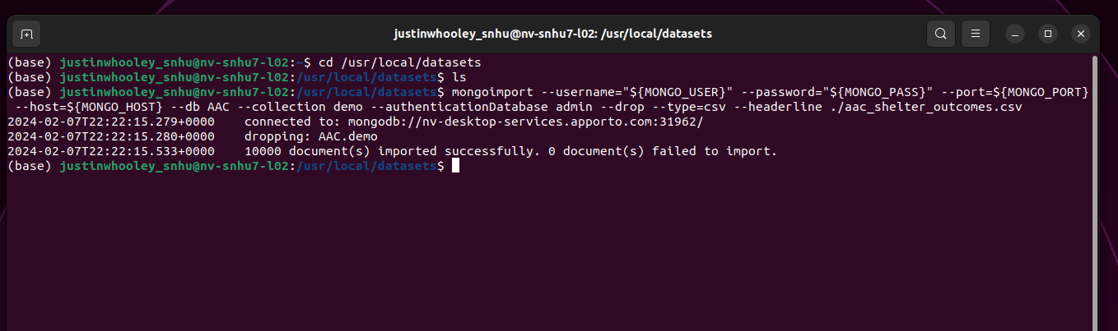

Installation
- Python 3
- Pymongo
- MongoDB 6

Usage
Use this space to show useful examples of how your project works and how it can be used. Be sure to include examples of your code, tests, and screenshots.

Code Example
One of the main functions in the program is the ability to create a new document in the collection. To do this in the python program we are using the pymongo driver. Below is how the function is written. The data is in a dictionary format which in python is written in the {“key”: “value”} format. 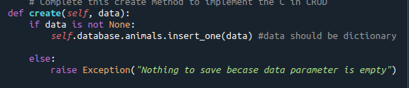
Tests
Using Jupyter notebooks to test the functionality of this program is wrote a script and ran it, while checking in my mongosh terminal if the document has been created, then updated, and finally deleted.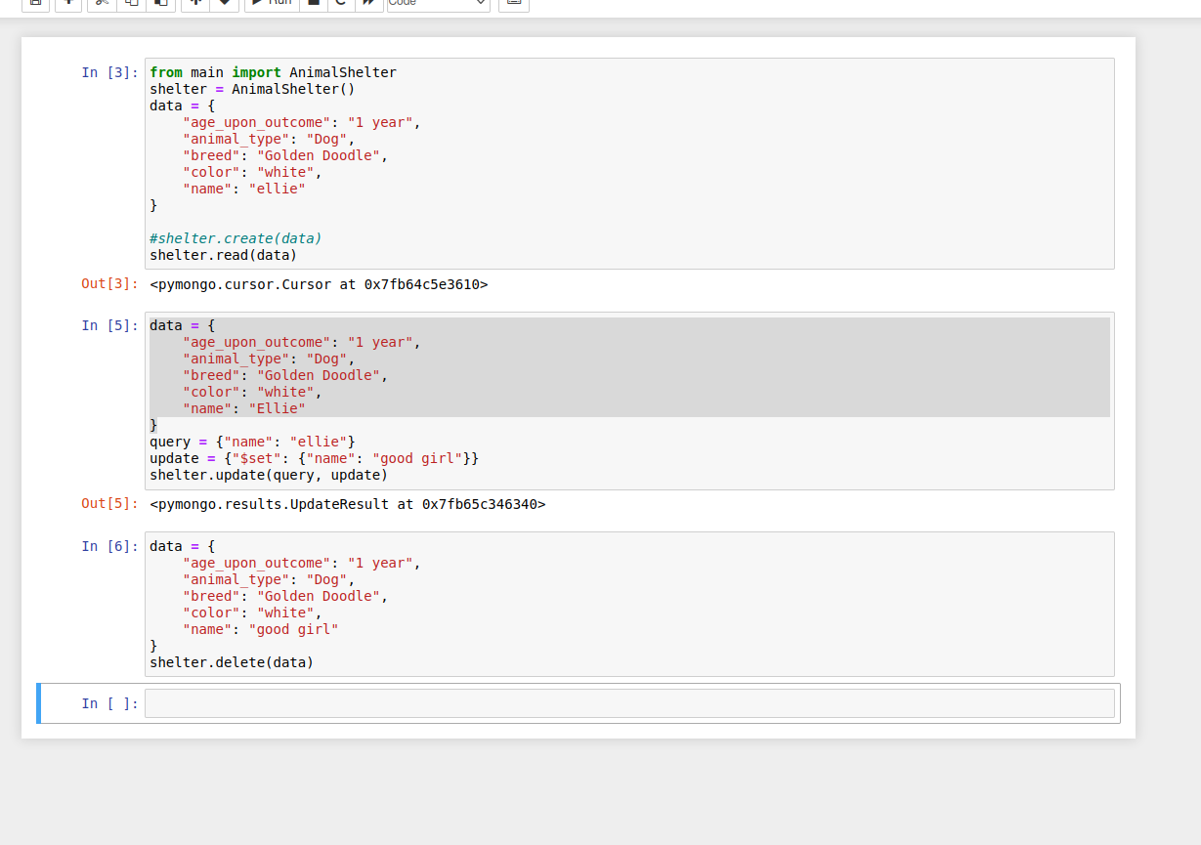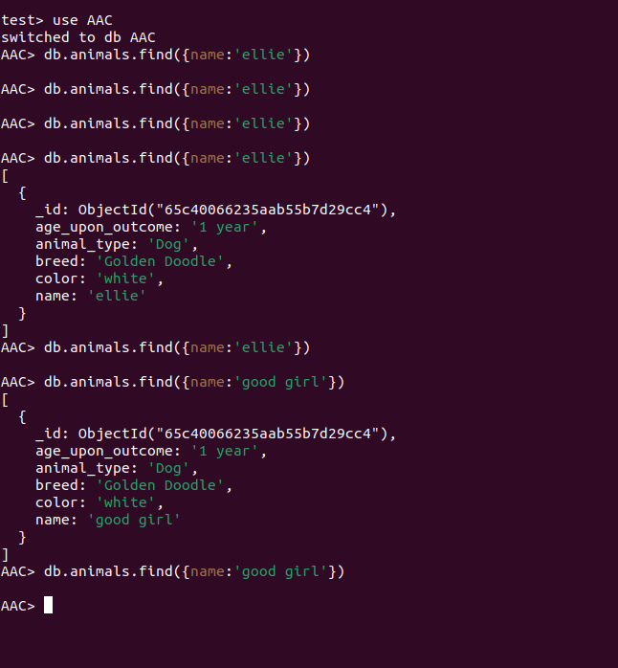

Roadmap/Features (Optional)
Provide an open issues list of proposed features (and known issues). If you have ideas for releases in the future, it is a good idea to list them in the README. What makes your project stand out?
Note: This section is optional for the purposes of this assignment. If you choose not to fill out this section, remove it from your final README file.

Contact
Justin Whooley

