Analysis of sustainability disclosure of food retailers in Europe

Johannes W.H. van der Waal

7-3-2022

# Objective

* objectively chart the sustainability themes of food retailers
* identify relevant topics that we must not miss
* match our sustainability focus areas with those of retailers

# Method

Using *quanteda*, we perform text analysis of sustainability reports of European food retailers over 2020 (published 2021) or the closest year we can get. Some of the reports are in other languages than English. These were machine-translated into English using Deepl.com. Then we perform some supervised and non-supervised text analyses. Some of the sustainability reports were annual reports with a section on sustainability, so called “integrated” reports. OF all reports the document variables of the retailer publishing, the year of publication and the type (SR = sustainability report, AR = annual report, GC = Global Compact communication) were recorded.

The documents were converted from pdf to text and stored in a corpus (library or collection of documents). The corpus was further preprocessed, by removing numbers, spaces, various frequently appearing words, such as the names of the retailers, lower cased, stopwords were removed, and finally stemmed. The tokenized corpus was converted to a document-feature matrix (dfm). The dfm is the basis for further analysis.

## Description of the reports

The following graph shows the number of sentences in the reports per retailer.

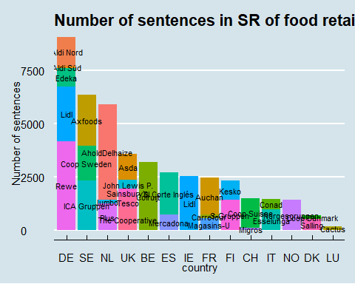 ## Topic Modeling We can perform an unsupervised topic modeling procedure on the corpus using Latent Dirichlet Allocation. This allows to automatically extract a number of topics accross documents.

### Latent Dirichlet Allocation (LDA)

LDA assumes that every document in a corpus is a random mixture of latent topics. Every topic is considered as a mixture or distribution of words. LDA is an algorithm that tries to find the mixture of words that best defines a set number of topics, while at the same time estimating the mixture of topics that describes a document. LDA computes for every word the probability that it belongs to a certain topic (beta) and the estimated probability that a word in a document belongs to a certain topic (theta). Retrieving the words with the highest thetas allows to characterize the topic.

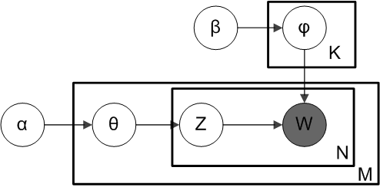 In the above figure of the LDA algorithm (“plate model”) denote:

* alpha - the per-document topic distributions,
* beta - the per-topic word distribution,
* theta - the topic distribution for document m,
* psi - the word distribution for topic k,
* z - the topic for the n-th word in document m, and
* w - the specific word

### Applying LDA to the food retailer sustainability report corpus

Using the package *seededlda* an LDA model was estimated, using 9 topics. This number was chosen somewhat arbitrarily but appeared to give a reasonable resoltion and discrimination between topics.

country

retailer

no_of_tokens

NL

AholdDelhaize

78595

BE

Colruijt

48891

SE

ICA Gruppen

42485

SE

Axfoods

39928

ES

El Corte Inglés

28278

FI

S-Gruppen

23788

UK

The Cooperative

23721

NO

Norgesgruppen

22572

IT

Esselunga

21781

FR

Auchan

21102

UK

Asda

20336

CH

Coop Suisse

19686

FI

Kesko

16251

FR

Magasins-U

15804

ES

Mercadona

14074

NL

Plus

12419

DK

Salling

11059

IT

Conad

9991

IE

Lidl

9195

UK

John Lewis P.

8215

DE

Aldi Nord

4424

UK

Tesco

3340

UK

Sainsbury’s

3230

DK

Coop Danmark

2766

LU

Cactus

2510

NL

Jumbo

1855

DE

Aldi Süd

1215

De following table shows the ten words with the highest theta’s per topic. These characterize the topic.

topic1

topic2

topic3

topic4

topic5

topic6

topic7

topic8

topic9

wast

employe

product

financi

report

support

sustain

store

board

emiss

work

packag

asset

risk

food

supplier

custom

member

energi

train

sustain

tax

audit

communiti

chain

sale

share

store

manag

plastic

incom

inform

peopl

suppli

product

committe

reduc

compani

label

valu

manag

help

respons

market

manag

consumpt

health

food

liabil

financi

work

product

retail

compani

climat

develop

recycl

cash

statement

custom

gri

food

director

food

safeti

organ

net

data

make

right

increas

execut

scope

employ

anim

amount

control

donat

social

onlin

meet

target

total

certifi

statement

intern

local

human

shop

remuner

From the topic words we can derive a more descriptive name for the topic. Then we can plot the topics against the retailers. It is to note that the theta’s of all the topics together sum to 1. So whether the retailer in question publishes a large report or a small one, the theta’s give a relative probability of the presence of the topics in the document, irrespective of the document size. So there is no measure for the weight.

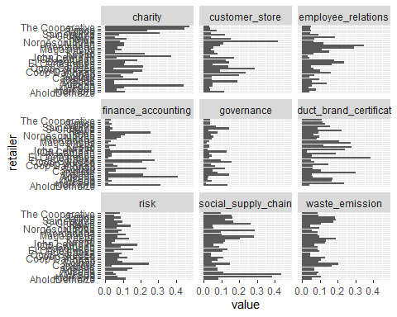

Likewise, we can check if there are marked differences in topics between types of reports, notably integrated or annual reports and sustainability reports.

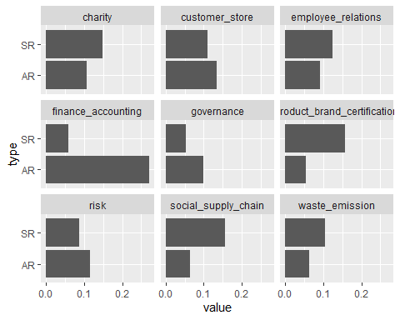

If we had a time series of sustainability reports, it would be possible to visualize temporal changes in topics.