|  |  |  |
| --- | --- | --- |
| Edited by: Margit Houtman | Date: | Signature |
| Authorised by: Margit Houtman | Date: | Signature |

**1. SAMPLE TAKING**

**1.1 Control**

The Quality Inspection must be done on a sample that represents the load. Each load must receive a quality inspection.

*Sample size - container*

**1or 2 pallets** per container; **5 boxes** per pallet.

**Note: The minimum sample size is 1 pallet, 5 boxes.**

Pallets are to be taken at random.

*Sample size - underdeck*

In general, the equivalent of **2 pallets** per container and **5 boxes** per pallet have to be checked. This amount should be prorated for the underdeck volume. If the number of pallets is very large, the sample size can be reduced according to the following scheme:

|  |  |  |  |
| --- | --- | --- | --- |
| Number of pallets | Pallets to be checked | Boxes per pallet to be checked | Total number of boxes to be checked |
| 1-20 | 2 | 5 | 10 |
| 21-40 | 4 | 5 | 20 |
| 41-60 | 6 | 5 | 30 |
| 61-80 | 8 | 5 | 40 |
| 81-120 | 10 | 5 | 50 |
| 121-180 | 15 | 5 | 75 |
| 181-300 | 20 | 5 | 100 |

**Note: The minimum sample size is 1 pallet, 5 boxes.**

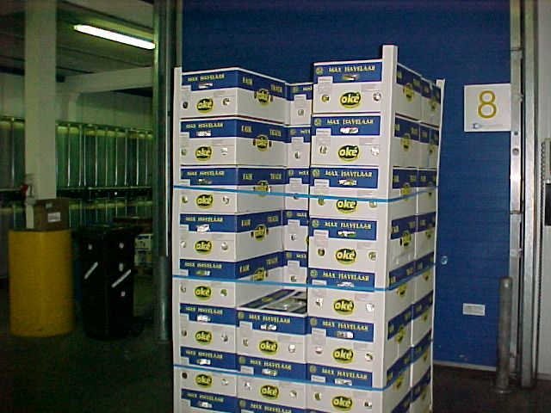

**1.2 Sample selection**

*Instruction*

* The 5 cartons for inspection are taken from the middle row, from the top layer down, as shown in the picture.

**2. QUALITY INSPECTION**

**2.1 Facilities and materials**

The Quality Inspection should be executed in a clean area where hand washing facilities are available. The inspection area should be well lit and have an inspection table or -cart with enough space to place the box and fruit as well as other materials needed for the inspection.

**2.2 Recording the results**

*Inspection Form*

The results are recorded digitally on location using a touchscreen. On locations where this device is not available the results of the quality check are recorded manually on location on the form AFFO-QA-012.

**2.3 Execution of the checks**

**2.3.1 Packaging check**

Trade specifications are available on all inspection locations. Information on labels, cartons and pallet label design and placement should be verified and if not correct, recorded on the ‘average’ sheet of the inspection form.

Severe deviations are to be communicated to Quality dept of Agrofair immediately because they must be corrected/ discussed with the sales dept and customer before loading. Such deviations include:

* Labelling suggesting a certification which is not there (example: organic labels on a conventional banana)
* Mistakes in commercial labels (example: BIOBIO bananas in an Edeka carton; ALT labels in a Spar carton).
* ‘Demeter in Umstellung’ bananas with a ‘Demeter’ label/ box/ pallet label.

**2.3.2 Weighing the box**

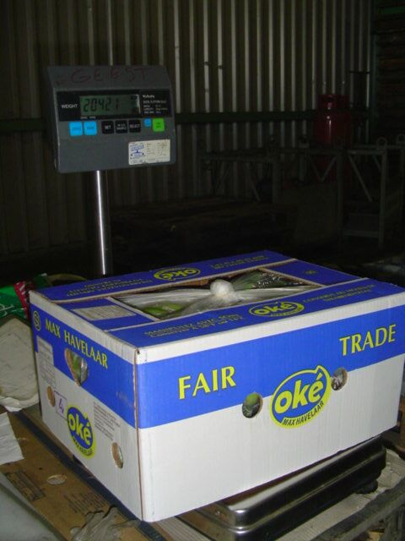

*Instruction*

- Weigh the selected cartons (see

illustration)

- Write down the weight of the fruit (incl.

carton) on the top of the carton

*Points of attention*

- Let the balance stabilize before writing

down the carton weight

**2.3.3 Observing defects on fruit**

* After opening the box, first take into consideration the packing of the fruit per line; look for defects caused by insufficient packing.
* Take each cluster from the box and observe it carefully from all sides and between the fingers and look for defects. For a description of the defects please look at AFWI-QA-011.
* Place the clusters on the inspection table. Note: Place the clusters with defects separate from the defect-free clusters.
* Register the defects. Note: Only register the heaviest defect per cluster.

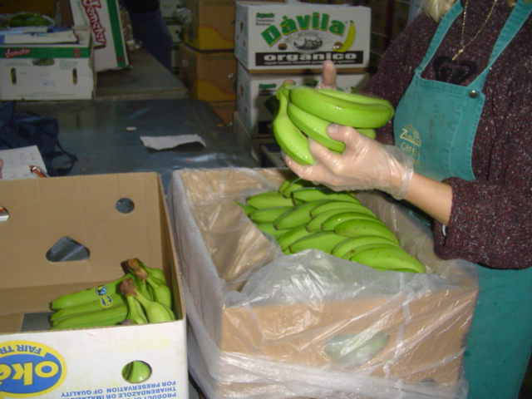

**2.3.4 Taking Pictures**

In order to provide the producer and the sales department with a complete panorama of the status of the load, pictures should be taken of the problems.

* Pictures are taken with the lowest possible density (e-mail quality).
* 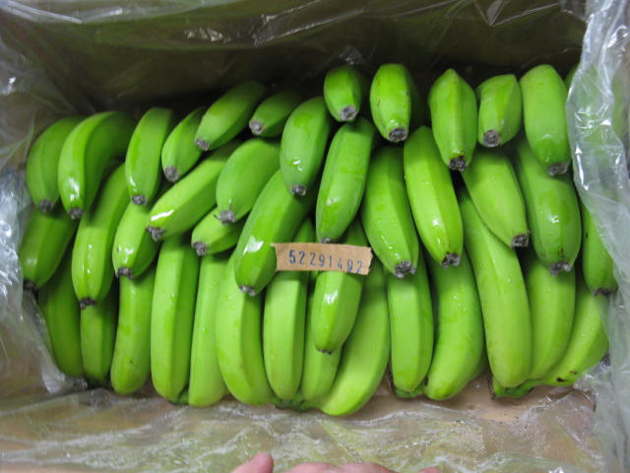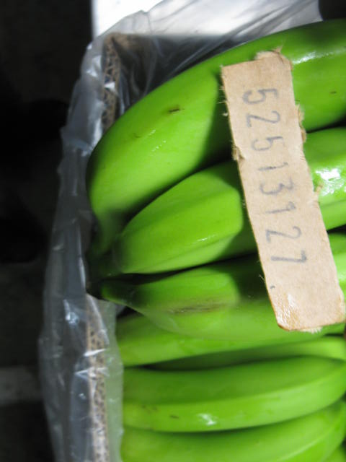The boxcode is cut out of 1 of the boxes and the box code is included in every picture taken of the problems in fruit from that box code.
* Pictures are taken of both fruit still in the box (for defects caused by insufficient packing) as well as for individual clusters showing growth related defects, decay etc.

The pictures are uploaded onto the AgroFair server to the Map with the corresponding Quality Reports.

**2.3.5 Doing measurements**

**Temperature**

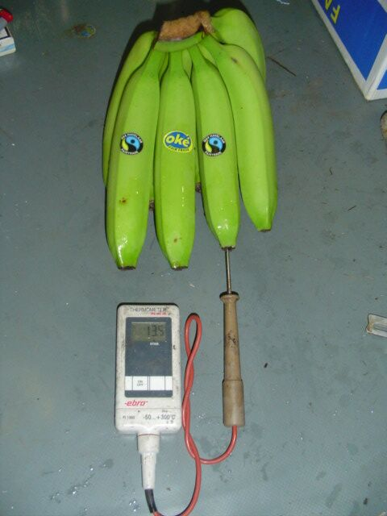*Actions*

* Select a random cluster from those displayed on the inspection table.
* Insert the thermometer into the end of one of the fingers (see illustration)
* Record the measured temperature.

*Points of attention*

- Make sure the numbers on the thermometer are stable before writing it down.

**Grade**

* Select a random cluster from those displayed on the inspection table.
* Place the grading instrument at the outside finger next to the cutting edge (see illustration).
* Record the measured grade.

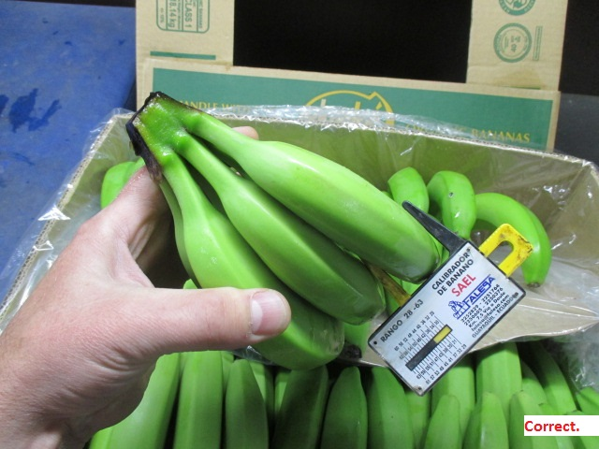

**Length**

*Instruction*

* Select a random cluster from those displayed on the inspection table.
* Measure the length from tip to neck
* Record the measured length.

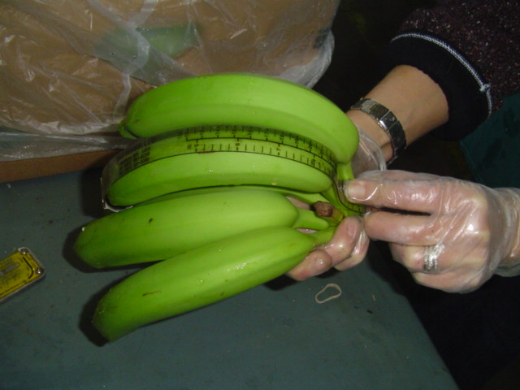

**2.3.6 Repack clusters in carton**

*Instruction*

- Put all clusters from the inspection table into the carton (see left illustration)

- Close the plastic bag

- Put the lid on the bottom (see right illustration)

- Put the carton back on the pallet of origin

*Points of attention*

- Put the clusters in a gentle way into the carton

- The cluster must be packed with the crown pointing down

- Pack the cluster in a way that there is no friction between the clusters

