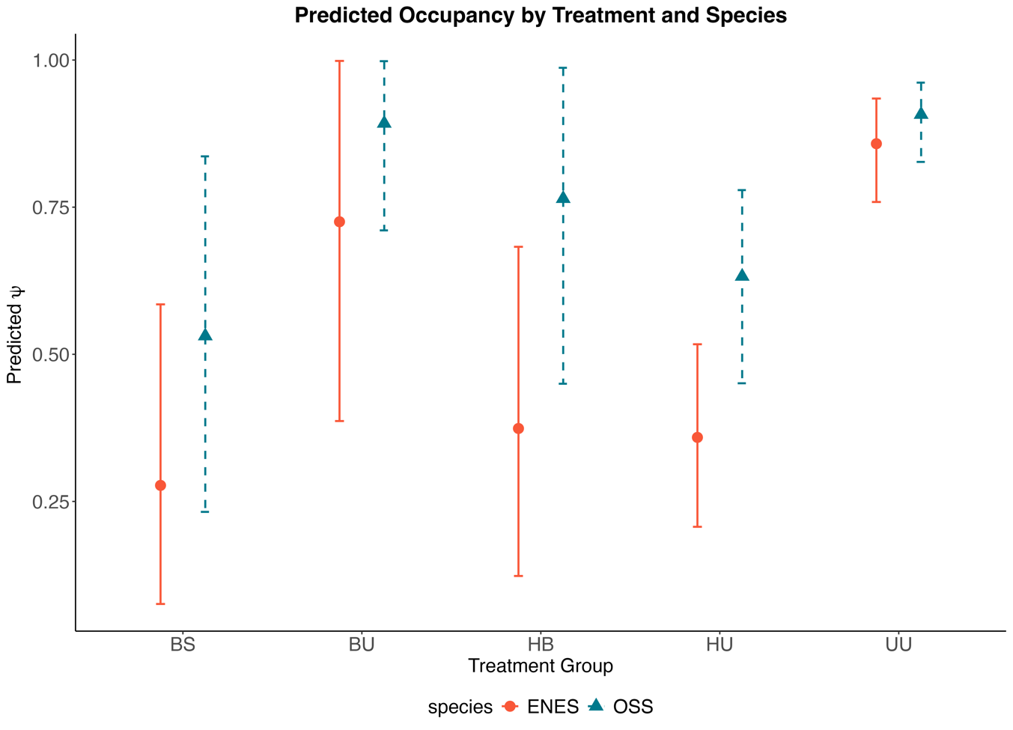

Predicted occupancy for each treatment and each species over the study period. This includes all data from 2013-2024.

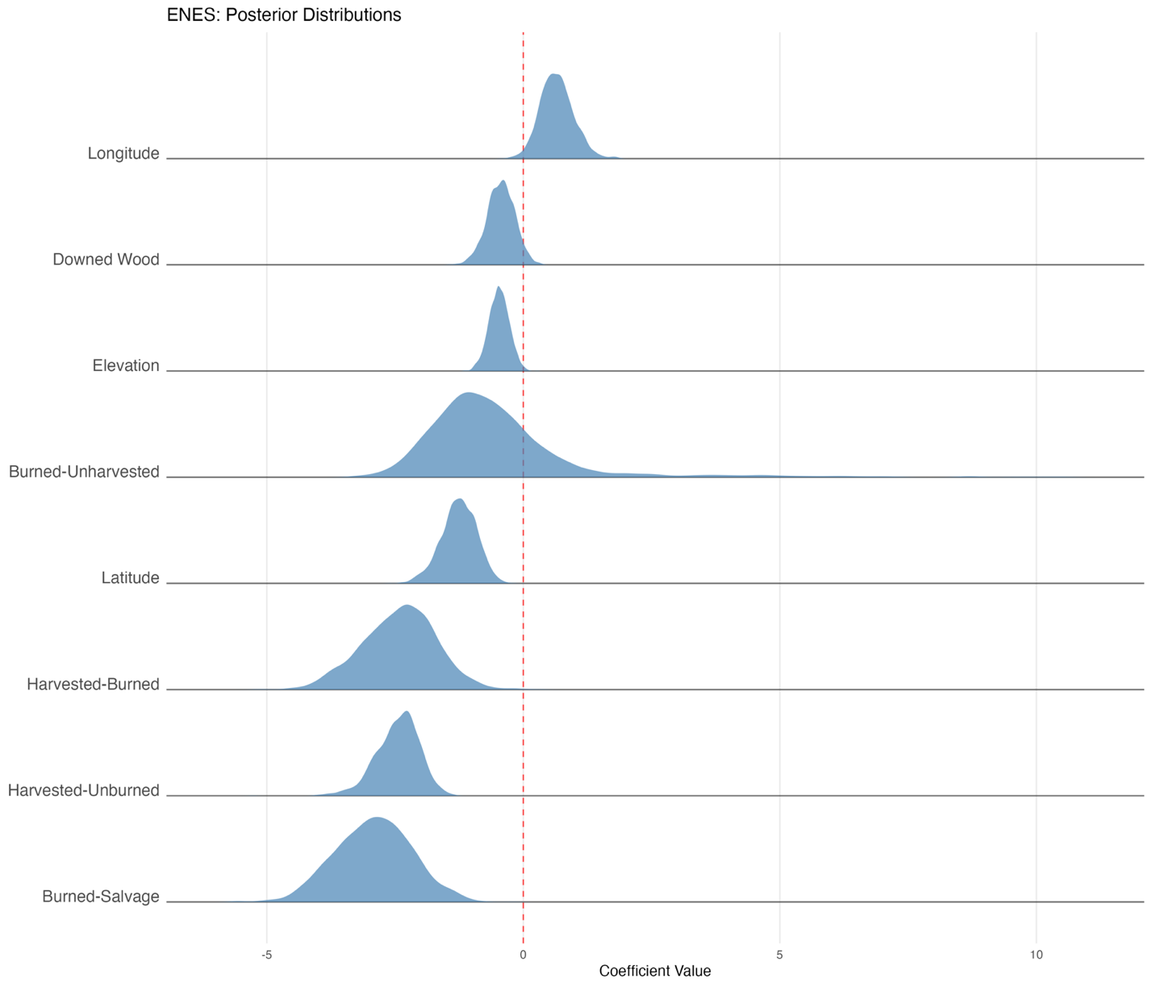

Posterior probability distributions: this shows both the estimated effect size and associated uncertainty for each predictor variable. Each distribution indicates the most likely coefficient value (the peak) and the range of plausible values (the width), allowing you to assess both the magnitude and reliability of each relationship in the model.
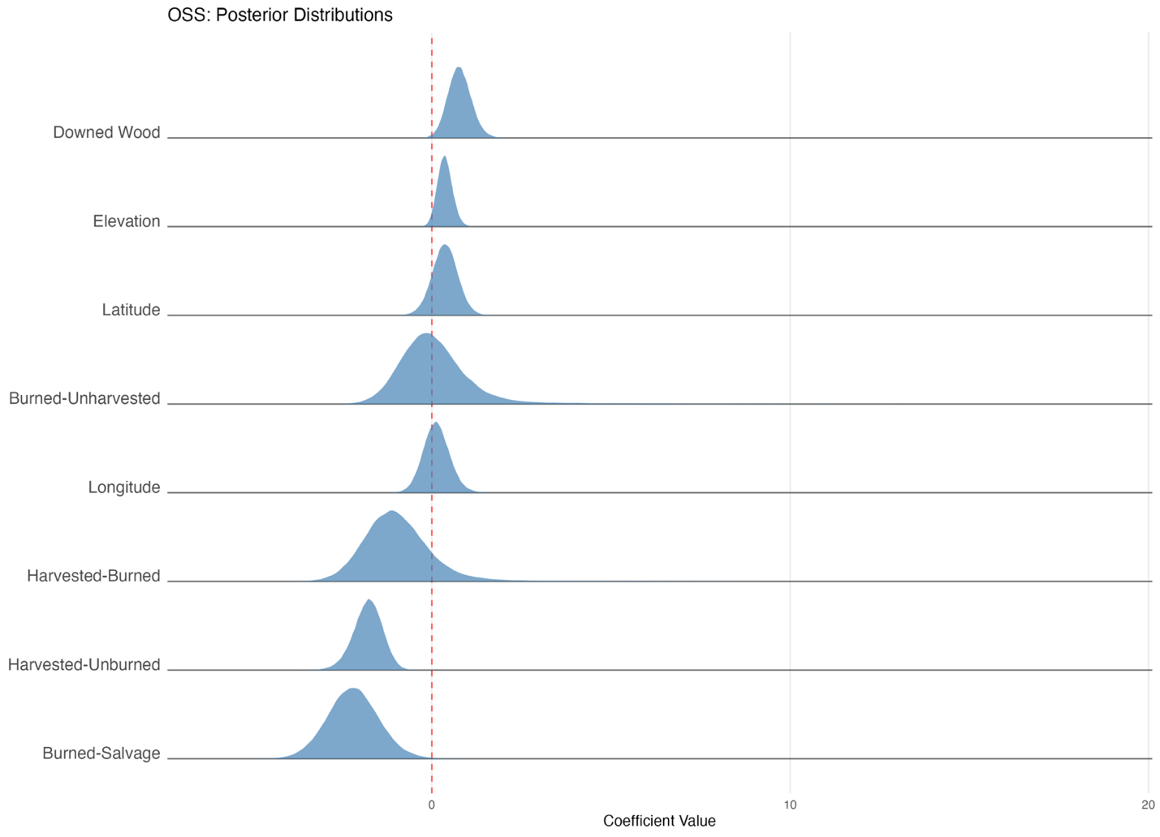
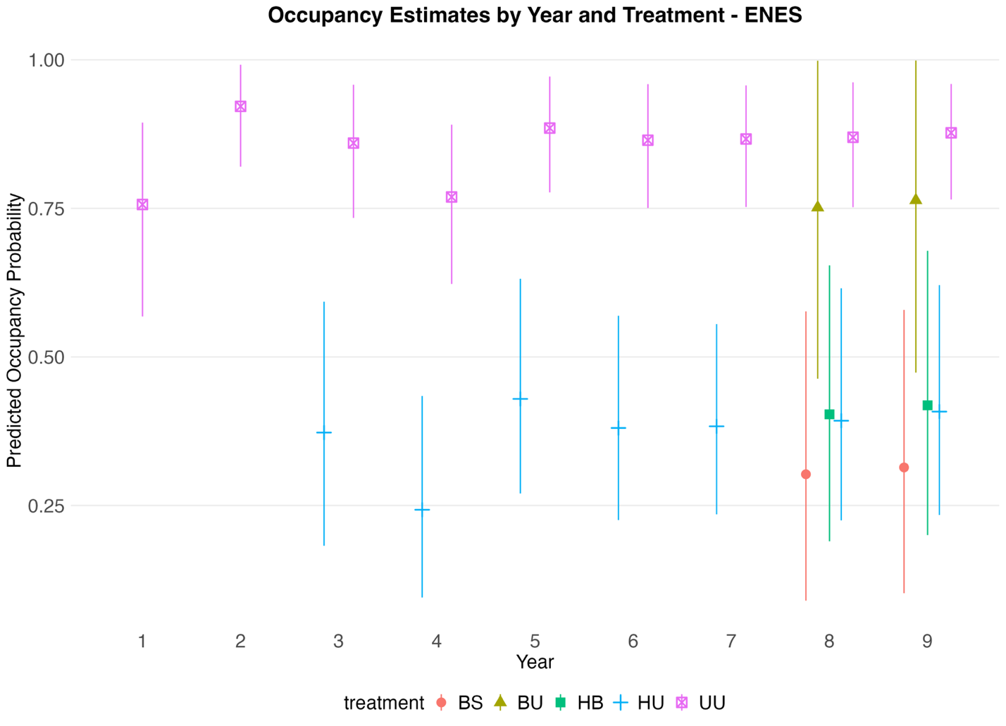

Occupancy estimates for each year and each treatment within that year. Years 1-7 are 2013-2019, while 8 and 9 are 2023-2024. 95% CI are shown.
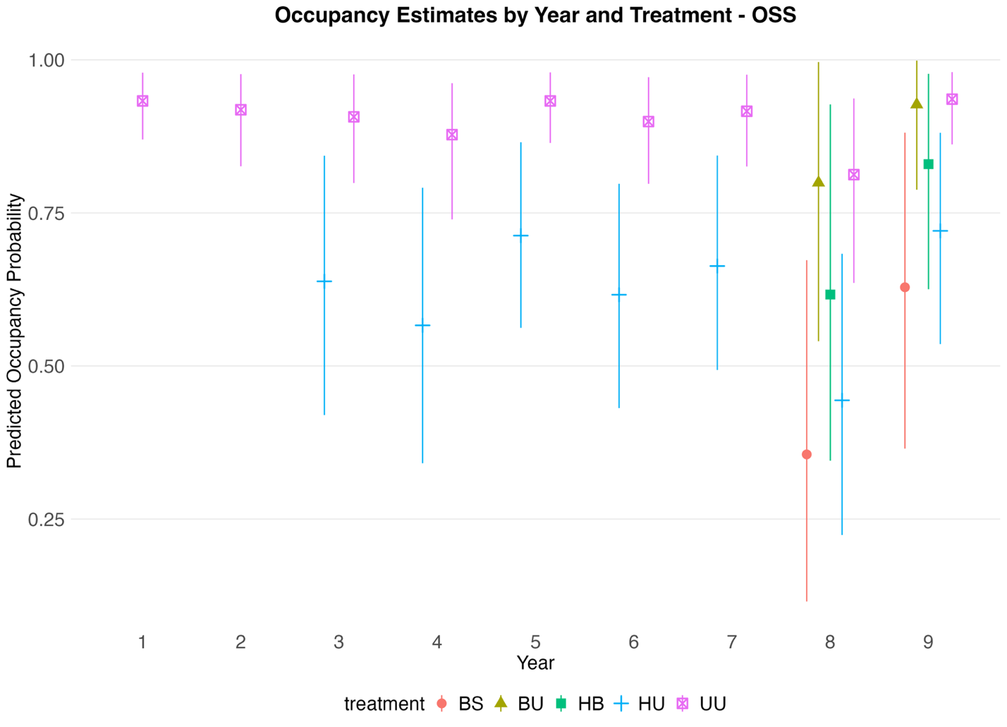

OSS
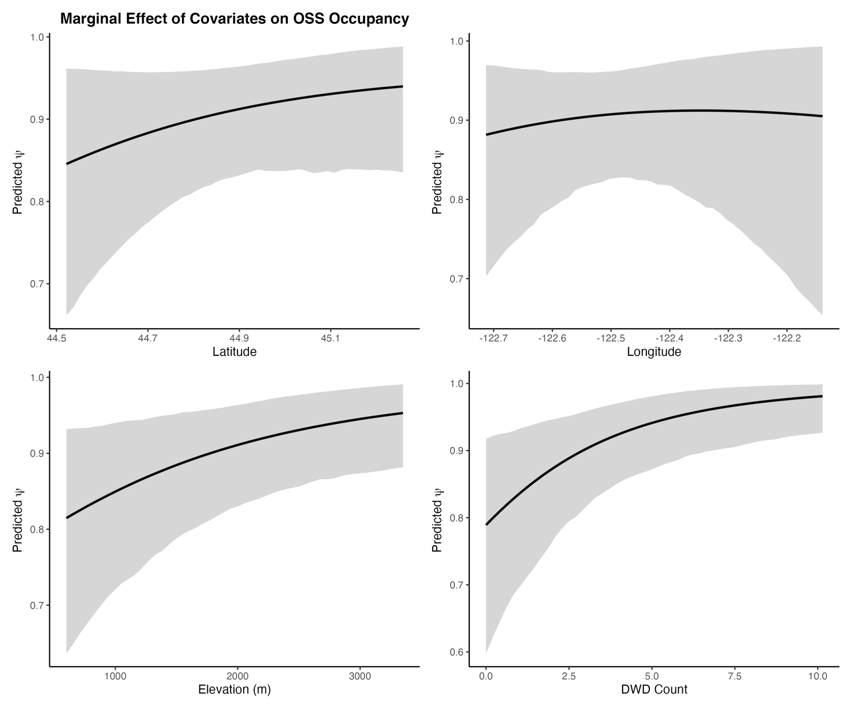

ENES
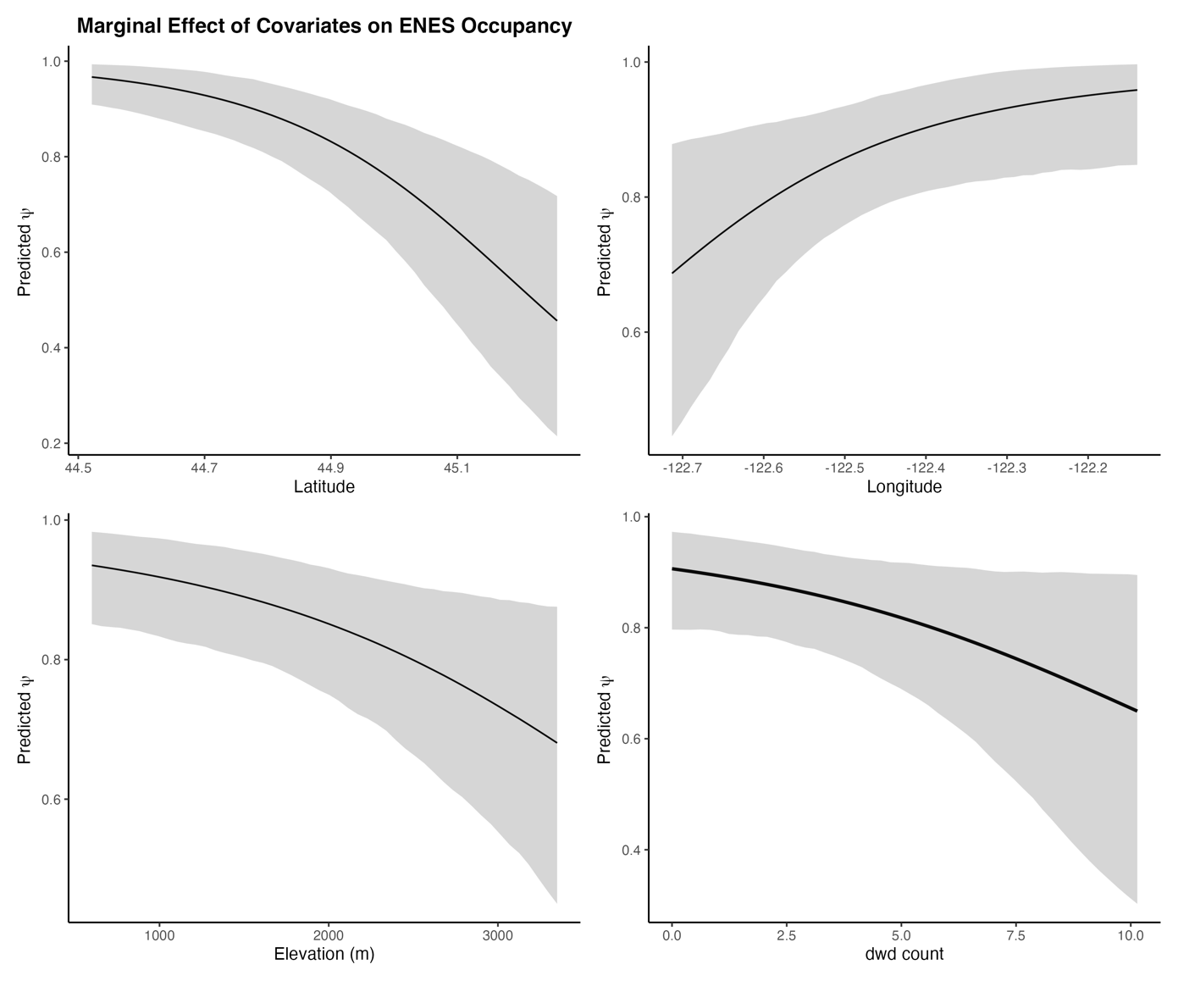
Effect of downed wood on occupancy. No, I have no idea why ENES is NEGATIVE. TBD.

Tables show estimated average effect (Mean), most likely value (Median), confidence interval from CI_2.5 to CI_97.5, and probability that the effect is positive or negative. It's essentially a scorecard telling you which factors have strong evidence for mattering (high Percent_Pos or Percent_Neg) versus which ones are uncertain (closer to 50/50 split).
