Coach WAR: A Counterfactual Approach to Evaluating NFL Head Coach Impact in the Modern Era
Football

- Introduction

NFL head coaches are often judged on win-loss records, which conflate coaching with roster talent, schedule, injuries, and cap health. Wins Above Replacement (WAR) models have previously isolated individual value for players in baseball [1] and offensive players in the NFL [2]. We extend it to head coaches, asking how many wins a coach adds over a replacement-level coach given the team context.
- Methods

We assembled 1,637 modern-era team-seasons (1970–2024) with 365 features from Pro Football Reference and Spotrac: draft capital, roster turnover, age and experience by position, starter injuries, positional cap allocation, strength of schedule, and 139 coaching features describing each head coach’s experience and era-normalized team results from all prior seasons as coordinator and head coach. An XGBoost model [3] predicts winning percentage. For each team-season, we substitute a replacement-level coaching profile (the median of coaches’ career-average features) and re-predict; Coach WAR is actual minus replacement-level wins per 16 games. We validate on 54 coaches held out with all their seasons, imputing missing data separately within training and test sets to prevent leakage, then refit on all seasons to estimate WAR. Career estimates carry t-based 95% confidence intervals, and a Benjamini-Hochberg (BH) correction [4] controls the false discovery rate across 13 tests.
- Results

On held-out coaches the model reaches R² = 0.43 (RMSE of 2.5 wins per season), near the 1.9-win binomial noise floor of a 16-game season, and nearly triples the out-of-sample R² of tuned ridge regression (0.15), though a ridge-based WAR ranks coaches similarly (Spearman ρ = 0.81). Roughly 3.8 wins per season separate 95th- and 5th-percentile coaches. John Madden has the best career mark (+2.3 WAR per season, 95% CI [+1.4, +3.2]); Table 1 lists the best and worst coaches based on average WAR per season for coaches with at least 3 seasons coached.
Table 1. Top and bottom 10 coaches by career WAR (wins per season), 3+ seasons
Coach | Seasons | Avg. WAR | 95% CI
John Madden | 9 | +2.3 | [+1.4, +3.2]
Kevin O’Connell | 3 | +1.9 | [−0.1, +3.9]
Mike McDaniel | 3 | +1.9 | [−0.6, +4.4]
John Ralston | 5 | +1.8 | [+1.1, +2.5]
Kevin Stefanski | 5 | +1.8 | [−0.5, +4.0]
Nick Sirianni | 4 | +1.6 | [−0.2, +3.3]
Don Shula | 26 | +1.5 | [+1.2, +1.9]
Kyle Shanahan | 8 | +1.5 | [+0.5, +2.6]
Bill Parcells | 19 | +1.4 | [+0.8, +2.0]
Gene Stallings | 4 | +1.4 | [−1.4, +4.1]
J.D. Roberts | 3 | −2.1 | [−4.2, −0.0]
Bruce Coslet | 8 | −2.3 | [−3.4, −1.1]
David Shula | 5 | −2.3 | [−5.5, +0.9]
Paul Wiggin | 3 | −2.4 | [−5.4, +0.6]
Jack Patera | 7 | −2.5 | [−4.5, −0.5]
Rod Marinelli | 3 | −2.5 | [−6.2, +1.1]
Matt Eberflus | 3 | −2.9 | [−5.8, +0.0]
Scott Linehan | 3 | −3.0 | [−7.3, +1.3]
Pat Shurmur | 4 | −3.1 | [−5.0, −1.2]
Steve Spagnuolo | 3 | −3.2 | [−7.0, +0.7]
Background effects depend on era (Figure 1). In the 1970s, defensive-background coaches outperformed offensive-background coaches by 0.89 wins per season (p = 0.0001). Offensive coaches’ average WAR has since risen 0.87 wins (p = 0.0009), and in the 2020s they lead by a directional 0.36 wins (95% CI [−0.24, +0.97]).
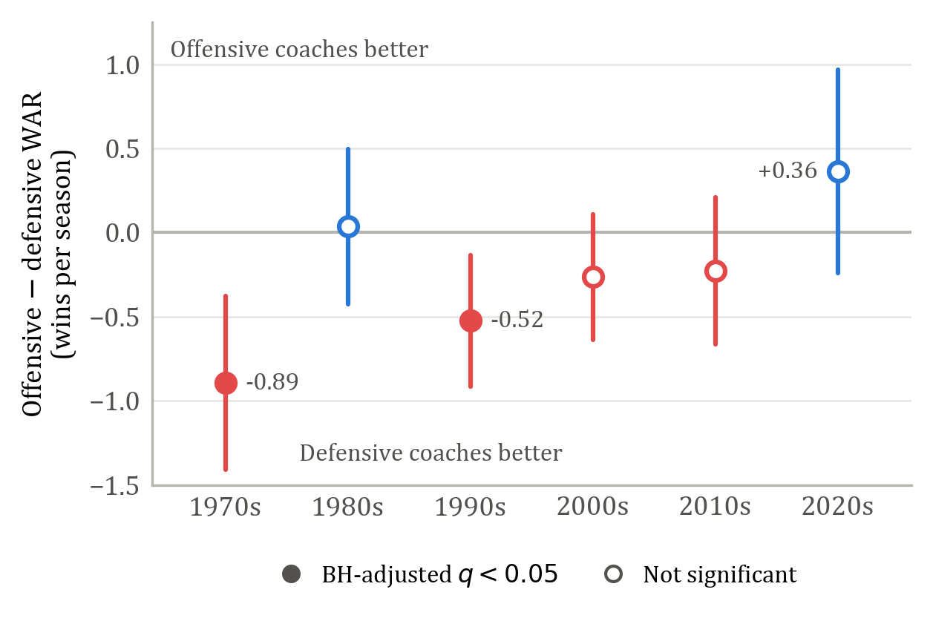
Figure 1. Offensive minus defensive WAR by decade (Welch 95% CIs; filled points BH-significant).
Single seasons are noisy: Year N WAR explains only 6.5% of Year N+1 variance, indicating that the true coaching signal is small relative to season-to-season luck, or alternatively, that the league adapts quickly to advantages from coaching behavior.
- Conclusion

Head coaching decisions carry significant leverage, with roughly 3.8 wins per season separating top and bottom coaches. Coaches are often evaluated on win-loss records, which reflect roster quality, schedule, and season-to-season variance alongside coaching. Averaged across seasons, Coach WAR offers a context-adjusted view of coaching performance and a more rigorous basis for tenure decisions. Isolating coaching from elite quarterback play remains a key limitation.
References

[1] B. S. Baumer, S. T. Jensen, and G. J. Matthews, “openWAR: an open source system for evaluating overall player performance in Major League Baseball,” Journal of Quantitative Analysis in Sports, vol. 11, no. 2, pp. 69-84, 2015.
[2] R. Yurko, S. Ventura, and M. Horowitz, “nflWAR: a reproducible method for offensive player evaluation in football,” Journal of Quantitative Analysis in Sports, vol. 15, no. 3, pp. 163-183, 2019.
[3] T. Chen and C. Guestrin, “XGBoost: a scalable tree boosting system,” in KDD ’16: Proceedings of the 22nd ACM SIGKDD International Conference on Knowledge Discovery and Data Mining, pp. 785-794, 2016.
[4] Y. Benjamini and Y. Hochberg, “Controlling the false discovery rate: a practical and powerful approach to multiple testing,” Journal of the Royal Statistical Society: Series B, vol. 57, no. 1, pp. 289-300, 1995.

