Signup:

Valid Login:

Invalid login with error message:

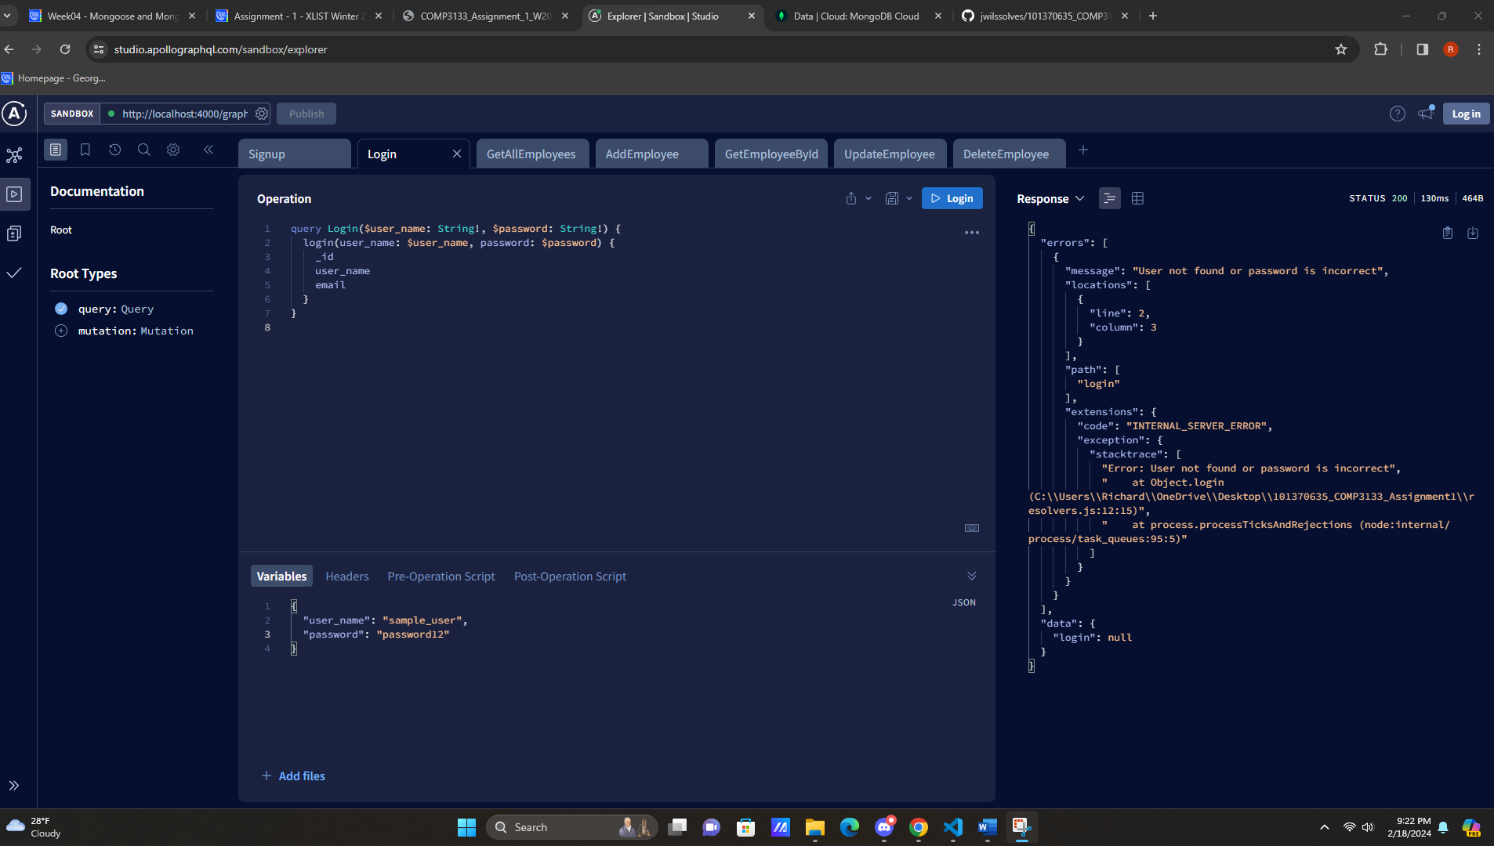

Add Employee:

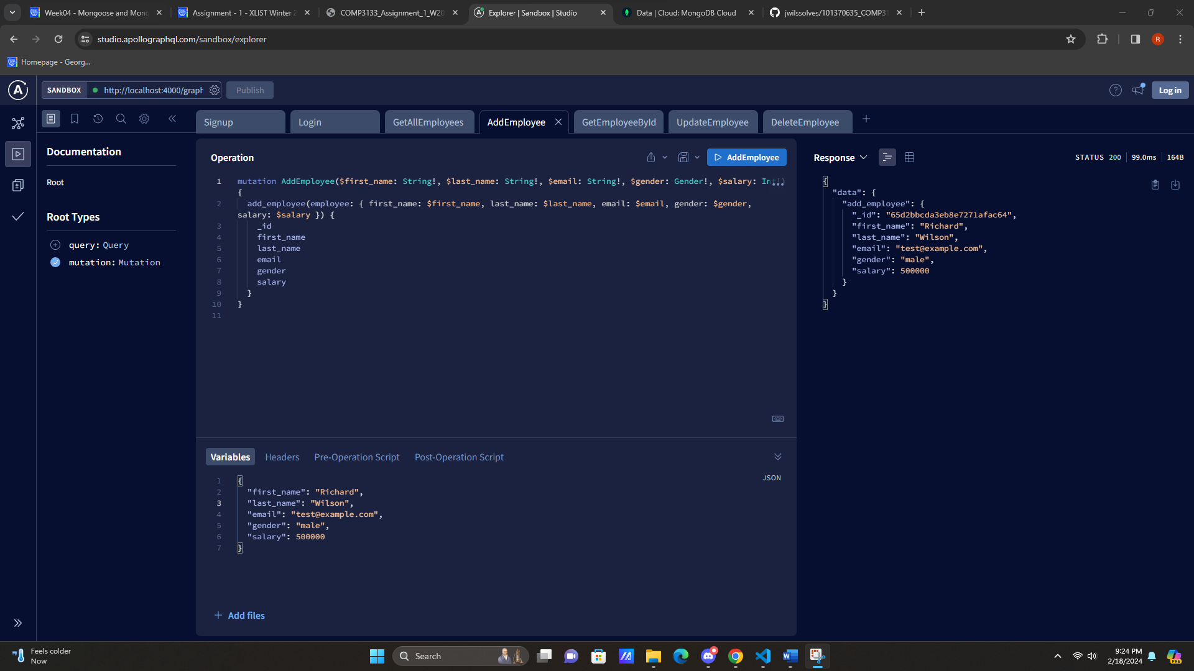

Get all employees:

Get employee by ID:

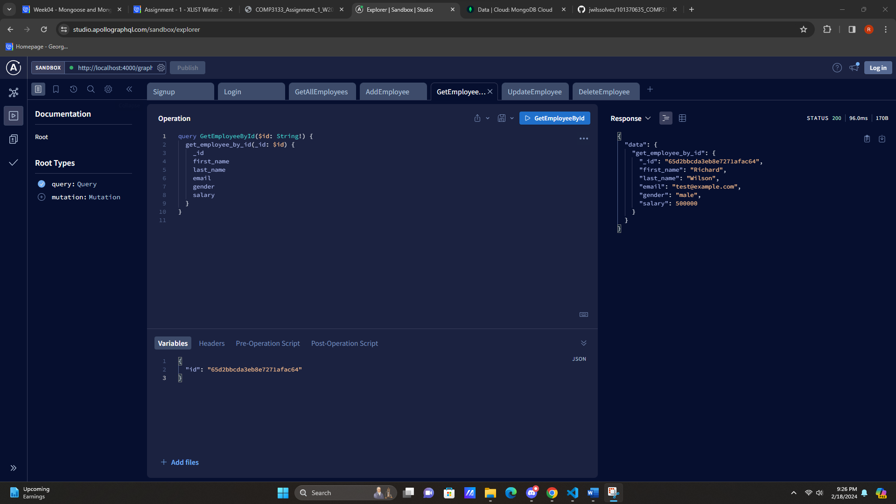

Update Employee:

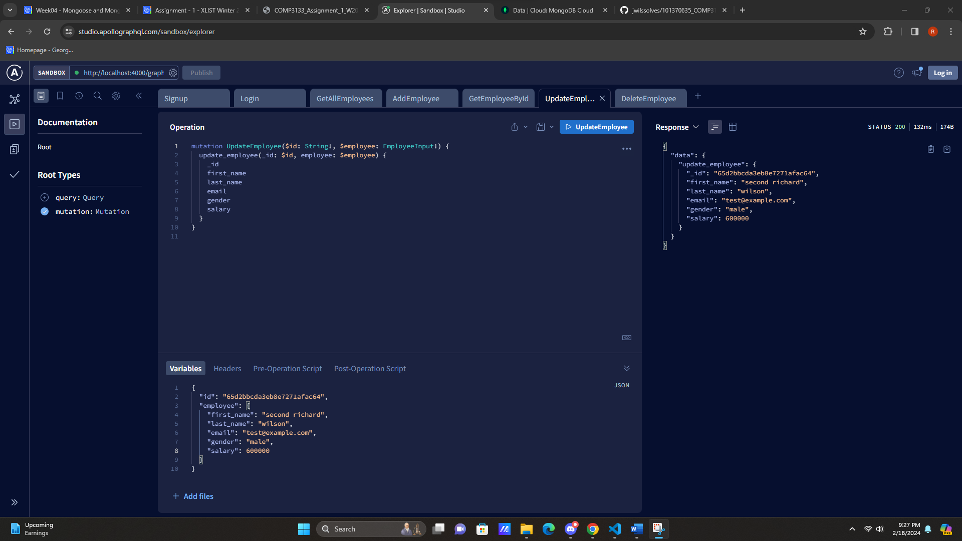

Delete Employee:

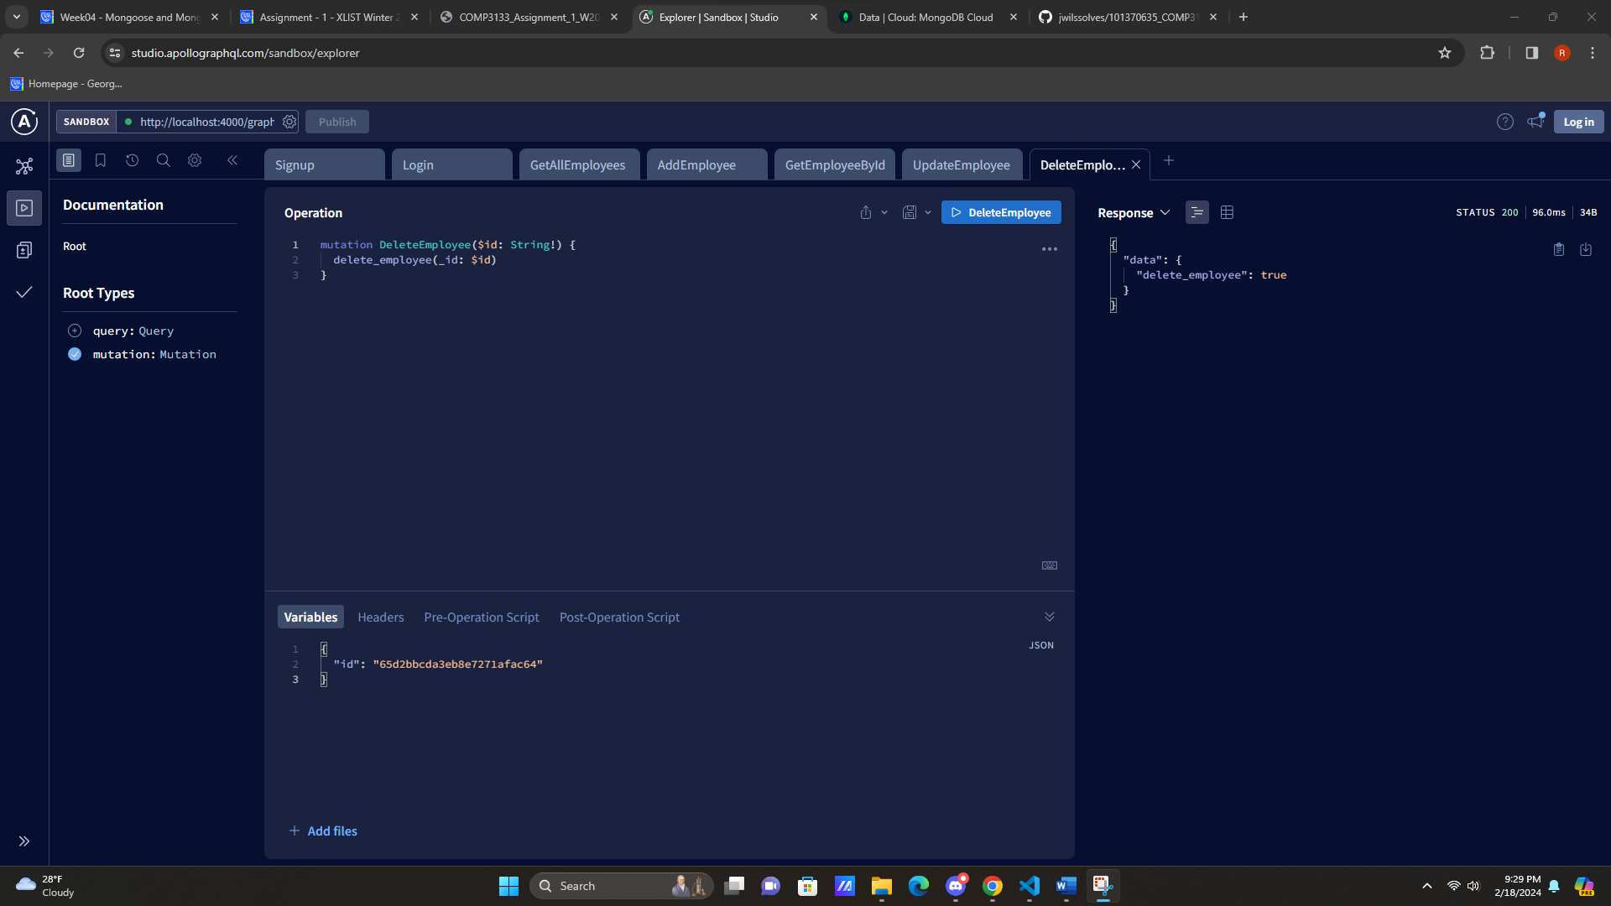

Atlass Screenshot (instead of console):

