实验报告
专业： 地理信息科学
姓名： _______
学号： __
日期： 2022.11.25
地点： 曹西-501

课程名称：____计算机图形学___ 指导老师：_童若锋_____ _______成绩：_______ __
装 订 线
实验名称： OpenGL光照模型 实验类型：_____基础实验_____同组学生姓名：______________

- 实验目的和要求

掌握着色器语言GLSL的基本语法，类比Lambert光照模型，利用GLSL书写Phong光照模型顶点着色器与片段着色器代码，并实现材质对平行光与聚光灯等光源的相应。

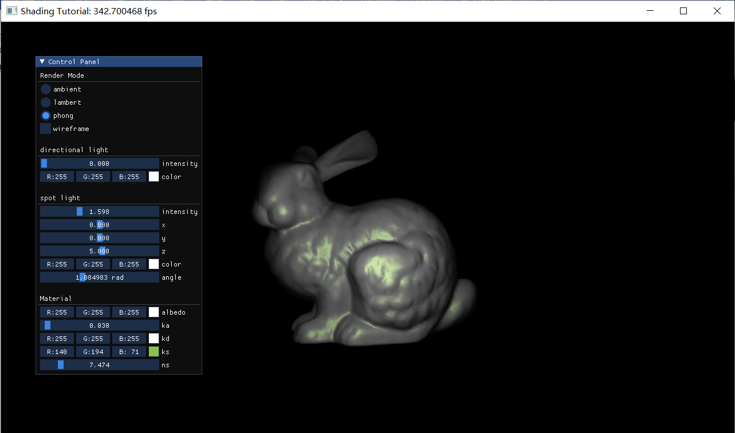

- 实验内容和原理
- 掌握冯氏光照模型的原理
- 利用OpenGL编写冯氏光照模型着色器
- 利用着色器显示模型

三、主要仪器设备
PC with Ubuntu 20.04
GCC with CMake and OpenGL
Visual Studio Code

四、操作方法和实验步骤

1. 编写环境光源片段着色器
- "// ambient light data structure declaration\n"
- "struct AmbientLight {\n"
- " vec3 color;\n"
- " float intensity;\n"
- "};\n"

- "// uniform variables\n"
- "uniform Material material;\n"
- "uniform AmbientLight ambientLight;\n"
- 定义光线反射参数
- "// material data structure declaration\n"
- "struct Material {\n"
- " vec3 ka;\n"
- " vec3 kd;\n"
- " vec3 ks;\n"
- " float ns;\n"
- "};\n"

- 定义平行光线和聚光灯光线
- "// directional light data structure declaration\n"
- "struct DirectionalLight {\n"
- " vec3 direction;\n"
- " float intensity;\n"
- " vec3 color;\n"
- "};\n"

- "// spot light data structure declaration\n"
- "struct SpotLight {\n"
- " vec3 position;\n"
- " vec3 direction;\n"
- " float intensity;\n"
- " vec3 color;\n"
- " float angle;\n"
- " float kc;\n"
- " float kl;\n"
- " float kq;\n"
- "};\n"

- "uniform DirectionalLight directionalLight;\n"
- "uniform SpotLight spotLight;\n"

- 编写漫反射光线片段着色器
- "vec3 calcDirectionalLight(vec3 normal) {\n"
- " vec3 lightDir = normalize(-directionalLight.direction);\n"
- " vec3 diffuse = directionalLight.color * max(dot(lightDir, normal), 0.0f) * material.kd;\n"
- " return directionalLight.intensity * diffuse ;\n"
- "}\n"

- "vec3 calcSpotLight(vec3 normal) {\n"
- " vec3 lightDir = normalize(spotLight.position - fPosition);\n"
- " float theta = acos(-dot(lightDir, normalize(spotLight.direction)));\n"
- " if (theta > spotLight.angle) {\n"
- " return vec3(0.0f, 0.0f, 0.0f);\n"
- " }\n"
- " vec3 diffuse = spotLight.color * max(dot(lightDir, normal), 0.0f) * material.kd;\n"
- " float distance = length(spotLight.position - fPosition);\n"
- " float attenuation = 1.0f / (spotLight.kc + spotLight.kl * distance + spotLight.kq * distance * distance);\n"
- " return spotLight.intensity * attenuation * diffuse;\n"
- "}\n"

- 在顶点着色器计算片段的世界坐标
- const char *vsCode =
- "#version 330 core\n"
- "layout(location = 0) in vec3 aPosition;\n"
- "layout(location = 1) in vec3 aNormal;\n"
- "layout(location = 2) in vec2 aTexCoord;\n"

- "out vec3 fPosition;\n"
- "out vec3 fNormal;\n"
- "out vec3 FragPos;\n"

- "uniform mat4 model;\n"
- "uniform mat4 view;\n"
- "uniform mat4 projection;\n"

- "void main() {\n"
- " fPosition = vec3(model * vec4(aPosition, 1.0f));\n"
- " fNormal = mat3(transpose(inverse(model))) * aNormal;\n"
- " gl_Position = projection * view * model * vec4(aPosition, 1.0f);\n"
- " FragPos = vec3(model * vec4(aPosition, 1.0));\n"
- "}\n";

- 编写镜面反射片段着色器
- "uniform vec3 viewPos;\n"

- "vec3 calcSpecDirectionalLight(vec3 normal) {\n"
- " vec3 lightDir = normalize(-directionalLight.direction);\n"
- " vec3 viewDir = normalize(viewPos - FragPos);\n"
- " vec3 reflectDir = reflect(-lightDir, normal);\n"
- " vec3 diffuse = directionalLight.color * pow(max(dot(reflectDir, viewDir),0.0f), material.ns) * material.ks;\n"
- " return directionalLight.intensity * diffuse ;\n"
- "}\n"

- "vec3 calcSpecSpotLight(vec3 normal) {\n"
- " vec3 lightDir = normalize(spotLight.position - fPosition);\n"
- " vec3 viewDir = normalize(viewPos - FragPos);\n"
- " vec3 reflectDir = reflect(-lightDir, normal);\n"
- " float theta = acos(-dot(lightDir, normalize(spotLight.direction)));\n"
- " if (theta > spotLight.angle) {\n"
- " return vec3(0.0f, 0.0f, 0.0f);\n"
- " }\n"
- " vec3 diffuse = spotLight.color * pow(max(dot(reflectDir, viewDir),0.0f), material.ns) * material.ks;\n"
- " float distance = length(spotLight.position - fPosition);\n"
- " float attenuation = 1.0f / (spotLight.kc + spotLight.kl * distance + spotLight.kq * distance * distance);\n"
- " return spotLight.intensity * attenuation * diffuse;\n"
- "}\n"

- 计算最终冯氏光照模型
- "void main() {\n"
- " vec3 ambient = material.ka * ambientLight.color * ambientLight.intensity;\n"
- " vec3 normal = normalize(fNormal);\n"
- " vec3 diffuse = calcDirectionalLight(normal) + calcSpotLight(normal);\n"
- " vec3 specular = calcSpecDirectionalLight(normal) + calcSpecSpotLight(normal);\n"
- " color = vec4(ambient + diffuse + specular, 1.0f);\n"
- "}\n";

- 利用imgui输入冯氏光照模型参数
- _phongShader->use();
- // 1. transfer the mvp matrices to the shader
- _phongShader->setUniformMat4("projection", _camera->getProjectionMatrix());
- _phongShader->setUniformMat4("view", _camera->getViewMatrix());
- _phongShader->setUniformMat4("model", _bunny->transform.getLocalMatrix());

- // 2. transfer the camera position to the shader
- _phongShader->setUniformVec3("viewPos", _camera->transform.position);

- // 3. transfer the material attributes to the shader
- _phongShader->setUniformVec3("material.ka", _phongMaterial->ka);
- _phongShader->setUniformVec3("material.kd", _phongMaterial->kd);
- _phongShader->setUniformVec3("material.ks", _phongMaterial->ks);
- _phongShader->setUniformFloat("material.ns", _phongMaterial->ns);

- // 4. TODO: transfer the light attributes to the shader
- _phongShader->setUniformVec3("ambientLight.color", _ambientLight->color);
- _phongShader->setUniformFloat("ambientLight.intensity", _ambientLight->intensity);

- _phongShader->setUniformVec3("spotLight.position", _spotLight->transform.position);
- _phongShader->setUniformVec3("spotLight.direction", _spotLight->transform.getFront());
- _phongShader->setUniformFloat("spotLight.intensity", _spotLight->intensity);
- _phongShader->setUniformVec3("spotLight.color", _spotLight->color);
- _phongShader->setUniformFloat("spotLight.angle", _spotLight->angle);
- _phongShader->setUniformFloat("spotLight.kc", _spotLight->kc);
- _phongShader->setUniformFloat("spotLight.kl", _spotLight->kl);
- _phongShader->setUniformFloat("spotLight.kq", _spotLight->kq);
- _phongShader->setUniformVec3("directionalLight.direction", _directionalLight->transform.getFront());
- _phongShader->setUniformFloat("directionalLight.intensity", _directionalLight->intensity);
- _phongShader->setUniformVec3("directionalLight.color", _directionalLight->color);

五、实验结果与分析

在冯氏光照模型下显示的模型如图

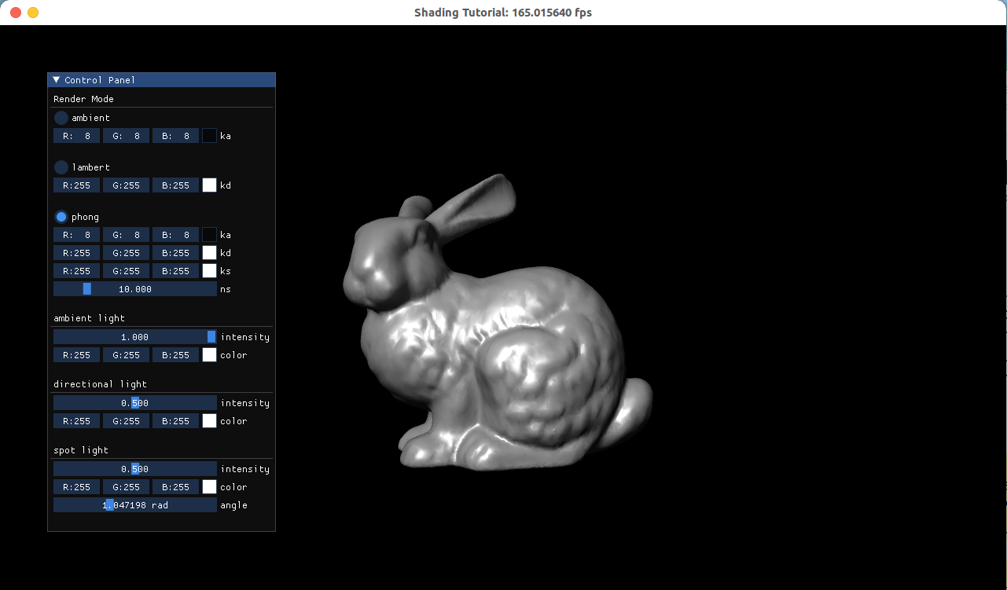

六、讨论、心得

深入理解了光照模型并且成功实现一个简单的光照模型

七、参考链接

[1] 颜色 - LearnOpenGL CN (learnopengl-cn.github.io)

[2] 基础光照 - LearnOpenGL CN (learnopengl-cn.github.io)

[3] 材质 - LearnOpenGL CN (learnopengl-cn.github.io)

[4] 投光物 - LearnOpenGL CN (learnopengl-cn.github.io)

[5] 多光源 - LearnOpenGL CN (learnopengl-cn.github.io)

