实验报告
专业： 地理信息科学
姓名： _______
学号： __
日期： 2022.12.25
地点： 曹西-501

课程名称：____计算机图形学___ 指导老师：______ 童若锋 _______成绩：_______ __
装 订 线
实验名称： OpenGL视锥剔除 实验类型：_____基础实验_____同组学生姓名：____无_______

一、实验目的和要求
使用CPU和GPU算法进行视锥体剔除，从而提升程序的绘制效率。

二、实验内容和原理
利用视锥体去除的原理实现CPU和GPU视锥体去除算法，提升场景绘制的帧数

三、主要仪器设备
PC with Ubuntu 20.04
GCC with CMake and OpenGL
Visual Studio Code

四、操作方法和实验步骤
1.求解视锥体
视锥体（frustum），是指场景中摄像机的可见的一个锥体范围。它有上、下、左、右、近、远，共6个面组成。
一个平面可以由平面上的三个点确定，也可以由平面法线和平面上的一个点确定。
只需要根据已知变量求解出下图中的ntl,nbl,ntr,nbr,ftl,fbl,ftr,fbr这八个点就可以确定6个平面。
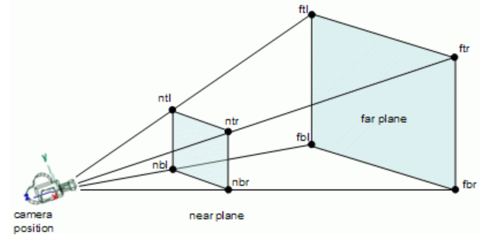
根据OpenGL的相机参数可以很容易计算六个点，从而得到表示视锥体六个面的方程，即plane，采用vec3的向量模式表示其法向量
- Frustum PerspectiveCamera::getFrustum() const {
- Frustum frustum;
- const float halfVSide = zfar * tanf(fovy * 0.5f);
- const float halfHSide = halfVSide * aspect;
- const glm::vec3 frontMultFar = zfar * this->transform.getFront();

- frustum.planes[Frustum::NearFace] = {this->transform.position + znear * this->transform.getFront(), this->transform.getFront()};
- frustum.planes[Frustum::FarFace] = {this->transform.position + frontMultFar, -this->transform.getFront()};
- frustum.planes[Frustum::RightFace] = {this->transform.position, glm::cross(this->transform.getUp(), frontMultFar + this->transform.getRight() * halfHSide)};
- frustum.planes[Frustum::LeftFace] = {this->transform.position, glm::cross(frontMultFar - this->transform.getRight() * halfHSide, this->transform.getUp())};
- frustum.planes[Frustum::TopFace] = {this->transform.position, glm::cross(frontMultFar + this->transform.getUp() * halfVSide, this->transform.getRight())};
- frustum.planes[Frustum::BottomFace] = {this->transform.position, glm::cross(this->transform.getRight(), frontMultFar - this->transform.getUp() * halfVSide)};

- return frustum;
- }
- CPU视锥体剔除——包围球和视锥体相交判断
利用透视投影矩阵与某个点（p）的齐次坐标相乘，可以得到一个半NDC坐标(p’)，即还没有除以w的NDC坐标。令p’的xyz坐标同时除以w之后，就得到了NDC坐标（p_ndc)，那么在OpenGL的NDC坐标标准下，p_ndc的xyz三个值都应该是在-1到1之间，即：
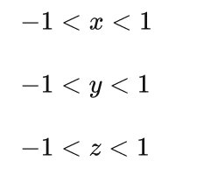
然后把点与透视投影矩阵相乘的形式，也给写出来：
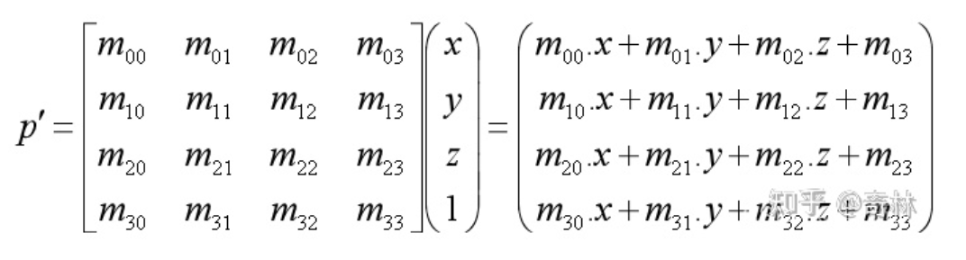
此时得到的还并不是NDC坐标，所以我们需要除以最后的w值，从而得到NDC，如下：
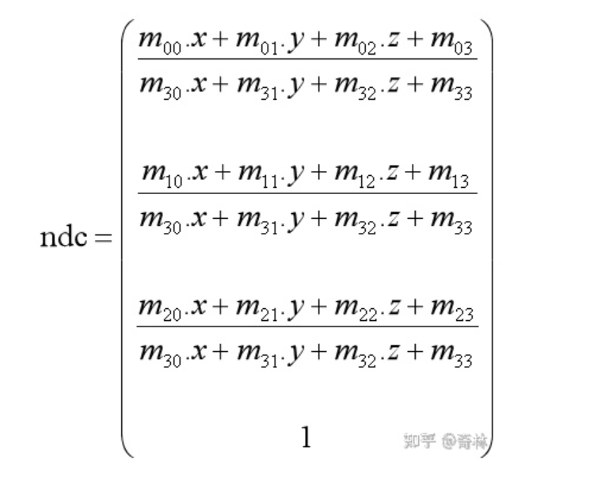
得到了NDC坐标的表达式，所有坐标都必须在-1到1之间才能算作在视锥体范围内。
整理得到六个面的判断条件
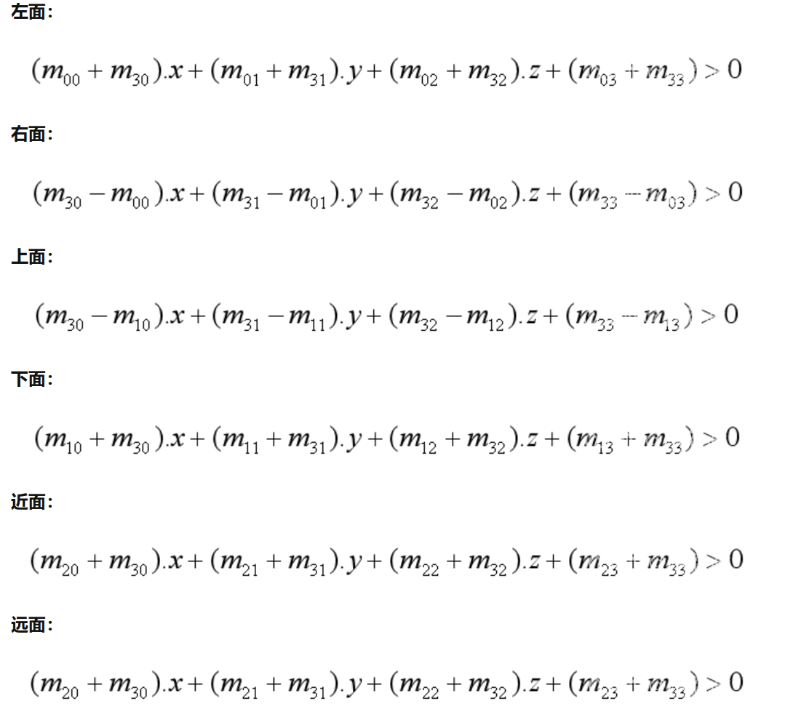
具体相交判断实现如下
- bool intersect(const BoundingBox& aabb, const glm::mat4& modelMatrix) const {
- glm::vec3 center = {(aabb.min + aabb.max) * 0.5f};
- glm::vec3 extents = {(aabb.max - aabb.min) * 0.5f};

- const glm::vec3 globalCenter = {modelMatrix * glm::vec4(center, 1.0f)};
- const glm::vec4 globalCenter4dim = {modelMatrix * glm::vec4(center, 1.0f)};

- glm::vec3 right = modelMatrix * glm::vec4(1.0f, 0.0f, 0.0f, 1.0f);
- right = (right - globalCenter) * extents.x;
- glm::vec3 up = modelMatrix * glm::vec4(0.0f, 1.0f, 0.0f, 1.0f);
- up = (up - globalCenter) * extents.y;
- glm::vec3 front = modelMatrix * glm::vec4(0.0f, 0.0f, 1.0f, 1.0f);
- front = (front - globalCenter) * extents.z;

- const float newIi = std::abs(glm::dot(glm::vec3{1.0f, 0.0f, 0.0f}, right)) +
- std::abs(glm::dot(glm::vec3{1.0f, 0.0f, 0.0f}, up)) +
- std::abs(glm::dot(glm::vec3{1.0f, 0.0f, 0.0f}, front));
- const float newIj = std::abs(glm::dot(glm::vec3{0.0f, 1.0f, 0.0f}, right)) +
- std::abs(glm::dot(glm::vec3{0.0f, 1.0f, 0.0f}, up)) +
- std::abs(glm::dot(glm::vec3{0.0f, 1.0f, 0.0f}, front));
- const float newIk = std::abs(glm::dot(glm::vec3{0.0f, 0.0f, 1.0f}, right)) +
- std::abs(glm::dot(glm::vec3{0.0f, 0.0f, 1.0f}, up)) +
- std::abs(glm::dot(glm::vec3{0.0f, 0.0f, 1.0f}, front));

- const glm::vec3 newcenter = globalCenter;
- const glm::vec3 newextents = {newIi, newIj, newIk};
- bool Left, Right, Bottom, Top, Near, Far;

- // left
- const float rl = newextents.x * std::abs(planes[Frustum::LeftFace].normal.x) +
- newextents.y * std::abs(planes[Frustum::LeftFace].normal.y) +
- newextents.z * std::abs(planes[Frustum::LeftFace].normal.z);
- Left = (-rl <= planes[Frustum::LeftFace].getSignedDistanceToPoint(newcenter));
- // right
- const float rr = newextents.x * std::abs(planes[Frustum::RightFace].normal.x) +
- newextents.y * std::abs(planes[Frustum::RightFace].normal.y) +
- newextents.z * std::abs(planes[Frustum::RightFace].normal.z);
- Right = (-rr <= planes[Frustum::RightFace].getSignedDistanceToPoint(newcenter));
- // top
- const float rt = newextents.x * std::abs(planes[Frustum::TopFace].normal.x) +
- newextents.y * std::abs(planes[Frustum::TopFace].normal.y) +
- newextents.z * std::abs(planes[Frustum::TopFace].normal.z);
- Top = (-rt <= planes[Frustum::TopFace].getSignedDistanceToPoint(newcenter));
- // bottom
- const float rb = newextents.x * std::abs(planes[Frustum::BottomFace].normal.x) +
- newextents.y * std::abs(planes[Frustum::BottomFace].normal.y) +
- newextents.z * std::abs(planes[Frustum::BottomFace].normal.z);
- Bottom = (-rb <= planes[Frustum::BottomFace].getSignedDistanceToPoint(newcenter));
- // near
- const float rn = newextents.x * std::abs(planes[Frustum::NearFace].normal.x) +
- newextents.y * std::abs(planes[Frustum::NearFace].normal.y) +
- newextents.z * std::abs(planes[Frustum::NearFace].normal.z);
- Near = (-rn <= planes[Frustum::NearFace].getSignedDistanceToPoint(newcenter));
- // far
- const float rf = newextents.x * std::abs(planes[Frustum::FarFace].normal.x) +
- newextents.y * std::abs(planes[Frustum::FarFace].normal.y) +
- newextents.z * std::abs(planes[Frustum::FarFace].normal.z);
- Far = (-rf <= planes[Frustum::FarFace].getSignedDistanceToPoint(newcenter));

- return Left && Right && Top && Bottom && Near && Far;
- }
3.GPU视锥体剔除——使用GLSL着色器实现相交判断
GPU与CPU的实现原理相同，但是实现方式是通过绑定着色器判断其是否visable
着色器实现相交判断如下
- const char *vsCode =
- "#version 330 core\n"
- "layout(location = 0) in mat4 aInstanceMatrix;\n"
- "out int visible;\n"

- "struct BoundingBox {\n"
- " vec3 min;\n"
- " vec3 max;\n"
- "};\n"

- "struct Plane {\n"
- " vec3 normal;\n"
- " float signedDistance;\n"
- "};\n"

- "struct Frustum {\n"
- " Plane planes[6];\n"
- "};\n"

- "uniform BoundingBox boundingBox;\n"
- "uniform Frustum frustum;\n"

- "void main() {\n"
- " visible = 0;\n"
- " vec3 boxCenter = 0.5f * (boundingBox.min + boundingBox.max);\n"
- " vec3 center = (aInstanceMatrix * vec4(boxCenter, 1.0f)).xyz;\n"
- " vec3 right = (aInstanceMatrix * vec4(1.0f, 0.0f, 0.0f, 0.0f)).xyz;\n"
- " vec3 up = (aInstanceMatrix * vec4(0.0f, 1.0f, 0.0f, 0.0f)).xyz;\n"
- " vec3 front = (aInstanceMatrix * vec4(0.0f, 0.0f, 1.0f, 0.0f)).xyz;\n"
- " float Ii = abs(dot(vec3(1.0f, 0.0f, 0.0f) , right)) + abs(dot(vec3(1.0f, 0.0f, 0.0f) , up)) + abs(dot(vec3(1.0f, 0.0f, 0.0f) , front));\n"
- " float Ij = abs(dot(vec3(0.0f, 1.0f, 0.0f) , right)) + abs(dot(vec3(0.0f, 1.0f, 0.0f) , up)) + abs(dot(vec3(0.0f, 1.0f, 0.0f) , front));\n"
- " float Ik = abs(dot(vec3(0.0f, 0.0f, 1.0f) , right)) + abs(dot(vec3(0.0f, 0.0f, 1.0f) , up)) + abs(dot(vec3(0.0f, 0.0f, 1.0f) , front));\n"
- " vec3 extents = vec3(Ii, Ij, Ik);\n"
- " float r[6];\n"
- " r[0] = extents.x * abs(frustum.planes[0].normal.x) + "
- " extents.y * abs(frustum.planes[0].normal.y) + "
- " extents.z * abs(frustum.planes[0].normal.z);\n"
- " r[1] = extents.x * abs(frustum.planes[1].normal.x) + "
- " extents.y * abs(frustum.planes[1].normal.y) + "
- " extents.z * abs(frustum.planes[1].normal.z);\n"
- " r[2] = extents.x * abs(frustum.planes[2].normal.x) + "
- " extents.y * abs(frustum.planes[2].normal.y) + "
- " extents.z * abs(frustum.planes[2].normal.z);\n"
- " r[3] = extents.x * abs(frustum.planes[3].normal.x) + "
- " extents.y * abs(frustum.planes[3].normal.y) + "
- " extents.z * abs(frustum.planes[3].normal.z);\n"
- " r[4] = extents.x * abs(frustum.planes[4].normal.x) + "
- " extents.y * abs(frustum.planes[4].normal.y) + "
- " extents.z * abs(frustum.planes[4].normal.z);\n"
- " r[5] = extents.x * abs(frustum.planes[5].normal.x) + "
- " extents.y * abs(frustum.planes[5].normal.y) + "
- " extents.z * abs(frustum.planes[5].normal.z);\n"
- " if(-r[0] <= frustum.planes[0].signedDistance + dot(frustum.planes[0].normal, center) && "
- " -r[1] <= frustum.planes[1].signedDistance + dot(frustum.planes[1].normal, center) && "
- " -r[2] <= frustum.planes[2].signedDistance + dot(frustum.planes[2].normal, center) && "
- " -r[3] <= frustum.planes[3].signedDistance + dot(frustum.planes[3].normal, center) && "
- " -r[4] <= frustum.planes[4].signedDistance + dot(frustum.planes[4].normal, center) && "
- " -r[5] <= frustum.planes[5].signedDistance + dot(frustum.planes[5].normal, center))\n"
- " visible = 1;\n"
- "}\n";
随后在randerFrame内实现绑定和绘制模式
- case Method::GPU:
- _frustumCullingShader->use();
- // 写入包围盒
- _frustumCullingShader->setUniformVec3("boundingBox.min", box.min);
- _frustumCullingShader->setUniformVec3("boundingBox.max", box.max);
- // 写入视锥体
- _frustumCullingShader->setUniformVec3("frustum.planes[0].normal", frustum.planes[Frustum::LeftFace].normal);
- _frustumCullingShader->setUniformFloat("frustum.planes[0].signedDistance", frustum.planes[Frustum::LeftFace].signedDistance);

- _frustumCullingShader->setUniformVec3("frustum.planes[1].normal", frustum.planes[Frustum::RightFace].normal);
- _frustumCullingShader->setUniformFloat("frustum.planes[1].signedDistance", frustum.planes[Frustum::RightFace].signedDistance);

- _frustumCullingShader->setUniformVec3("frustum.planes[2].normal", frustum.planes[Frustum::BottomFace].normal);
- _frustumCullingShader->setUniformFloat("frustum.planes[2].signedDistance", frustum.planes[Frustum::BottomFace].signedDistance);

- _frustumCullingShader->setUniformVec3("frustum.planes[3].normal", frustum.planes[Frustum::TopFace].normal);
- _frustumCullingShader->setUniformFloat("frustum.planes[3].signedDistance", frustum.planes[Frustum::TopFace].signedDistance);

- _frustumCullingShader->setUniformVec3("frustum.planes[4].normal", frustum.planes[Frustum::NearFace].normal);
- _frustumCullingShader->setUniformFloat("frustum.planes[4].signedDistance", frustum.planes[Frustum::NearFace].signedDistance);

- _frustumCullingShader->setUniformVec3("frustum.planes[5].normal", frustum.planes[Frustum::FarFace].normal);
- _frustumCullingShader->setUniformFloat("frustum.planes[5].signedDistance", frustum.planes[Frustum::FarFace].signedDistance);

- glEnable(GL_RASTERIZER_DISCARD);
- glBindTransformFeedback(GL_TRANSFORM_FEEDBACK, _transformFeedback);
- glBeginTransformFeedback(GL_POINTS);

- glBindVertexArray(_transformFeedbackRenderVao);
- glDrawArraysInstanced(GL_POINTS, 0, 1, _amount);

- glBindVertexArray(0);

- glEndTransformFeedback();
- glDisable(GL_RASTERIZER_DISCARD);
- glFlush();

- // 读出transformfeedback中的visible值
- glGetBufferSubData(GL_TRANSFORM_FEEDBACK_BUFFER, 0, sizeof(_visibles[0]) * _amount, &_visibles[0]);

- break;

五、实验结果与分析

CPU模式

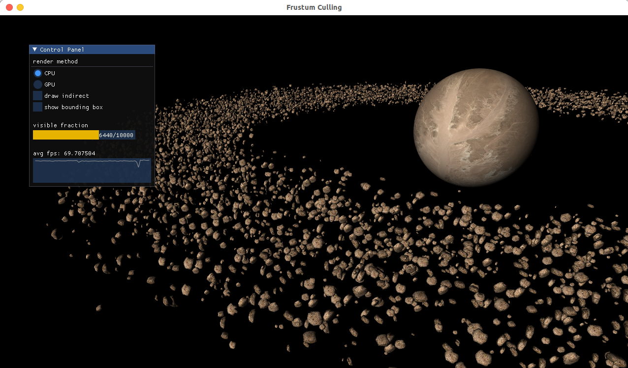

GPU模式

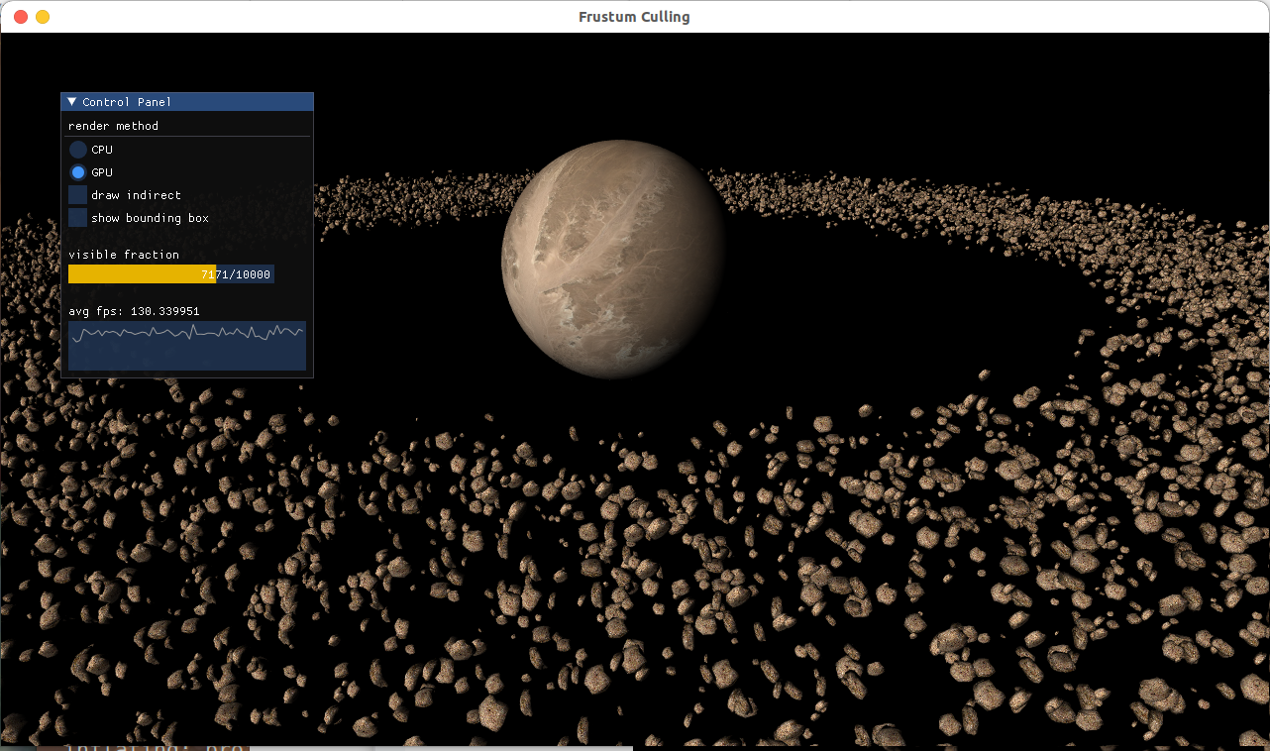
- 讨论、心得

实现了GPU视锥体剔除算法
- 参考链接
[1] LearnOpenGL - Frustum Culling
[2] OpenGL - Transform Feedback

