San Diego State University
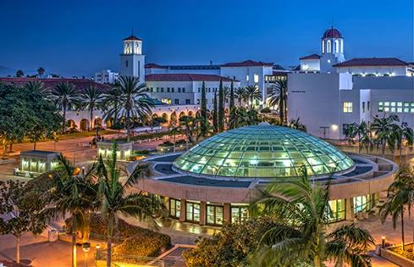

URL: http://arweb.sdsu.edu/es/admissions/majors/computerscience.htm

First year of courses in the major teaches you the fundamentals of programming. In the second year, you will begin to take more specialized courses, learning about how computers function, as well as advanced and efficient ways of organizing information. As you move into the upper division courses, you will learn several different computer languages, as well as elements of circuit design and how operating systems such as Windows and UNIX function. You will also have the opportunity to take courses in elective areas such as software engineering, robotics, and artificial intelligence. .

Year 1 | First Term  CS 107 , MATH 150 ,STAT 250 OR STAT 119,  Second Term  CS 108, MATH 151 , CHEM 200  Third Term  CS 237, MATH 245, CHEM 201
Year 2 | First Term  MATH 254 , GEOL 100, CS 310  Second Term  GEOL 101, CS 320, STAT 350A  Third Term  GEOL 104, CS 370,
Year 3 | First Term  CS 440,  Second Term  CS 490  Third Term  CS 530 , CS 550
Year 4 | First Term  CS 560 ,CS 553  Second Term  CS 570,CS 556  Third Term  ?
Graduate School | The department offers a graduate study in the Master of Computer Science. The areas in which courses are offered include software, systems, architecture, artificial intelligence, and computer science theory. A Master’s degree in Computer Science provides education and creative experience to prepare graduates for advanced professional employment in industry or government, or for college-level teaching.  Master’s level research projects are available in the following areas of computer science: distributed systems, multiprocessing, operating systems, graphics, neural networks, formal languages, numerical methods, robotics, signal processing, and computational complexity. Specialized laboratories exist for microprocessor architecture, graphics, and robotics and intelligent machines.

California Institute of Technology
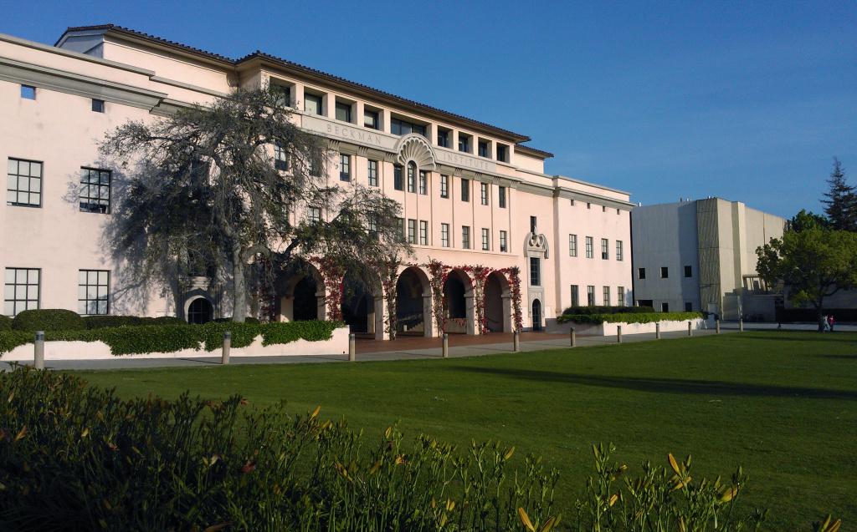

URL : http://www.cms.caltech.edu/academics/ugrad_cs

CMS is an academic department of the Engineering and Applied Science division, located in the spectacular Annenberg Center for Information Science and Technology on the campus of the California Institute of Technology---a world-renowned private university widely acknowledged to be among the best universities in the world despite its notably smaller size compared to peer institutions. CIT offers undergraduate degree programs in Applied + Computational Mathematics and Computer Science. In addition, CIT offers graduate degree programs in Applied + Computational Mathematics ,Computer Science, Computing + Mathematical Sciences , Control + Dynamical Systems , and Computation + Neural Systems .

Year 1 | First Term  CS 1, MA 2  Second Term  CS 2, MA 3  Third Term  CS 4, MA/CS 6
Year 2 | First Term  CS 11, ?? - Scientific Fundamentals  Second Term  CS 21, HSS Electives  Third Term  CS 24
Year 3 | First Term  CS 38, HSS Electives  Second Term  CS 80  E10- Technical Seminar Presentations  Third Term  CS 81, EAS/Ma Courses
Year 4 | First Term  CS 121, EAS/Ma Courses, HSS Electives  Second Term  CS 122  Third Term  CS 123
Graduate School | The graduate computer science option is primarily oriented toward Ph.D. research. Students complete advanced coursework to achieve a breadth of knowledge in the core areas of computer science, and specialized coursework in their intended research area as directed by their research advisor and the graduate option representative. The M.S. degree entails a thesis and coursework and is normally awarded in the first two years as part of the overall progress toward the Ph.D.

