Software Engineering CSC 4350

Spring Semester 2016

The JANPR Group

Patrick Crouch, Nelly Fuentes, Robert Kee, Aidan Jones, James Wingo

April 21st, 2016

Table of Contents

Introduction
Requirements Elicitation
System Analysis & Design
Object Design
Test cases
Rationale
Function Point Cost Analysis
Prototype
Project legacy
Work Share Document
Gantt Chart
Glossary of Term
Group Resumes
User Guide

Introduction

The topic we have chosen to address is the creation of an Android software application (app) that will translate mathematical symbols and numbers drawn by the finger of the user onto the touch screen of a device into the text equivalent of the same symbols and numbers entered using a word processor with mathematical capabilities. We believe this will allow for a much more streamlined user experience when entering complex formulae and equations when on a mobile device, since alternatives available for the entry of mathematical symbols are often either too complex for the average user (like Latex), or so simplistic as to only allow for very limited functionality (eg. The standard calculator on a mobile device).

Requirements Elicitation

Problem Statement:
The problem we have chosen to address is the creation of an Android software application (app) that will translate mathematical symbols and numbers drawn by the finger of the user onto the touch screen of a device into the text equivalent of the same symbols and numbers entered using a word processor with mathematical capabilities. We believe this will allow for a much more streamlined user experience when entering complex formulae and equations when on a mobile device, since alternatives available for the entry of mathematical symbols are often either too complex for the average user (like Latex), or so simplistic as to only allow for very limited functionality (ie. The standard calculator on a mobile device). In addition, the app will be able to export the translated mathematical symbols to the Wolfram Alpha API for processing and evaluation, and will be able to show the data from WA to the user, and save it.
The software application will take 1 symbol at a time, drawn by a user that has previously given a writing sample to the application consisting of several examples of each letter, number, and symbol of the mathematical and alphanumeric symbols that he/she wishes to reproduce on the screen. Once the user has drawn the symbol to his/her satisfaction, the symbol will be sent to the back-end algorithm for processing into the most likely intended symbol, and will then be displayed as its Unicode equivalent in a running queue at the bottom of the app screen, on top of a fresh screen for drawing another symbol. The app should ask the user to confirm their inputs are correct, potentially offering 3-5 next-best guesses much like autocorrect/autofill functionality for text input.
Once the user is satisfied with the series of alphanumeric and mathematical symbols that they have produced, he/she may choose to send the string of Unicode text to Wolfram Alpha (via Wolfram Alpha's API), save the string of text to a file, clear the string of text and start over, or copy the string of text into his/her Android device's clipboard. If text is sent to Wolfram Alpha, the app will take the data received back (a summary of equation data provided by wolfram alpha in the form of an image file) and display it on the screen, with an option to save the image locally, or discard it entirely. If saving the string locally, the user will be taken to his/her default file manager (or will select one from a list, as per the Android MIME-type handling protocol), and if copying the string to the device clipboard, the app will show a short message that the text has been copied to the clipboard, and will exit.
The features and functions of the application mentioned so far comprise a base case and proof of concept for features necessary to a handwriting recognition app with minimum functionality. There exist, however, several other potential functions and features that, though difficult to implement during the project's time constraint of 3 months, would be great additions to the overall experience and functionality of the application were they to appear in the final version. The ability to enter exponents as small numbers above and to the left of a regular number without first having to enter exponent mode (using a caret ("^")) would speed the entering of more complex exponential functions, as would the ability to enter multiple characters at once into the writing surface. Error correction in the running string readout could be made easier via the ability to directly edit a containing text box in the user's field of view, and the use of a genetically derived algorithm on the back end could make for a more adaptable approach to the translation of the user's handwriting with less upfront necessity for multiple samples of a user's handwriting. These features should be considered only after base functionality is established, and only implemented if possible within the time constraint of the project.
Additionally, as of 4/20/2016, the MHRA will be able to receive text from any other application on an Android device capable of using a ‘share’ functionality, and place it directly into the running string readout of the MHRA itself.

Breakdown of Problem Statement into Functional Requirements:
- The MHRA shall run on the Android operating system.
- The Android device shall be connected to the internet when querying the Wolfram Alpha API.
- The MHRA shall take input from a user in the form of persistent black lines drawn on a touch screen device meant to represent a single symbol at a time.
- The MHRA shall use a custom-designed algorithm to translate the input from the user, one character at a time, into a text representation conforming to the IEEE Unicode specification.
- The MHRA shall allow the user to copy the text representation to the Android clipboard.
- The MHRA shall be able to send the text representation of the equation the Wolfram Alpha API as a query, and shall be able to receive, display, and save the image returned from Wolfram Alpha containing information returned by the query to the API.
- The MHRA shall allow the user to save a produced string locally in the form of a Unicode text file.
- The MHRA may allow for the entry of multiple characters at once.
- The MHRA may allow the entry of exponents without a preceding caret symbol ("^").
Nonfunctional Requirements
- The MHRA shall employ a GUI following the "Best Practices for User Interface" guidelines set forth by the Android Developers website (http://developer.android.com/training/best-ui.html) to ensure usability.
- The MHRA shall use minimal resources as necessary to produce the expected result.
- The MHRA shall not track user behavior.
- The MHRA may allow the use of a genetic algorithm for the processing of handwritten symbols.
- The MHRA may allow for the user's direct editing of a running tabulation of previously entered alphanumeric characters and mathematical symbols.

Requirements Traceability Matrix

System Analysis and Design

RTM Entries | Application shall run on an Android touch screen device  Application shall mimic persistence of lines drawn onto touch interface  Symbols shall be entered one at a time
Use Case ID  Use Case Name  Actors/Participants | 1  UC_1_handWritingConversion  User
Entry Condition | User draws a symbol on the canvas presented by the app
Flow of Events | User opens or resumes app from initial state  User moves finger across touch screen area of device to create symbol  User finishes drawing in one (1) or multiple strokes  User activates send to algorithm functionality (“submit”)  |Or|  User clears screen and restarts handWritingConversion
Exit Condition | User finishes drawing symbol and sends symbol data to handWritingInfoAccess  |Or|  User finishes drawing symbol and clears screen to retry
Quality Constraints | No lag or delay should be present while user is drawing on canvas  Device should remain in ready (on) state while user is drawing

RTM Entry: | Application shall interface with local file storage to store either user input data or data received from Wolfram Alpha
Use Case ID  Use Case Name  Actors/Participants | 2  UC_2_handWritingInfoAccess  Android File System
Flow of Events | Receive request for each symbol data  File system sends data for each symbol to algorithm  Receive equation Data from Wolfgram alpha  Save in temporary file for processing
Entry Condition | When the algorithm begins searching for symbol match
Exit Condition | After the System has processed all data to be displayed or the symbol has been interpreted
Quality Constraints | The transaction between the file system and the app should happen almost instantly

RTM Entry: | App shall have access to device clipboard
Use Case ID  Use Case Name  Actors/Participants | 3  UC_3_clipboard  System Services
Flow of Events | The current expression shall be sent to a System Service called the ClipboardManager.  This global class of the Android system shall be called by invoking a reference to getSystemService(CLIPBOARD_SERVICE).  The text string expression shall become the current copy buffer text.
Entry Condition | User has pressed the clipboard button.
Exit Condition | Data has been exported to the keyboard.
Quality Constraints | The transaction between the file system and the app should happen almost instantly and with 100% accuracy.

RTM Entry: | The mobile application (MHRA) shall use the Wolfram Alpha API to transmit and receive information to and from Wolfram Alpha
Use Case ID:  Use Case Name:  Actors/Participants | 4  UC_4_Wolfram_Alpha  Wolfram Alpha API
Entry Conditions: | Application sends desired input to Wolfram Alpha, via Wolfram Alpha's API
Flow of Events: | Application queries the Wolfram Alpha API with string converted from user input  Wolfram Alpha API receives input from application  |Or|  Wolfram Alpha API cannot be contacted, application displays error  Wolfram Alpha API returns response to query as image  |Or|  Wolfram Alpha API doesn’t respond, application returns error
Exit Conditions: | Application receives response from Wolfram Alpha  |Or|  Application response receiver times out
Quality Constraints: | - Internet connection should be available  2. Query to Wolfram Alpha should be shown immediately

User Interaction Diagram:
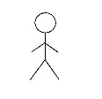
User
Timeline
DrawingCanvas
Draw()
Clear
Button
Send
Button(s)
File System Interaction Diagram:
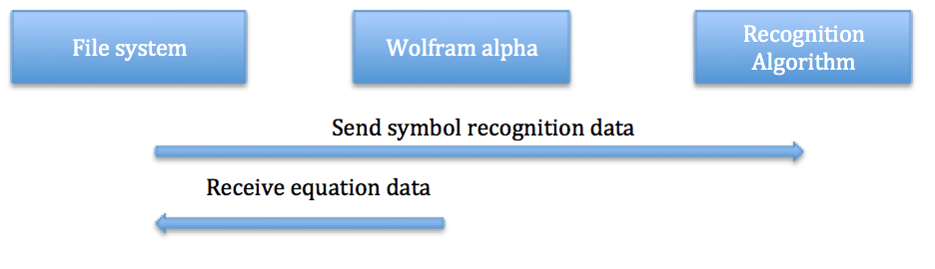

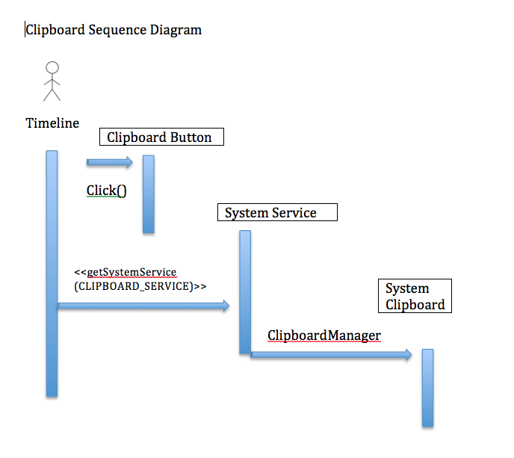

Wolfram Alpha Interaction Diagram

User
<create>>

desiredString

<<create>
Wolfram_Alpha API
<<create>>
Timeline
resultsToUser

sendDesiredString( ) evaluateString()
returnResults() showResults()

UC_1_handwritingConversion_CID  - User opens or resumes app from initial state  - User draws a symbol on the canvas presented by the app  - User finishes drawing in one (1) or multiple strokes  - User activates send to algorithm functionality (“submit”) or clears screen to restart handWritingConversion  - User finishes drawing symbol and sends symbol data to handWritingInfoAccess, or user finishes drawing symbol and clears screen to retry | User  Timeline  GUI  2.Draw()  GUI  GUI  4. onSubmit()  4. onClear()

UC_2_HandWritingInfoAccess_CID

Android File System
Wolfram Alpha
Running Queue
Recognition Algorithm

1: sendSymbolData( ) 2: sendIntendedSymb() 3: sendForEvaluation()

3.1: returnedEquation()

UC_2_handWritingInfoAccess_CID

1. The file system send the users desired data to the algorithm
2. Algorithm begins searching for symbol match and presents the user with several choices on the running queue at the bottom of the screen
3. From the Running queue the desired date is submitted to WA for evaluation
3.1 WA returns the evaluated equation back to the Android File System.

User
UC_3_Clipboard_CID
Timeline
System
System
System
1.onClick()
2. <<<getSystemService
(CLIPBOARD_SERVICE)>>>
3. sendToClipboard()

UC_3_Clipboard_CID
- The current expression shall be sent to a system service called ClipboardManager by the click of a button.
- The global class of the Android system shall be called by invoking a reference to getSystemService(CLIPBOARD_SERVICE)
- The text string expression shall be sent to the clipboard as the current copy buffer text

UC_4_Wolfram Alpha_CID

User
Wolfram_Alpha
GUI

1: sendEquation( ) 2: evaluateEquation()

3.1 showResults() 3: returnResults()

UC_4_Wolfram Alpha_CID
1. User send desired equation to WA for evaluation
1.1 Wolfram Alpha API evaluates the equation
1.2 Wolfram Alpha API return evaluated equation
1.3 Evaluated string is shown on the screen to user.

Object Design
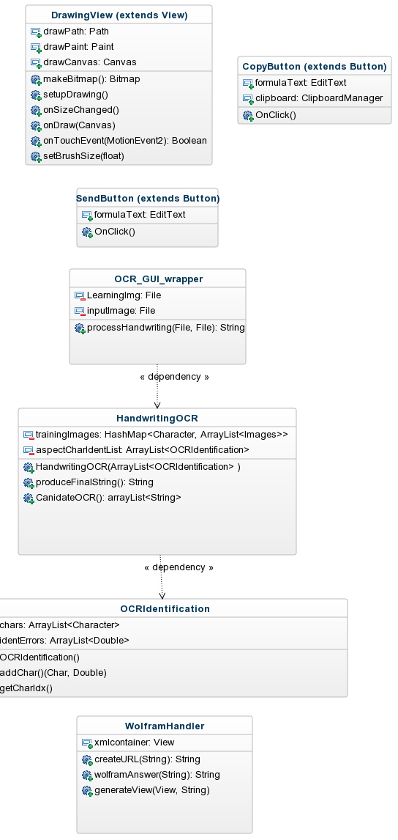

Test Cases

Rationale
We have made several key decisions already in the creation of this project, and our work towards its completion.
As for our topic:
- we chose a handwriting recognition app that interfaces with wolfram alpha because it has not been done before (that we know of), whereas many of the recommended projects (ie. inventory control system, online shopping cart) have been done many times, and do not represent a unique project;
- we chose to interface with Wolfram Alpha, because designing our own calculator would be overly time-consuming, and could not match the power and flexibility of Wolfram Alpha concerning computational ability;
- we chose a mobile app (that will run only on Android mobile devices) because of the flexibility and accessibility of the Android platform (open source), and because of the necessity of having a touch interface on which to draw.

We have chosen to interpret characters one at a time because:
- interpreting characters up to 20 or more at a time is possible, but an algorithm that could parse such inputs would have significantly larger computational resource requirements than those available on an Android device, whereas parsing each character drawn one at a time is computationally inexpensive;
- interpreting multiple characters would add at least an order of magnitude worth of complexity to any algorithm used to parse them, increasing development and testing time of such an algorithm to limits beyond the scope and time frame of a three month project.

For our handwriting recognition app we chose 4 separate use cases: the User, the File System, the System Clipboard, and Wolfram Alpha. We chose not to include the algorithm that processes the user-entered symbols as a use case because the algorithm is not directly accessible to any actor involved in using the software, and its visibility to either the client or any actor is not necessary to ensure the software’s operation as defined within specifications. Furthermore, due to the algorithm’s likely complex operation and need for revision, including it in the user (or any other) use case might result in scope creep and muddling of the existing use cases.
Though the number of use cases (4) might seem low for the average piece of software, keep in mind that our app needs neither authentication (Android devices are already logged in to a secure user profile when in normal operation) or multiple levels of credentialed access (ie. administrators vs. normal users) since the operation of the software within the limits required by the RTM does not necessitate a privileged user or users.
We chose to include both the filesystem and Wolfram Alpha as actors with separate use cases for each due to the variability of functionality offered by each. Since Wolfram Alpha is a service independent of our application, it can maintain several different states, each of which need to be handled in a separate chain of events, necessitating a separate use case. Since the filesystem is responsible for multiple differing functions with regard to the app (all of which might have separate pass/fail requirements), it has also been given a separate use case as well. The system clipboard operates separately from the filesystem and at the request of the user, giving it a different functionality profile and necessitating a separate use case.

Our choices in objects used basically reflect the functionalities necessary to perform the task of handwriting conversion. At this stage, there are very few trade-offs to make in terms of object operation and design, since the task itself is relatively simple from the perspective of modules necessary to complete our app’s task, and the complexity of that task, the translation of handwriting to text, is performed within our OCR object, not between a group of objects. In this respect, it may seem that we have a simpler system from an outside perspective because we are able to accomplish the main goal of object-oriented programming, specifically, the hiding of our implementation within the boundaries of the classes.
The choice of a Model-View-Controller architecture within the context of the Android operating system was an easy one, since the design structure recommended by Android follows this paradigm very closely. More importantly, our specific application will be a series of inputs from the View (the canvas element of our handwriting app, which is meant to emulate a physical writing surface) to the Model (our algorithm, which will take the user input and put forth a “best guess” as to what the user’s intended symbol is) maintained through the transaction by the controller (the application’s routing of said data, both from the View to Model as explained, and from the Model to the view). Abstracting the application in this way makes it easy to explain the inputs/outputs in each step, and makes it easy to justify the use of a small number of classes with very clear functionality. Though other architectures might solve minor challenges in our ability to have the system fit the model, Model-View-Controller most closely mimics the base structure of our app, and also very closely resembles the mental model we have been using to refer to different components in the project since we started the planning phase.
Our development process’s architecture, much like our Android application, will most closely resemble the architecture of its environment, Github. Github uses a Repository-style architecture, in which our central codebase is maintained in one location which is then accessed by all of its subsystems (in this case, our group members) for modification. In addition to the benefit of all changes being visible from all members simultaneously, regardless of location, Github also creates an incremental, total backup of each and every modification made to our source code. Github also allows for the branching of the repository into a separate repository in order to test code changes away from the main code, before recombining it with production code. We feel that these advantages justify the use of Github (and its repository architecture) as our main development tool.
Though our project will be accomplishing a complex goal, our test cases are fairly simple to verify. Since our number of Use Cases is limited, our test case load is probably smaller than other groups, but no less important. We found that even with a good plan, the amount of testing we’ve had to do has been significant, and that the design of these tests had to be made programmatic, in order to test more inputs in less time, rather than relying on manual testing. Hopefully, this will pay off in the end result, as it has definitely saved us time overall.

Function Point Cost Analysis

Unadjusted Function Point Calculation Tables
Measurement Parameters
 | Count |  | Simple | Average | Complex |  | Total
Number of User Inputs (EIs) | 4 | x | 3 | 4 | 6 | = | 15
Number of User Outputs (EOs) | 4 | x | 4 | 5 | 7 | = | 19
Number of User Inquiries (EQs) | 1 | x | 3 | 4 | 6 | = | 4
Number of Internal Files (ILFs) | 4 | x | 7 | 10 | 15 | = | 39
Number of External Interfaces of Files (EIFs) | 2 | x | 5 | 7 | 10 | = | 12
Total Unadjusted Function Point Count (UFP) | 89

Function  Type | Functional Complexity |  | Complexity  Totals | Functional Type Totals
EIs | Low 3 x 3  Average 0 x 4  High 1 x 6 | =  =  = | 9  0  6 | 15
EOs | Low 3 x 4  Average 0 x 5  High 1 x 7 | =  =  = | 12  0  7 | 19
EQs | Low 0 x 3  Average 1 x 4  High 0 x 6 | =  =  = | 0  4  0 | 4
ILFs | Low 2 x 7  Average 1 x 10  High 1 x 15 | =  =  = | 14  10  15 | 39
EIFs | Low 1 x 5  Average 1 x 7  High 0 x 10 | =  =  = | 5  7  0 | 12
Total | 89

Rating Estimation of Categories
 | Category | Rating (0-5)
1 | Does the system require reliable backup and recovery? | 0
2 | Are data communications required? | 5
3 | Are there distributed processing functions? | 5
4 | Is performance critical? | 3
5 | Will the system run in an existing, heavily utilized operational environment? | 2
6 | Does the system require online data entry? | 2
7 | Does the online data entry require the input transaction to be build over multiple screens or operations? | 0
8 | Are the master files updated online? | 0
9 | Are the inputs, outputs, files or inquiries complex? | 3
10 | Is the internal processing complex? | 3
11 | Is the code designed to be reusable? | 4
12 | Are conversion and installation included in the design? | 3
13 | Is the system designed for multiple installations in different organizations? | 0
14 | Is the application designed to facilitate change and ease of use by the user? | 0
Total |  | 30

Value Adjusted Factor = [0.65 + 0.01(Total)]
VAF = [0.65 + 0.01(30)]
VAF = 0.95

Functional Point Cost = Unadjusted Function Point * Value Adjusted Factor
FPC = UFP * VAF
FPC = 89 * 0.95
FPC = 84.55

Prototype

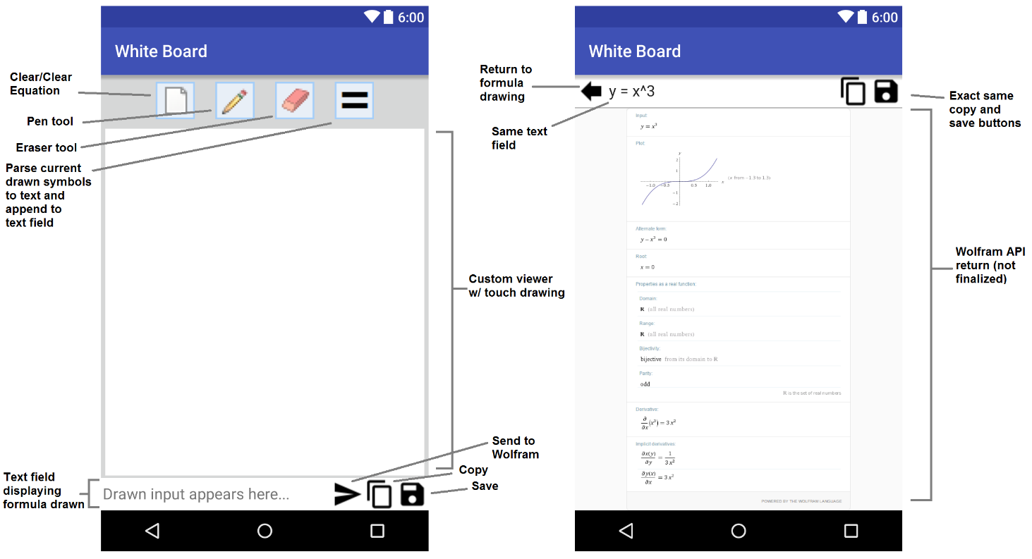
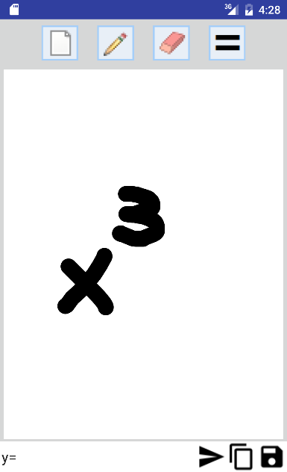

Work Share Document

Gantt Chart

Glossary of Terms

Group Member Resumes

Patrick Crouch

Summary:
- Background in Information Technology with varied work experience including scripting, upgrades, physical and software-level networking, and customer support
- Demonstrated communication skills from front-line customer service work
- Motivated beginning programmer ready to contribute as part of a team
Technical Skills:
- Languages: Java SE, C, Bash shell scripting, Google Apps Scripting, Javascript,
- Source Control: Git, Mercurial
- Database: MySQL, SQL Lite, PostgreSQL, Microsoft Access
- Design Tool/IDEs: Eclipse, Netbeans, Terminal IDE, AIDE, BlueJ, IntelliJ IDEA
- OS: Windows XP, Vista, 7, 8, Server 2012 R2, Unix (Ubuntu, Mint, Debian)

Technical Experience:
KEM Vending Sales and Service, Athens GA
IT Support/Clerical
8/2012 - 6/2015
- Installed and maintained 9 networked computer systems running a host of software and protocols
- Developed three automated solutions to business problems using various scripting languages
- Increased office productivity by drastically reducing equipment and software failure
- Enabled 100% remote operation of critical systems
- Managed IT infrastructure along with clerical duties
Transcend Communications, Athens GA
Technician
6/2008 - 9/2009
- Worked with a team deploying and maintaining physical data networks
- Learned the physical side of data communication and common failure points
Computerland Business Services, Athens GA
Technician
05/2000 - 09/2005
- Repaired more than 175 customer computers on and off-site
- Safely transported, and reinstalled over 100 corporate systems as part of a team
- Deployed hundreds of software packages using industry best practices

Nelly Fuentes

Class: CSC 4350 - Software Engineering

Education:
Georgia State University. Tentative Graduation date: December 2016
Bachelor of Science - Computer Science(Computer Software Systems)

Related Courses taken:
Java, Data Structure, Embedded Systems, Web Programming, Computer Networks

School and work experience with Languages:
C, Java, HTML, CSS, PHP, mySQL

School and work Experience with Software:
Visual Studio, Android Studio, Eclipse, Github, Clearcase, Jira, Mantis, mySQL workbench

Work Experience:
Echostar LLC
- Refactoring code written in C language in embedded systems
- Beta projects coordinator
- Manipulation of flash memory in embedded systems
- Embedded software testing: black box and white box
- Software release support

Aidan Jones

EDUCATION
Georgia State University – Atlanta, GA Scheduled Graduation: September 2016
Bachelor of Science - Computer Science (Graphics and Human-Computer Interaction)
GPA : 3.58/4.00

RELATED COURSES
- Completed: Automata, Human/Computer Interaction, Digital Image Processing, Windowed Systems (GUIs), Game Design, Natural Language Processing
- Registered: Artificial Intelligence, Computer Animation

SKILLS
Active Languages:
- Java, C#, XAML
Previous Experience Languages:
- Python, Assembly, C++, C, HTML, CSS, SQL
Software:
- Visual Studio 2015, Unity, Blender, FL Studio 10, Audacity, MS Office, Photoshop & Paint Tool SAI
General:
- Logic-oriented thinker
- Intense desire to work in a software design/engineering career
- Trained to competently handle common IT issues (Cisco Networking Academy)

EXPERIENCE
Gwinnett Co. Information Management Division – Suwanee, GA Jan 2011 – April 2011
Interned under Coordinator of Database Administration
- Tested new software the county planned to implement (SeaPine Test Track)
- Worked with SQL database software, given informal database lessons
Senior Capstone Experience Aug 2012 – May 2012
Developed 3D game in Java
- Used JMonkeyEngine library
- Cross between Jenga and Brickbreak, bouncing a ball off of a wall of stacked bricks w/ collision
Game Development
Kinesis, in Unity 5.0 Spring 2015
- 3D Puzzle Platformer with Telekinesis gimmick
- Video demo link (1 week into development)
“Dual Drive,” (working title) in Unity 5.0 Fall 2015
- Creating realistic yet simple space craft controls using 2 engines to control torque and thrust
- Video demo link (24 hours into development)
Freelance video game music remixes Sept 2010 – Present
- soundcloud.com/cyanblur
Audio analysis tool Oct 2015 – Dec 2015
- Built in WPF for a GUI-heavy self-assigned project, uses NAudio library
- Helps users determine key and tempo of audio file uploaded, with soundwave visualization.

Robert Kee
160 Flat Shoals Ave. Atlanta, GA 30316
404.368.8699 robert@roberthayeskee.com

Skilled with:
Software: Windows, Windows Server, MS Office Suite, Outlook and Exchange, Adobe Acrobat, Photoshop, Mac OSX, Java, all major audio editing platforms

Hardware: Windows desktop / laptops, Apple desktop / laptops, Cisco routers, switches and hubs, VOIP and analog phone systems, most printers, copiers and faxes, all PA / sound systems

Education
BS in Computer Science from GSU (2013 - 2017)

BA in Philosophy from Oglethorpe University (2003 - 2007)
- Recipient of Presidential Scholarship
- Dual Minor in History and Art History
- Presented papers at 4 academic conferences

Work
Freelance Computer and Audio-Video Technician (2012-present)
- repair and update Apple, Windows and Linux computers
- install and upgrade sound systems
- run live sound at concerts in multiple venues (30+)
- record music and audio in concerts and presentations
Computer Lab Technician at the Art Institute of Atlanta (2007 – 2012)
- Directly assisted students, staff and faculty daily
- Provided support for computers, audio / visual equipment, phones and office equipment.
- Conducted inventory of all staff computers with 100% accuracy
- Developed and taught general technology training course for faculty

Outreach
Member, Board of Directors at Eyedrum Art & Music Gallery (2009-present)
- Chairperson of the Board (2010-2015)
- Managed social media with over 2000 followers on multiple networks
- Member of tech committee and contributor to website overhaul
- Worked as an engineer, promoter, archivist and press contact
- Curated, promoted and managed hundreds of events
James Wingo

Education: Georgia State University, Atlanta, GA 1/2015 – Present
Candidate for Masters in Computer Science

Georgia Institute of Technology, Atlanta, GA 9/2007 – 5/2011
Bachelor of Science, Electrical Engineering
Graduated: May 2011

Skills: Technical Skills: Understanding of Standard PLC programming and project development for Industrial
automation, Embedded microcontrollers, circuit construction and analysis, Basic
electronic testing and measurement instrumentation, FPGA programming and basic understanding
of TCP/IP protocol, Ethernet IP, Ethernet Powerlink, Servo Control theory for synchronous and asynchronous motors, VFD’s, Windows OS, Mac OS, Unix/Linux,

Industry Computer Programs: PSpice, Matlab, Mathcad, Microsoft Office, Automation Studio

Programming: C/C++, Ladder Logic, Structured Text, IEC 61131, PLCopen, JAVA, MATLAB,
Automation Studio

Previous Work Experience:
B&R Automation 6/6/2011 – Present – Industrial Automation company with 2,500 employees worldwide.
Account Manager – 5/2013-1/2015
- Promoted to be regional Sales Engineer in order to use my previous technical skills to assist in sales process
- Undergone extensive sales and marketing training for Industrial Automation and process controls
- Managed project of a major customer with $1,000,000 worth of potential
Product Engineer - 11/2011-5/2013
- Selected from a team of engineers to move to Salzburg, Austria to facilitate Industrial Automation Control and Drives between the US Applications and Austria R&D teams for 1 year
- Extensive work with PLC applications both in programming and in sizing systems for both customers and application engineers
- Assisted application and sales engineers in various stages of a project development including pre- sales and software solutions.
- Trouble shooting multiple systems in a wide array of industries. For example: Injection molding, blow molding, CNC robotics, metal bending, welding and general manufacturing
B&R Orientation and Engineering training 6/2011-11/2011
- 5 month intense training course for Industrial automation
- Ground up project management and coding practices for Application Engineers in the automation industry
- Various short projects to be completed to learn programming and project management for various industries.

Summary of Applicable Education:
Java Projects
- Visual Learning Application for Computer Architecture learning in order to visually showcase how Mano’s computer works from the book Computer Architecture by Morris Manos
- Android app to record a sound and then add different sound effect to that soun
Parallel Solution for Fast Fourier transforms
- Compared Transform split method vs Local Distributed method for FFT
- Used P threads to solve FFT on one system
- Used MPI to solve FFT across distributed Super computer cluster
Parallel Solution for Fast Fourier transforms
- Compared Transform split method vs Local Distributed method for FFT
- Used P threads to solve FFT on one system
- Used MPI to solve FFT across distributed Super computer cluster
BS Senior Design Project
- Created shooting gallery using Allen-Bradley Equipment including linear actuator, PLC and touch screen.
- Learned basic knowledge of Allen-Bradley software
- Integrated microcontroller (Arduino) with PLC and photoelectric diodes
C/C++ Projects
- Prototyped a video game on Game boy advanced hardware in C
- Optimized Dijkstra’s algorithm in 3-D space to find the shortest path for an avatar in C++
Embedded Microcontroller Design Project
- Used a PIC microcontroller to make a portable altitude sensor
- Interfaced a pressure sensor using I²C part
Microelectronics Project - Filter Design
- Designed band pass and notch filters
- Built the circuits on a protoboard
- Used Multimeter, Oscilloscope, Function Generator

User Guide

This User Guide details the installation and operation of the Mathematical Handwriting Recognition Application (‘White Board’) created by the JANPR Group on the Android Mobile Platform.
Installation Instructions:
If compiling from source (not recommended):
  - Unzip the source code file contained in the JANPR Dropbox to your local system. For the compilation, you must have the latest version of Android Studio installed on the system you will be compiling the source code on, and you must have either (a) a running Android emulator, or (b) an Android device able to be operated in Developer Mode.
  - Import the project from its root directory into Android Studio, and build/run the project.
If installing from the included .apk file (recommended):
- Download the .apk file to your Android device’s local storage.
- With your android device in developer mode, open the .apk file with the file browser of your choice. A warning is likely to pop up concerning the installation of software from unverified sources (vs. installation through the play store); authorize the installation, and the app will install to the device.
- Run the ‘Whiteboard’ app by selecting it from your application manager.
Operation Instructions:
- Open the ‘Whiteboard app from your application manager (or drawer) of choice.
- The initial screen is called a Canvas, and is referred to as such throughout this document. On the Canvas, use your finger to draw either one or two numbers (0-9), or a mathematical operator (for now, +, -, x, and / are recognized by the app). Keep in mind that this operation uses gesture recognition. If the gesture is caught (recognized) by the system, the line you have drawn will turn yellow in the middle. If it does not turn yellow after you have lifted your finger, you should attempt the same line again.
- When you have finished drawing your symbol or number, press the button marked ‘=’ at the top of the Canvas to initiate the gesture processing, and have the recognized number or symbol added to the Queue.
- Continue to add symbols to the Queue via steps 2 & 3. Once you are satisfied with the mathematical expression or formula you have entered, you then have three options:
    - You can copy the contents of the Queue into the device clipboard, which will allow you to take the formula you’ve entered from the Mathematical Handwriting Recognition App into another app of your choice, provided that it has a Paste functionality.
    - You can save the contents of the Queue as a text file (.txt) using the file manager of your choice. This option will even allow you to save to off-site locations, such as a Google Drive account or a Dropbox account, provided you have those applications installed on your device; if you do not have an application that process plain text installed, then a message will show up saying that there is no application installed to save the content of the queue.
    - You can use the send functionality to send the contents of the Queue as a query to the Wolfram Alpha website. This requires that your device be connected to the internet for the duration of the send time. This operation uses a small amount of data. To avoid charges, make sure you are on an unmetered connection when using this application.
Once your device receives the return from Wolfram Alpha, it will display on your device’s screen. Use your device’s back button to return to the Canvas to input another formula, or use the on-screen ‘save’ button to save the return from Wolfram Alpha using your device’s save functionality.
- The New Equation button provides the ability to get a new and clean canvas. When selecting the New Equation button a dialog box appears asking weather you would like to start a new equation. It has the Cancel and Yes options.
- The Pencil button provides the ability to choose the thickness of your drawing. If you would like to change the thickness of your drawing select the Pencil button and three choices show up where any option can be selected. The default is the smallest (thinnest)
- The eraser button provides the ability to erase anything drawn on the canvas. Once you are done erasing and the canvas is clear, select the pencil again to start drawing.

Additional Functionality Operation:
The Whiteboard App can also take Unicode-formatted strings as input from another app! From any app on your device with a ‘share’ functionality:
- Select or highlight the desired text (such as a formula on a webpage or in another app).
- Open the outside app’s ‘share’ function.
- Select the ‘White Board’ app from the dialogue that comes up (also known as a ‘flyover’ menu).
- The ‘White Board’ app will open, and the text you selected in the outside app will be pasted into the Queue! This text can then be put through any of the functions outlined in the above Operation Instructions.
Thanks for using our app!
Sincerely,
Project JANPR: Patrick Crouch, Nelly Fuentes, Aidan Jones, Robert Kee, and James Wingo.

