Establishing subpopulation structure in tumors by clustering phylogenies

Jeff Wintersinger
CSC 2515 Project
April 17, 2015

Abstract

Background
Tumours consist of multiple genetically distinct subpopulations of cells that have evolved from common ancestors. Each subpopulation contains mutations promoting growth and metastasis (1,2). Some cancer-associated mutations are present in all cancerous cells, but many occur in only a subset (3). By drawing on whole-genome sequencing data from tumours, one can infer "tumour phylogenies" that reconstruct the sequence of mutations transforming normal cells into cancerous ones. These phylogenies support classification of tumour subtypes and characterization of key steps in tumour evolution, such as the development of drug resistance and progression from nonmetastatic to metastatic cells (4). By examining the evolutionary progression of tumours from multiple patients, one can understand which variants are “driver” mutations critical for cancer's development, and which are “passenger” mutations with little functional significance. Beyond improving our understanding of cancer's progression, this knowledge can inform development of better treatments.
The Morris lab recently developed PhyloWGS (5), a method for inferring tumour phylogenies from both single nucleotide variants (SNVs) and copy number variations (CNVs) (Fig. 1). Tumors consist of multiple populations of genetically heterogeneous cells, with each population present in different proportions and bearing a characteristic set of mutations. Characterizing a tumor's mutations necessitates examining a cell sample composed of cells from different populations, such that one can observe the frequency of each mutation, but not the particular cell or population from which it originated (Fig. 2A). To recover this information, mutations with similar frequencies can be inferred to belong to the same population (Fig. 2B), yielding an estimate of the population's abundance within the sample as a whole (Fig. 2C). Unambiguously reconstructing the tumor population phylogeny from these estimates may not be possible, however. For example, both linear and branching phylogenies may be equally consistent with available data (Fig. 2D).
This phylogenetic uncertainty prevents PhyloWGS does from producing single consensus trees. Instead, it yields as output multiple trees sampled via Markov-chain Monte Carlo from the posterior distribution of trees consistent with the observed frequencies of SNVs and CNVs (5), using a tree-structured stick-breaking (TSSB) process prior (6). Though each resulting tree has an associated likelihood, the highest-likelihood tree may poorly reflect the model's consensus as to tree structure. For example, multiple trees may be equally consistent with the observed variant allele frequencies (Fig. 2D), with the highest-likelihood tree reflecting only one such possibility. In the case of two equally consistent structures, each should be reflected in approximately half of the trees sampled from the distribution of possible trees.
Understanding variation in phylogenies amongst the thousands sampled is essential. Sometimes, discrepancies between the sampled phylogenies reflects uncertainty in the tree's principal structure, as when the model cannot distinguish between branching and linear phylogenies. In other cases, however, differences between phylogenies arise merely from model noise—one may observe different trees, bearing different likelihoods, but possessing the same essential features. Consider five trees selected amongst 2500 sampled for an example sarcoma (Fig. 3). In considering only tree structure, while ignoring the inferred frequency of each subpopulation as well as its assignment of mutations, the first tree appears to differ significantly from the other four—it exhibits a linear structure, while the others possess branching structures. In reality, however, the discordance between these trees is inconsequential. In all four branching trees, the third tumor population possesses only a meager number of mutations, implying it is only an artifact of the tree-sampling procedure, rather than a legitimate biological entity. Thus, it can safely be eliminated from consideration, meaning all five trees in fact show the same linear, two-tumor-population structure.
Consequently, through this project I endeavor to represent uncertainty in tree structure by clustering sampled trees, then generating a representative tree for each cluster. Significant discrepancies amongst sampled trees. as in the case of equally plausible branching and linear tree structures, should be communicated to the researcher, while minor variations resulting from model noise should be ignored.

Methods
Inferring tumor phylogenies
PhyloWGS [ref] was run on twelve tumors used in the Pan-Cancer Analysis of Whole Genomes project, an ongoing effort to characterize some 2400 tumors. The number of mutations used to reconstruct phylogenies varied between 147 to 675 SNVs across these twelve tumors. CNVs were not used directly in the reconstruction; instead, CNV data was used only to reject mutations lying in regions of variant copy number, for such variations would skew the mutation frequencies relied upon for phylogenetic reconstruction. For each dataset, 2500 phylogenetic trees were sampled via Markov-chain Monte Carlo from the distribution of trees consistent with the observed mutation frequencies, after first running 1000 burn-in iterations. Though each sampled tree had an associated likelihood, these were not used for analysis.
Determining relationships between mutation pairs
Clustering trees required converting them into forms amenable to application of clustering algorithms. This was done by producing mutation-pair matrices for each tree. Two mutations can bear one of four relationships to each other (Fig. 4A): they can exist in the same population; they can exist in different populations on wholly distinct branches of the phylogeny; the first mutation can exist in a population ancestral to the second's; or the second mutation can exist in a population ancestral to the first's. Which of these four possibilities holds for a given mutation pair can be encoded in a binary vector. Consequently, a single phylogeny constructed from n mutations can be represented as the set of all pairwise mutation relationships, yielding a 4x(n choose 2) matrix (Fig. 4B).
The 2500 trees sampled from each tumor were each converted into mutation-pair matrices. Tree clustering was thus determined by clustering each tree's associated mutation-pair matrix.
Clustering
Clustsering was performed using both k-medioids and expectation maximization over a mixture of multinoullis (hereafter referred to as “EM”). K-medioids offered particular appeal, as the medioid of each cluster offered an intuitive representation of the cluster's consensus tree. EM, conversely, did not provide so natural a consensus representation.
Using k-medioids required a suitable distance metric defined between mutation-pair matrices. Given the mutation-pair matrices A and B generated from two trees, each of which was inferred from the same dataset possessing M mutations, there are (M choose 2) mutation-pair vectors composing A and B. Let a_{p} and b_{p} correspond to the same column chosen from the A and B matrices. The distance between A and B, then, is thus:
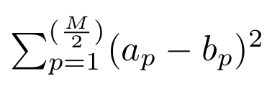
That is, the distance is simply the sum of distances between all constituent vectors. As these are all binary vectors possessing only a single non-zero element, if a_{p} = b_{p}, then distance( a_{p}, b_{p}) = 0. Otherwise, if a_{p} ≠ b_{p}, then distance( a_{p}, b_{p}) = 2.
Choosing the number of clusters

Results & Discussion
K-medioids has a greater likelihood than EM of generating validation data
To evaluate how well each clustering method captured the characteristics of its associated data, I computed for each dataset the likelihood of generating 500 validation trees from the average characteristics associated with clusters produced from a 2000-tree training set. K-medioids exhibited a much greater likelihood of generating these data than did EM (TB2)—in testing cluster numbers varying from K=1 to K=10 across all twelve datasets, yielding 120 comparisons between methods, EM generated a higher likelihood in only one case, when comparing K=2 for dataset 7f1ca. (Neither value corresponded to the highest method-specific likelihoods for this dataset, however—k-medioids preferred K=3, while EM preferred K=9, with the k-medioids likelihood still higher than EM's.) In the other 119 cases, k-medioids demonstrated log-likelihoods rendering its models vastly more likely to have generated the observed data than the corresponding EM models.
Notable is the discrepancy in the cluster sizes yielding the highest likelihoods between the two methods. For the twelve datasets, in only one case does EM select the same most-likely cluster size as k-medioids (TB2). In the other eleven cases, neither method exhibits a preference for larger or smaller cluster sizes—in five of the twelve datasets, EM selects a smaller cluster size than k-medioids, while in the remaining six, k-medioids selects the smaller cluster size.
BIC selects smaller clusters than predictive likelihood under EM
Bayesian information criterion (BIC) scores reflect likelihood of the observed data being generated under a given model, penalized by the model's complexity. Thus, selecting the model with the lowest BIC score should achieve a balance between a model's bias and variance. BIC scores for the EM method suggest that models composed of few clusters are best (TB3). This is in stark contrast to the predictive likelihood scores in the training/validation split datsets, which generally prefer larger clusters. Under EM, BIC never selects models composed of more than three clusters; the predictive likelihood method, conversely, never selects models with fewer than five clusters.
BIC's preference for fewer clusters likely arose from its penalty for model complexity. Given 500 mutations, each additional cluster requires adding 3*(500 choose 2) = 3.7e+5 parameters, to represent the probabilities that each pair of mutations corresponds to one of the four possible pairwise relationships for each pair of mutations. Thus, despite greater-complexity models yielding improved likelihoods, the imposed model-complexity cost is too great. These findings run contrary to what [NIPS '03]'s assertion that, in k-means, BIC does not sufficiently penalize unreasonably complex models. This may be because the large number of parameters required for each cluster imposes a severe complexity burden favouring simpler models. The predictive likelihood method, in comparison, suffers no such penalty—as the likelihood of a given tree being generated under the model is calculated as the sum, not the product, of the tree's likelihood under each cluster, the model is not punished for adding eccentric clusters primarily responsible for only a handful of outlying trees. Thus, the validation data set's generative probability tends to be maximized for larger numbers of clusters.
The smaller cluster counts chosen by BIC compared to predictive likelihood better match what we expect. PhyloWGS is unlikely to sample trees with sufficient structural diversity to promote the creation of five or more clusters; the one, two, or three clusters chosen via BIC, conversely, are more realistic for the problem domain. Thus, we conclude BIC is superior to predictive likelihood for selecting cluster counts.
EM produces clusters with greater homogeneity than k-medioids
K-medioids and EM can be compared for the same dataset by examining mean cluster quality. Cluster quality is determined for each cluster by dividing the number of trees associated with the cluster, by the number of unique tree structures (i.e., relationship between populations, ignoring the proportions and mutation assignments for each) observed within each cluster. The mean cluster quality for a given model, thus, represents the average number of trees per unique tree structure across all clusters. Consequently, the higher the mean cluster quality for a given model, the more homogeneity exists within the model's clusters.
EM, with cluster count for each dataset selected via predictive likelihood, demonstrated significantly higher mean cluster qualities than k-medioids, with only three of twelve datasets (7f1ca, 8d4cb, and d8f0b) possessing higher values under k-medioids than EM (TB4). The mean value across datasets for mean cluster quality is also significantly higher under EM, with the EM value of 112.6 nearly doubling k-medioids' 63.7. This discrepancy in homogeneity suggests EM's clusters possess greater internal consistency than k-medioids', implying EM models should be preferred. Notably, this finding is in opposition to the apparent k-medioids superiority that emerged from the predictive likelihood evaluation. When selecting EM's cluster count via BIC, higher-yet mean cluster qualities are obtained. All twelve datasets see higher mean cluster qualities when cluster count is chosen via BIC rather than predictive likelihood, with the mean across datasets increasing to 187.4, further improving upon predictive likelihood.
Also conspicuous is the substantial number of zero-member clusters under the EM models when choosing cluster number via predictive likelihood (TB4). K-medioids, by comparison, never used empty clusters. Under EM-using-predictive-likelihood, when the “soft” responsibilities of each cluster for each tree were converted to “hard” assignments by associating each tree with the cluster most responsible for it, many clusters possessed zero members. Consider dataset 81a8b, whose most-likely EM model used ten clusters, only two of which had trees for which the cluster was most responsible. Thus, we may infer the pairwise mutation relationship responsibilities associated with these empty clusters lent themselves to “composite” profiles, such that the empty clusters shared responsibility for numerous trees during E's step, without being sufficiently tailored to any one variety of tree to take primary responsibility for it. This finding is intuitive—to select each medioid, k-medioids used “hard” assignments of trees to medioids such that the sum of distances between medioids and their trees was minimized. These hard assignments ensured that, using the cluster number deemed most likely by the predictive likelihoods, every cluster would possess at least some members; empty clusters would needlessly penalize the validation data set's likelihood. EM, by contrast, would suffer no such penalty, since, unlike k-means, it inherently optimized for “soft” responsibilities. Using BIC instead of predictive likelihood to choose cluster number for EM largely corrected this issue—as discussed above, predictive likelihood suffered no penalty for introducing additional clusters into each dataset into which it could assign outliers, while BIC was penalized for greater model complexity in the same scenario, constraining its cluster count choices to more reasonable values.
K-medioids and EM yield equally good cluster consensuses
In addition to the cluster quality metric described previously, we can achieve another measure of a cluster's homogeneity by determining the highest proportion of trees within it that can be assigned to a single unique tree structure. We term this measure the top-tree fraction for a cluster. More homogeneous clusters will have a greater proportion of their trees derived from a single tree structure, meaning higher top-tree fractions correspond to greater homogeneity.
Similar to cluster quality, we can evaluate the overall homogeneity for a clustering model by computing the mean top-tree fraction for all the model's clusters. By this metric, both k-medioids and EM-using-predictive-likelihood are nearly equally good (TB4). Though individual datasets may differ substantially in mean top-tree fraction between EM and k-medioids, neither consistently does better than the other—for seven datasets, k-medioids' mean top-tree fraction is superior to EM's, while for the other five, EM ranks best. Computing this metric's mean across all datasets suggests the two methods are comparable, as the inter-dataset mean of mean top-tree fractions is 0.709 for k-medioids, and 0.713 for EM (TB4). Both methods improve upon the top-tree fraction observed in the unclustered trees for all datasets. On average, k-medioids realizes an increase of 8.5 percentage points in mean top-tree fraction relative to unclustered data, while EM achieves an increase of 8.9 percentage points.
When EM with K chosen BIC is also considered (TB4), the mean top-tree fraction averaged across datasets falls to 0.653. By using BIC's lower optimal cluster counts, we can infer the model increases the number of trees assigned to each cluster, in addition to the number of unique tree structures within each. This increase in unique tree structures per cluster is not offset by the additional number of trees, reducing homogeneity. Such a relationship is intuitive—fewer, larger clusters should exhibit less homogeneity than a greater number of smaller clusters better tailored to their constituent trees.
Alternative quality metrics yield different choices of cluster number
The cluster quality and top-tree fraction metrics introduced for comparing clusters between k-medioids and EM can be repurposed as alternative methods for choosing cluster counts. Previously, this was done via predictive likelihood, which selected the cluster count for each dataset most likely to concur with mutation relationships in the validation data, and via BIC, which balanced each model's likelihood against model complexity to choose an optimal cluster number. We can also, however, choose cluster number by computing mean cluster quality for each possible number of clusters (i.e., K=1,...,10). Using this method, we find

Future Work

Conclusion

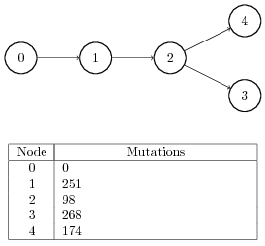

Figure 1: Example phylogenetic tree indicating subpopulation structure in a tumour, as well as the number of mutations associated with each subpopulation. Node 0 represents the somatic cells from which the tumour descended, meaning no tumour-specific mutations are associated with it. Node 1 represents the originating tumour cell population, meaning that all tumour cells share its mutations. From this subpopulation, three additional subpopulations descended.

TODO: replace with tree having both SNVs and CNVs.
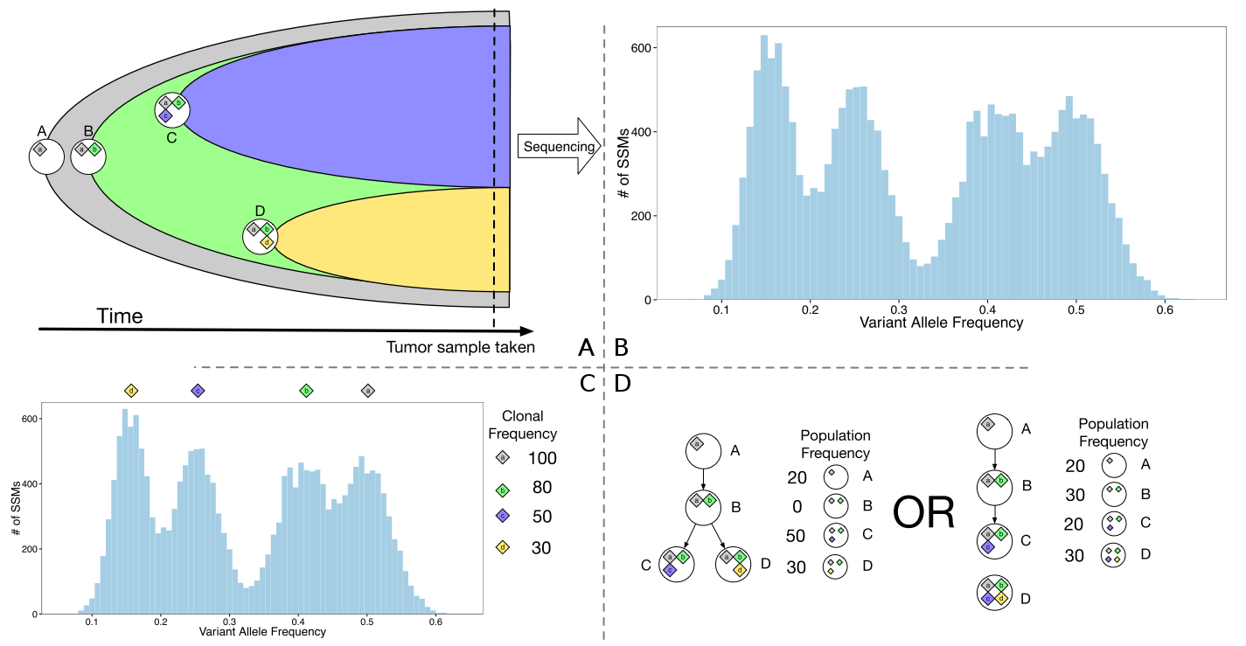

Figure 2: Adapted from (5). A. In a given tumour, subpopulations A, B, C, and D exist. The diamonds within each subpopulation's circle indicate sets of mutations associated with that subpopulation. Though only subpopulations C and D are extant when the sample is taken, ancestral subpopulations A and B can be inferred from variant allele frequencies. B. The observed distribution of allele frequencies for tumour-specific variants. C. Four distinct clusters of allele frequencies exist, representing alleles assumed to be present in varying combinations within the four subpopulations. Clonal frequencies are twice the observed variant allele frequencies, as each mutation is assumed to be heterozygous, with only one copy thus present in every cell. D. Two subpopulation structures are equally consistent with the observed variant allele frequencies. Though panel A reveals the branched structure to be correct, the linear structure is no less valid for the given allele frequencies. Each tree structure should correspond to approximately half the trees sampled from the distribution of possible trees.
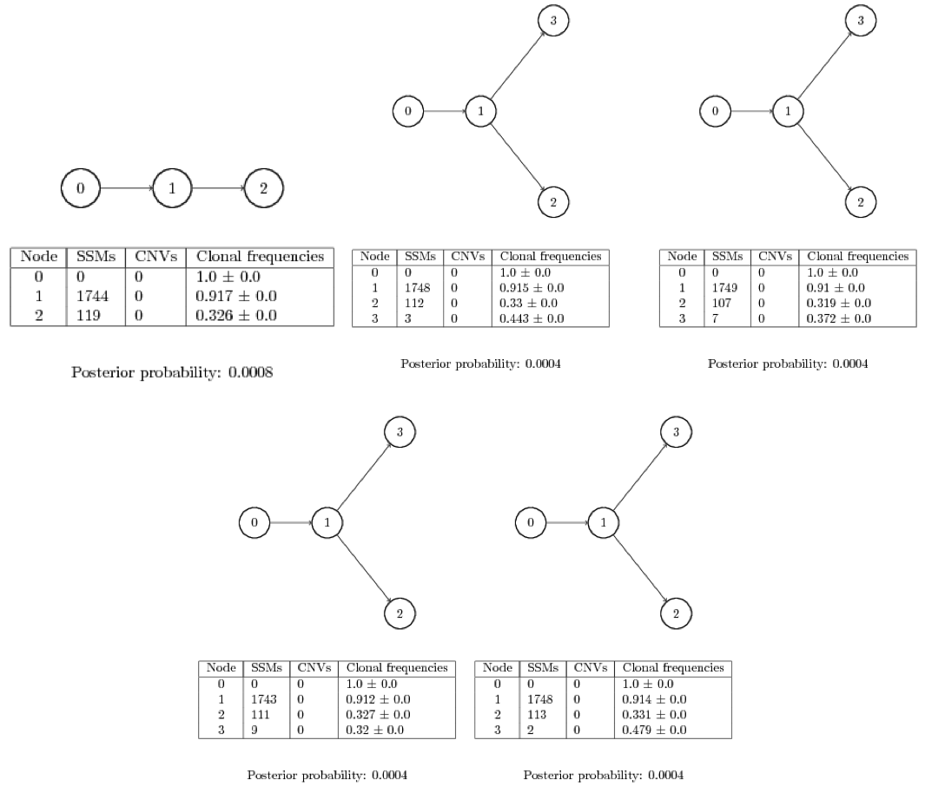

Figure 3: Five distinct phylogenetic trees produced for an example sarcoma. Though four of the five possess trees with the same four-node branching structure, these differ from one another in the population frequencies inferred for each node, as well as exactly which mutations have been assigned to individual populations.

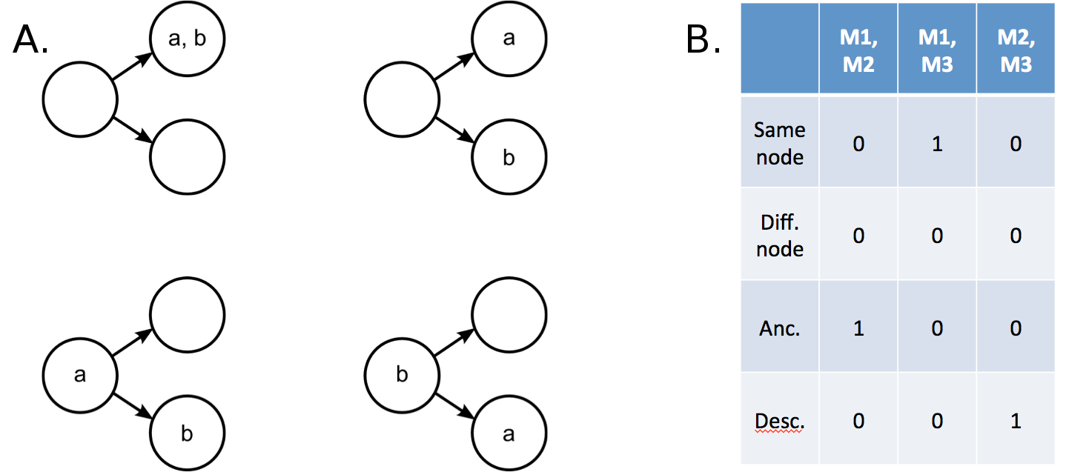
Figure 4: Trees can be characterized by the relationships between mutations. A. Given mutations a and b, four pairwise relations are possible. Mutations a and b can be in the same population (top left); they can be in entirely different tree branches (top right); a can be an ancestor of b (bottom left); or b can be an ancestor of a (bottom right). B. A tree comprised of multiple populations, each of which has hundreds or thousands of mutations associated with it, can be represented as a 4x(n choose 2) matrix listing all pairwise mutation relationships, given n total mutations. Each column is a four-element binary vector indicating which relation holds for the given mutation pair. In this example, there are three total mutations in the phylogenetic tree, but with a real dataset there would be thousands.

Table TB1: Mutations per sample.

Table TB2: Log-likelihoods of generating the validation datasets from the training clustering model for both k-medioids and EM. The highest likelihood value is rendered in boldface for each sample.

Table TB3: Bayesian information criterion (BIC) scores for each training dataset under expectation-maximization clustering. The lowest (best) BIC score is rendered in boldface for each sample.
K-medioids

EM, Most likely K chosen via predictive likelihood

EM, Most likely K chosen via BIC

Table TB4: Comparison of cluster quality metrics across k-medioids and EM.
- Most likely K corresponds to the cluster number with the highest likelihood of generating the validation data (TB2). All additional values are calculated for the cluster number corresponding to most likely K for each method and dataset.
- Empty clusters indicates the number of clusters possessing no trees.
- Mean cluster quality corresponds to the mean quality value, where the quality value is calculated for each cluster as the number of trees assigned to the cluster, divided by the number of unique tree structures observed amongst those trees.
- Top tree fraction is the mean of the top-tree value for each cluster, with the top-tree value determined for each cluster as the greatest proportion of trees represented by a single unique tree structure .
- Unclustered top tree is the top-tree value for the unclustered data—i.e., the greatest proportion of all trees within the dataset represented by a single tree structure.
- Improvement is the difference between Top tree fraction and Unclustered top tree.
Preferred K values for trees clustered via k-medioids

Preferred K values for trees clustered via EM

Table TB5: The choice of K differs depending on which metric is employed.

