CSCI 562: Formal Specification Methods - § 31370 - Sp26
Team Project Progress Report I (PDF format as per instructions prompt)

Due: 03-01-2026

Scott Johnson Thomas Perez
s.j.johnson@und.edu thomas.perez@ndus.edu

Introduction

Our team is writing formal specifications for the HomeSafe system, an automatic landing system for Dahler aircraft. The system, after being invoked by a passenger, will automatically land the aircraft safely in the event of pilot incapacity. We are basing our system off of a design, assuming it would be installed in a TBM-980 aircraft. This aircraft will be the basis for resolution of any conflicts in installation criteria (see assumptions, below).

Current Progress and Issues
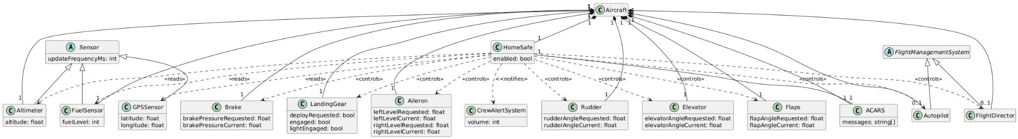
Included above is a requirements-level class diagram for the HomeSafe system.
We have not encountered any major issues at this point. The issues we did encounter are actually nuances within the Mermaid UML tool, and they are fairly easily solvable. For example, one issue is the usage of comments in the Mm (Mermaid) code. It appears as though the implementation is inconsistent, including from project to project.
Another issue is obtaining an official Pilot Flight Manual and Pilot Checklist. Technical documents, especially, are not possible for download or physical delivery for us at this point, apparently, because of copyright considerations and high cost.
Assumptions:
• The Pilot Operating Handbook is extremely expensive. Having taught in HP (high-performance) aircraft in my past, I can assume certain conditions to be true regarding flight, emergency procedures, minimum FAA requirements for VFR and IFR flight, including part 121 and part 135 regulations, ATP certifications requirements, and more. Because of our inability to obtain this document, we will have to make some assumptions as time goes on with the likely outcome that our specification will be simpler than a fully operational system.
- We assume the HomeSafe system will be equipped in a TBM 900 series, viz. a TBM-980.
- We assume that the TBM-980 is equipped with all optional equipment and upgrades, including:
  - Flight Management System (FMS)
  - Autopilot
  - Flight Director (FD)
  - Airborne Flight Control System (AFCS)
  - Full Authority Digital Engine Controller (FADEC)
  - Autothrottle (AT)
  - Ground Warning Proximity System (GPWS)
  - Radar Altimeter (RA)
Goals for Next Reporting Period (3/22/26):
- Complete up to Zed Notation implementation, (including consideration of the following factors:)
  - Pinpoint errors in ongoing progress
  - Continually make improvements on ongoing progress
  - Check for accuracy, as well as check for logical and sound thinking
  - Continually search for verified FAA-approved sources of information and adjust specification according to new information found
- Learn Zed Notation and/or OCL
- Read relevant chapters in our textbook - "Concise Guide to Formal Methods".

