I found my dataset using Kaggle.com. It is a dataset tracking different factors that might influence student performance. I found it interesting because I am a student and I’m interested in efficiency and health, which can both be found in this dataset.

I started by cleaning my dataset in excel to make sure everything was formatted correctly, standardized and that there were no missing values.

I then wanted to start simple and verify a few things I had previously assumed. I used PowerBI to visualize differences in test scores between two genders. The difference was nominal, with boys’ average test score being 0.02 better than girls. I found similar results with average attendance.

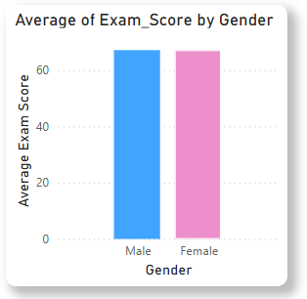

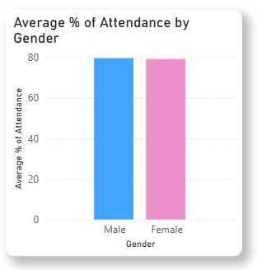

I also visualized the count of extracurricular activities by gender. Here, I found a significant difference between girls and boys. Boys tended to have more extracurricular activities than girls did. I can’t verify this, but my guess is that sports are traditionally more popular with boys and that is why boys have a lot more extracurriculars. I also looked at if doing extracurricular activities had an effect on exam scores.

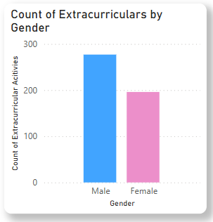

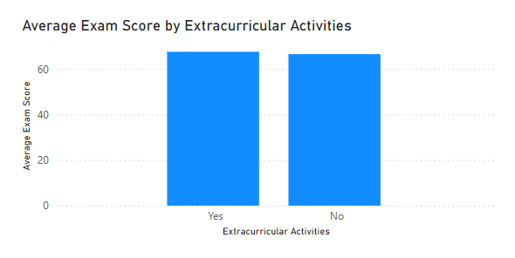

I am generally fascinated by sleep and the effects of sleep, so the next thing I chose to do was create a line graph showing the correlation between average exam scores and hours of sleep. As you can see, the best average performance on tests came from people with about 4 hours of sleep. This didn’t make a ton of sense to me because sleep has huge effects on cognition.

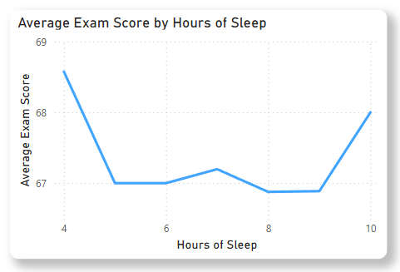

I wanted to investigate further and was curious if people chose to study more instead of sleeping and that’s how they got higher average test scores, so I created a similar visualization. There wasn’t much of an increase in hours of study when it came to the people who had an average of 4 hours of sleep.

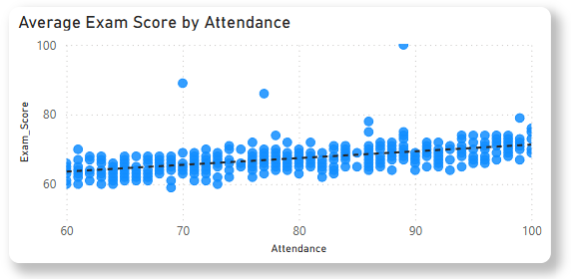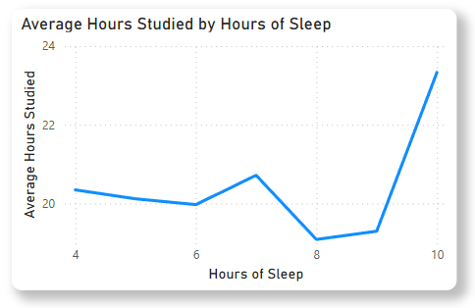

I then wanted to visualize what factors positively influenced exam scores the most, so I tested tutoring sessions, attendance, physical activity, and teacher quality.

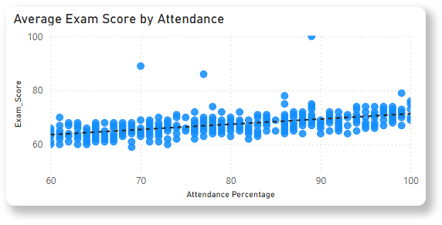

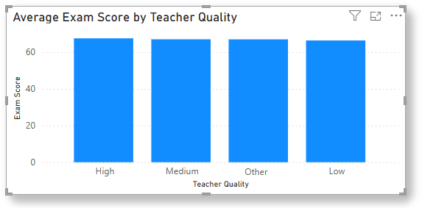

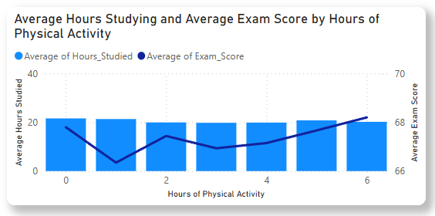

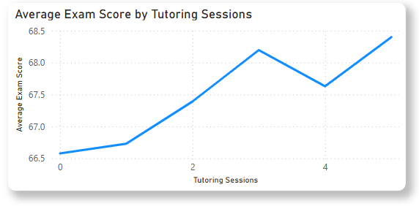

Each of these visualizations provided interesting insights into student performance. First off, attendance had a weak positive correlation with exam scores. I thought it would have a stronger effect. Second, I looked at teacher quality since I believed that the ability of a teacher to teach students was crucial to performance on exams and tests. To some degree this was too, but for the most part teacher quality didn’t matter. Third, I wanted to see if the average number of hours studied influenced hours of physical activity and compare both of those with exam scores. Even if students spent more time doing physical activity, the amount of time they spent studying remained consistent. Both seemed to be effective at producing better exam scores. Finally, I looked at how tutoring sessions affected exam scores, and this seemed to be the most effective method of improving exam scores for students.

Altogether, if a student wanted to maximize performance on tests and exams, they should receive tutoring, try to get at least 10 hours of sleep, and attend class extremely consistently. All of these are very basic pieces of advice, so some more traditional things that you might stay away from because they are less effective would-be things like being super selective about teacher quality or avoiding extracurricular activities. This allows students to work toward their goals in the most efficient way possible.