SUPPLEMENT 1

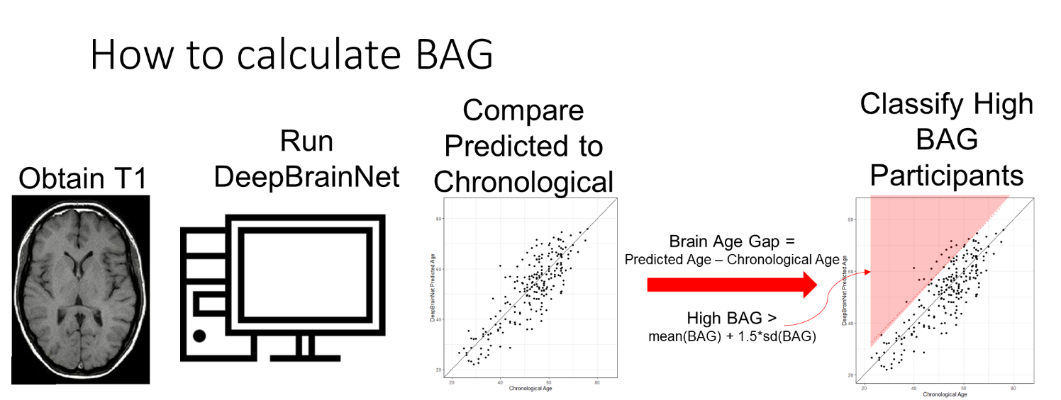

Supplemental Figure 1. Brain Age Gap (BAG) is calculated by comparing the output of the DeepBrainNet algorithm8 to an individual’s chronological age. Individuals classified as having a high BAG have a BAG, based on a T1 scan that is at least 1.5 standard deviations above the mean. This represents approximately 20% of a normally distributed cohort of BAGs.

Supplemental Table 1. We re-analyzed the data using a cohort that was more closely matched, demographically to Saint Louis City. By reducing the cohort to 182 individuals, we were able to achieve a group that was matched on race, sex and education. This reduced cohort was still slightly older than the population of St. Louis City.

|  |  |  |  |
| --- | --- | --- | --- |
|  | **St. Louis City Residents aged 20+** | **Reduced Cohort** | **p** |
| N | 241113 | 182 |  |
| Age | 47.2 (16.6) | 51.9 (12.3) | < 0.001 |
| Sex |  |  | 1.00 |
| Female | 114994 (47.7%) | 87 (47.8%) |  |
| Male | 126119 (52.3%) | 95 (52.2%) |  |
| Race |  |  | 0.368 |
| Black | 103497 (42.9%) | 90 (49.5%) |  |
| White | 122229 (50.7%) | 92 (50.5%) |  |
| Education |  |  | 0.347 |
| Less than High School | 26828 (8.7%) | 27 (14.8%) |  |
| High School | 52444 (17.0%) | 45 (24.7%) |  |
| Some College | 60331 (19.6%) | 40 (22.0%) |  |
| BS or Higher | 79669 (25.9%) | 70 (38.5%) |  |

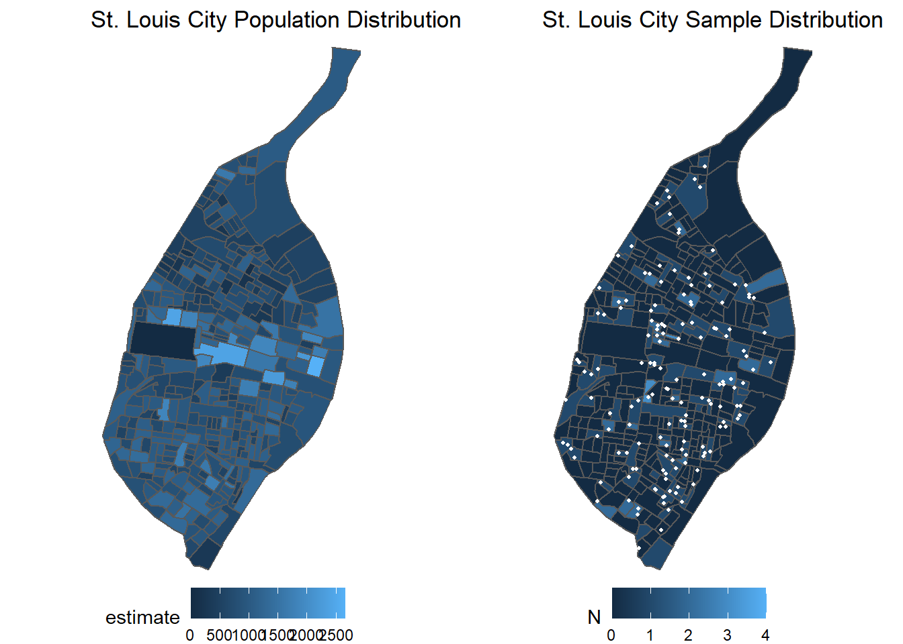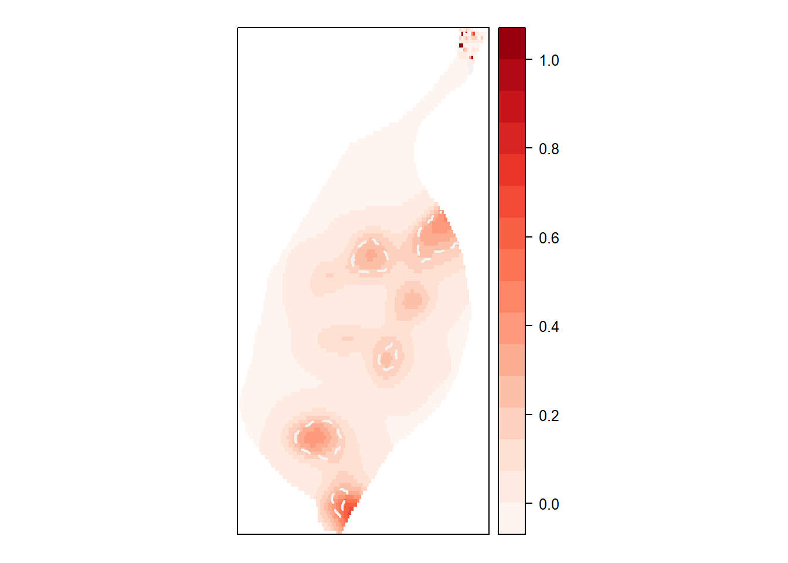

Supplemental Figure 2. The spatial distribution of the smaller cohort (described in Supplemental Table 2) is similar to the original larger cohort (A). The kernel smoothing analysis identified the same three regions from the full cohort and two additional regions where individuals were more likely to have a higher BAG (B).

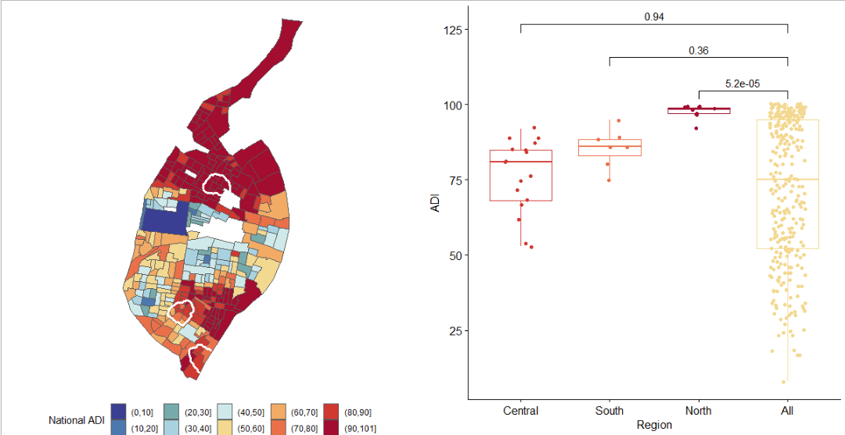

Supplemental Figure 3. (A) The Area Deprivation Index (ADI) was developed to quantify socioeconomic disadvantage at the census block level3. These scores aggregate multiple domains including income, education, employment and housing quality. Areas of high ADI indicate greater levels of deprivation. (B) When compared to the neighborhoods identified as having significantly increased BAG, we observe that the region identified in North St. Louis overlaps with tracts of the very highest ADI, and has significantly higher ADI than the overall city of St. Louis. The two southern regions that associate with increased BAG do not have significantly higher ADI, suggesting further research is required to identify the drivers behind elevated BAG in these regions.