SUPPLEMENT 1

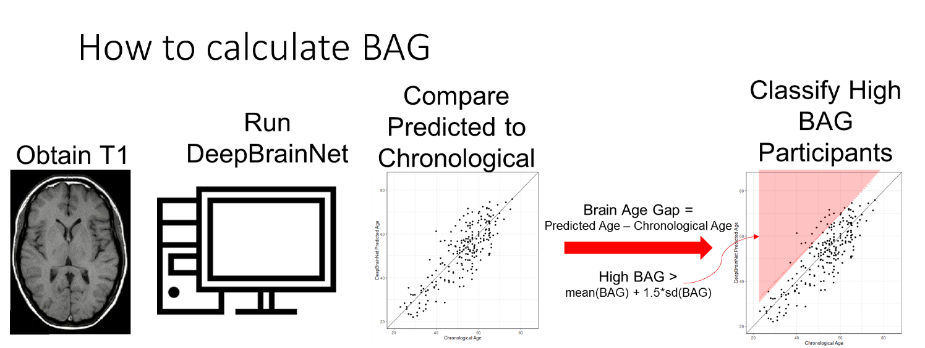

Supplemental Figure 1. Brain Age Gap (BAG) is calculated by comparing the output of the DeepBrainNet algorithm8 to an individual’s chronological age. Individuals classified as having a high BAG have a BAG, based on T1 scan, that is at least 1.5 standard deviations above the mean. This represents approximately 20% of a normally distributed cohort of BAGs.

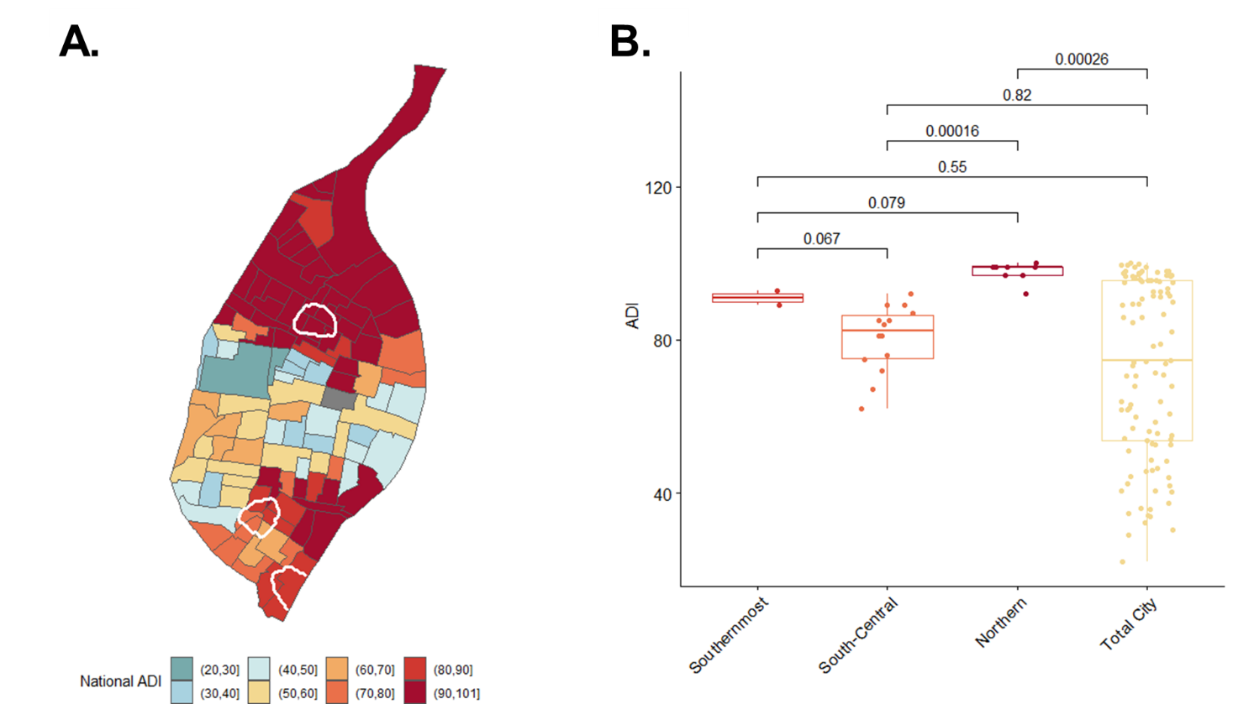

Supplemental Figure 2. (A) The Area Deprivation Index (ADI) was developed to quantify socioeconomic disadvantage at the census block level3. These scores aggregate multiple domains including income, education, employment and housing quality. Areas of high ADI indicate greater levels of deprivation. (B) When compared to the neighborhoods identified as having significantly increased BAG, we observe that the region identified in North St. Louis overlaps with tracts of the very highest ADI, and has significantly higher ADI than the overall city of St. Louis. The two southern regions that associate with increased BAG do not have significantly higher ADI, suggesting further research is required to identify the drivers behind elevated BAG in these regions.