SUPPLEMENTAL MATERIALS

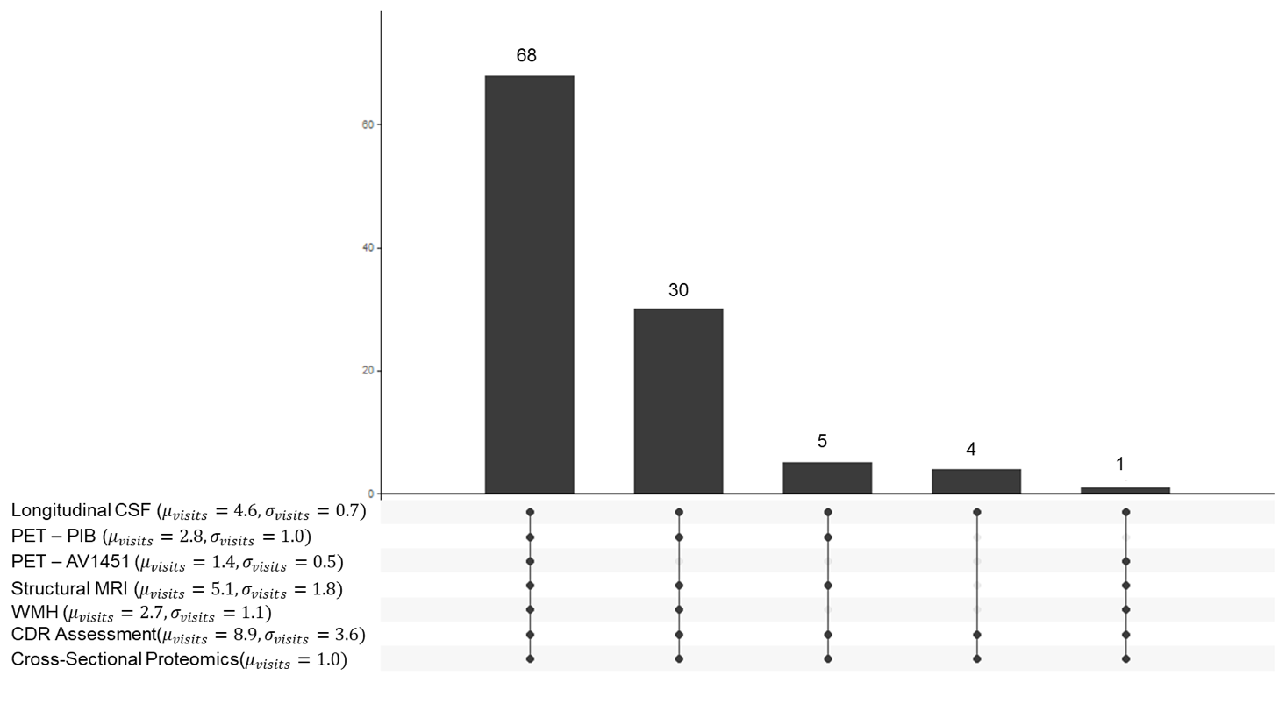

Supplemental Figure 1. Most (N = 68) participants provided all biomarkers and cognitive measures considered in this manuscript. The most frequent missing biomarker was PET – Tau (N = 39). For all measures considered except proteomics, longitudinal data was included where available. The mean number of visits is included in the image.

Supplemental Table 1. A comparison of modeling classification AUCs for different model formulations. All reported AUCs are derived from model performance on a hold out set.

|  |  |  |  |
| --- | --- | --- | --- |
| **Model Inputs** | **Proteomics Only** | **Proteomics + Age + Sex** | **Age and Sex Only** |
| **Algorithm** | *Pelora* | *Pelora* | *Lasso* |
| **Classification** |  |  |  |
| AD Biomarker Positive vs Intermediate AD Biomarkers | 0.525  (0.146, 0.903) | 0.625  (0.179, 1.00) | 0.725  (0.364, 1.00) |
| AD Biomarker Positive vs AD Biomarker Negative | 0.857  (0.729, 0.986) | 0.811  (0.669, 0.954) | 0.754  (0.594, 0.913) |
| Intermediate AD Biomarkers vs AD Biomarker Negative | 0.952  (0.850, 1.00) | 0.865  (0.640, 1.00) | 0.625  (0.253, 0.997) |

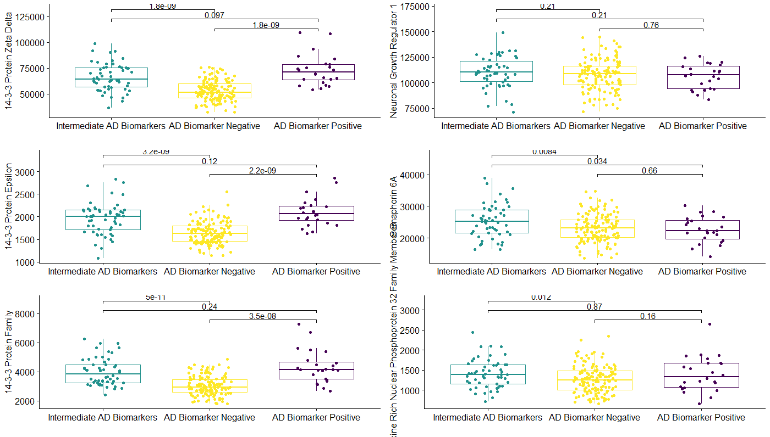

Supplemental Figure 2. Quantification of protein expression for proteins associated with neurodegeneration. Presented p values are the result of a Wilcoxon test and are not corrected for multiple comparisons.

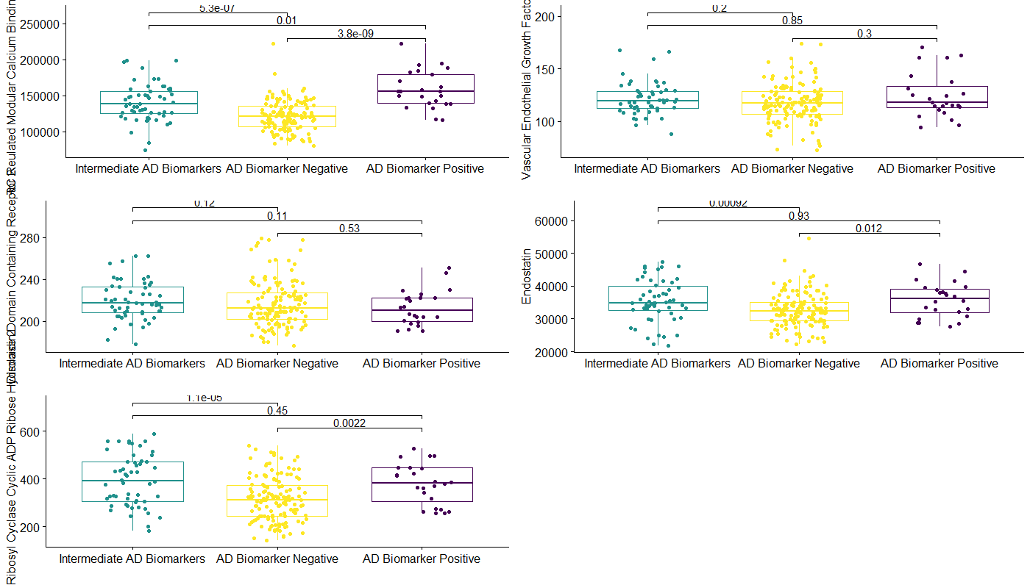

Supplemental Figure 3. Quantification of protein expression for proteins associated with BBB/vascular function. Presented p values are the result of a Wilcoxon test and are not corrected for multiple comparisons.

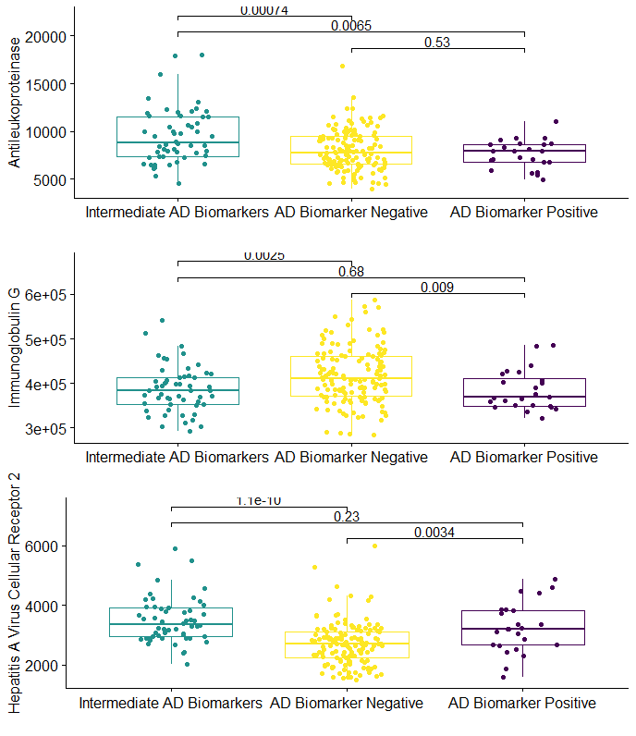

Supplemental Figure 4. Quantification of protein expression for proteins associated with immune function. Presented p values are the result of a Wilcoxon test and are not corrected for multiple comparisons.

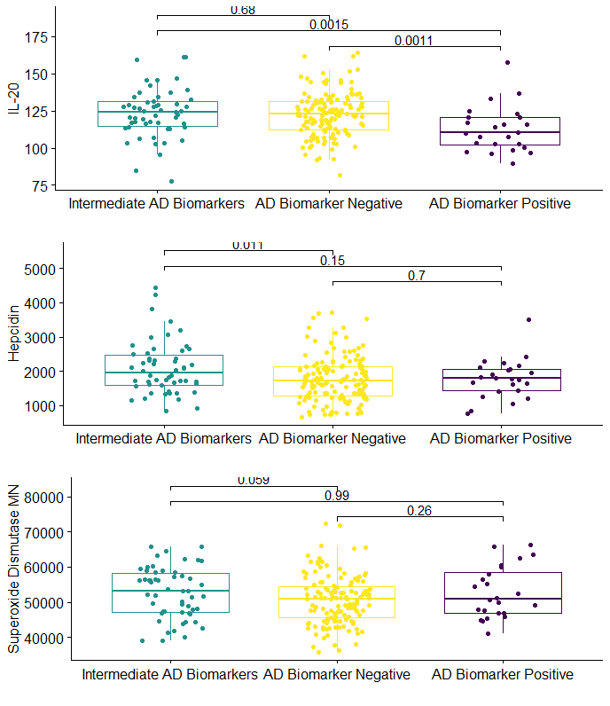

Supplemental Figure 4. Quantification of protein expression for proteins not otherwise classified. Presented p values are the result of a Wilcoxon test and are not corrected for multiple comparisons.

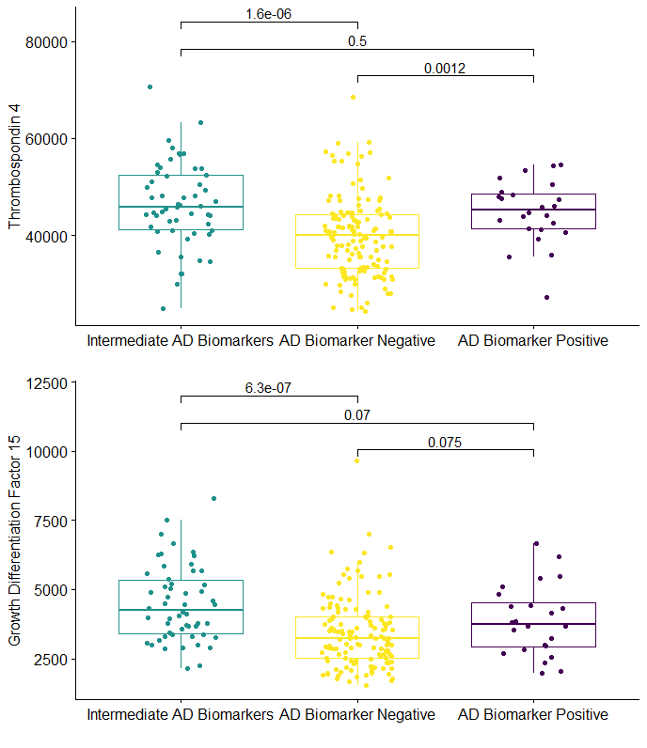

Supplemental Figure 5. Quantification of protein expression for proteins associated with inflammation. Presented p values are the result of a Wilcoxon test and are not corrected for multiple comparisons.

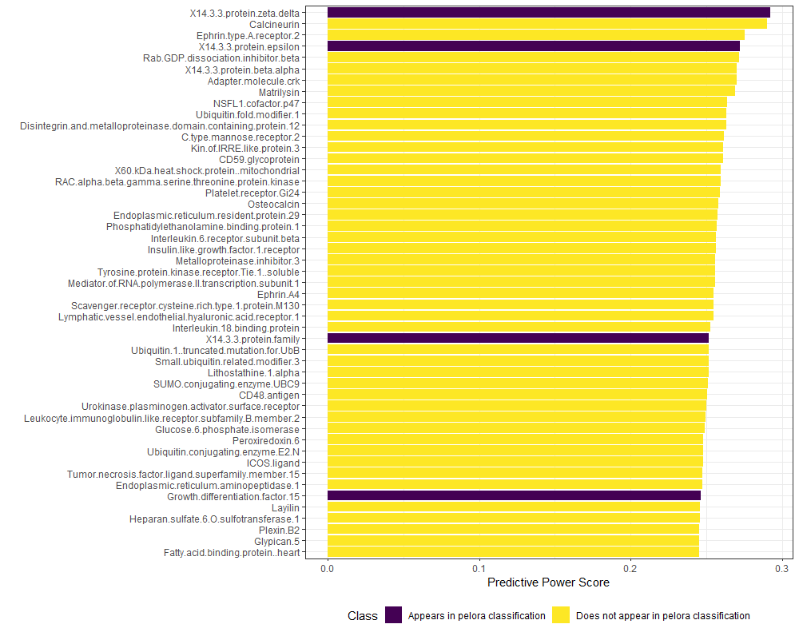

Supplemental Figure 6. The individual predictive power score (PPS) of proteins for classifying individuals for group membership is shown above. PPS is a value that ranges between 0 and 1. 14-3-3 protein values and Growth Differentiation Factor 15 were also identified by the pelora-based classification scheme. This indicates that these individual proteins are strongly tied to group membership, rather than being important by virtue of their interactions with other proteins. Only proteins with a PPS > 0.25 are shown.

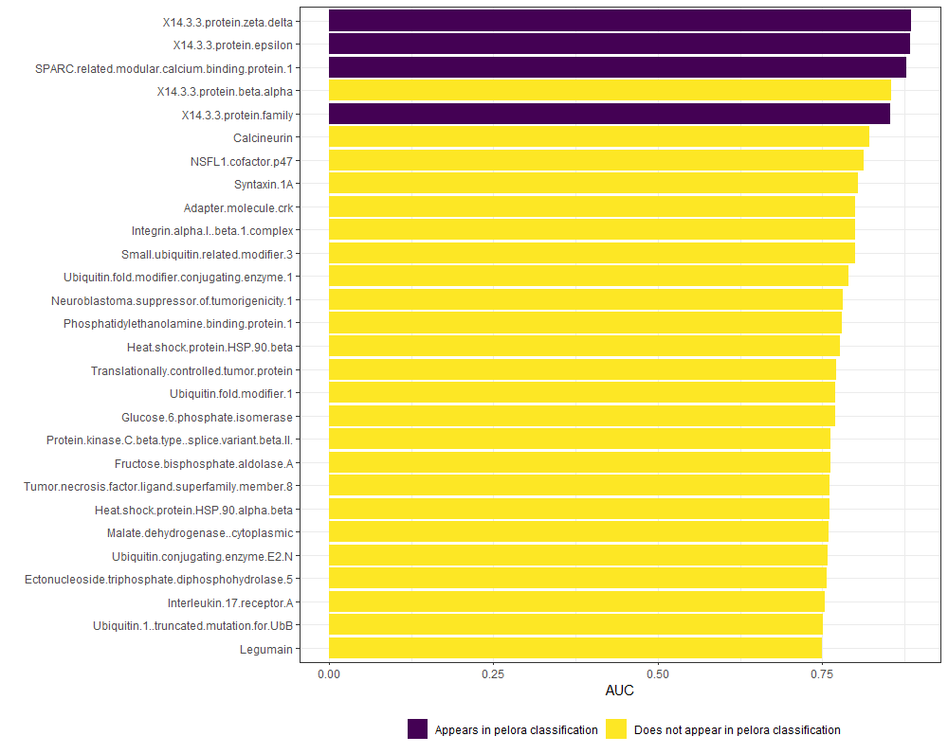

Supplemental Figure 7. All proteins with an individual AUC of greater than 0.75 when classifying individuals as belonging to either the AD Biomarker or AD Biomarker Negative cohort. Recall that the AD Biomarker vs. AD Biomarker Negative classification AUC was 0.857. This means that the combination of proteins identified as useful for classification (including proteins from the 14-3-3 family and SPARC) was more powerful than any individual protein for classification.

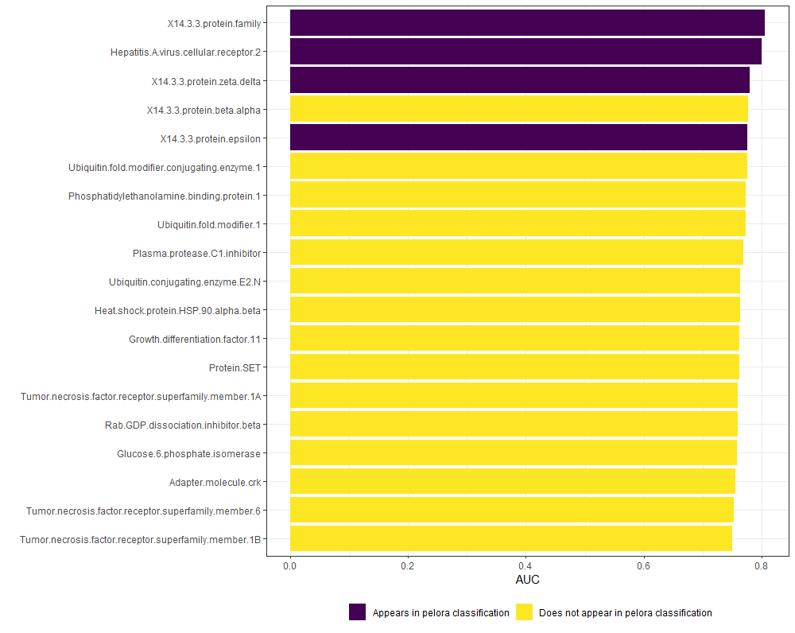

Supplemental Figure 8. All proteins with an individual AUC of greater than 0.75 when classifying individuals as belonging to either the Intermediate AD Biomarkers or AD Biomarker Negative cohort. Recall that the Intermediate Biomarker vs. AD Biomarker Negative classification AUC was 0.952.

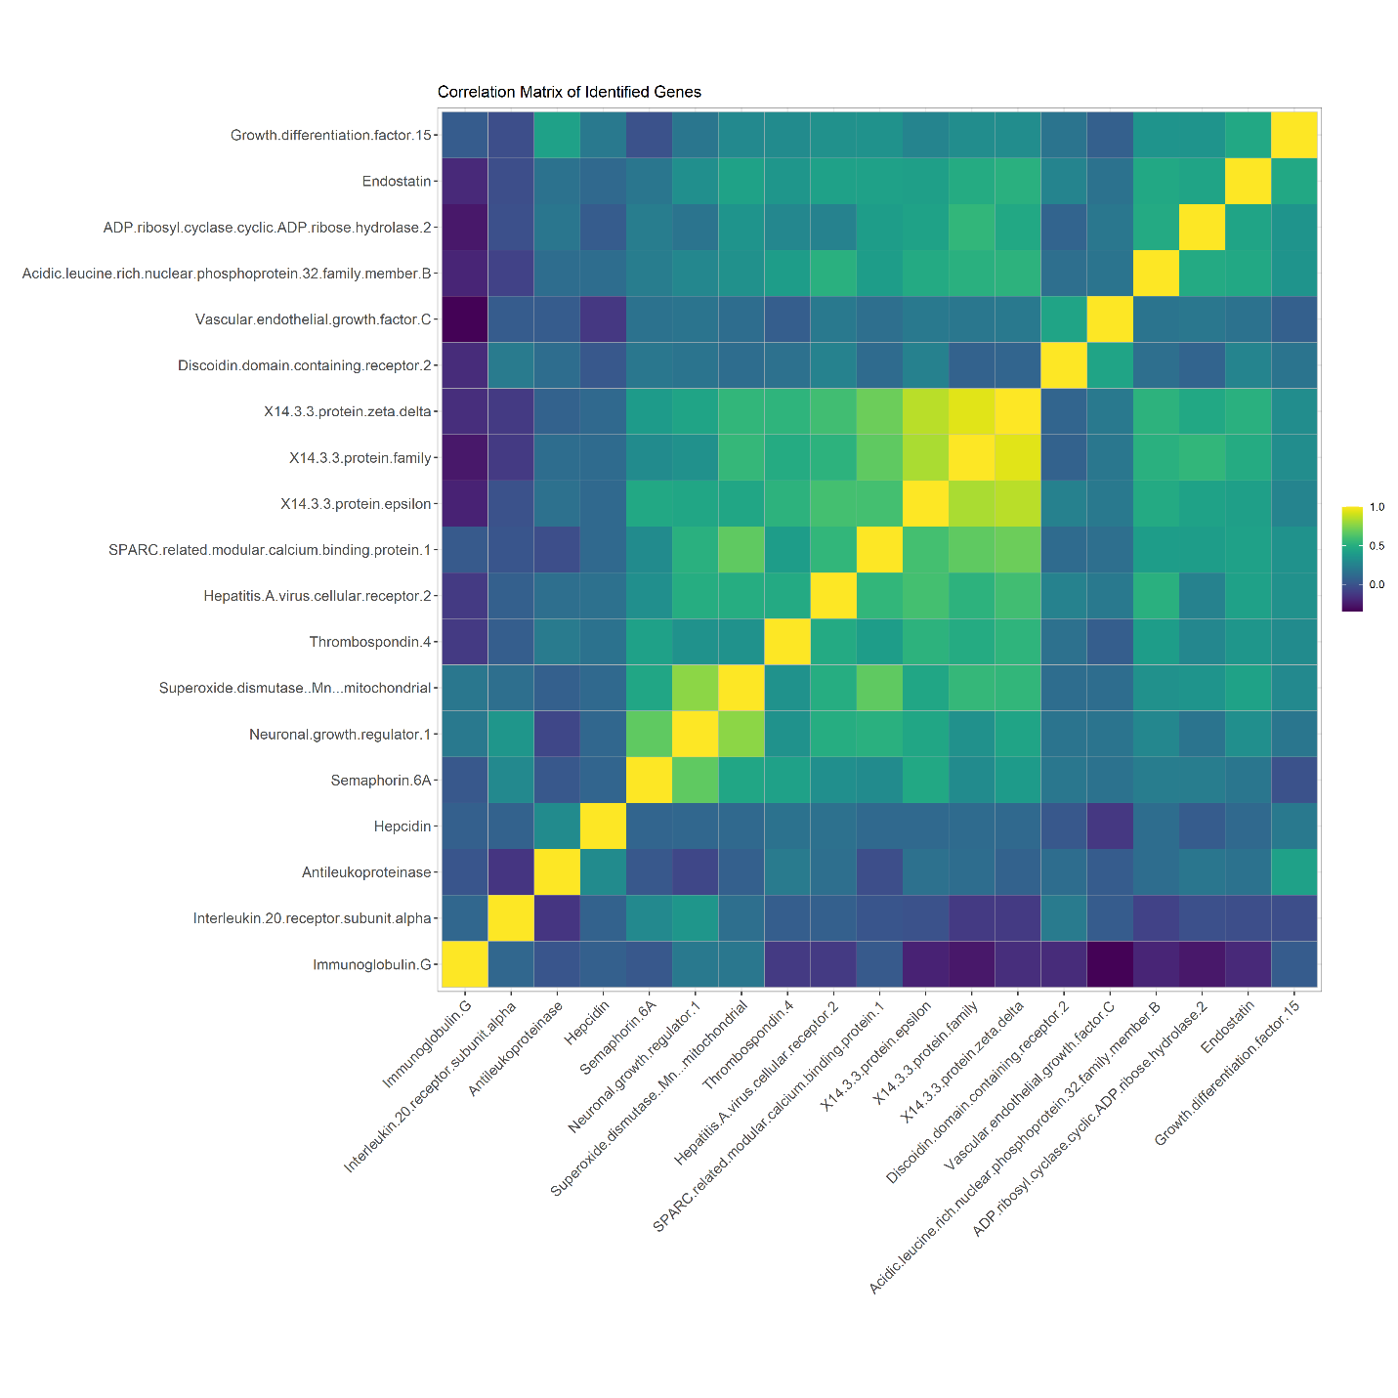

Supplemental Figure 9. Spearman correlations between all proteins identified by Pelora as important for the AD Biomarker Positive –AD Biomarker Negative and Intermediate AD Biomarkers – AD Biomarker Negative classifications.