Solar Panel and Roof semantic segmentation report
Jing Wang

1. Dataset exploration and cleaning
Quickly browse the dataset. All images are in .jpg format. All masks are in .npz format. There are many images without the panel and roof classes, and some are empty or noisy.

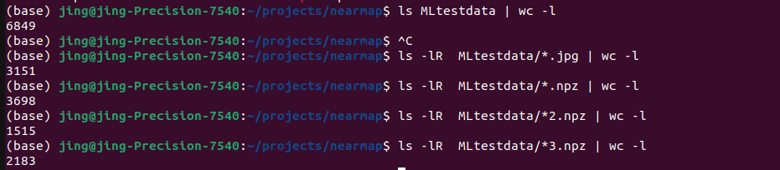
There are 6849 files in total. 3151 jpg images, 3698 numpy masks.
Resize all images to 896*896*3
Remove images without mask file. Remove images with no foreground labels.

Check number of roof, no roof, no label, and number of solar, no solar, no label.
The majority are no labels points. For class with labels, the negative samples are much more than positive samples. (need weight balance)The number of roof / noroof labels is different from the number of solar / nosolar labels (need weight balance)

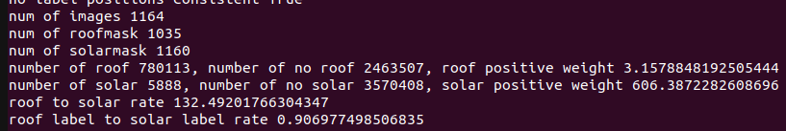
Since roof and solar are independent. Use two independent binary classifier.
Since majority are no label. The loss is not calculated on no label locations, by masking them in the loss function.

For masks,
Convert all >=1 to 1 for BCE loss.

Split train / test
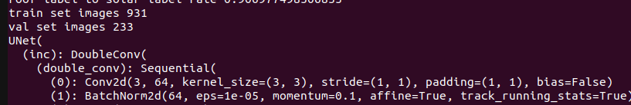

2. Model selection

Use a simple Unet to train it.

The loss function needs to be designed:
1. all no label locations are to be excluded from loss calculation and gradient backprop

2. The output of the network has two channel of 896*896, each has an independent BCE loss, and the two loss are weighted.

3. positive and negative are very imblanced. This is solved by positive weight in BCElosswithLogits.

Experimental training:
Final accuracy: roof 85.99%, solar 79.94%
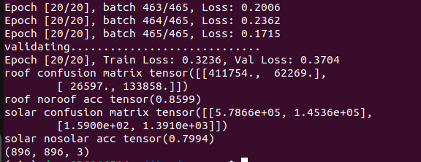

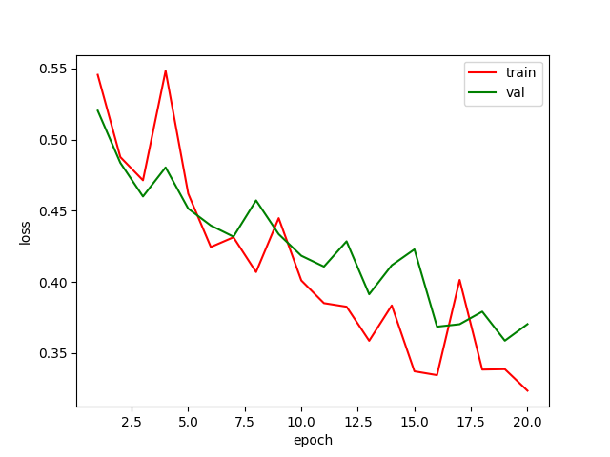
Improvements:
My memory only allow batch_size = 2, which is not good, The BN layer require larger batch size. And the optimisation tends to be more up and down.
More hyper-parameter tuning needs to be done. Lr, weight_decay, scheduler. Optimizer.This training is no converge, needs train longer.
More data augmentation can be done, such as rotate and scaling
Advanced network architecture can be tried, such as deeplab and Segformer. Dilated convolution, Muliscale.
Can use pretained network backbone as a feature extractor.
Negative samples are too much, could consider sampling
More data can improve performance
For data annotation, can use SAM to convert point to masks.

