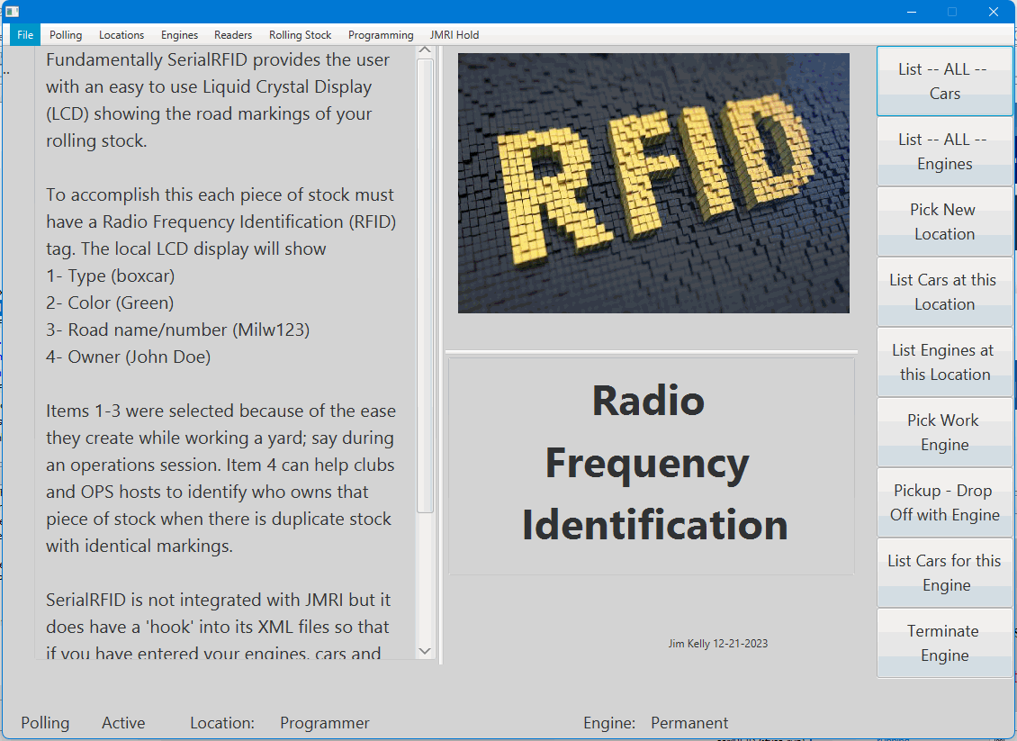

SST Computers

SerialRFID

Radio Frequency Identification

For Model Trains

User’s Manual

Version 1.0

Document Identifier: |  |  |  | ## 200-001
Issue1 | Date | Author | Checked |  |  | Approved
0 | 26 Mar. 07 | Jim Kelly
DCD Date

CHANGE HISTORY

Issue | Date of Issue | CR/DR Numbers | No. of Pages | Pages Changed and  Reasons for Change
0 | 3 Apr 07 |  |  | Initial draft for revision 1.0
1 | 5 Jun 07 |  |  | Section 11 – Changed text to reflect the new “My Club” link on the main menu.

Distribution List

Copy | Registered Holder
Master
Copy 1 | .

© Copyright 2007. SST Computers. All Rights Reserved.

While every effort has been made to ensure the accuracy of this document SST Computers assumes no responsibility for omissions and errors. Neither is any liability assumed for damages resulting from the use of information contained herein.

SST Computers reserves the right to revise any information contained in this document without prior notice.

Questions or comment regarding this document or the product to which it relates should be directed to:

SST Computers
3071 Hazy Park Dr.
Houston Texas 77082

CONTENTS

1. program overview 6
2. what is a Server? 6
3. what is a client? 6
3.1. browser settings 6
4. User levels 7
4.1. Guest Account 7
4.2. Registered Users 7
4.3. club member 7
4.4. Moderators 7
5. menu overview 8
5.1. opening menu 8
5.2. club recipe menu 9
5.3. moderator – administrator menu 10
5.4. home menu 10
6. registration / user profiles 10
6.1. User Registration Information 11
6.2. User Profile Information 11
7. log-in 13
8. clubs 14
8.1. who may start a club? 15
8.2. who may join a club? 16
8.3. other links associated with clubs 17
9. Recipes 17
9.1. May I add new categories? 17
9.2. printing recipes 17
9.3. adding new recipes 18
9.4. editing recipes 20
9.5. deleting recipes 20
10. help screens / faq list 20
11. formatting my input 20
11.1. What is a HTML tag? 21
12. Moderator accounts 22
13. administrator account 23
14. Terms and agreement for use 23

FIGURES

Figure 4-1 User levels 8
Figure 5-1 user menu 1 8
Figure 5-2 user menu 2 9
Figure 5-3 recipe menu 9
Figure 5-4 moderator menu 10
Figure 5-5 home menu 10
Figure 6-1 registration – profile 12
Figure 6-2 profile editor 13
Figure 7-1 log-in 14
Figure 7-2 log-in welcome 14
Figure 8-1 sample club introduction 15
Figure 8-2 start a club 15
Figure 8-3 join a club 16
Figure 8-4 drop a club 16
Figure 9-1 add / edit recipes step 1 18
Figure 9-2 add / edit recipes step 2 19
Figure 9-3 add / edit recipes step 3 20

program overview
Lydia’s Kitchen is a simple web based Client / Server recipe program and is intended for general use. The original release will not support unit conversions. The main feature of the program is to capture anecdotal histories of each recipe adding to the appeal of recording them.

what is a Server?
A server is usually a remotely located computer that runs programs that allow multiple users to access them. They are often referred to as “data providers”; in our case the server provides the recipes you want to use and/or share. The secret here is to understand that the magic address LYDIAS-KITCHEN.COM connects your computer to the server where all the recipe data is stored.

what is a client?
A client is considered to be a “data consumer” or in simple terms someone who connects to a server to use the program. Since Lydia’s Kitchen is a web based program you will connect to the server using a web browser. Popular browsers include Internet Explorer and Netscape. Browsers are standardized general purpose client programs. This means you don’t need to load any software to use Lydia’s Kitchen.

browser settings
There are a handful of browser settings that you can check to improve your user experience. Lydia’s Kitchen requires some specific browser settings before it will run.

Screen resolution and color quality
All of Lydia’s Kitchen web pages have been developed using resolution setting of 1024 by 768 and colors defined as 32 bit. Current poles indicate that this resolution setting is the most popular (64%). The program will run on any setting but lower resolutions (like 800 by 600) will make the program too big for the screen requiring the browser to add window scroll bars. Higher resolutions (like 1280 by 1024) will make the program smaller and will not fill the entire screen.

JavaScript (scripting)
JavaScript is used for testing data entry on all forms and the browser must enable JavaScript operation. Lydia’s Kitchen will test for JavaScript settings at start-up and if this feature is not enabled will terminate the program. . A message will be provided to the user asking them to enable JavaScript and then start the program. A link is provided as part of this message that will take you to a site which has links to “how to enable JavaScripts” for most popular browsers.

Cookies
Cookies are used for tracking session information and must be enabled on the browser. Lydia’s Kitchen will test the cookie setting at start-up and if this feature is not enabled will terminate the program. A message will be provided to the user asking them to enable cookies and then start the program. A link is provided as part of this message that will take you to a site which has links to “how to enable cookies” for most popular browsers.

User levels
User levels, also referred to as log-in levels, are used to control privileges extended to each user. As soon as you connect to the server you are ready to use Lydia’s Kitchen no registration or payment options are necessary. Lydia’s Kitchen is a “free to use” program, SST Computers maintains the copyright of all programming. Copyright of the recipes themselves remains the property of the original author. Registration, though optional, has its benefits; please read the different log-in levels provided.

Guest Account
The guest account is the default user level when the program begins execution. A guest may view and print all recipes in the PUBLIC area. Guests may not enter clubs and may not create/edit recipes.

Registered Users
Registered users inherit all the features of a guest account plus:
    - Create/Edit recipes in the public area
    - Create a user profile
    - Join a maximum of four (4) clubs – The PUBLIC area does not count against club totals.
    - Request to start a club and become the moderator

club member
Registered users who elect to join a club:
    - Create/Edit recipes in the club area
    - Drop membership from a club

Moderators
Registered users who request to establish a club become Moderators. Moderator privileges include:
    - Configure club overview screen
    - Add / remove other registered users as members of that club
    - Edit / delete ALL recipes within the club.
    - Distribute a club news letter

From the user menu if you chose the What are user privileges link the following static screen is displayed. This is an informational screen only; meant to aid visitors who have not read this manual.

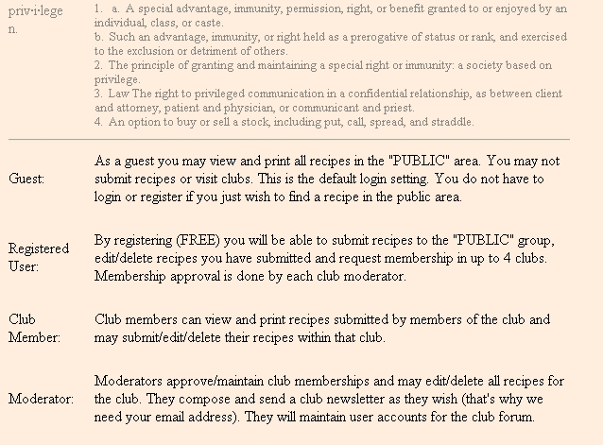
Figure 4-1 User levels

menu overview
There are four primary menus, two of which are used by everyone and a third is dedicated to moderators and the administrator. If you are not a moderator then you will never see the link for the third menu. The forth menu is the dedicated HOME link at the bottom left of the screen.

opening menu
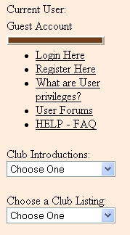
Figure 5-1 user menu 1
There are two slightly different versions of the opening menu, which one you see depends on your registration status. When the program opens it must be prepared to accept both guests and registered users. If you are a registered user then you are interested in the Login Here link. If you are not a registered user the menu will show you as a guest account and the link for Register Here will be visible to you. Please continue reading below for an explanation of all the common features.

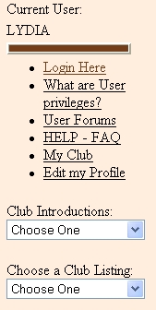
Figure 5-2 user menu 2
As a a registered user once you login your user name will be displayed and the register here link is removed. Now you will see an Edit my Profile link and if you are a club moderator you will see the My Club link too.
Regardless if you are a Guest or a registered user you will always see two drop down list boxes.
The “Club Introductions” list will show you all the clubs available for members to join. Clicking on a club title will open that club’s introduction page. If you wish to join that club at the bottom of the introduction page will be a Join This Club link. (details to follow)
The “Choose a Club” list is filled with all the clubs for which you are an approved member. Guest users will only see the Public Area listed. Clicking a club title will open the second user menu.

club recipe menu
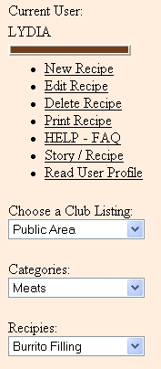
Figure 5-3 recipe menu
As mentioned in the opening menu section clicking on the “Choose a Club” link brings up the selected club’s recipes. As a Guest you will not see the New Recipe, Edit Recipe, Delete Recipe links. Registered users will always see the new recipe link as you are an approved club member. The edit recipe and delete recipe links will appear and disappear as you select different recipes. These links are only available to you if you submitted the recipe to the club (Moderators will always see these links).
The Print Recipe link is available to everyone; this link will “dump” the recipe to your printer. There are no print format options available. The print feature is meant to provide you a working “counter top” copy for cooking and shopping and not as a formatted binder copy.
The Help – FAQ link is a short list of commonly asked questions with short answers: think of it as a quick reminder or reviews, for detailed explanations refer back to this manual.
The Story / Recipe link is a toggle operation allowing you to switch between the author’s anecdotal story and the recipe.
The Read User Profile link allows you to read about the author; get to know them and their interests better.
The “Choose a Club” list is filled with all the clubs for which you are an approved member. Guest users will only see the Public Area listed. Clicking a club title will open this menu filtered for the new club selection.
The “Categories” list will filter the club recipes to the desired recipe types. If no recipes for the selected category are available you will be greeted with Lydia’s picture and her request for you to enter a new recipe. Once you have selected a category the “Recipes” list will allow you to pick individual recipes for display.

moderator – administrator menu
This is the utility menu for the club moderators and the administrator. It is accessed from the opening menu.
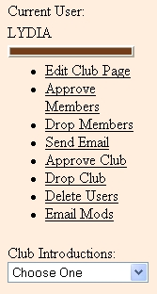
Figure 5-4 moderator menu
The Edit Club Page link is where the moderator gets to update the club introduction page and picture.
The Approve Members link will display members who have requested to join this club. Your profile is displayed for the Moderator to review. This is really the only way the moderators get to know potential members so you should have an interesting profile; perhaps showing why you have an interest in this club.
Drop Members link allows the moderator to remove a user from the club. It does not destroy the user’s Lydia’s Kitchen account nor does it delete that user’s recipes. It simply drops the user from the club.
The Send Email link allows the moderator to send the same email to all the club members.

Next are the links for the administrator (that’s me). They are visible to no one except the administrator. When a member wants to start a club I can review their club introduction page with the Approve Club link. For those times when a club wishes to be dissolved I may elect to Drop Club. With the Delete Users link I can remove a user’s Lydia’s Kitchen registration and for those special occasions when I need to communicate with the club moderators I can send them email with the Email Mods link.

home menu

Figure 5-5 home menu
The home menu link always appears in the bottom left corner of the screen.
Use the home menu to return to the top menu. For example if you are on the Club Recipe Menu page; then pressing the HOME menu link will return you to the Opening Menu page.

registration / user profiles
The act of registration creates a database entry for new users on the server. This is a permanent record of your user name, password and profile information. The act of registering and initiating a profile are combined into one input form. Fill in the form and press the submit button. The program will check that all required entries have been made and send the information to the server. Registration is open to anyone and is free. Please read the terms and agreement statement (Section 13) before registering.

User Registration Information
This information will be used each time you log into the program. Record this information for future use. No provision has been made for forgotten names and/or passwords. The site is not secure so never provide detailed personal information about yourself or others. If you should lose your password just re-register with a new user name and enjoy life. The user name and password are only used to enable or disabled recipe editing, deleting and club membership privileges.
User Name – A 20 character name (maximum) which can contain only 0-9 / A–Z characters. This is a required entry on the form. It is converted to all UPPERCASE characters before it is stored on the server. Your submitted user name is tested against all other user names so no two are identical.
  - Password – 20 characters (maximum) which can contain only 0-9 / aA – zZ characters. Passwords are not checked for duplicate database entries. This helps prevent the discovery of know passwords. – required

User Profile Information
Tell us about yourself; that’s the function of our profile. What do we have in common? Do we live near each other? Do we both like French food? Though most form entries are marked required they are not checked for factual accuracy, perhaps you want to share your nickname and not your real first name, that’s okay. As for the email name you might want to keep it real, it is the only way club moderators may contact you.
    - First Name ( xx characters) – required
    - Last Name ( xx characters) – required
    - City ( xx characters)
    - State ( xx characters)
    - Email ( xx characters) – required
    - Profile ( xx characters) – required
From the user menu if you chose the Register Here link the following screen is displayed.
NOTE: After successfully registering you may edit your profile and upload a picture of yourself for display on your profile page.

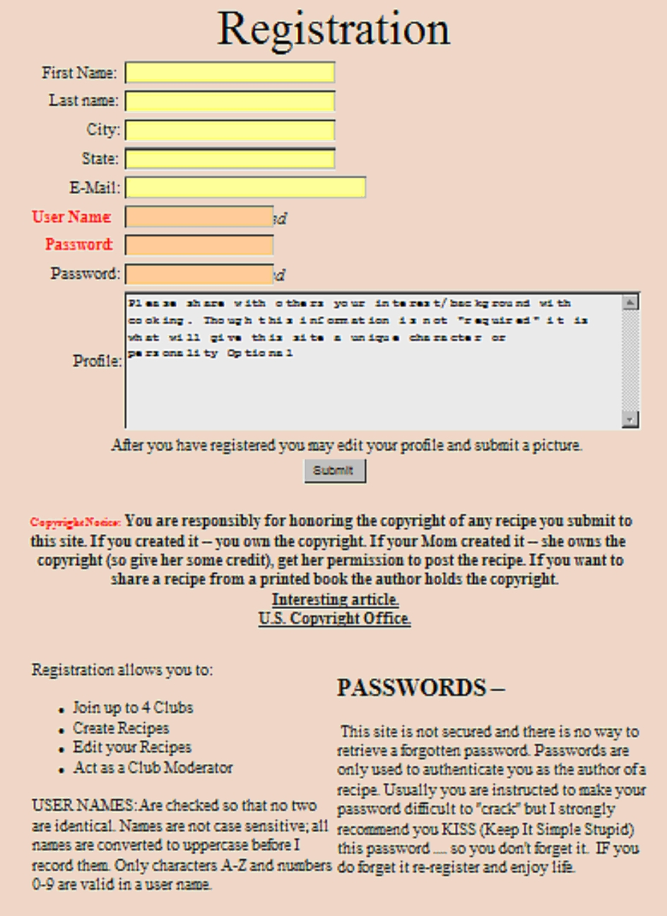
Figure 6-1 registration – profile

Editing Profile Information
Once you have registered and filled in the initial user profile record an Edit Profile link will be added to the menu. Clicking this link will display the profile data form which is identical to the registration form; with the exception that you are not allowed to change your user name. This is also the screen to use if you want to change your password.

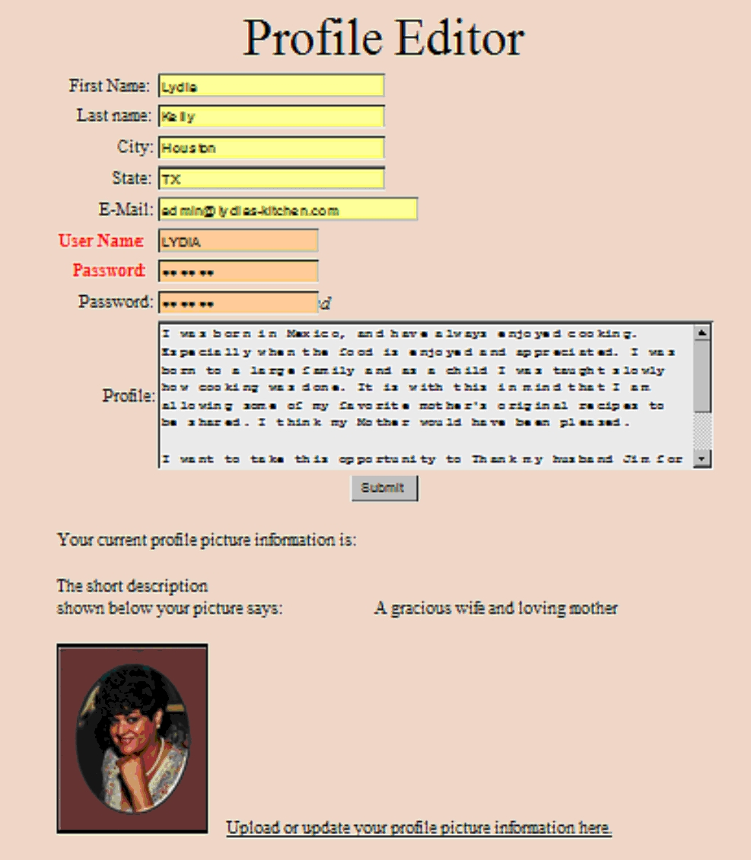
Figure 6-2 profile editor

log-in
The log-in process checks your user name and password against the database. For non valid entries the server returns a “UserName / Password Invalid” type message and ends the log-in process. For valid requests a welcome screen is returned. The welcome screen will display a list of your current club memberships.
Once logged-in you may perform all the features explained above for a registered user.

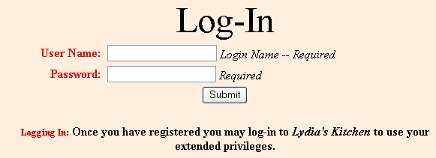
Figure 7-1 log-in
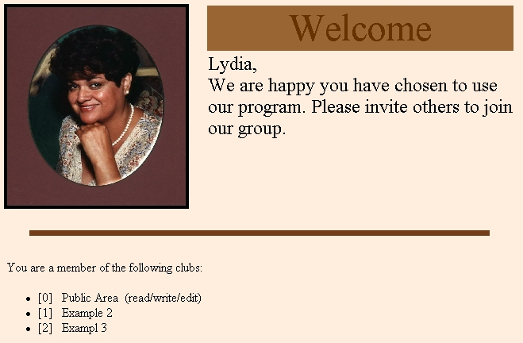
Figure 7-2 log-in welcome

clubs
Clubs are a lose-knit group of registered users sharing a common interest. No hard fast definitions are provided for clubs. Clubs are supposed to be based around food, but you may add any twist that you can dream up. Just one rule is hard and fast BE NICE! Club Moderators may elect to send out news letters to club members. News letters will be restricted to “text only” messages. Members who drop club membership, or are dropped by the Moderator, will automatically be removed from the mailing list. No Moderator mailing list maintenance is required. Club members can not elect to be excluded from the mailing list. Lets face it you joined the club because of a shared interest, plus the fact that mail traffic shouldn’t be that heavy.
Each club will have a club introduction page that is maintained by the Moderator. This page content consists of:
  - Club name – long version; the full club name
  - Club name – short version; the shortened version for display in the menu list box. (Visible only to the moderator in the edit mode.)
  - Club graphic – A GIF or JPG file only; with a maximum size of one (1) Megabyte.
  - Introduction paragraph – This is where you explain the club focus and / or purpose. View this as your recruitment ad. Write this ad to appeal to desired members and don’t forget the old 5 W’s (Who – What – When – Where – Why) answering these questions will help you write a complete introduction for your club.
  - Moderated by – The Moderator’s user name is displayed here

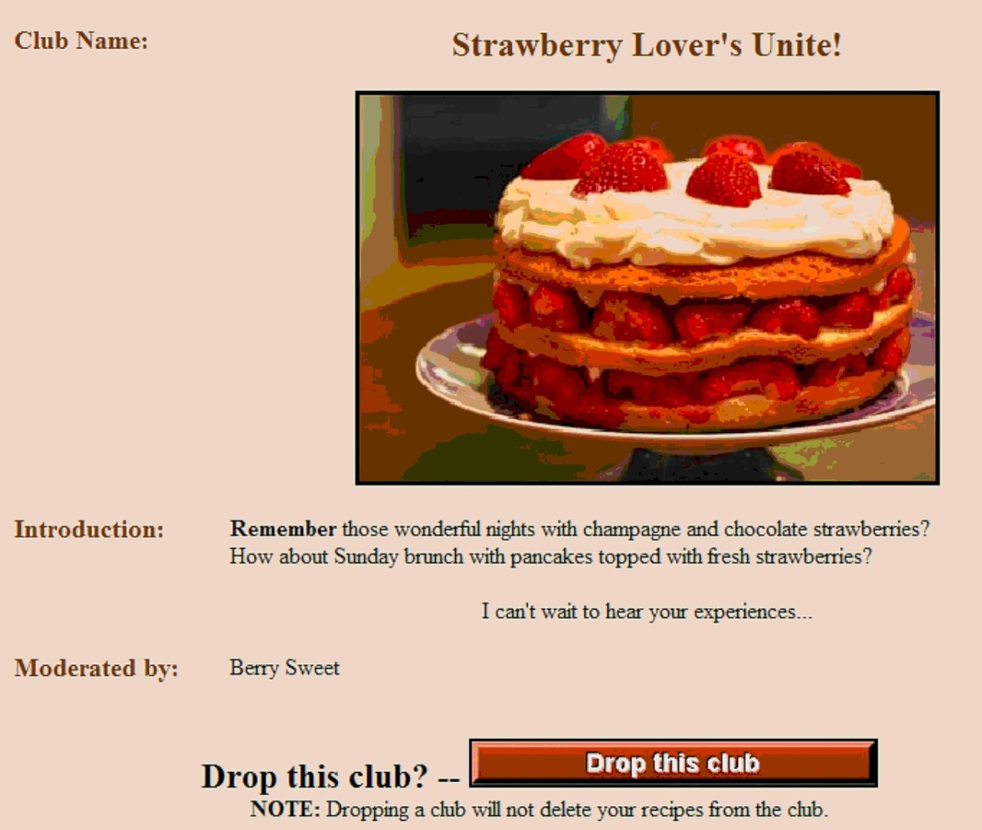
Figure 8-1 sample club introduction

who may start a club?
Any registered user may request to start a club. To start a club go to the menu list titled Club Introductions and view the Club Overview page. This page is basically an on-line version of this section of the manual. If you decide to start a club click the link I wish to start a club at the bottom of the page to submit your request. A member may only moderator one club at a time.

Figure 8-2 start a club
The request is sent to the Administrator who approves / rejects the request. If the request is approved then your account is flagged as a Moderator and given the new moderator privileges. When you request to start a club you will actually fill in the club introduction form which is sent to the administrator. When your club is approved it will appear in the menu list box titled Club Introductions so other members may view your introduction screen.
In addition you will have a menu link titled Club Mod which will allow you to administer your club.
- Change introduction screen
- Add / drop members
- Write a news letter

who may join a club?
Club membership is restricted to registered users. A user may be a member of a maximum of 4 clubs at any one time. Users submit a request for membership to the club Moderator and if the membership is approved their account is flagged to permit access to the club recipes.
To join clubs select clubs from the menu list box titled Club Introductions. This will display the club’s introduction page. If you decide to join this club click the link I wish to join this club at the bottom of the page to submit your request to the moderator. Once the moderator has approved your membership the title will appear in the menu Choose a Club list box and on your log-in welcome screen (See picture in section 6.0).

Figure 8-3 join a club

May I drop a club?
Once you have joined a club visiting the club introduction page will reveal that the link at the bottom of the page has been replaced. Now instead of a link to I wish to join this club it has been replaced with I wish to drop this club. Clicking this link will immediately drop your club membership. No action is required by the Moderator since this is strictly your personal decision. Members may drop club memberships at any time, but must once again use the request procedure to re-join the dropped club. User recipes entered into the club area will remain unless the user elects to delete them before dropping membership.

Figure 8-4 drop a club

other links associated with clubs
As you participate with clubs the links you will see vary depending on your activity. For example once you start a club you will see
 as you are allowed to moderate just one club. As soon as you request to join a club the “join a club” link will be replaced with
and the pending club counts against the total 4 clubs you may join.
When you have reached the 4 club limit then the introduction pages will show

and of course the most basic link displayed is for our Guest account which states


Recipes
Recipes are always filtered; either they are PUBLIC recipes or CLUB recipes. Users select the desired filter by selecting a club from the Choose a Club list box. Once a filter has been set the user will see a new recipe menu with list boxes titled Categories and Recipes. Sub filtering within a club is done by selecting a category. When a category has been selected then the recipe list box will be populated with available recipes and the first entry in the list box is displayed.

The user selects a recipe from the list box and it is displayed on the web page. With a recipe displayed the print feature is enabled. If the user is the author of this recipe then the edit/delete features will also be enabled.

May I add new categories?
In order to maintain consistence throughout the program control of categories has been restricted to the Administrator. You may submit a category request to the Administrator who is always open to suggestions to improve the site.

printing recipes
Printing is limited to the displayed recipe, no formatting is provided and printing is considered a “raw dump”. All print settings, such as “print background”, are controlled by the user’s browser settings.

adding new recipes
All registered users may add recipes to the PUBLIC area and users who have joined clubs may add recipes to their club areas. To add new recipes click the “New Recipe” link. You will be presented with a 3 step process:
- Step 1 The basics – On this form you will be asked the fundamental questions: Name, Serving size and cooking directions. If you are not the originator of this recipe please give the chef credit in your recipe history. Anecdotal story – Enter why this recipe has become so meaningful for you. Share with us the family history, friendship or special event that makes this meal such a fond memory.
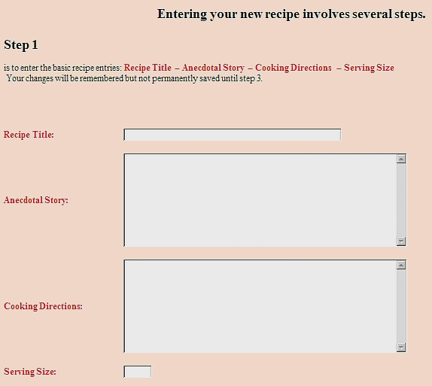
Figure 9-1 add / edit recipes step 1

- Step 2 Ingredients – This form is repeated for each ingredient you want to enter. Be prepared to provide the Quantity, Unit of Measure and the name of the ingredient (noun).

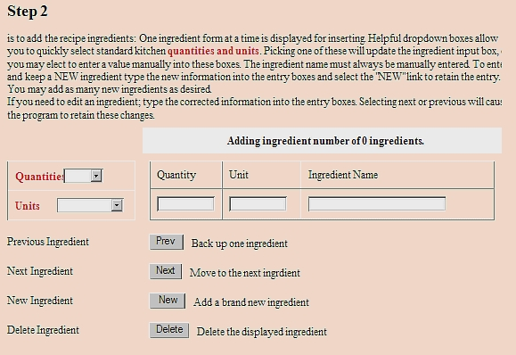
Figure 9-2 add / edit recipes step 2
When adding new ingredients be sure to use the NEW button, using the PREV or NEXT button will replace and existing ingredient.
New Ingredients – When first opened the form will be empty (as shown) type in the [Ingredient Name] and then you may choose to type in the [Quantity] and [Unit] manually or select one from the drop down list boxes. Click the NEW button. Above the [Ingredient Name] box is the ingredient counter it will show you the total count of ingredients entered (1 of 1 etc). After you enter the first ingredient the input boxes will always display ingredient information “type over” the existing entry and click the NEW button again.
Editing Ingredients – Use the PREV or NEXT buttons to scroll through the ingredients until the ingredient you want to change is displayed. Above the [Ingredient Name] box is the ingredient counter it will show you the total count of ingredients and which ingredient you are currently editing (1 of 10 etc). Change the ingredient data and then click PREV or NEXT to record the changes.
Deleting Ingredients – Use the PREV or NEXT button to display the ingredient to be deleted and then click the delete button. The counter will show one less total ingredient (1 of 9 etc).

- Step 3 Submit recipe – This will enter the recipe into the database and make it available to all members.
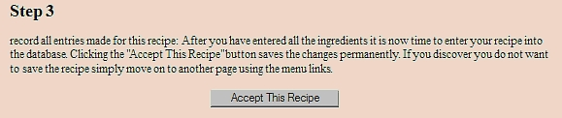
Figure 9-3 add / edit recipes step 3

editing recipes
To edit a recipe login and navigate to the recipe, your login name will be tested against the user ID that entered the recipe and if they match the “Edit Recipe” link will be made available for you. You will be presented with the exact same screens described in the “Adding New recipes” section but the forms will be pre-filled with the current recipe information. Edit the desired areas and then select the SUBMIT link to permanently store the recipe changes.

deleting recipes
To delete a recipe login and navigate to the recipe, your login name will be tested against the user ID that entered the recipe and if they match the “Delete Recipe” link will be made available for you. Clicking this link will delete the recipe. There is no recovering a deleted recipe so be confident of your action.

help screens / faq list
The on-line help system is presented as a FAQ (frequently ask questions) list. Each question is immediately followed with the answer. This FAQ is limited to how to use Lydia’s Kitchen. Scroll up and down the list until you find the question of interest. Version 2.0 of Lydia’s Kitchen will have an active user forum where the forum will be able to expand the help to cooking tips and related subjects.

formatting my input
You may desire to format portions of the information you submit to Lydia’s Kitchen and this is possible. The two areas where formatting is acceptable are User Profile and the Club Introduction. All other entries have formatting stripped away. Only a sub-set of HTML tags are permitted, any tags not listed below will be stripped away.

HTML Tags
Start Tag | End Tag | Purpose / Use
<B> | </B> | Bold text
<I> | </I> | Italicized text
<U> | </U> | Underlined text
<BR> |  | New line
<P> | </P> | New paragraph
<UL> | </UL> | Unordered list (bullets)
<LI> | </LI> | Item in an unordered list
<CENTER> | </CENTER> | Center everything on page
Table 10-1

What is a HTML tag?
HTML stands for HyperText Markup Language and is used for web pages. Without getting too technical lets use some of the tags from Table 10-1 to illustrate their use.
Say I want bold text : <B>this would be bold text</B>
Note how the desired bold text is surrounded by <B> and </B> these are start and end tags for bold text. Everything after the <B> start tag will be displayed as bold text until the browser see the </B> end tag. Look closely and you will see that an end tag has a “/” as part of the tag. That’s how you can tell the difference between start and end tags.
You must be careful and properly form your tags or the submitted data may look awful funny. All tags start with < (that’s the greater than symbol) have the tag name and then end with > (that’s the less than symbol)
You may have noticed that the <BR> tag has no ending tag and that is correct. The new line command does not require an end tag.
The term un-ordered list may confuse some of you. It simple means a bulleted list.
Example List
- Item 1
- Item 2
- Item 3
To make this bulleted list on a web page you would format it as follows.
Example List<BR><UL><LI>Item 1</LI><LI>Item 2</LI><LI>Item 3</LI></UL>
This is the most difficult formatting that I permit and if you understand this you’ll surely do fine with all the other tags.
First notice I didn’t place each item on a separate line (though I could), the formatting instruction does that for me.
I start my list with <UL> -- now the browser knows what to expect
I start my first line with <LI> and end it with </LI> -- the browser now knows to associate all the text in-between with one bullet.
I repeat the <LI></LI> tags for every bullet I want.
I end the unordered list with </UL>

Tags may be nested (grouped together) for example to underline and bold some text you would:
<B><U>this is bold and underlined text</U></B>

Moderator accounts
Registered users who wish to moderate a club may request to start a club on the “club Overview” page. At the bottom of the page is a link “I wish to start a club”. Each member may act as moderator for one club. There is one requirement for starting a club, it must be cooking related; but you can add any twist you can think of.
Pressing the “I want to start a club” link will bring up the club overview form. The new moderator fills in this form and submits it to the administrator. The form contains the information that will be displayed on the club introductory page. It provides the administrator (and future members) with an idea of what the club focus will be, say French food or Deserts, and the club name.
Once the administrator approves the new club the club overview information is added to the “Club Overview” link on the main menu and registered members may now apply for membership. The request for membership is sent to the Moderator.
As a club moderator the user will find a new link called “My Club” on the main menu page. When clicked the main menu will change to the moderator’s menu. This menu has links to:

Editing the club overview screen
The moderator may update and change the club introduction page without restrictions.

Add / remove other registered users as members of that club
As registered users request membership they will be displayed on this page. Each requesting user’s profile will be available to the Moderator for review. The moderator may accept or refuse each request.

Distribute a club news letter
You may elect to send a club news letter, these are not mandatory. If you elect to use this feature you will fill in the email form and the program will automatically detect all current members and sent the mail to them. No mailing list maintenance is required of the Moderator. Dropped members or members who drop themselves are automatically removed from the list.

Edit / delete ALL recipes within the club.
As club Moderator you are given permission to edit all recipes associated with the club. The idea is that you best understand the “intended purpose” of the club. If you find yourself deleting many recipes perhaps you should revisit the club introduction page. Most likely you would be editing for spelling and/or prohibited language within the club.

If a moderator elects to step down from the role of club moderator they are expected to inform the club members and attempt to recruit a new moderator.

administrator account
The administrator account is a super user account and has full access to all user accounts, clubs and recipes. All users must understand that the use of Lydia’s kitchen is at the discretion of the administrator. The primary role of the administrator is expected to be approving club moderators. In the event a moderator wants to discontinue a club the moderator will temporarily continue the club while asking another club member to assume the moderator role. The administrator features are displayed on the “My Club” menu. The unique features for the moderator are:
- Approve a new club
- Drop a club
- Delete a user’s account
- Email to all club moderators

Terms and agreement for use
Lydia’s Kitchen is provided free of charge and “as is”. The administrator assumes no responsibility for the user’s computer hardware or software interaction with this program. The intellectual content of the club pages and recipes remain the property of the registered user. Full control of the user content is provided in the form of editing and deleting all contributions, plus the ability to unconditionally drop club memberships. While efforts are made to protect the server and users from malicious code attacks the user agrees not to hold the owner of Lydia’s kitchen liable for such an occurrence. Users are expected to apply their own ethics and standards as to which clubs they elect to join.

