Sample distribution:

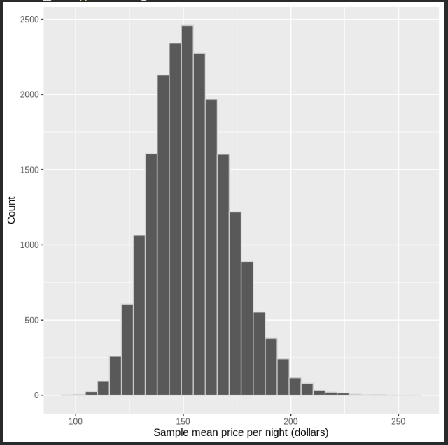
Sampling statistics:
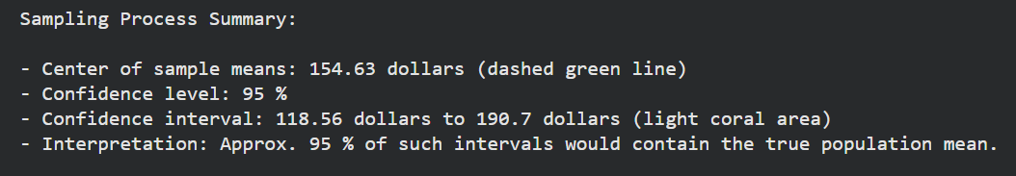

Sample distribution shaded by 95% confidence interval:
