Looks like they used a Pixhawk board with FMUv4 architecture (possibly pixracer)

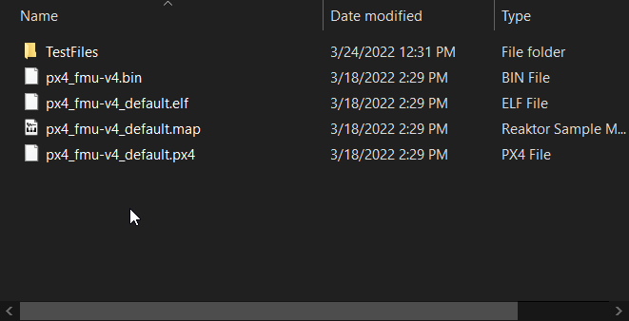

The flight core says

* “ModalAI Flight Core is a PX4 flight controller that uses a very similar architecture to FMUv5x. It’s design goal is to be software compatible with the FMUv5x architecture in a smaller Pixracer-style form factor.”
* <https://docs.modalai.com/flight-core-datasheets-functional-description/>

**So in my understanding, we are trying to flash firmware meant for an FMUv4 architecture onto an FMUv5 board.**

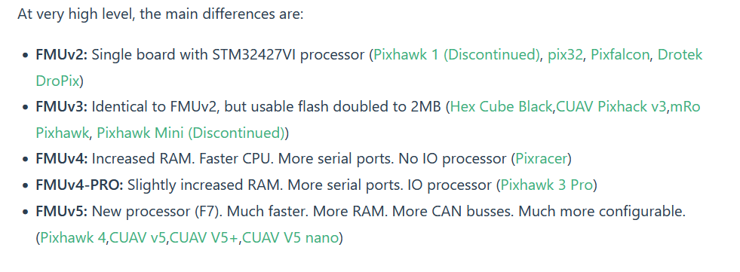

Source: <https://docs.px4.io/v1.12/en/flight_controller/pixhawk_series.html>

Apparently the FMU standard says the boards of the same FMU version should be compatible across different boards built on it:

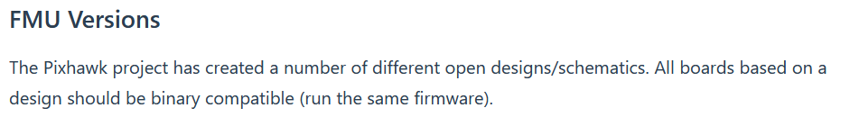

FOR REFERENCE: this is the current firmware on the board:

<https://docs.modalai.com/flight-core-firmware/>

We were able to change the board id of the DOD firmware to the right number (41775, was 11 previously) manually. The firmware **successfully flashed**, but upon restart, the flight core gets stuck in its bootloader, indicated by 10 Hz flashing green light. Through a quick internet search, we determined that this was due to incompatible firmware.

* Source: <https://www.racedayquads.com/tools/forum/forums/4792-tech-help-problem-solving/topics/17025-flash-latest-beta-flight-then-fc-stuck-in-boot>

Luckily, the chip inside the flight core is impossible to brick, as per this source

* Source: <https://docs.px4.io/master/en/advanced_config/bootloader_update_from_betaflight.html>

Some parameters of the DOD firmware are shown below

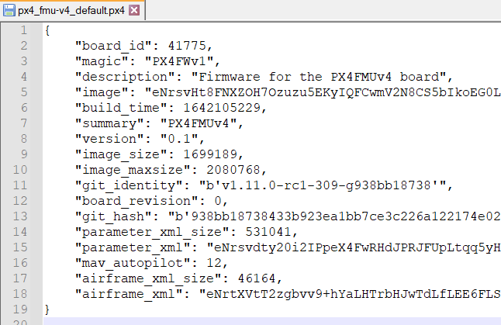

of note is git_identity - could maybe show where they forked from??

You can also see where the board_id is checked