First Iteration

## Rapid Idea Prototyping for Games

Fall 2014

Photosynthesize

A game by Julia Wlo

# The Challenge:

Make a game using a verb not commonly used in games.

# photosynthesize

## [foh-t*uh*-**sin**-th*uh*-sahyz]

verb (used without object), photosynthesized, photosynthesizing.

1.to produce carbohydrates by [photosynthesis](http://dictionary.reference.com/browse/photosynthesis) :

Plants with light green leaves don't photosynthesize as well as those with darker leaves.

verb (used with object), photosynthesized, photosynthesizing.

2. to produce by [photosynthesis](http://dictionary.reference.com/browse/photosynthesis) :

Plants photosynthesize sugars from carbon dioxide and water.

# photosynthesis

## [foh-tuh-sin-thuh-sis]

noun, Biology, Biochemistry

1. the complex process by which carbon dioxide, water, and certain inorganic salts are converted into [carbohydrates](http://dictionary.reference.com/browse/carbohydrate) by green plants, algae, and certain bacteria, using energy from the sun and [chlorophyll](http://dictionary.reference.com/browse/chlorophyll).

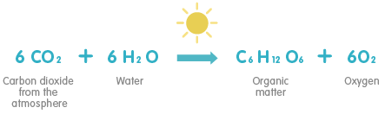

# Concept

Life as a tree in the forest is no walk in the park. You have to compete against all manner of other shrubs, fungus, and underbrush to reach the resource you need most to survive: sunlight.

## Narrative:

* You are a sapling
* In a world without humans
* A large tree has just fallen, letting in sunlight from above
* Now is your only chance to grow
* Reach the sunlight before other saplings get the chance!

## Mechanics:

* Grow
* Manage resources
* Stunt the competition
* Dynamic environment

## Values:

* Materialism
* Competition
* Social Commentary – funny how competition between trees over resources is like human war over resources – I’m still considering this, right now the game isn’t focused on it

## Genres & Conventions:

* Multiplayer
* “Board game”
* Action game
* Physics
* Emphasis on quick reflexes

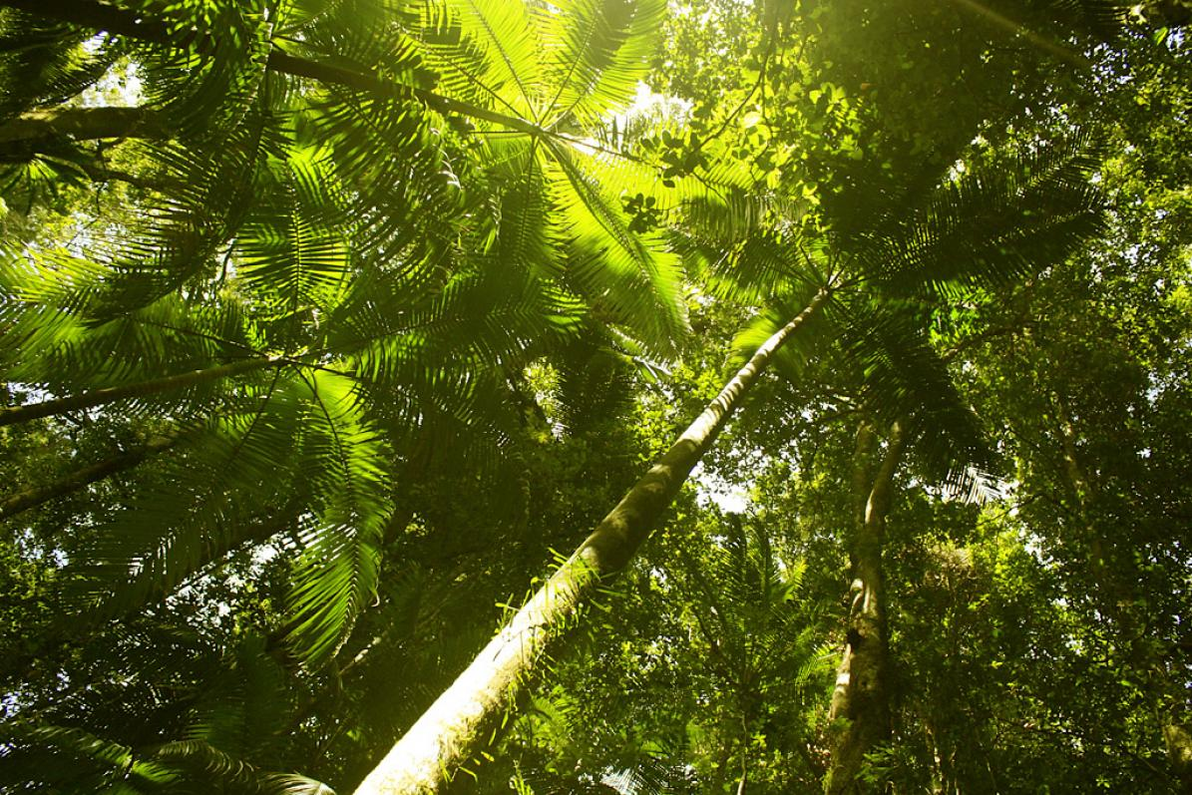

# Instructions

## About:

* 2+ players
* 10-15 minutes
* Ages 5+

## Objective:

* **Be the first to grow to the top!**

## Materials:

* Large corkboard, preferably a wall which you can stick pushpins into
* Many thumbtacks
* Assorted rubber bands
* A ruler or straightedge

## Setup:

* **Lay out the boundaries. If you’re playing on a wall, decide where on the wall you are going to play, then mark it out somehow. You can use extra rubber bands and thumbtacks to do so. It’s recommended that the top border is no higher than players can reach, and that the side borders are 2 to 3 fully-stretched rubber band lengths apart. If you are playing with more than two players, add a rubber band length to the width of the playing area for each additional player.**
* **Place a seed for each player. A seed is a thumbtack with three rubber bands hanging off of it. Seeds are placed at the bottom of the playing area. Seeds must be more than one rubber band length apart.**
* **Set the angle of the sun.** (optional) Towards the top of the playing area, place two thumbtacks about an inch apart with a rubber band connecting them. The angle of the rubber band represents the angle that the sunlight is shining down. It’s recommended that you set the sunlight completely vertical at the start of the game.

## Gameplay:

* Play has two phases: **day** and **night.**

Day**:** It’s time to grow!

* On the count of three, players start hooking the thumbtacks into the rubber bands, stretching them out and sticking the thumbtacks on the board.
* **Everyone acts simultaneously!** Act quickly to get the best spots on the board.
* **Grow towards the top!** The first player to reach the top wins!
* **Try to shade your opponent’s buds!** If you block the sun from other player’s buds, they won’t be able to grow next turn!
* **Only touch thumbtacks**! You are not allowed to touch the rubber bands during the day.
* You can touch thumbtacks you’ve already placed.
* You and your thumbtacks cannot touch other players’ rubber bands or thumbtacks.
* Your rubber bands CAN touch other players’ thumbtacks and rubber bands.
* You can stretch your rubber bands as far as you want, in any direction you want (but remember to grow towards the top!) This includes wrapping your rubber band around a thumbtack.
* **Don’t drop your rubber bands!** If one of your rubber bands falls to the floor, tough luck! You can’t pick it up.
* **Don’t let your thumbtacks come loose!** If one of the thumbtacks you’ve placed falls off the board, you can’t pick it up! Any rubber bands that fall off with it are also lost. Remember, you can push down on thumbtacks you’ve already placed.
* **Don’t snap rubber bands!** You’ll poke someone’s eye out! If you break one of your rubber bands, you don’t get another.
* **The exception to the last 3 rules is your seed.** If your seed comes loose or if you drop/break the first 3 rubber bands on it, then you may replace those items. **You may only do this once.**

Night: New buds form, seasons change.

* Each player counts up which thumbtacks on their tree are collecting sunlight. Draw an imaginary line from the top of the board to your thumbtack, at the same angle of the sunlight. Use a ruler if you want to be really accurate with this part. If there is nothing in the way, then your thumbtack grows a new bud! Hang a loose rubber band off of it. If your line crosses through any thumbtacks or rubber bands, including your own, then that thumbtack does not grow a new bud and you do not place a new rubber band on it.
* The angle of sunlight is the same anywhere on the board. If the sunlight is going diagonally to the left, then everything on the board is receiving sunlight at that angle.
* Change the angle of the sunlight. The sun should gradually move from being vertical to more horizontal, but never completely horizontal. Sunlight always points downwards.