Tornado onset from radar
Two experiments with a pretrained detector: current-scan detection and short-horizon onset
Jake Van Slyke
Jeffrey Gregory
2026-10-15

The problem
TorNet is a benchmark of storm-centered, polarimetric radar sequences and a published convolutional neural network (CNN) trained to detect a tornado in the observed radar. We asked whether the information learned by that detector could also improve a small adaptation, or identify tornado presence before the signal becomes obvious. Those are two different questions, so we ran two related studies rather than presenting them as one chain of controlled changes.
Study A (Jeffrey): Detect a tornado in the current scan. Freeze the published CNN, train a small classifier on its features, and test three one-factor adaptations against that trained baseline. Study B (Jake): Give the model the two oldest scans of a four-scan sample and predict tornado presence in the two unseen scans, about five and ten minutes later. Compare a frozen encoder with one adapted to this new target.

The data and the comparison
TorNet v1.1 contains 203,133 storm-centered samples from 2013–2022. Each sample holds four radar scans about five minutes apart, with binary labels for each scan; the released CNN consumes the underlying radar variables and range-folding information rather than pictures of radar screens. Both studies use 2014–2015, but their training populations, test splits, labels, and metrics differ.
Table 1. The two experimental setups.
 | Study A: detection | Study B: onset
Task | Tornado in newest observed scan | Tornado at +5 and +10 minutes
Training | 3,667 clips; 1,325 validation | 37,168 source training samples; 15% of days held out
Held-out test | 1,422 clips; 89 positives; 10 storm groups | 6,448 samples; 495 selected pre-onset cases by +10 min
Main metric | Average precision (AP) | ROC AUC against warned storms (WC AUC)
We report each experiment against references evaluated on its own test set. AP and ROC AUC are different quantities; differences across the two studies cannot be interpreted as head-to-head model improvements.

Study A: detecting tornadoes from frozen features
Jeffrey used the released TorNet CNN as a frozen feature extractor and pooled its spatial features into 384 values per scan. A 385-parameter linear classifier trained on current-scan features was the adaptation baseline. Three changes were evaluated separately, holding the data split and basic training protocol constant. Each configuration was trained with seeds 42, 43, and 44; validation average precision selected the configuration and operating threshold.
Table 2. Controlled detection adaptations, with mean validation AP and seed standard deviation.
Configuration | Change from trained baseline | Validation AP
Linear baseline | Current scan; linear head (385 parameters) | 0.658 ± 0.005
History | Average prior and current scan features; same head | 0.675 ± 0.001
Hard negatives | Double loss weight for warned negative clips | 0.656 ± 0.005
Larger head | Current scan; nonlinear 64-unit MLP | 0.670 ± 0.007
The predeclared rule selected the two-scan feature average. That operation may retain persistent storm features, but averaging does not explicitly learn motion or a storm trajectory. Held-out test thresholds were fixed using validation, targeting at least 80% recall there.
Table 3. Held-out current-scan detection on the 1,422-clip test split.
Model | Test AP | Positives found | False positives
Released TorNet detector | 0.517 | 68 of 89 | 276
Trained one-scan linear head | 0.508 | 70 of 89 | 571
Selected two-scan linear head | 0.548 | 69 of 89 | 564
History averaging increased held-out AP by +0.031 relative to the original detector, but the 95% paired storm-group bootstrap interval was [−0.061, +0.155]. This interval includes zero. At similar test recall, the selected adaptation produced 288 more false positives to detect one additional positive clip. These are selected radar crops, not a stream of operational warning decisions.
Result: A small two-scan adaptation was competitive on this split, but neither a reliable test improvement nor fewer false alarms was established. Hard-negative weighting did not help validation, and extra head capacity was not sufficient to outperform the predeclared selection rule.
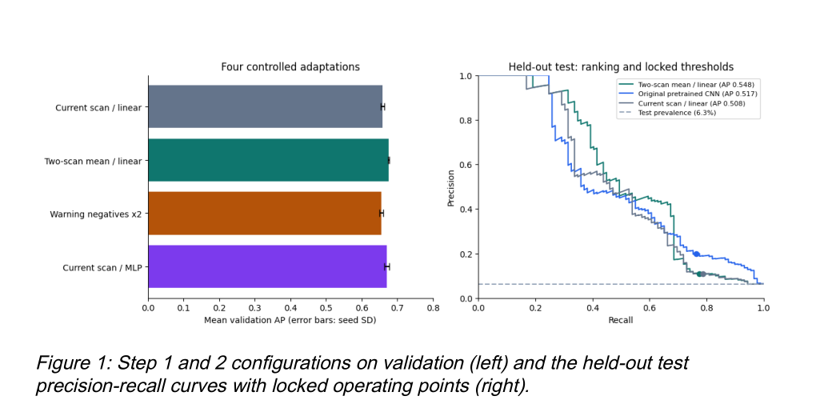

Study B: predicting the next two radar labels
Jake changed the prediction target, not just the readout. The pretrained encoder processes two observed scans using shared weights. Their 384-channel spatial feature maps are concatenated, and a new convolutional head predicts one binary label for each future scan. The head is trained on the future labels with weighted cross-entropy. In the first run the encoder stays frozen; in the second its weights are fine-tuned at a lower learning rate. The trainable target and the test set differ from Study A.
Evaluation selected pre-onset tornado cases retrospectively: neither input scan was labeled tornadic, but the last (+10-minute) target was. This yields 495 positive cases at +10 minutes; 208 had become positive by +5 minutes. Warned storms without confirmed tornadoes supplied the difficult comparison negatives. Because the sample selection uses a future label, these results are not a deployment-time warning estimate.
Table 4. Pre-onset WC AUC on the authors' 2014–2015 source-test partition.
Reference or adaptation | +5 minutes | +10 minutes
Persistence: released detector on latest observed scan | 0.731 | 0.726
Two observed scans, newly trained head; frozen encoder | 0.699 | 0.710
Two observed scans, newly trained head; fine-tuned encoder | 0.724 | 0.728
Oracle: released detector on the actual future scan | 0.769 | 0.797
With its encoder frozen, the new onset head fell below the persistence detector by 0.032 AUC at +5 minutes and 0.017 at +10. Fine-tuning lifted it to 0.724 and 0.728, effectively matching persistence (paired differences −0.007 and +0.001) rather than outperforming it.
The future-scan oracle is diagnostic: it gives the released detector data that were unavailable to the forecaster at prediction time. It is not a theoretical performance ceiling on other prediction models. The original onset uncertainty intervals used example-level bootstrap resampling, although successive radar clips share storms and weather systems. Those intervals therefore need cluster-aware reanalysis before claims of statistical separation.
Result: The fine-tuned future-label classifier recovered roughly what the detector already extracted from the latest observed scan. Two scans and a new output head did not demonstrate additional advance discrimination on this retrospective selection.
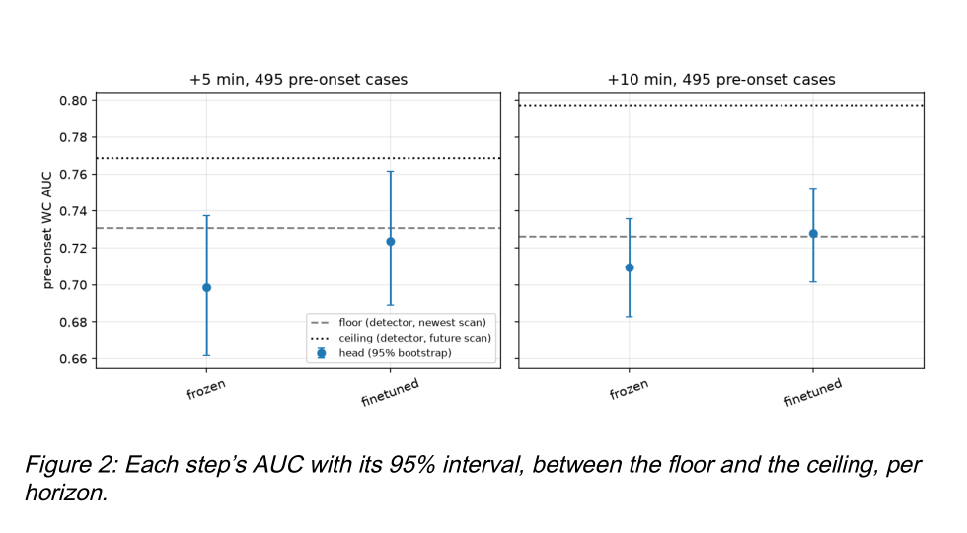

What the experiments tell us
The studies support a narrower conclusion than “TorNet can forecast tornadoes.” In Study A, five minutes of additional observed history improved a ranking metric modestly, but with too much uncertainty and too many false alarms to establish a practical gain. In Study B, adapting the detector to future labels matched a simple persistence comparison without showing improvement. These are informative, qualified outcomes, not proof that useful forecasting is impossible.

Limits of the evidence
Different questions and splits. Study A scores detection with AP; Study B scores retrospectively selected onset cases with WC AUC. Results cannot be directly pooled. Dependence and leakage. Study A has only ten held-out storm groups, and exposure of the pretrained CNN to related weather dates cannot be wholly excluded. Study B needs weather-event or episode-cluster uncertainty estimates. Forecast selection. Looking backward from a tornado to define a pre-onset sample is different from scoring every storm as it arrives. Training budget. Fine-tuning was capped at five epochs and used just two test years.

A stronger next test
Keep the released detector as a reference, then train a small temporal model on strictly earlier radar history. Hold out complete storms or weather systems, retain the same evaluation population at each forecast horizon, and report false alarms per storm or hour, recall, calibration, and event lead time. Use more years and longer training without revisiting the final test set during model selection.

Contributions and reproducibility
Jeffrey implemented and evaluated the frozen-feature detection experiments and grouped-split audit. Jake built the future-label onset model, data pipeline, and fine-tuning comparison. Together the studies test two distinct ways to use the published TorNet representation; code and methods are available in the team repository.

References
Veillette et al., TorNet: A Benchmark Dataset for Tornado Detection and Prediction Using Full-Resolution Polarimetric Weather Radar Data. https://doi.org/10.1175/AIES-D-24-0006.1
MIT Lincoln Laboratory, TorNet: https://github.com/mit-ll/tornet
Team code (Jake Van Slyke and Jeffrey Gregory): https://github.com/jwm-dev/deep-learning-tornet-team-project
Jeffrey's executed detection study: https://github.com/jwm-dev/tornet-transfer-learning
Dataset and converted checkpoint: https://huggingface.co/datasets/jakeryderv/tornet ; https://huggingface.co/jakeryderv/tornet-detector-torch

