# Bug 00001

Describe the bug

There is not a month “0” (zero). The month entry should only accept integers 1 – 12. No exceptions.

Program

The name of the program/version/build you are running.

full_retirement_calculator_app.py

PyCharm 2019.2 (Community Edition)

Build #PC-192.5728.105, built on July 23, 2019

Runtime version: 11.0.3 + 12-b304.10 amd64

Component

By default, all bugs associated with a given component are routed to the lead developer for that component.

Error Type

Design error.

Severity

Nuisance

Priority

Set by management

## State

Open

To Reproduce

Steps to reproduce the behavior:

1. Run the program full_retirement_calculator_app.py
2. Enter the birth year when prompted; press Enter.
3. Enter “0” (zero) as the birth month when prompted; press Enter.

Expected behavior

The entry of “0” (zero) should prompt the user to enter a valid birth month.

Screenshots

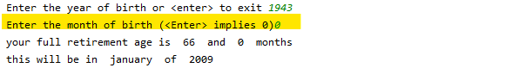

Desktop

Please complete the following information:

* OS: [Windows 10 Home]
* Version [1909]
* Browser [Microsoft Edge]
* Version [85.0.564.68 (Official build) (64-bit)]

Additional context

Add any other context about the problem here.

Assigned

Current owner of the issue. Initially, assigned to the Component's lead developer.