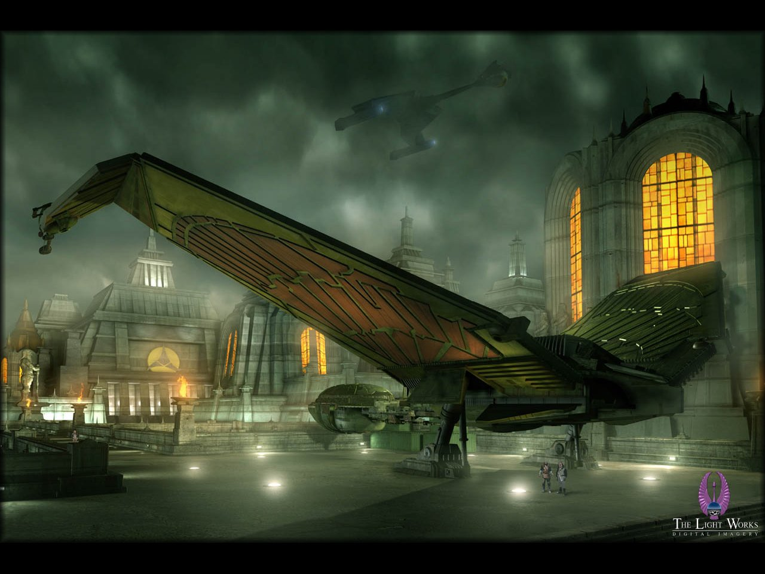

You are about to embark on a uniquely different style of Fan Club. You are entering into the realm of the Klingon Empire and learning what it is to be a Klingon Warrior in the 21st Century.

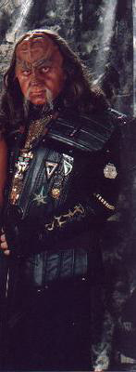

IKEF is but one of many Star Trek related Fan Clubs situated across the world, the only thing that sets IKEF apart from the others is that it is one of the fastest growing Klingon Fan Clubs in the world.

As a member of IKEF, you will learn “The Way of the Warrior” which is the embodiment of what it is to be Klingon; you will experience what we do, how we do it and why we do it.

Along the way you will meet different and interesting people who enjoy playing a Klingon in a modern day society, they could be your next door neighbour, your family Doctor, your mailman or even a co-worker.

We all have one thing in common and that is our love of Star Trek which was the dream of our creator Gene Roddenberry and let’s not forget the most important reason for why we choose to be a Klingon Warrior, our lust for having fun.

While the majority of our members are Klingon, we are not limited to just Klingons. This manual explains the various types of Klingons found within our membership, you could be a Klingon/Human Fusion as found in “Enterprise” and “The Original Series” or a Klingon Romulan Hybrid as found in “The Next Generation” or even a Klingon mixed with one of the many different species found in the Star Trek Universe then IKEF is the place for you.

If you are interested in starting a local chapter or ship this manual will show you how, IKEF has it all. Welcome Warrior to the Imperial Klingon Expeditionary Forces, may you serve with Distinction, Honor and bring Glory to the Empire. Qapla’

Late Klaad epetai K’Tarra Qang

### The First Klingons

According to Klingon myth, after they slew the gods, the First Klingons were forced to survive in the harsh wilderness of Qo'noS. The world was a hostile and dangerous place and, although they were strong, the first Klingons were faced with terrible hardships, and hunted by dangerous beasts. But they were Klingons, and they did not despair. Instead, they took the fire from within their hearts and brought light into the darkness. They took stones from the mountains and worked them into weapons to fight the beasts that menaced them. With these tools, they overcome all obstacles that stood in their way.

In fact, the earliest recognizable Klingon skeleton uncovered by archaeologists dates back too approximately 500,000 BC. At this time, Klingons apparently lived in extended family tribal units that were at least somewhat nomadic, travelling from place to place in search of food, following the migrations of various food animals. These early Klingons discovered fire and used stone and bone tools made by hand. Archaeological evidence suggests these weapons were used for more than hunting; Klingon remains have been uncovered with spear and knife points lodged in them. The early Klingons likely fought over the most valuable hunting territories on Qo'noS, beginning their long history of conflict.

### The First Houses

Archaeologists have uncovered the remains of what must be one of the first Klingon settlements, around 25,000 BC. A small collection of stone huts built around a central fire-pit, surrounded by a low stone boundary wall. This coincides with the dawn of agriculture and animal domestication on Qo'noS, as well as the formation of the first extended communities or "Houses." These developments appear quite suddenly in Klingon prehistory, and no scientific evidence has been uncovered about how they originated.

The early Klingons grew and harvested food near their villages, and hunted in the surrounding area along with domesticating animals like the targ, which served as a source of food, hides, and bone tools. Archaeologists believe early Klingons also raised gagh (serpent worms), although there is no proof of this.

Klingon legend offers an explanation in the form of Ja'Duch, a legendary warrior and hero, said to have founded the first Klingon house. Ja'Duch was a great hunter and fought battles against other tribes to protect his people. He was renowned for his generosity, and for his unusual custom of performing the *r’uustai* ("bonding") ceremony with the families of his honoured enemies, who lost their own protectors. In this way Ja'Duch brought the families of his defeated enemies into his own tribe, which grew quickly and became strong. They established a *vaS'a*, a village, under Ja'Duch's direction, so creating the House of Ja'Duch, the first great hall or "house" of a Klingon warlord. Nothing is known of what became of the House of Ja'Duch following the death of its founder.

#### Klingon Burial Customs



Ancient Klingons held to burial customs quite different from those of modern Klingons. Archaeologists theorize the ancient Klingons believed in the need for the body to be interred in the ground for the spirit to find its way into the afterlife. Ancient burial sites have bodies wrapped in shrouds and placed in deep pits or natural caves, often decorated with paintings or carvings of *Fek'lhr,* the Guardian of *Gre'thor* the underworld.

With the rise of powerful city-states and a true Klingon ruling class, burial customs became even more elaborate. Powerful leaders built massive tombs to glorify themselves, decorated with paintings and carvings of their achievements. Bodies were mummified, wrapped in chemically treated bandages to preserve them, and decorated with jewellery and glyphs. These tombs have been compared to the glories of the First Hebitian Civilization on Cardassia, or the Egyptian civilization on Earth. Although many ancient Klingon tombs were looted and destroyed-by later Empires as well as during the Hur'q Invasion-some of them still stand and are preserved by the Klingons as treasures of their ancient past.

## The Rise of the First Empire

For thousands of years, the Klingons lived in small settlements and villages. The idea of extended houses spread throughout Klingon society. Houses offered many advantages, not the least of which was greater numbers and more allies in battle. Other Klingon leaders adopted the idea, performing the *r’uustai* to unite different tribes together as a single house under their leadership. Many of these houses did not survive the death of the leader that brought them together, but others were passed down to successors able to hold them together for another generation or two. In time, the leadership of a house became a traditional position, passed on from father to son, although an upstart could always challenge the current leader for his position.

### The First City-State

Around 6,000 BC, the concept of houses was firmly established in Klingon culture. Settlements grew larger as the more successful houses grew and continued to war against one another. As the great houses grew, it became more and more difficult to incorporate one's enemies into one's own house after defeating them. Rival houses were simply too large for such forced alliances, and attempts made to unify houses by force resulted in bloody civil wars that tore the newly unified house apart and destroyed both sides.

According to legend, a Klingon warlord named Kargas hit upon the idea of bringing different houses together without forcing them to become one house. Instead, as individuals and families joined a house, so could houses join together to form a nation, working together for their mutual benefit? It was a radical idea, but Kargas made it work through a combination of cunning diplomacy and persuasion at the point of his sword. The heirs of his enemies were allowed to keep their house and their title, so long as they swore oaths of loyalty to the House of Kargas. More importantly, houses were allowed to join Kargas' new alliance of their own free will, and some did once they saw the potential benefits.

Kargas and his allies are believed to have the Klingon city that still bears his name, the first true city-state on Qo'noS. Although the city has been conquered, destroyed, and rebuilt many times over thousands of years, Kargas' original alliance lasted for generations before the tides of war brought down his house, which is lost in the mists of legend.

The idea of the city-state spread through Klingon society, and other houses began to form alliances of their own. From these new city-states emerged the first true signs of modern Klingon ideas of nobility, along with blood feuds between houses, which began during this time.

Although Klingon city-states were successful, they also grew too rapidly for the meagre resources of their territory to sustain them. This led to the first large-scale wars in Klingon history, as city-states and alliances fought each other for control of valuable land and resources. Vast armies battled on the plains of Qo'noS, and city-states rose and fell based on the outcomes of those battles.

One of the bloodiest and fiercest battles of this time was the Battle of Tong Vey. Tong Vey was ancient city-state that refused the advances of a warlord named Sompek to join his new and growing empire. Sompek led an army of ten thousand Klingon warriors to lay siege to Tong Vey for months. Legends speak of the "vast sea of warriors that broke against the walls of Tong Vey." Starvation and disease gripped the populace of the city as they held out against Sompek's army for as long as they could. Their continued defiance to his will only angered the Emperor more and more.

Finally, after months of siege, the people of Tong Vey had no choice but to surrender to Sompek and agree to join his empire. The Emperor accepted their surrender but, as the gates of the city opened, he ordered his troops to kill every inhabitant of the city and to burn Tong Vey to the ground, so no sign of the defiant city would survive.

Sompek's destruction of Tong Vey set the tone for millennia of Klingon history, as petty empires rose and fell across Qo'noS. The leaders of great houses schemed and forged alliances, raising new warlords to rule over collections of powerful city-states. New empires warred with the old, falling before their might, or toppling them and taking their place.

Although many legendary Klingon heroes appear in this period, Klingon culture acknowledges it as a dark time, when Emperors and leaders had no understanding of Honor or the obligations of a leader to his people, as shown by heroes like Ja'Duch or Kargas. The so-called "Time of the Tyrants" is often the subject of tragic Klingon operas, where cruel leaders and warlords are brought down by their own lack of Honor.

### The Coming of Kahless



Some fifteen hundred years ago, a figure arose that would change Klingon culture and society forever. Kahless was born to a common family in an empire ruled by the tyrant Molor. Molor was known as a cruel and despotic leader, who built his empire on conquest and cunning, oppressing his people with heavy taxes and other demands to supply Molor's own army and to fill his palace with luxuries.

After their father died in Molor's army, Kahless' brother Morath went to the great hall of Molor to ask the Emperor for money to support the family's lands. To gain the money, Morath told the egotistical tyrant his father supported Molor, and that the emperor's people loved him. When Kahless found out about Morath's lie, he insisted on returning the money to Molor. Morath refused, leading the two brothers to fight. According to Klingon legend, Kahless and Morath battled for twelve days and twelve nights before Morath surrendered, realizing his brother was right.

When they attempted to return the money to the tyrant emperor, Molor was offended. He ordered Morath killed and the family's land confiscated. The two brothers fought to escape, and Morath gave his life so Kahless might live, having learned the lessons of Honor at last.

Kahless escaped into the mountains surrounding Molor's city, where he lived alone for many years as an exile and hermit. According to the legend, one day, while pondering his fate, Kahless was struck by inspiration. The idea of a code of Honor, as a way to govern the actions of true Klingons, formed in his mind. With the fires of Honor burning in his heart and mind, Kahless, forged the first *bat'leth* in the fires of Kri'stak, a volcano in those mountains. When his weapon was ready, Kahless returned home. He fought his way through one hundred warriors to reach Molor's throne room, where he challenged Molor to face him in battle. Kahless slew the tyrant after a duel that lasted for seven days and nights.

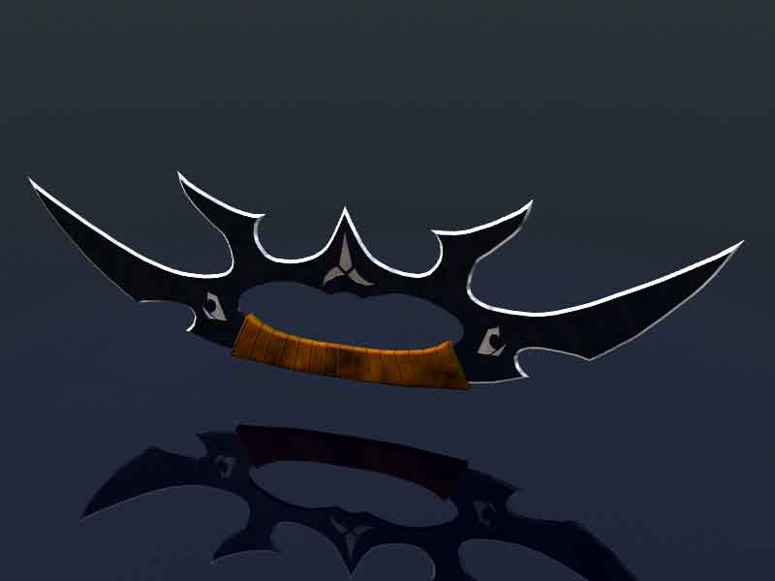

With the defeat of Molor, his people hailed Kahless as a hero and liberator. It is said his first act after Molor's defeat was to return to his family's farm, where he used his bat'leth to harvest all the fields in a single day, ensuring his family would have food to eat and money to support them. Kahless then assumed the role of Emperor, and rallied the people around him. They quickly swore fealty to their liberator, and word of Kahless' victory spread.

When news of Molor's death and Kahless' ascension reached the nearby city-states, their rulers thought they sensed weakness in this commoner-turned-Emperor. They prepared to invade and seize Molor's former territory for their own. Some few city-states, swayed by Kahless' philosophy of Honor, chose to join him. Kahless himself led the city's warriors to defend it. His small army withstood an assault from a force more than ten times their size at Three Turn Bridge, where Kahless is said to have held the pass entirely by himself. The blood of his enemies flowed so freely the river there is still known as "The River of Blood."

After his victory at Three Turn Bridge, the Noble Houses agreed to support Kahless and he won the respect of friend and enemy alike. Nobles flocked to swear fealty to the new Emperor. Those who continued to defy Kahless' power soon felt it for themselves as the Empire continued to grow.

As the years passed, Kahless' Empire became the largest and most powerful on Qo'noS. Kahless conquered and unified the whole world under his rule, creating the First Klingon Empire. Many legends grew up around Kahless and his successors, and Klingons often regard the First Empire as a kind of "golden age" of Honor and Heroism.

#### The Legend of Kahless

Stories of Kahless' exploits are found all throughout Klingon culture and lore, so many that it is impossible to believe any one man could have accomplished so much in a single lifetime. Among other things, Kahless is attributed with creating the code of Honor that is the foundation of Klingon culture. He forged the first *bat'leth* and created the first combat styles based around it, winning numerous battles (often single-handedly). He slew the Serpent of Xol and conquered the Fek'lhri, carved statues, and performed an endless array of other feats.

His battle with the Serpent of Xol is typical of many of Kahless' legendary deeds. The Serpents lair was in the mountains where Kahless spent his years of exile, before learning the ways of the warrior and forging his bat'leth. As a test of his new weapon, Kahless sought out the serpent in its mountain lair. Finding it asleep, he woke it with a terrible battle cry and proceeded to fight it for hours on end.

Finally, battered and bleeding, the serpent's venom burning in his blood, Kahless drove the point of his bat'leth into the serpent's brain, killing it. As he lay on the floor of the serpent's lair, he had a vision of the future. The poison burned away his thirst for vengeance against Molor, and made him realize his greater destiny, to unite the Klingon people. He coined the Klingon proverb; "revenge is a dish best served cold." Kahless wore the hide of the serpent of Xol as his armour when he went to face Molor, and he kept it always as a reminder of his duty to his people.

#### The Story of the Promise

Kahless lived to be a great age. It is said that in his later years Kahless feared his fame and greatness were a liability to the Empire rather than an asset. He worried that his people were growing dependent on him, losing the fire in their hearts. So Kahless chose to abdicate as Emperor and depart, without naming a successor, so his people could learn what it meant to be Klingons again. Before he left, Kahless pointed to a star in the night sky and said he would return from there one day. Then he departed the Imperial City, leaving his weapons and armour behind, and vanished into the wilderness, never to be heard from again. But the spirit of Kahless lives on in every Klingon who remembers his name and hears tales of his glory.

### The Hur'q Invasion

In 1372 AD, more than 700 years after the founding of the First Empire, the Klingons were firmly in an industrial era. The Empire unified all of Qo'noS and established extensive routes of trade and commerce. It also solidified the power of the noble houses and established the beginnings of the Klingon High Council. Although the houses still struggled against each other, most of the great wars of conquest were over. Klingons often longed for the glory days of the past, the great battles of Kahless. They longed for an enemy to fight, and they got one.



Little is known about the Hur'q. The name means simply "outsider" in Klingon. According to historical records, the Hur'q wore full-body environmental suits, and never showed their faces. They may have come from a non-Class M environment. Their technology was superior to that of the Klingons, although there is no evidence they possessed transporter or force field technology. Still, the Hur'q, were more than a match for Klingon Warriors armed with blades and primitive firearms. They invaded Qo'noS and killed hundreds of thousands of Klingons who fought against them. The Hur'q raided and plundered many of the homeworld's cultural and historical treasures, including the Sword of Kahless, which they took with them back to the stars.

The Hur'q Invasion lasted for only seven months, but it left Qo'noS practically in ruins. Klingon history and legend records that they drove off the Hur'q and prevented them from taking over the planet, but it is entirely possible the Hur'q were not interested in conquest, merely looting, and they left of their own accord. Archaeologists have found Hur'q ruins as far away as the Gamma Quadrant, suggesting the Hur'q had access to extremely advanced starships or some sort of shortcut like a wormhole in order to cover such a vast distance.

## The Age of Expansion

It took the First Empire nearly a century to fully recover from the damage done by the Hur'q Invasion. Recovery was hindered by infighting between the different noble houses for control over scarce resources. Slowly but surely, the Klingons rebuilt their shattered Empire and repopulated their cities. They looked towards space with a new vision. Now they knew there were enemies out there, enemies of the Klingon people. The Hur'q were gone, but they might come again and the Klingon Empire fully intended to bring the battle to them.

The Klingons embarked on a study of the sciences of flight and space travel. Previously, there was little interest in either, apart from a few scholars who studied the prophecy of Kahless. Now the whole Empire devoted itself to learning how to reach the stars. The program suffered from various setbacks as civil wars split the Empire from time to time, and many early Klingon astronauts died in the name of science, but every effort taught the Klingons a little more.

By the early 21st century, the Klingon space program was well underway. The Klingons used vast slower-than-light generation ships to explore and colonize nearby star systems. These ships took decades to reach their destinations, carrying hundreds, even thousands of Klingons in suspended animation. If they found their destination uninhabited, the Klingons colonized. Where they found other civilizations, they conquered. In time, the Klingon Empire encompassed a cluster of systems surrounding Qo'noS. Governance of this vast Empire was difficult without the advantage of subspace communication, so many of the great houses directly governed colony worlds. This increased the power of the houses and further divided them into separate camps.

In 2069 AD the last Klingon Emperor died without a successor. For a short time civil war on Qo'noS-and throughout the Empire-seemed certain, but the High Council of the noble houses stepped forward to take up the reins of power. For generations the High Council had grown in power and influence, going from an advisory body established by Kahless to the real power behind the imperial throne.

The death of the Emperor worked in the Council's favour, and they decided to secure power for themselves. The Chancellor of the Council assumed executive power and the role of Emperor was left vacant. Klingons consider the death of the last Emperor the end of the First Empire, and the ascension of the Council as the beginning of the Second Empire.

Oath of the Klingon Empire

Beneath the stars that drip with blood, I stand

Defiant and alone. I am here my Emperor.

Call on me I beg of thee. I was nothing before this day

And nothing shall remain if I cannot serve thee now.

Pain and suffering are my just rewards. Do with me as

Serves thee best. It matters not that I serve,

Only that which I defend.

Forfeit of life, but not of Honor. In thy cause, death at the last is welcomed. I am here my Emperor, ready at last to

Be an instrument of thy will.

Ready to obey and die.

Klingon Laws

* These are broad based and contain no so-called “Grey Areas”, they are cut and dry. Punishment is always left up to the courts and only extenuating circumstances are allowed to be brought forth during trials.
* One thing to remember about Klingon law, if enough evidence is brought forth to bring a Klingon to trial, that Klingon is guilty until proven innocent. Also if he or she is brought to trial and found to be innocent because of someone trying to frame, lying, or incompetence; the person responsible will do what ever punishment the accused would have gotten. Also a Klingons word is his/her bond and any testimony given by a Klingon is considered above most other kinds of evidence. All Klingons have the right to a speedy trial within one solar month. (A Klingon day is 28 Terran hours long)
* A Klingons word is his contract. No matter what race or culture he or she is dealing with.
* Klingons do not commit treason.
* Klingons do not show cowardliness in battle.
* Klingons do not murder. (Murder is an act of killing an unknowing combatant or foe without Challenge)
* Klingons do not disobey the ruling Council. (Unless the Council has acted dishonorably)
* An Honorable death requires no vengeance. (An Honorable death is one where the warrior was killed during duty, challenge, battle, accident or as a result of ailment)
* The Right of Vengeance is the right of every Klingon. Anyone trying to stand in the way of it will be subject to prosecution under this right. (Right of Vengeance is the right to avenge a death that was caused through another’s dishonorable act or acts. Example**;** A warrior kills another’s mate or dishonors him or her badly in front of others)
* Honor or Position Challenge; is the right of all Klingons. Every Klingon has the right to challenge a dishonorable superior Commander or boss for his position to the point of combat.
* Any Klingon that wins a challenge must take on the loser’s responsibilities. This includes and not limited to House members, lands, debts and work.
* Klingons follow orders completely.
* No law shall be made, insinuated, or practiced that brings pressure on any Klingon because of his or her origin, color, beliefs, or political affiliation.
* Klingons do not steal.
* Klingons pay their debts.
* Klingons must answer challenges within one standard solar day. (He or she must choose to fight, give up what he or she has been challenged to, or retract his or her statement) But it is rare that it is postponed at all.
* Klingons do not aid or help criminals in any manor.
* Klingons must show honor to those who deserve it, by not doing so results in the offended having the right to challenge you.
* Klingons must obey all rules and laws of the area or planet, which they are visiting. (Unless we are at war with them at such time)
* Klingons will respect the property other Klingons.
* When visiting another’s House, may it be Klingon or not, the visitor must show honor to the House. (Usually done through a gift or sacrifice of oneself as in doing something for the House they are visiting)
* Respect another’s mate. There is no adultery.
* The dishonor of a member of a House dishonors that House for 3 generations.
* It is the right of all Klingons to have proper medical treatment, chance at career choice, chance of advancement, and the right to live their lives as they wish within the context of the laws.

Klingon Code of Honor

What is the Klingon Code of Honor? It is a way of acting or feeling about certain things that brings Honor or Dishonor to oneself or House. Morales may be another word that could be used. Example; There is no Honor in killing the weak. There is no punishment in say, killing an unarmed Ferengi because he upset you. But in doing so, it would prove to others that you are too weak to curve your emotions and you are not to be trusted. It would also bring shame to your House for not teaching you better. So by breaking a rule you bring Dishonor to your House also and would likely result in your banishment from the House.

The Following Code of Honor is to Help Guide a Warrior.

* Klingons do not procrastinate.
* Klingons do not rebel against their House or Leadership. (Unless the leader of the House or Council has acted dishonorably)
* Klingons do not attack the weak or involve themselves in dishonorable battles.
* Klingons do not let friends fight alone.
* Klingons do not forget their responsibilities. (House and Position in the culture, may it be military or civilian)
* Klingons do not complain about discomfort. (As in harsh living or working conditions) Not to be confused with complaining about poor Commanders or politicians.
* Klingons do not lie, cheat, or steal.
* Klingons do make sure their children are taught respect, Honor, culture, and learn what it takes to succeed in the Empire. This includes schooling in all major academic fields. An uneducated Klingon reflects badly upon us all.
* Klingons do not infringe on other’s life decisions. Such as choice of fields of endeavors, military service, etc. It is ok however to give sound advice.
* Klingons always show respect to their fellow Klingons no matter what Position he/she holds.
* Klingons whenever possible, help to expand our sphere of influence throughout the universe.
* Klingons do report all crimes against the Empire that they witness.
* Klingons do admit to their mistakes
* Klingons do not waste.
* Klingons do not make idle threats.

Duj tIvoq taH

“Always trust your instincts.”

Klingon Anthem

Sons of Kahless

Qoy qeylIS puqloD

Qoy puqbe’pu’

YoHbogh matlhbogh je SuvwI’

Say’moHchu’ may’ ‘Iw

MaSuv, manong, ‘ach wovqu’

nI’be’ yInmaj ‘ej maHoHchu’

batlh maHeghbej ‘ej yo’ qIjDaq

vavpu’ma’ Dimuv

Pa’ reH maSuvtaHqu’

MamevQo’

MaSuvtaH ma’ov

Translation

Hear, Sons of Kahless

Hear daughters (too)

The blood of battle washes

Clean the warrior brave and true

We fight, we love, and then we kill

Our lives burn short and bright

We die with Honor and join our

Fathers in the Black Fleet.

There, we will fight forever.

We do not stop.

We go on fighting, we compete.

A Non-Profit Making Organisation

It is said that for a Warrior, Honor is more important than life and Duty is like a blade sharpened to pierce any obstacle. A Warrior is nothing without Loyalty to one’s House and the Empire, all of these things a Warrior must do to truly master the field of battle. To set apart the true Warrior from the savage we now introduce the Official Warriors Guide to aid you in your journey for Honor & Glory.

The Warrior’s Guide is designed to enhance and inspire all Klingons for the better enjoyment of Klingon Fandom and Culture. In this guide we will examine every facet of the Klingon Military, Commissioning ships and Commanding Ships, Awards, Ranks and so on.

Chancellor

Imperial

Intelligence Advisor

Chief

Fleet Operations

Mempa

mIch

ra’wI’

Civilian Representative

Imperial

Marines

Commandant

Imperial Ministry of State

Thought

Admiral

Qo’noS

mIch ra’wI’

Chief

Fleet

Operations

Mempa

mIch

Qo’noS

mIch

Imperial Ministry of State

Squadron

Commands

Fleet

Commands

Squadron

Commands

Fleet

Commands

Fleet

Quartermaster

House

Line

Registrar

Fleet

Medical

Fleet

Genetics

Battle

Groups

Battle

Groups

Ship

Commands

Ship

Commands

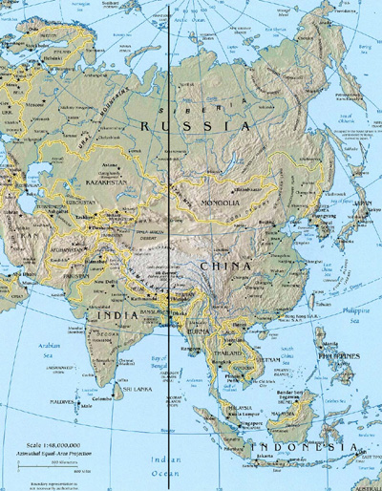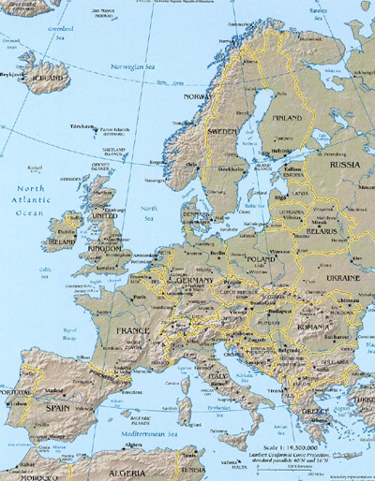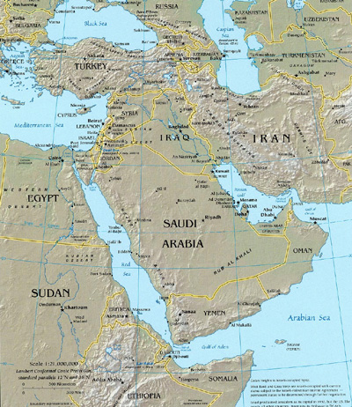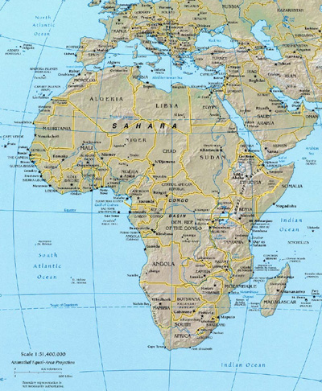

Mempa mIch Qo’noS mIch

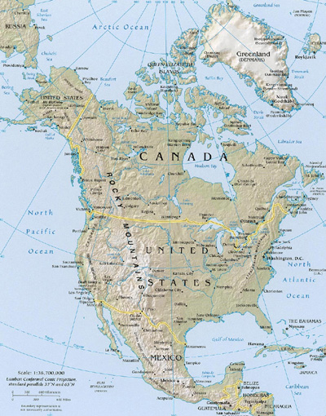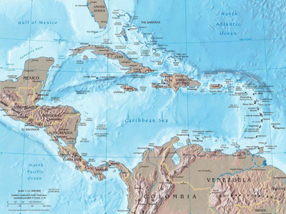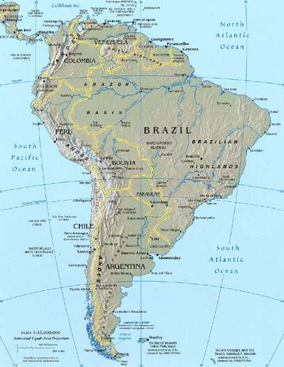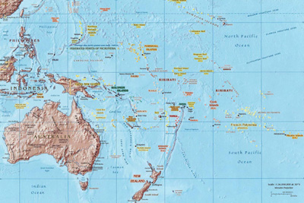

Fleet Formation

Currently there are 10 Operational Fleets under direct control of the Expeditionary Forces that answer directly to the Chief of Fleet Operations, yujquv (High Council), the Thought Admiral and the Chancellor.

Mempa mIch (Mempa Sector)

Cha’DIch yo’ (2nd Fleet) Operational Areas:

* UK & Europe

Qo’noS mIch (Kronos Sector)

wa’DIch yo’ (1st Fleet) Operational Areas:

* Ohio, Indiana, Kentucky, Michigan, West Virginia and Virginia

wejDIch yo’ (3rd Fleet) Operational Areas:

* Georgia, Florida, Alabama, Tennessee, Mississippi, North & South Carolina

loSDIch yo’ (4th Fleet) Operational Areas:

* Missouri, Louisiana, Arkansas, Arizona, Texas, New Mexico, Oklahoma

vaghDIch yo’ (5th Fleet) Operational Areas:

* Connecticut, Distract of Columbia, Maine, Massachusetts, New Hampshire,New Jersey, New York, Pennsylvania, Rhode Island and Vermont

javDIch yo’ (6th Fleet) Operational Areas:

* Alaska, California, Colorado, Hawaii, Idaho, Montana, Nevada, Oregon

SochDich yo’ (7th Fleet) Operational Areas:

* Illinois, Iowa, Kansas, Minnesota, Nebraska, North Dakota, South Dakota and Wisconsin

HutDIch yo’ (9th Fleet) Operational Areas:

* Australia, Japan and The Phillipines

wa’ maHDIch yo’ (10th Fleet) Operational Areas:

* Argentina

Squadron Formation

Squadron Operations are very common within the Empire as they are the structural backbone of the Fleets and during crisis situations form Battle Groups and have been covered by Klingon Tacticians in great detail. A Squadron consists of a minimum of 3 ships or 5 when the Squadron is formed from Scouts Class vessels or smaller, unlike those of Starfleet, Klingon Squadrons are named after their Commanders such as for example “Vamphry’s Squadron” and operate in a formation known as a k’tazi or Arrowhead. During extended missions the Squadron will have a Fleet Tender assigned for the sole purpose of re-supply; this vessel is placed in the hollow centre.

Battle Groups

Battle Groups are only established during a crisis situation and contain a maximum of three Squadrons and the Battle Group is given a number and form what is known as a d’li’k’tazi or Grand Arrowhead, the strongest Squadron is placed at the tip while the other two Squadrons form the corners, the hollow centre is where the Admirals Flagship and Fleet Tenders take up position. The Battle Group is only dispersed once the crisis situation has been averted and the individual Squadrons return to normal Fleet Operations.

IKEF Imperial Marine Command

Welcome to the Imperial Marine Command of the Imperial Klingon Expeditionary Forces.

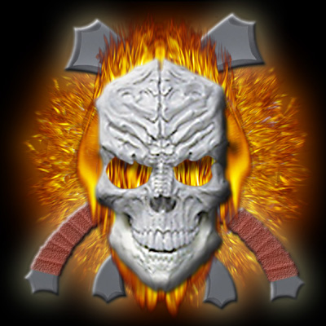

* First and Foremost have fun, enjoy the fellowship of all Klingon fans throughout the Empire.
* Promote the IMC through Community Activities and Convention Appearances, which includes providing Security at Conventions.
* Recruitment Drives are the only way for the IMC to grow, this can be done by recruiting new members and remember to have fun when doing it and the only restriction is your imagination.

The Imperial Marine Command is our first line of battle; they are the ground troops in warfare. They patrol our domain with the assistance of the Imperial Navy and are responsible for takeovers, seizures of worlds, bases and other vessels when necessary.

In IKEF, the Marines have Non-Commissioned and Commissioned Officer Ranks just like the Imperial Navy, they operate within the same Chain of Command i.e. Ship, Battle Group, Sector and Quadrant Commands. Only Marines can promote Marines, their voice is represented by the Marine Commandant who resides on the High Council to assist in strategic affairs of the Empire; the Commandant is also responsible for the IKEF Special Forces, a classified missions department.

A Marine can achieve like any other member the Highest Honors that can be bestowed upon a Warrior for their hard work and devotion to duty in the name of IKEF which will elevate them through the ranks. They can achieve Command positions such as Ship, Battle Group, Sector, Quadrant or even one day Commandant but that would take a great many years of service.

Marine positions such as Deputy Commandant and Command Sergeant Major are given by the Marine Commandant to assist him in keeping contact and function to all members.

* Deputy Commandant – Keeps track of all Marine Officers and all Marine Promotions.
* Command Sergeant Major – Keeps track of all enlisted personnel.

On occasion the Marines serving aboard Naval Vessels may be called upon to assist in specific duties that fall directly under Marine Jurisdiction. When this happens, the Marine Commandant will inform Imperial Naval Command that there is an upcoming mission and will request a specific number of Marines depending on the availability of said Marines.

The First Duty of Marines *(see below)* serving onboard a Naval Vessel is the Ship and its Commanding Officer, who may also assign them as personal guards for specific personnel aboard the ship such as a visiting ‘aj (Admiral) or Diplomat.

Ranks and Honorifics

Ranks within Fandom are achieved through merit, dedication and the willingness to be apart of an Organisation or Fan Club. All new members starting out in Fandom for the first time will enter the Navy/Fleet with Bekk which is more commonly known as Warrior as there are no enlisted ranks in the Navy and are encouraged to acquired a uniform as soon as possible, with the Marines however they start in the enlisted ranks with Da’ wa’DIch which is the Federation equivalent to a Lance Corporal. When a Warrior has proven him/herself they would be considered for promotion by their Commanding Officer unless they are considered Officer Material thus gaining the rank of lagh – Ensign (Navy) and lagh – 2nd Lieutenant (Marines) with both receiving the Honorific of akhtai, once an Honorific is awarded it can not be removed unless a Warrior undergoes Discommendation.

Naval & Marine Officer Rank Insignia and Honorifics

The following Ranks and Honorifics are indicative to IKEF only

Rank Pins are worn on the Right Collar, the Branch Insignia on the Left

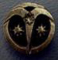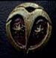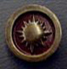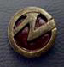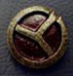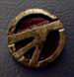

Branch Insignia



Uniforms

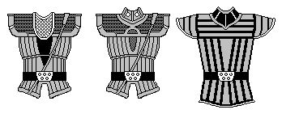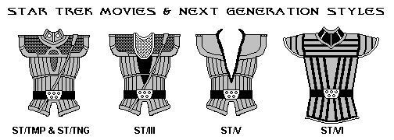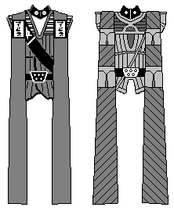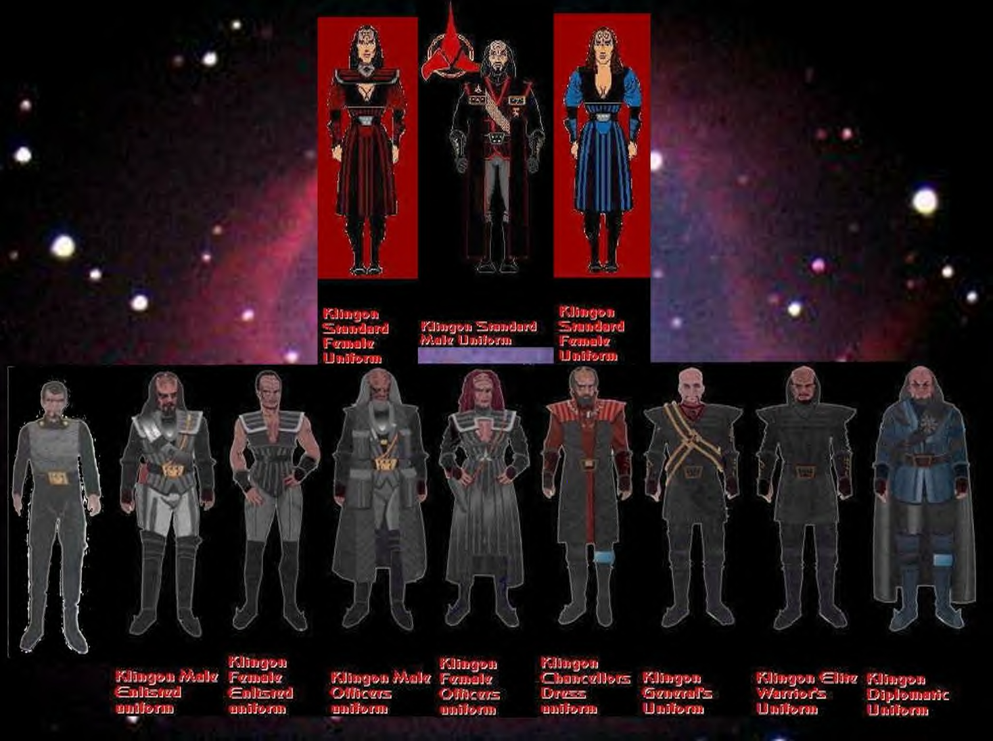

Promotion Policy and Procedures

Promotions are awarded for service to IKEF; all promotions are earned and will not be granted for any other reason. Promotions are made only one rank and honorific at a time in all circumstances it must be remembered that no one can promote himself or herself, the lowest level promotion resides with the ship C.O. All Commanders of Ship, Battle Group, Sector and Quadrant can promote up to one rank and honorific below their own but not equal to.

Just for the sake of clarification rank and honorific are fictitious and do not mean that one member is superior to another and must never be used to demean or belittle another member. If a

Warrior is transferring from another fan club IKEF will accept any rank last held as long as you provide IKEF with the proper documentation from a previous Commanding Officer. Ranks such as yo’ HoD (Fleet Captain), ‘aj (Admiral) and higher are awarded by the High Council when earned within IKEF.

How Do I Get Promoted?

All of us like to get some type of recognition or award for service; promotions involve participation and contributions to IKEF. What you put into your membership you will get out of it, IKEF’s policy is if you participate you will get promoted, it’s that simple. Members are encouraged to participate at the Battle Group, Sector or Quadrant levels if they inform Command of their interest.

# Approaching the High Council

The High Council will hear anyone who comes to us about anything within reason of course, in the event of dissatisfaction a formal complaint must be typed or hand written and submitted to all Council Members. If your problem involves another member of IKEF you must first talk with this member before formally complaining, a formal complaint will have little merit unless a verbal or (written in the event of great distance) effort to rectify the situation has been attempted. The facts that are made available will be the deciding factor in all decisions made.

Once a decision is reached all parties involved are expected to go back to their posts with business as usual, professionally. In the event that an Officer on any level of Command makes a decision that is sorely disagreed with, it may be brought before the High Council for appeal. At which time the Council Members will examine the facts at hand, make enquiries and rule in the fairest manner they can. Decisions made are final unless new evidence is submitted which deems a review of the dispute in question.

# What Decisions Do the High Council Make?

The High Council endeavours not to interfere but to assist and rules over the following:

* Unresolved issues
* New proposals
* Flag Officer appointments and promotions
* Club changes on a Fleet or World-wide scale
* Changes in the Chain of Command design to suit Fleet needs

# What Can Area Commanders Do without the Need of Council Approval?

The Commanders of the various levels of the Fleet can do anything they want within their Command as long as it does not breach IKEF Policy. To clarify, all Commanders can:

* Promote any and all Warriors under their Command as deemed worthy
* Appoint Warriors to positions as needed
* Activate new (uninhabited) Command Areas upon gaining members
* Design logos and symbols for their Command Area(s)
* Reduce Rank if warranted, not Honorific
* Remove Warriors from positions if warranted under poor performance

# Changing How Things Are Done Within IKEF

In every fan club there is always something that doesn’t work right at one time or another, the best way to get changes made within IKEF is to submit a proposal in writing to the yejquv (High Council.) Your submission will not fall on deaf ears; we will look into issues no matter how minor they may seem. If you are right and we benefit from it we will reward you for strengthening the Empire, if you are wrong then we will just go back to our original course until another solution presents itself.

Once a proposal is ratified or denied the individual proposing will be notified as to what the decision is and how it may be implemented into IKEF. Obviously, not everything must go through the High Council; most issues can be solved through the various levels of Command and most of the time they are.

Treat any situation with wisdom, give your immediate C.O., a chance to address your suggestions and if they fail to do so then and only then take it before the High Council for consideration.

Ranks and Honorifics upon Entering IKEF

Members with prior organised fandom experience: IKEF believes that a Star Trek fans’ work is his own whether it was done in IKEF or not, a fan is a fan and we have all done our part at one time or another to keep Star Trek alive. Therefore, those who come into IKEF with ranks earned in previous clubs may join with the last rank earned after approval of the Sector Commander, Chief of Fleet Operations or the Thought Admiral. If not approved they will start out as HoD (Captain) in IKEF.

Note: Members from previous fan clubs entering IKEF must show credible documentation from a previous Commanding Officer and/or Organisation. If unable to do so, the Warrior will enter as a Lieutenant. Members who are joining fandom for the first time will start out as a crewman.

Ranks in Relation to Positions in IKEF

Which is to be put first, a Warriors rank or the position they hold? Is it a HoD (Captain) who Commands a Battle Group or a la’ Hom (Lieutenant Commander) who runs a Sector? The answer is the position, no matter what the rank of a Warrior the position is adhered to first, then the rank. People come together and form groups out of their experiences in previous clubs and often go by their rank last earned, over time this has created situations like the above example that makes a Warriors rank not always denote their position.

It isn’t convenient but it does give a Warrior a rare opportunity to get involved without having to start from scratch in terms of rank.

Dual Membership

Dual membership is acceptable within IKEF, however when a member is in Command on any level we prefer that they do not have dual membership due to potential conflicts of interest but it is not mandatory because we want our members to interact with other groups and friendship between groups is a good thing but we ask these Officers to show due diligence giving the proper time and effort to their Command.

Duties of All Positions

Most of us are familiar with the various positions that can be earned within a Klingon Fleet but what exactly is the job description? What are Warriors holding these positions supposed to be doing, here is the answer?

Leader of the yujquv “High Council”

Only one Klingon may hold the position of Leader of the High Council and that is the Thought Admiral who is in overall Command of the Organisation and this Warrior can be either male or female. The duties of the Thought Admiral is to provide an atmosphere in which to play and with the aid of the Chief of Fleet Operations distributes duties and objectives for the Fleet to accomplish, assign Commands in areas to further growth and fan excitement, design battle strategies for all affairs, activities and/or concerns voiced by the membership.

Chief of Fleet Operations

The Chief of Fleet Operations is responsible for the daily operation of IKEF Administration and Commands, assisting the High Council and the Thought Admiral in accomplishing objectives within the organisations sphere of operations and beyond. The CFO is responsible for all literature, brochures and promotional materials to be designed and distributed among the membership and sees to it that all positions within IKEF are running at peak efficiency to accomplish the directives laid down by the Thought Admiral and/or the High Council.

Administrative Staff

The duties of the Administrative Staff are to provide support and assistance for the Fleet coordinating with the membership to acquire the raw materials to accomplish tasks on a Fleet wide scale.

The Imperial Ministry of State

To you, the new Imperial Ministry officer, I bid you greetings. What you are holding in your hand is a revised edition of the Operations and Procedures manual of the Diplomatic branch of the IKEF- the Imperial Ministry of State.

What I’ve tried to do in this manual is to set a framework for all of us to work within and clarify exactly what is expected as well as how we will operate. The text is not set in stone - all things are subject to change. There may be a procedure that may be altered or abolished altogether because it may not work. And if you come up with a new idea or have a question about something, don’t be afraid to speak up. I want working channels of communication in this branch. Never be afraid to contact me.

You can email me at [heghetlh@ntlworld.com](mailto:heghetlh@ntlworld.com) .

I will make every effort to return all correspondence or if you would prefer a phone call I can do that as long as I have your details on file. In short, let me welcome you to the IKEF and to the ranks of the IMoS.  
  
Qonlatlh zantai martaH yo''aj (Fleet Admiral) Wayne Haines  
IKEF Imperial Minister of State  
  
Definition and Mission Statement

The Imperial Ministry of State (IMoS) is best defined as the diplomatic branch of the Imperial Klingon Expeditionary Forces. Its purpose is to make primary contact with other TREK and science-fiction clubs, act as liaison between the IKEF and the public/media.

Introduction

If you’re reading this document, then the mission statement you just read in the previous paragraph is about as formal as things are going to get. What we do here is simple in design, yet quite complex in nature.  We’re the diplomats of the IKEF.

We are the ones who go and make contact with the rest of the ships, fleets, and groups that are out there. We are also the ones who interact with the public and media when it’s time to set up an event, be it an appearance, a promotion, a convention, or whatever is needed in the line of publicity.   

Well, who are you? You ask. Good question.

I am Qonlatlh zantai martaH yo''aj (Fleet Admiral), Imperial Minister of State for the IKEF and the Commanding Officer of the IKS Hegh'etlh and hold a seat on IKEF High Council. But that’s enough about me.

You may think that it’s unconventional for Klingons to have an Ambassador or any Diplomats at all. I’ve actually heard it said many times. To that, I say that there is more than only one battlefield.  The battle is not always fought with the blade or energy bolt - words are just as powerful, if not more so. Why, diplomats can easily start a war with just a well-placed word. Now I’ll explain the structure of the Imperial Ministry of State.

IMoS Rank Structure  
  
Imperial Minister of State  
Imperial Chief of Staff  
Imperial Consulate-General  
Imperial Consul  
Imperial Pro Consul  
Imperial Aide-de-Camp (boQDu')   
Imperial Attaché  
Imperial Envoy  
  
Imperial Minister of State: The Imperial Minister is the Chief Diplomatic Officer and leader of the IMoS. His is the final word on all diplomatic matters. The Imperial Minister is empowered to grant Diplomatic Appointments, bestow Diplomatic Ranks, and approve any and all Alliances.   
  
Imperial Chief of Staff: The Chief of Staff is 2nd-in-command of the Ministry. The Chief of Staff regulates the work of all Consulate-Generals and may recommend to the Minister of State any prospective Diplomats for Consular Appointments and monitors Consular dialogues in regards to the forging of Alliances. He answers to the Minister of State.  
  
Imperial Consulate-General: The Consulate-General is the Officer in charge of IMoS personnel in an established Sector (State), and answers to the Imperial Chief of Staff. The Consulate-General is duly empowered to establish an Embassy in his/her Sector and appoint Regional Consuls within various Regions of their Sector.  
  
Imperial Consul: The Consul is the Officer in charge of IMoS personnel in an established Region of a given Sector and answers to the Consulate-General of the Sector. A Consul is empowered to establish an Imperial Regional Consulate (a satellite IKEF diplomatic post) with Staff, and may also form and establish Alliances with approval.   
  
Imperial Pro Consul:  A Pro Consul is the Executive Officer of an Imperial Consulate and oversees the workings of the Aides working within the Consulate’s area. Imperial Consuls are empowered to select their Pro Consul.  
  
Imperial Aide-de-Camps: Aide-de-Camps (Aides) are Senior Consulate Officers and are empowered to oversee the work of the Attaches and Envoys.  
  
Imperial Attaches: Attaches are Junior Consulate Officers, and may often carry Dual Memberships with other Organizations. They act as representatives of IKEF to other ships when conducting Diplomatic business.  
  
Imperial Envoys: Envoys are usually entry-level Diplomatic Officers, but may often be assigned to a specific Allie to work with as a Special Liaison.   
  
Regardless of what rank you hold in IKEF, the proper title for any and all Ministry Officers to use in all Diplomatic business is “Ambassador”.   
  
Embassies

The Imperial Minister of State and any Imperial Consulate-General are empowered to establish Imperial Embassies (where they reside). To avoid any confusion between them, the Imperial Minister’s embassy shall be referred to as the “IKEF Imperial Embassy”, while a Consulate-General’s Embassy shall be referred to as “IKEF Imperial Embassy - [name] Sector” and a Consul‘s Embassy shall be referred to as “IKEF Imperial Embassy - [name] Region [name] Sector“.     
  
Liaisons

Besides working to establish links with other clubs, Ministry Officers are called upon to serve their ship as liaison to the media and the public in general. “What does this entail?” you ask.

Simply put, you’ll oversee setting up promotional events when they are planned (In other words, if your ship decides to help promote a STAR TREK event at a local hotel or convention centre, it’ll be your task to set things up with the venue, such as making sure there’s at least one or more tables and two or three chairs and the like.) and working with the local media when possible in order to promote such events.

What I’ve just explained doesn’t make you a glorified Publicity Officer (although if your ship has one, no offence intended, I’ve always believed that every office on a ship serves a viable purpose, no matter what it is.) No; not by a long shot.

You’ll also be the Officer who makes contact with local Organizations, Groups, or places for specific projects or any event/outing that your ship may want to take part in for fun. By this point in your reading, you’re probably wondering exactly what it is you’ve gotten into. You’re probably thinking, “I’m going to be making all the phone calls and setting everything up myself.”

Listen, it’s not that bad. But its work and I won’t deny it. You don’t have to do it all yourself, especially if others just happen to know the contacts you need to make and everyone knows someone. Learn to delegate as it’s an important skill (one I’m still working on to this day, believe it or not).  One of the principle rules of the Ministry is “Don’t be afraid to ask for help.” I’ll discuss this and the other rules later.  
      
Operating Principles

Another name for what I’m going to discuss next might be our “Commandments”. These are the tenets by which you as a Ministry Officer should keep in mind as you do your work. Some of these may be self-explanatory and common sense, but they need to be said.

* Know when to turn the role-playing switch on or off. There’s a time and place to be Klingon, make sure you know the difference.
* Learn to take No for an answer. If you’re told “No” by someone, be they a Store Manager, a Media Figure, or another Club’s Representative, accept the answer and move on. If you press the issue, it makes you appear rude and pushy and in turn it reflects badly on Fandom in general.
* Never be afraid to ask for help. I cannot stress this rule enough. If you should take on a task and find that it’s more than you can handle, there is no disgrace in asking for help.
* The disgrace is in trying to do it all yourself and ending up with something half-done, poorly done or not even done at all. (This also applies to the next step - if you are in a situation where things are getting out of hand and you may be heading for trouble, ask for help QUICKLY.)
* Avoid Politics at all costs, I cannot stress this enough. Politics are the kiss of death to any Organization. If you should find yourself in a situation that is turning political -- GET OUT OF IT QUICKLY. Notify your Superiors immediately. (If necessary, notify me as well.)
* Never be afraid to ask questions. If you don’t understand the task at hand, ask questions. It’s the only way you can learn. It’s how I learned when I got started.
* Don’t be an embarrassment. This needs no explanation.
* What worked yesterday won’t work today, and what doesn’t work today may help design what will work tomorrow. The old methods may not always be effective, you should always be looking for new and innovative ways to do things and if something fails to work, then learn from it and apply that knowledge for the next time.
* The only sort of failure that will not be tolerated is the failure to risk failure. There is a saying in The Klingon Way that states, “If you are afraid to die, you have already died.” All I will ever ask of any IMoS Officer is that you at least try. If you are able to learn from your failures, you can only improve.
* Never let your success go to your head. Enjoy a success for that moment and after the glow has faded, get started on a new goal. If you rest on your laurels, you’ll lose your edge. Never be satisfied, always be hungry.
* Be nice, as I said in the first step, there’s a time and place to be the fierce Klingon Warrior. Role-playing is fun, but when it comes down to business, put the Warrior away. A little Martok in your behaviour never hurts, but too much could land you in jail. Kindness and politeness do work. In the Diplomatic trade, they are essential tools.
* Above all, remember - this is a hobby and meant for fun.

I’ll be the first to tell you that diplomacy is a difficult art to master; it involves constant communication and knowing how to handle yourself when things get taken out of context or just messed up. You should always attempt to maintain a proper perspective in all situations and if you have to compromise, do so but try to do so that it benefits both the Club and yourself.

If a problem should arise and at times it will, regardless of what you do (Remember Murphy’s Law – that human really knew what he was talking about) try to figure out what went wrong and solve the problem, above all else, be professional. If the gagh hits the warp coil (the Terrans call this “The spam hitting the fan”) and (Kahless forbid) politics should enter the situation - back away from it all. There is no cowardice in backing out of a conflict.

Take the time to re-examine everything - including your own part in the matter, then if you’ve got a grasp of the situation, try starting over. If it doesn’t work again, keep trying. There are no set rules for doing this sort of work. The rules I gave you in the previous paragraphs were also principles to keep in mind as a Diplomatic Officer. I cannot teach you my style as it took me this long to actually develop my own style and I’m always improving, changing and building on it – even after a decade, I’m still learning. You have to develop your own style and I know you can do it.  
  
Alliances

This is to use a Terran expression the “meat and potatoes” of our work. We work to find and forge Alliances with other forces in order that we all can grow and benefit from sharing knowledge with our counterparts. Forging Alliances is not something done quickly, as I said previously, it is an art form and my style may not work for you. But it is something that should always be done carefully.

The first step that you should take when you discover a prospective Allie is to find out who’s who within their Chain of Command. Do they have a Diplomatic Representative? If so, this is the one you open a dialogue with. If they don’t, then you contact the Head of the Organization – that’s right, go right to the top! 

Once you have the dialogue opened, explain who we are and what we do and offer the idea of an Alliance with them. If they accept the idea, that is when you craft the Articles of Alliance – the Accord (see the Appendix), installing the names of the respective Allie and their Representative (replacing the respective example that you see), as well as your own name and that of the IKEF. Be sure to include the proper Signature Statement, also known as the Full Powers Statement– this is a paragraph that certifies you are a Diplomatic Officer who is duly empowered to conduct the forging of the specific Alliance.

DO NOT SIGN ANYTHING UNLESS SPECIFICALLY NOTIFIED BY ME!

As Klingons, our given word should be enough and this statement has been sufficient.  [If you have never actually made an Alliance using this template, fill it out and send the Chief of Staff or myself a copy of your work before sending it to a prospective Allie so that the work can be double-checked before the Alliance is finished.]

Disciplinary Measures

This is the section that I hope I’ll never have to deal with but it has to be here so that you have a complete understanding of how things will be done. Should any Ministry Officer commit a flagrant and serious violation of any rules of the Fleet or any of the prescribed rules of the Ministry itself, as well as any common sense rule or social law (i.e. physical/mental abuse, property damage, etc.), the following sanctions will be levied against that Officer.

1st Violation: A written warning will be issued to the officer in question as well as to his CO.

2nd Violation: The officer in question will be on probation for a period of no less than 30 days and no more than 120 days.

3rd and Final Violation (“The 3rd Strike Rule”): The Officer in question will be summarily dismissed from the Imperial Ministry with an official recommendation for summary dismissal from the IKEF which will be sent to the Thought-Admiral.  
  
Conclusion

I’ve spent these pages telling you how things will be in this Branch and what I expect from you as a Ministry Officer. Now I want to tell you what you can expect from me.

* You won’t be doing all the work. I’ll be working just as hard as you are - if not harder. We’re all in this together.
* As long as you’re straight with me, I’ll be straight with you. Above all, I value honesty.
* If you’ve got problems with your work, don’t ever be afraid to contact me and ask questions. Like I said earlier - it’s the only way you’ll learn.  It’s the same way I learned; if I didn’t know about something, I asked.
* If you make a mistake in doing something, tell the Chief-of-Staff about it, and if needed, I’ll be informed. We can sit down and figure out how things went wrong. If you make a mistake and I should find out about it second-hand, then we will have a problem.
* I won’t reprimand you for making mistakes. I will reprimand you, however, if you don’t learn from the mistake.
* You’re my Officers - I’m your Superior. If you should draw any sort of flak from doing your work, I will back you all the way (unless any rules are broken).

This is what you can expect from me - pure and simple.  
  
In closing, I can only say one last thing to you - welcome to the Imperial Ministry of State!

Qonlatlh zantai martaH yo''aj

IKEF Imperial Minister of State  
  
Written on this Star date - 9711.01  
Revised on 08.14.06  
APPENDIX I: ACCORD TEMPLATE  
  
Diplomatic Accord  
  
Between [Organization/Group/Ship] and the Imperial Klingon Expeditionary Forces, negotiated by Ambassadors of these respective Governments.  
  
All diplomatic dialogue will take place between designated representatives of both groups. Unless otherwise specified, the chief diplomatic representative from [Allie name] will be [representative name]; the Chief Diplomatic Representative from the Imperial Klingon Expeditionary Forces will be [IKEF Diplomatic Officer].  
  
Part I - Preamble  
  
The terms and conditions having been negotiated and agreed to be identically understood, [allie name] and the Imperial Klingon Expeditionary Forces mutually pledge to each other their solemn word for the following purposes, effective Stardate [date];  
  
    ¥ to reconfirm the balance of power in the Quadrants while accepting each other as worthy opponents in role-play and partner in matters of real life;  
  
    ¥ thus to define a stable and lasting relationship and understanding between these two Governments; a relationship which relies on communication, cooperation in mutually beneficial activities, and the pursuit of peaceful enjoyment of their respective Organizations in the STAR TREK Universe.  
  
Part II - Declaration  
  
Now come the representatives of [allie name], hereafter known as [allie name], and the Imperial Klingon Expeditionary Forces, hereafter known as the IKEF, to declare that an alliance has been formed for the mutual benefit of their respective Organizations.  
  
Part III - Purpose  
  
This Alliance does not denote the implication of a merger, or for the purpose of a coup de tar, but to strengthen the individual Organizations in the world of Fandom and promote good will between Organizations of similar interests and concerns.

Part IV - Statement of Separate Entities  
  
Under the provisions of the Alliance, [Allie name] and the IKEF will remain separate entities governed by their established organizational bylaws and guidelines. In no way does the Alliance grant permission to the either present or future member(s) of the Alliance to exercise any type of control of member Organizations.  
  
Part V - Provisions  
  
The Alliance consists of the following provisions. These provisions may be amended by mutual agreement of the member Organizations.  
  
1. A continuing dialog through correspondence or face-to-face encounters between Diplomatic Representatives of the respective organizations for the exchange of information concerning the STAR TREK Universe and for their direct discussion, enabling further growth for both Organizations.  
  
¥ Diplomats are not only seen as Representatives of their Government. Preventing misjudgement and underestimation while supervising rights, Honor and interests of their Organizations and their members, but also as individuals being a positive example for the whole of Fandom, openly-minded they support interaction between the individual chapters and the Organizations.  
  
2. A continuing dialog through the contact between individual members: members of the Organizations who participate within the Alliance may attend meetings and functions as guests (non-voting members) and will be given the respect due to an Allie by the host Organization.  
  
3. A continuing dialog through role-play between chapters and members of the respective Organizations to support the aims, purposes, spirit, and philosophy of the Prime Directive and the Way of the Warrior.  
  
3.1. The members of the respective Organizations are:   
  
3.1.1. Welcome guests at any meeting of the respective Organizations:  
    ¥ As a guest, they will act as observers only; however, they may add input based on experience or knowledge.  
    ¥ The guest will be accorded the respect due to him or her as a Diplomatic Representative.  
  
3.1.2. Invited to take part in role-playing games (PBM/LARP).  
  
4. A translation of the Prime Directive and the Way of the Warrior.

4.1. Both Organizations – [Allie name] and IKEF is no forum for political or religious debate, nor are they vehicles of ambition.

4.2. All forms of competition only exist in the realm of fantasy.  
  
The Organizations commit themselves to the rule of equal rights, equal dignity, and mutual respect for all species, life forms, and sentient beings.  
  
4.3. All representatives of the undersigned Organizations shall take seriously any violation of one of these principles filed against a member of one Organization by a member of another Organization.

4.4. It is agreed to appropriately investigate such allegations, involving all necessary levels of the Organization as is necessary to resolve and ameliorate said situation.  
  
5. An agreement of mutual assistance.

5.1. [Allie name] may turn to the IKEF when needed and if required by the principles of the Prime Directive and the Way of the Warrior.

5.2. The IKEF may turn to [Allie name] under the same options.

5.3. This agreement may also include newsletter exchanges, cultural exchanges, and links between web pages, etc.  
  
6. Disagreement between individual Organizations.

6.1 Will be arbitrated in an open forum by the governing bodies of the interested Organizations.

6.2. If the matter cannot be settled by mutual agreement, an objective third party member may be selected to hear the arbitration, agreed upon by both parties in disagreement.  
  
7. Members may enter into open discussion concerning the Alliance with other Fandom Organizations.

7.1. Admission into the Alliance must be by mutual agreement of the members of the Alliance at the time of petition or request.  
  
8. Dual Membership.

8.1. If a member of the IKEF chooses to hold membership in [Allie name], they may do so.

8.1.1. The IKEF member shall begin this new membership with the respective rank of a new member.

8.1.2. Rank progression shall occur as per [Allie name] protocol.

8.1.3. When participating in any [Allie name] activity, the IKEF / [Allie name] member shall be subject to [Allie name] procedures, since they are acting as a [Allie name] member.

8.1.4. If the IKEF / [Allie name] member commits a violation of [Allie name] rules/procedures, he shall be adjudicated under [Allie name] auspices.  
  
8.2 Sections 8.1 to 8.1.4 shall also apply where a member of [Allie name] holds membership in the IKEF.  
  
Part VI – Signatures/Full Power Statement  
  
I, [Allie Representative name], having read the terms of this accord do hereby certify that I am a Diplomatic Representative of the [Allie name] with full powers to execute this accord on behalf of [Allie name];  
  
I, Imperial Ministry Officer [name], having read the terms of this Accord, do hereby certify that I am of [Imperial Ministry Rank] of the Imperial Klingon Expeditionary Forces, Imperial Ministry of State with the full power to execute this Accord on behalf of this Government.

Appendix II – Directory of Personnel  
  
Wayne Haines (Qonlatlh zantai martaH yo''aj)  
IKEF Imperial Minister of State  
Email: [heghetlh@ntlworld.com](mailto:heghetlh@ntlworld.com)   
  
Mary Thacker (Mara sutai Makhleod la’)   
Imperial Consul: Southern OH Sector  
Email: [cmdr_mara34@yahoo.com](mailto:cmdr_mara34@yahoo.com)   
  
Glenn Thacker (Rajuc sutai Makhleod la’)   
Imperial Envoy: ITF  
  
Keith Dennis (Qomass ‘ech)   
Imperial Consul: UK Sector  
Imperial Envoy: SFC

Email: [qomass@ikv-qongdij.fsnet.co.uk](mailto:qomass@ikv-qongdij.fsnet.co.uk)   
  
David Taylor (Ka’Vid sutai Trekkan HoD)   
Imperial Consulate-General: Oklahoma Sector  
Imperial Envoy: KAG  
Email: [klingondet@sbcglobal.net](mailto:klingondet@sbcglobal.net)   
  
Lee Schmidt  
Imperial Envoy: SFC/USA Sector  
Email: [LVSMO135@juno.com](mailto:LVSMO135@juno.com)   
  
Charles Hooper (Kh’Per Nveid Makhleod HoD)  
Imperial Envoy: RSE  
Email: [jelloman05@aol.com](mailto:jelloman05@aol.com)   
  
David Young (Khavid tai-vesmai Makhleod Sogh wa’DIch)  
Imperial Envoy – Black Knights Mercenaries Group  
Email: [khavid_makhleod@yahoo.com](mailto:khavid_makhleod@yahoo.com)   
   
Jessie Apel (Vekma sutai H’Tims Kpel HoD)

Imperial Consulate-General: Georgia Sector  
Email: [vekma@coastalnow.net](mailto:vekma@coastalnow.net)   
  
Chief of Intelligence

People often associate the term “Intelligence” with the word “Spy” but we now have no need for spy’s in light of the damage caused in times past from previous club experiences. The duties of the Intelligence Department is to acquire information regarding anything and everything that may impact fandom or IKEF in general, the reality that a lack of communication can kill you and most of the greatest battles have been waged based on information it is reasonable to have an intelligence department and in the light of the current situation within fandom information on those who would harm fandom is a must.

Fleet Medical

The Fleet Chief Surgeon holds this position which is the Head of all Medical within IKEF, this Warrior facilitates medical practices and encourages training in all life saving methods and keeps track of all medical personnel on all levels of Command within IKEF.

Special Forces

An Elite Force of Marines that handles the most delicate and extreme of missions when required but their primary duty is the internal and external security of all those who serve IKEF and their Allies when called upon.

Fleet Line Registrar

Duties are to make contact with all Family Lines within IKEF and keep a detailed database on each House and their members.

Fleet Quartermaster & Fleet Geneticist

Duties of these two Warriors are to assist in gathering information on companies where members can obtain the necessary materials to construct a uniform which would also include patterns, make-up, wigs, spirit gum, moulding clay and the liquid latex required for the head piece.

Command Duties

The duties of Area Commander’s include:

Promote growth.

Accomplish given tasks.

Making sure the communications between Commands are consistent.

Promotes Warriors as and when deemed worthy.

Appointing Warriors to positions as needed.

Keeping track of records for all members within their Command Area.

Making that all new members are contacted and officially welcomed to IKEF.

Appropriately deals with all concerns and/or issues.

These duties apply to all levels of Command

Ship

Battle Group

Squadron

Fleet

Sector

Principle of Command/Majority Rule

One thing a Warrior must have in order to Command on any level within IKEF is the majority support of those who serve under them.

Ship (Chapter)

How Do I Start a Klingon Ship?

Firstly you must have at least 3 people to start a ship or local chapter, after that you must try and recruit more crewmembers and at least the captain to have a uniform but not required. Ideally we would like to see as many crew member as possible to have a uniform from the basic TOS to Imperial.

As a Fandom Organisation we always like to see the following happen onboard a ship of the Fleet.

Ship Events

Joint Activities

See the crew prosper in fun

Things that we don’t want to see happen aboard ship.

Constant changing of the Commanding Officer

Constant unsolvable issues

There are always misunderstandings aboard ship, what is important is how these matters are resolved. Here are some valuable tips to keep in mind.

Your crew will make mistakes, how you deal with those making the mistakes is crucial to your Command and you must be able to properly determine who is at fault and help them to take responsibility and accept the consequences and make sure you get the facts as best you can.

As the Commanding Officer you will from time to time make mistakes yourself, as a leader it will most likely be a costly one because it’s your Command. All you can do is hold your head high and take responsibility and be ready to accept the consequences, as long as you do that Honor will remain intact and that you learn from the mistake.

Ship (Chapter) Activation

Once you have gathered a group of friends together numbering three or more who are interested in starting up a ship, you must first choose a name but remember to keep away from words like Knife, Blood or Bloody as they have been used too many times in the past. Then create the design of your ship or just use one of the regular Klingon designs from the show and leave dry-dock when convenient.

Ship (Chapter) Deactivation

The organisation does not deactivate a ship without a good reason; there must be an agreement from the crew unanimously before official deactivation can occur. In most cases a Warrior with support from the crew will step up and take Command and carry on that which was created.

Ship Positions

Commanding Officer – A Commanding Officer is responsible for the efficient running of his/her ship crew. (Refer to Command Duties)

Executive Officer (First Officer) – Duties are to directly work with crew to achieve efficient battle readiness, recommends Officers for tasks and advices the CO in all ship decisions.

Chief of Security (Tactical) – Secures areas or locations for events, ship functions and arranges security details, conducts investigations when necessary, communicates possible security risks to CO and XO.

Chief Engineer – Lists all materials needed to accomplish tasks, handles all hardware, knowledge in acquiring gadgets and materials to achieve possible objectives, someone who is the fix it type and provides hands on assistance for any station(s) in need of repair.

Chief Weapons Officer – Responsible for keeping the crew armed at all times by locating much needed supplies for creating none threatening weapons that look like the real thing.

Chief Medical Officer – Informs and encourages medical practices, keeps basic records of crew health history and conditions, is certified in at least one of three life saving methods.

* CPR
* Heimlich Manoeuvre
* Basic First Aid

Monitors weather conditions in preparation for arrival at events, checks accessibility for any disabled members and response times for medical services in the event of accidents. A detailed survey of the surroundings to make sure that all areas are accessible, labelling of products and arranging medical volunteers.

Helmsman – Pilots the vessel, plotting course corrections, a working knowledge of state routes, highways and interstates as these will come in handy for when arranging travelling to and from conventions.

Communications Officer – Organises communications between the vessels of the fleet, keeps the fleet and Allies alerted to all ship activities and events and of course keeping friends and family close and in the loop.

Transporter Chief – Coordinates with the Helmsman with regard to transportation and carpooling to and from events.

One question is asked regularly: “What positions can I use to give members when all of the above listed positions are taken? Well the answer to that is to consider the above positions as Department Heads and you start to build these departments up, if this build up occurs within all stations your ship will be unstoppable. In turn your Department Heads will resemble the show; they are your Senior Officers, your Bridge Staff, and a ship worthy of battle.

Note: The enlisted ranks work really well when each department is fully staffed.

These are the basic positions in the show, with everyone giving their best and following the position guidelines it should help the team work more efficiently. Of course these are only guidelines and are not required descriptions, every ship is different and the CO may apply the guidelines as he/she sees fit.

Klingon Hybrids – Fusional Characters

The creative imagination of a Star Trek fan is virtually without end but what guidelines should a fusion character go by and more importantly why? We learned from Lt. Dax on DS9 that the Klingon Empire is also quite diverse although the show never depicts that specifically. In the Star Trek Universe we know that there are characters such as Half Human, Klingon, Romulan and even Klingon Borg. What if you recruit a member into IKEF and they want to portray a Cardassian? Then the answer would be no, this is a Klingon Fan Club and what follows is the Official Club Stance on this matter.



IKEF has adopted what we call the “Fusion Philosophy” and it is: Any member of IKEF can represent any Star Trek characterization as long as there is some form of recognition of service displayed on the uniform of the character.

In other words, show your allegiance to the Empire! We know that non-Klingon races are scrutinised harshly by Klingons and are often thought of as outsiders, to avoid this type of stigma a Klingon Empire Service Pin or Medal worn on the uniform is considered Honorable.

It allows the member to explore the character and feeling no ambiguities with a sense of belonging, however to maintain our identity as a Star Trek Fan Club we must conclude that only characters from the Star Trek Universe are accepted as Fusion Hybrid characters within IKEF. Vorlons from Babylon 5 for example are not allowed for obvious reasons – that’s what Alliances are for.

Alliances

Does IKEF have friends, we do indeed and together they make up what is called the IKEF Alliances. Alliances are other fan clubs that don’t wish to join IKEF but just align with us which is an agreement to assist one another and play together successfully.

Negotiations are opened by our Ministry of State Department once our club has been approached; the Ministry of State governs all Ambassadors to and from IKEF, Alliances are not just with other Star Trek Organisations but to all Sci-Fi Organisations interested in mutual cooperation and the sharing of ideas. This is the only capacity in which IKEF will deal with organisations that are outside the Star Trek Realm and it fosters professional ties throughout fandom.

Complaints Concerning Other Fan Clubs

Sometimes we can’t play as well with others as we would like. If a member of IKEF submits a formal complaint regarding a member of another fan club the MOST that we can do is contact the club in question and make a formal address to the leadership regarding the incident in question. In order for the IKEF High Council to accuse a member of another fan club it must be provable and reasonably severe, we simply cannot go before other clubs complaining about their members, let’s face it no one is going to penalise their members without good reason no matter how shady the person may seem.