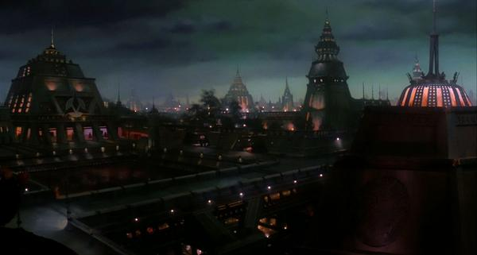

Imperial Klingon Expeditionary Forces
Member Manual and
Warrior Guide

Dedication
To all the members of IKEF, the hard work that went into this manual would have been for nothing without you. For it is because of you The Imperial Klingon Expeditionary Forces exists. This manual is just the beginning of a new era that is in it’s infancy. The manual will grow, as will our membership and our organization. Because of you, the members, this will happen. It is you who make this organization. Our love of Star Trek and Gene Roddenberry’s dream has brought us all together, to share stories, experiences and embracing the spirit of the Klingon Warrior.
All of you are a big part of this manual, this is for you!
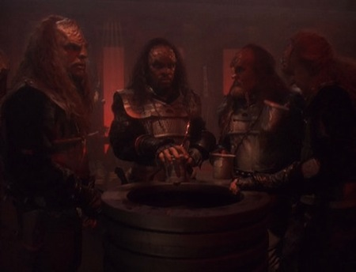
Special Thanks
I would be without honor if I didn’t give a special thanks to a few Great Warriors who have helped me in my task to try and design a manual to match this new era which is upon our organization. They assisted me in gathering some of the information within these pages.
Admiral Qonlatlh zantai-Mar’taH
Brigadier General QomaSS sutai-Trekkan
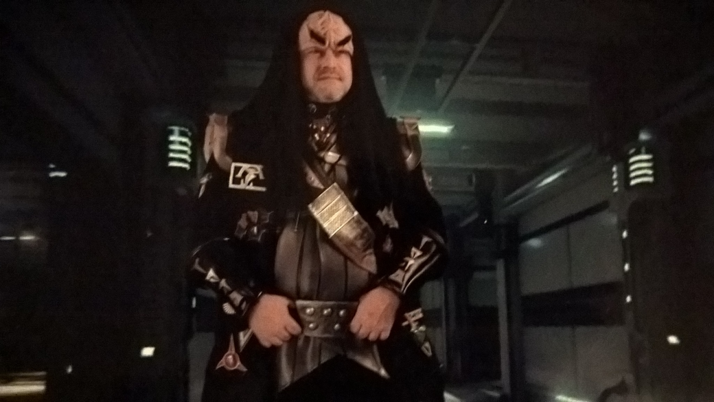
Q'apla
Thought Admiral Zarcon epetai-TaraQ
Greetings,
Great Warriors of The Imperial Klingon Expeditionary Forces
I Welcome You!
You are about to embark on a uniquely different style of Fan clubs. You are about to enter the realm of the Klingon Empire and learn what is to be a Klingon in the 21st century. The Imperial Klingon Expeditionary Force is but one of many Star Trek related fan Clubs. The only thing that sets IKEF apart from the rest is that we are one of the fastest growing Klingon Fan Clubs in the world. As a member of IKEF, you will learn the Ways of the Warrior, what it is like to be a Klingon, what we do, how we do it, and why we do it.
Along the way you will meet interesting and different people. People who enjoy playing a Klingon in a modern day society. These people might be your next door neighbor… your family doctor… your mailman…your co-worker. These people have all share one common interest….. the love of Star Trek and Gene Roddenberry’s dream. And let’s not forget the most Important reason why we choose to be a Klingon. We all want to have fun!
While most of the members of IKEF are Klingon, membership is not limited to just Klingons. This manual will explain the various forms and types of Klingons, found within our ranks. So if you would like to be a Klingon/Human Fusion, or a Klingon/Romulan Hybrid, or a mixed with part of a recognized alien species within the world of Star Trek, then the Imperial Klingon Expeditionary Force is for you.
If you’re interested in starting a local chapter (ship), this manual will tell you how to do it. If you just want to be part of, or join an existing chapter ship of IKEF, this manual will show you how. The Imperial Klingon Expeditionary Force has it all!
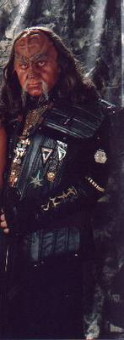
Chancellor Klaad epetai-K'tarra

An Introduction to The Imperial Klingon Expeditionary Force
A nonprofit organization
It is said that for a Warrior, Honor is more important than life. Duty is like a blade sharpened to pierce any obstacle. A Warrior is nothing without Loyalty. All of these things a Warrior must do to truly master the field of battle. To set apart the true Warrior from the savage. We present to you the Official Warrior’s Guide to aid you in your journey for Honor and Glory.
The Warrior’s Guide is designed to enhance and inspire all Klingons for the better enjoyment of Klingon fandom and culture. In this guide we will examine ways of doing things, starting and commanding ships, awards, ranks, and every facet of the Klingon military.

Klingon History
The Klingon Empire was founded about 1,000 years ago by the legendary “Kahless The Unforgettable”. Before this time, Klingons were a savage and warring race split into many different opposing factions, but Kahless united these clans to form the now legendary Klingon Empire!
The entire Empire is ruled by the High Council, who are situated in the Great Hall, in the planet’s capital city, known as the First City. Strictly speaking, as an Empire, it should be ruled by an Emperor, but there has not been one for centuries and the real power lies within the High Council itself. The Great Hall serves as an effectively neutral ground between the many feuding political parties throughout the Empire.
The Klingon Species
Physically, the Klingons are a most imposing race of beings. Males and females have a much greater muscle mass than most humanoids. They also grow taller and faster than humans. Their most striking feature is the ridged forehead that adorns their skull. Only seen in the genetically pure Klingons, the cranial pattern, like the human fingerprint, is unique to each individual.
Human explorers first encountered the Klingons in 2218, and the meeting was disastrous. The humans mistook the Klingons naturally aggressive attitude literally and there followed decades of conflict. At the time, humans and many other races did not understand the Klingon ways, and they were naturally viewed as being a domineering, bloodthirsty culture. In many respects, this is not far from the truth, but Klingons are not mindlessly violent. Klingons are a warrior race – proud and aggressive, and they have a very deep sense of tradition and honor. Their military is among the strongest in the Alpha quadrant. They have been warriors for centuries, and this has made them a race to be feared and respected. The Klingon culture is very similar to that of earth’s ancient Samurai, who followed very similar conducts of honor and tradition.
For many years after they were first encountered, the true Klingon appearance was not known. The Klingons originally encountered along the Federation borders were a Klingon/Human fusion to make infiltration easier. When a distress signal was received from a Klingon warship under attack by V’Ger, the true appearance of Imperial Klingons was discovered, and the level of Klingon genetic engineering amazed Federation scientists. Skirmishes and conflicts continued between the Federation and the Klingon Empire for years until 2293, when the Klingon moon Praxis was destroyed. Praxis was the Klingon’s key energy facility, and it’s loss had a detrimental effect on Klingon politics and economics. With their major energy output facility gone, the Klingon Empire could no longer afford to keep it’s economy together. The destruction of the moon also caused the oxygen in the atmosphere of Qo’noS to deplete rapidly, meaning that the planet itself would only be capable of supporting life for approximately 50 more years. Realizing their hopeless situation, the leader of the High Council at that time, Chancellor Gorkon, initiated an historic peace deal between the Federation and the Klingon Empire. Despite many attempts to unbalance the peace talks, the peace deal went ahead and was successful. Even after the death of Chancellor Gorkon himself. Now the two greatest space fleets in the Alpha quadrant were no longer enemies, more energy and resources could be put into furthering mankind’s projects of exploration, while at the same time helping to rebuild the Klingon economy.
Decades of peace have since followed with only minor upsets to the cooperation that exist between the Federation and the Klingon Empire. On numerous space missions, the Klingon Empire has proven time and time again to be a most valuable ally. And although Federation and Klingon crews still only serve within their respective fleets, it is hoped that one day the Klingon Empire and the Federation fleets will unify into one space fleet.
  Sons of Kahless | 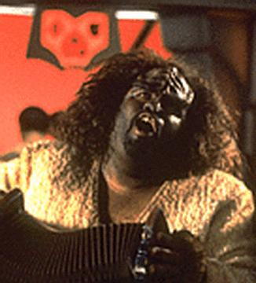  The Klingon Anthem
(The Klingon Anthem) | (Translated)
Qoy qeylIS puqloD | Hear, Sons of Kahless
Qoy puqbe’pu’ | Hear daughters, too
YoHbogh matlhbogh je SuvwI’ | The blood of battle washes
Say’moHchu’ may’ ‘Iw | Clean the warrior brave and true
MaSuv, manong, ‘ach wovqu’ | We fight, we love, and then we kill
nI’be’ yInmaj ‘ej maHoHchu’ | Our lives burn short and bright
batlh maHeghbej ‘ej yo’ qIjDaq | We die with honor and join our
vavpu’ma’ Dimuv. | fathers in the Black Fleet.
Pa’ reH maSuvtaHqu’. | There, we will fight forever.
MamevQo’ | We do not stop.
MaSuvtaH ma’ov. | We go on fighting, we compete.

The First Klingons
According to Klingon myth, after they slew the gods, the First Klingons were forced to survive in the harsh wilderness of Qo'noS. The world was a hostile and dangerous place and, although they were strong, the first Klingons were faced with terrible hardships, and hunted by dangerous beasts. But they were Klingons, and they did not despair. Instead, they took the fire from within their hearts and brought light into the darkness. They took stones from the mountains and worked them into weapons to fight the beasts that menaced them. With these tools, they overcome all obstacles that stood in their way.
In fact, the earliest recognizable Klingon skeleton uncovered by archaeologists dates back too approximately 500,000 BC. At this time, Klingons apparently lived in extended family tribal units that were at least somewhat nomadic, travelling from place to place in search of food, following the migrations of various food animals. These early Klingons discovered fire and used stone and bone tools made by hand. Archaeological evidence suggests these weapons were used for more than hunting; Klingon remains have been uncovered with spear and knife points lodged in them. The early Klingons likely fought over the most valuable hunting territories on Qo'noS, beginning their long history of conflict.

The First Houses
Archaeologists have uncovered the remains of what must be one of the first Klingon settlements, around 25,000 BC. A small collection of stone huts built around a central fire-pit, surrounded by a low stone boundary wall. This coincides with the dawn of agriculture and animal domestication on Qo'noS, as well as the formation of the first extended communities or "Houses." These developments appear quite suddenly in Klingon prehistory, and no scientific evidence has been uncovered about how they originated.
The early Klingons grew and harvested food near their villages, and hunted in the surrounding area along with domesticating animals like the targ, which served as a source of food, hides, and bone tools. Archaeologists believe early Klingons also raised gagh (serpent worms), although there is no proof of this.
Klingon legend offers an explanation in the form of Ja'Duch, a legendary warrior and hero, said to have founded the first Klingon house. Ja'Duch was a great hunter and fought battles against other tribes to protect his people. He was renowned for his generosity, and for his unusual custom of performing the r’uustai ("bonding") ceremony with the families of his honoured enemies, who lost their own protectors. In this way Ja'Duch brought the families of his defeated enemies into his own tribe, which grew quickly and became strong. They established a vaS'a, a village, under Ja'Duch's direction, so creating the House of Ja'Duch, the first great hall or "house" of a Klingon warlord. Nothing is known of what became of the House of Ja'Duch following the death of its founder.


Klingon Burial Customs
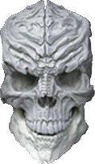
Ancient Klingons held to burial customs quite different from those of modern Klingons. Archaeologists theorize the ancient Klingons believed in the need for the body to be interred in the ground for the spirit to find its way into the afterlife. Ancient burial sites have bodies wrapped in shrouds and placed in deep pits or natural caves, often decorated with paintings or carvings of Fek'lhr, the Guardian of Gre'thor the underworld.
With the rise of powerful city-states and a true Klingon ruling class, burial customs became even more elaborate. Powerful leaders built massive tombs to glorify themselves, decorated with paintings and carvings of their achievements. Bodies were mummified, wrapped in chemically treated bandages to preserve them, and decorated with jewellery and glyphs. These tombs have been compared to the glories of the First Hebitian Civilization on Cardassia, or the Egyptian civilization on Earth. Although many ancient Klingon tombs were looted and destroyed-by later Empires as well as during the Hur'q Invasion-some of them still stand and are preserved by the Klingons as treasures of their ancient past.

The Rise of the First Empire
For thousands of years, the Klingons lived in small settlements and villages. The idea of extended houses spread throughout Klingon society. Houses offered many advantages, not the least of which was greater numbers and more allies in battle. Other Klingon leaders adopted the idea, performing the r’uustai to unite different tribes together as a single house under their leadership. Many of these houses did not survive the death of the leader that brought them together, but others were passed down to successors able to hold them together for another generation or two. In time, the leadership of a house became a traditional position, passed on from father to son, although an upstart could always challenge the current leader for his position.

The First City-State
Around 6,000 BC, the concept of houses was firmly established in Klingon culture. Settlements grew larger as the more successful houses grew and continued to war against one another. As the great houses grew, it became more and more difficult to incorporate one's enemies into one's own house after defeating them. Rival houses were simply too large for such forced alliances, and attempts made to unify houses by force resulted in bloody civil wars that tore the newly unified house apart and destroyed both sides.
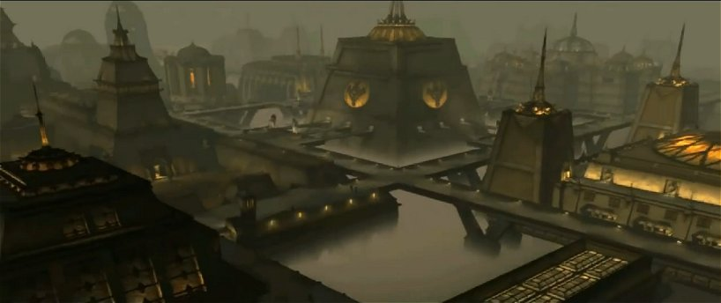
According to legend, a Klingon warlord named Kargas hit upon the idea of bringing different houses together without forcing them to become one house. Instead, as individuals and families joined a house, so could houses join together to form a nation, working together for their mutual benefit? It was a radical idea, but Kargas made it work through a combination of cunning diplomacy and persuasion at the point of his sword. The heirs of his enemies were allowed to keep their house and their title, so long as they swore oaths of loyalty to the House of Kargas. More importantly, houses were allowed to join Kargas' new alliance of their own free will, and some did once they saw the potential benefits.
Kargas and his allies are believed to have the Klingon city that still bears his name, the first true city-state on Qo'noS. Although the city has been conquered, destroyed, and rebuilt many times over thousands of years, Kargas' original alliance lasted for generations before the tides of war brought down his house, which is lost in the mists of legend.
The idea of the city-state spread through Klingon society, and other houses began to form alliances of their own. From these new city-states emerged the first true signs of modern Klingon ideas of nobility, along with blood feuds between houses, which began during this time.
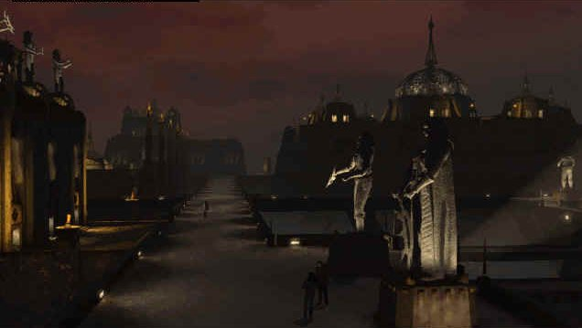
Although Klingon city-states were successful, they also grew too rapidly for the meagre resources of their territory to sustain them. This led to the first large-scale wars in Klingon history, as city-states and alliances fought each other for control of valuable land and resources. Vast armies battled on the plains of Qo'noS, and city-states rose and fell based on the outcomes of those battles.
One of the bloodiest and fiercest battles of this time was the Battle of Tong Vey. Tong Vey was ancient city-state that refused the advances of a warlord named Sompek to join his new and growing empire. Sompek led an army of ten thousand Klingon warriors to lay siege to Tong Vey for months. Legends speak of the "vast sea of warriors that broke against the walls of Tong Vey." Starvation and disease gripped the populace of the city as they held out against Sompek's army for as long as they could. Their continued defiance to his will only angered the Emperor more and more.
Finally, after months of siege, the people of Tong Vey had no choice but to surrender to Sompek and agree to join his empire. The Emperor accepted their surrender but, as the gates of the city opened, he ordered his troops to kill every inhabitant of the city and to burn Tong Vey to the ground, so no sign of the defiant city would survive.
Sompek's destruction of Tong Vey set the tone for millennia of Klingon history, as petty empires rose and fell across Qo'noS. The leaders of great houses schemed and forged alliances, raising new warlords to rule over collections of powerful city-states. New empires warred with the old, falling before their might, or toppling them and taking their place.
Although many legendary Klingon heroes appear in this period, Klingon culture acknowledges it as a dark time, when Emperors and leaders had no understanding of Honor or the obligations of a leader to his people, as shown by heroes like Ja'Duch or Kargas. The so-called "Time of the Tyrants" is often the subject of tragic Klingon operas, where cruel leaders and warlords are brought down by their own lack of Honor.

The Coming of Kahless

Some fifteen hundred years ago, a figure arose that would change Klingon culture and society forever. Kahless was born to a common family in an empire ruled by the tyrant Molor. Molor was known as a cruel and despotic leader, who built his empire on conquest and cunning, oppressing his people with heavy taxes and other demands to supply Molor's own army and to fill his palace with luxuries.
After their father died in Molor's army, Kahless' brother Morath went to the great hall of Molor to ask the Emperor for money to support the family's lands. To gain the money, Morath told the egotistical tyrant his father supported Molor, and that the emperor's people loved him. When Kahless found out about Morath's lie, he insisted on returning the money to Molor. Morath refused, leading the two brothers to fight. According to Klingon legend, Kahless and Morath battled for twelve days and twelve nights before Morath surrendered, realizing his brother was right.
When they attempted to return the money to the tyrant emperor, Molor was offended. He ordered Morath killed and the family's land confiscated. The two brothers fought to escape, and Morath gave his life so Kahless might live, having learned the lessons of Honor at last.
Kahless escaped into the mountains surrounding Molor's city, where he lived alone for many years as an exile and hermit. According to the legend, one day, while pondering his fate, Kahless was struck by inspiration. The idea of a code of Honor, as a way to govern the actions of true Klingons, formed in his mind. With the fires of Honor burning in his heart and mind, Kahless, forged the first bat'leth in the fires of Kri'stak, a volcano in those mountains. When his weapon was ready, Kahless returned home. He fought his way through one hundred warriors to reach Molor's throne room, where he challenged Molor to face him in battle. Kahless slew the tyrant after a duel that lasted for seven days and nights.
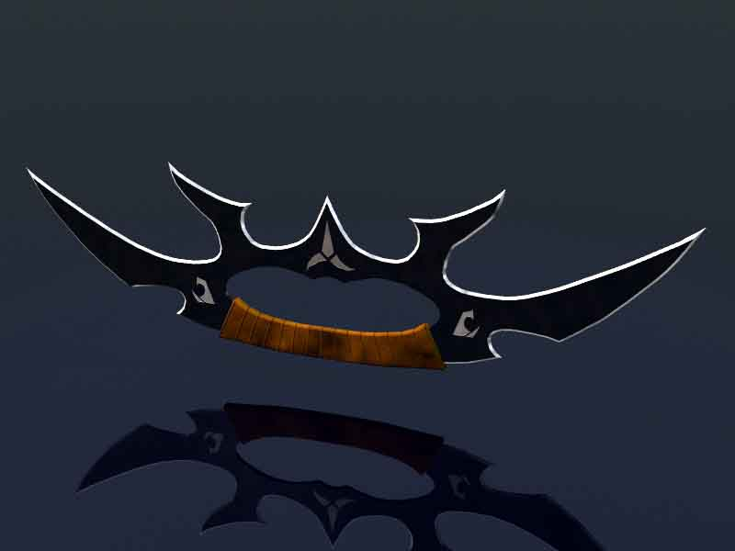
With the defeat of Molor, his people hailed Kahless as a hero and liberator. It is said his first act after Molor's defeat was to return to his family's farm, where he used his bat'leth to harvest all the fields in a single day, ensuring his family would have food to eat and money to support them. Kahless then assumed the role of Emperor, and rallied the people around him. They quickly swore fealty to their liberator, and word of Kahless' victory spread.
When news of Molor's death and Kahless' ascension reached the nearby city-states, their rulers thought they sensed weakness in this commoner-turned-Emperor. They prepared to invade and seize Molor's former territory for their own. Some few city-states, swayed by Kahless' philosophy of Honor, chose to join him. Kahless himself led the city's warriors to defend it. His small army withstood an assault from a force more than ten times their size at Three Turn Bridge, where Kahless is said to have held the pass entirely by himself. The blood of his enemies flowed so freely the river there is still known as "The River of Blood."
After his victory at Three Turn Bridge, the Noble Houses agreed to support Kahless and he won the respect of friend and enemy alike. Nobles flocked to swear fealty to the new Emperor. Those who continued to defy Kahless' power soon felt it for themselves as the Empire continued to grow.
As the years passed, Kahless' Empire became the largest and most powerful on Qo'noS. Kahless conquered and unified the whole world under his rule, creating the First Klingon Empire. Many legends grew up around Kahless and his successors, and Klingons often regard the First Empire as a kind of "golden age" of Honor and Heroism.

The Legend of Kahless
Stories of Kahless' exploits are found all throughout Klingon culture and lore, so many that it is impossible to believe any one man could have accomplished so much in a single lifetime. Among other things, Kahless is attributed with creating the code of Honor that is the foundation of Klingon culture. He forged the first bat'leth and created the first combat styles based around it, winning numerous battles (often single-handedly). He slew the Serpent of Xol and conquered the Fek'lhri, carved statues, and performed an endless array of other feats.
His battle with the Serpent of Xol is typical of many of Kahless' legendary deeds. The Serpents lair was in the mountains where Kahless spent his years of exile, before learning the ways of the warrior and forging his bat'leth. As a test of his new weapon, Kahless sought out the serpent in its mountain lair. Finding it asleep, he woke it with a terrible battle cry and proceeded to fight it for hours on end.
Finally, battered and bleeding, the serpent's venom burning in his blood, Kahless drove the point of his bat'leth into the serpent's brain, killing it. As he lay on the floor of the serpent's lair, he had a vision of the future. The poison burned away his thirst for vengeance against Molor, and made him realize his greater destiny, to unite the Klingon people. He coined the Klingon proverb; "revenge is a dish best served cold." Kahless wore the hide of the serpent of Xol as his armour when he went to face Molor, and he kept it always as a reminder of his duty to his people.


The Story of the Promise
Kahless lived to be a great age. It is said that in his later years Kahless feared his fame and greatness were a liability to the Empire rather than an asset. He worried that his people were growing dependent on him, losing the fire in their hearts. So Kahless chose to abdicate as Emperor and depart, without naming a successor, so his people could learn what it meant to be Klingons again. Before he left, Kahless pointed to a star in the night sky and said he would return from there one day. Then he departed the Imperial City, leaving his weapons and armour behind, and vanished into the wilderness, never to be heard from again. But the spirit of Kahless lives on in every Klingon who remembers his name and hears tales of his glory.

The Hur'q Invasion
In 1372 AD, more than 700 years after the founding of the First Empire, the Klingons were firmly in an industrial era. The Empire unified all of Qo'noS and established extensive routes of trade and commerce. It also solidified the power of the noble houses and established the beginnings of the Klingon High Council. Although the houses still struggled against each other, most of the great wars of conquest were over. Klingons often longed for the glory days of the past, the great battles of Kahless. They longed for an enemy to fight, and they got one.

Little is known about the Hur'q. The name means simply "outsider" in Klingon. According to historical records, the Hur'q wore full-body environmental suits, and never showed their faces. They may have come from a non-Class M environment. Their technology was superior to that of the Klingons, although there is no evidence they possessed transporter or force field technology. Still, the Hur'q, were more than a match for Klingon Warriors armed with blades and primitive firearms. They invaded Qo'noS and killed hundreds of thousands of Klingons who fought against them. The Hur'q raided and plundered many of the homeworld's cultural and historical treasures, including the Sword of Kahless, which they took with them back to the stars.
The Hur'q Invasion lasted for only seven months, but it left Qo'noS practically in ruins. Klingon history and legend records that they drove off the Hur'q and prevented them from taking over the planet, but it is entirely possible the Hur'q were not interested in conquest, merely looting, and they left of their own accord. Archaeologists have found Hur'q ruins as far away as the Gamma Quadrant, suggesting the Hur'q had access to extremely advanced starships or some sort of shortcut like a wormhole in order to cover such a vast distance.
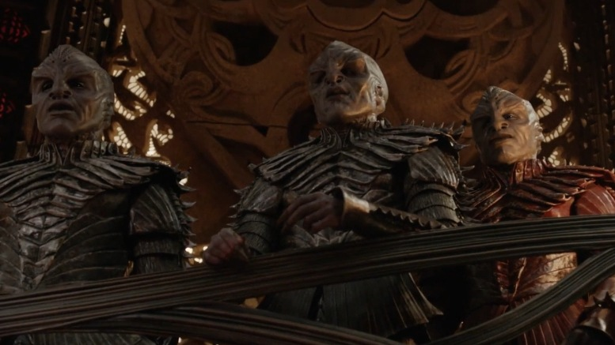

The Age of Expansion
It took the First Empire nearly a century to fully recover from the damage done by the Hur'q Invasion. Recovery was hindered by infighting between the different noble houses for control over scarce resources. Slowly but surely, the Klingons rebuilt their shattered Empire and repopulated their cities. They looked towards space with a new vision. Now they knew there were enemies out there, enemies of the Klingon people. The Hur'q were gone, but they might come again and the Klingon Empire fully intended to bring the battle to them.
The Klingons embarked on a study of the sciences of flight and space travel. Previously, there was little interest in either, apart from a few scholars who studied the prophecy of Kahless. Now the whole Empire devoted itself to learning how to reach the stars. The program suffered from various setbacks as civil wars split the Empire from time to time, and many early Klingon astronauts died in the name of science, but every effort taught the Klingons a little more.
By the early 21st century, the Klingon space program was well underway. The Klingons used vast slower-than-light generation ships to explore and colonize nearby star systems. These ships took decades to reach their destinations, carrying hundreds, even thousands of Klingons in suspended animation. If they found their destination uninhabited, the Klingons colonized. Where they found other civilizations, they conquered. In time, the Klingon Empire encompassed a cluster of systems surrounding Qo'noS. Governance of this vast Empire was difficult without the advantage of subspace communication, so many of the great houses directly governed colony worlds. This increased the power of the houses and further divided them into separate camps.
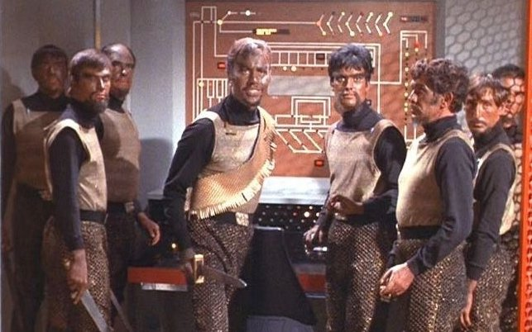
In 2069 AD the last Klingon Emperor died without a successor. For a short time civil war on Qo'noS - and throughout the Empire - seemed certain, but the High Council of the noble houses stepped forward to take up the reins of power. For generations the High Council had grown in power and influence, going from an advisory body established by Kahless to the real power behind the imperial throne.
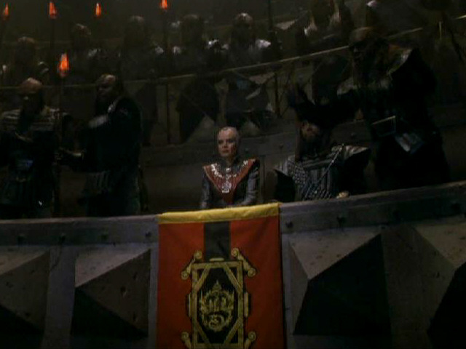
The death of the Emperor worked in the Council's favor, and they decided to secure power for themselves. The Chancellor of the Council assumed executive power and the role of Emperor was left vacant. Klingons consider the death of the last Emperor the end of the First Empire, and the ascension of the Council as the beginning of the Second Empire.
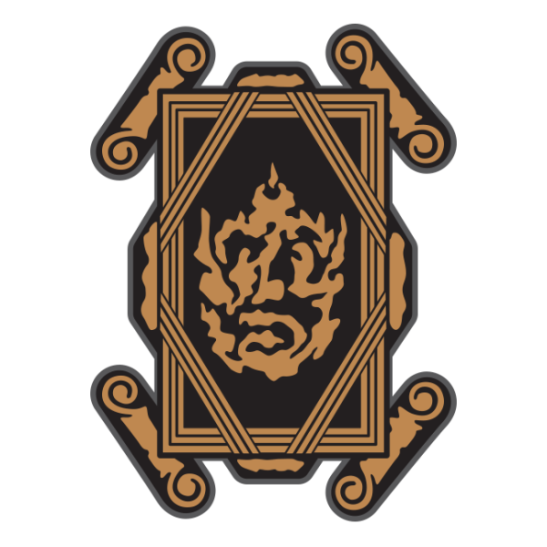
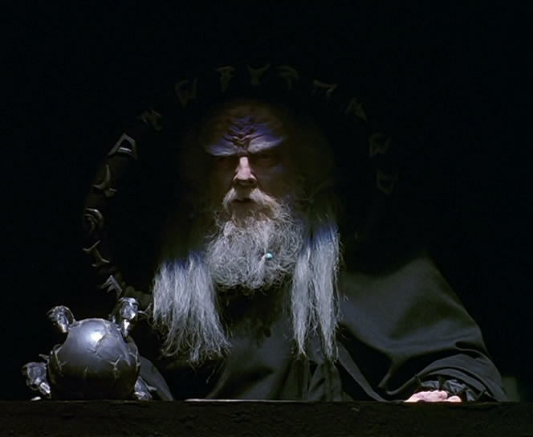
Klingon Laws
These are broad based and contain no so-called “Grey Areas”, they are cut and dry. Punishment is always left up to the courts and only extenuating circumstances are allowed to be brought forth during trials.
- One thing to remember about Klingon law, if enough evidence is brought forth to bring a Klingon to trial, that Klingon is guilty until proven innocent. Also if he or she is brought to trial and found to be innocent because of someone trying to frame, lying, or incompetence; the person responsible will do what ever punishment the accused would have gotten. Also a Klingons word is his/her bond and any testimony given by a Klingon is considered above most other kinds of evidence. All Klingons have the right to a speedy trial within one solar month. (A Klingon day is 28 Terran hours long)
- A Klingons word is his contract. No matter what race or culture he or she is dealing with.
- Klingons do not commit treason.
- Klingons do not show cowardliness in battle.
- Klingons do not murder. (Murder is an act of killing an unknowing combatant or foe without Challenge)
- Klingons do not disobey the ruling Council. (Unless the Council has acted dishonorably)
- An Honorable death requires no vengeance. (An Honorable death is one where the warrior was killed during duty, challenge, battle, accident or as a result of ailment)
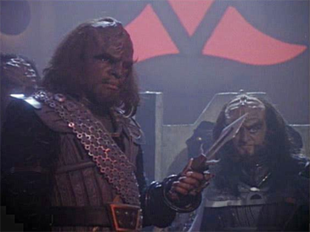
- The Right of Vengeance is the right of every Klingon. Anyone trying to stand in the way of it will be subject to prosecution under this right. (Right of Vengeance is the right to avenge a death that was caused through another’s dishonorable act or acts. Example; A warrior kills another’s mate or dishonors him or her badly in front of others)
- Honor or Position Challenge; is the right of all Klingons. Every Klingon has the right to challenge a dishonorable superior Commander or boss for his position to the point of combat.
- Any Klingon that wins a challenge must take on the loser’s responsibilities. This includes and not limited to House members, lands, debts and work.
- Klingons follow orders completely.
- No law shall be made, insinuated, or practiced that brings pressure on any Klingon because of his or her origin, color, beliefs, or political affiliation.
- Klingons do not steal.
- Klingons pay their debts.
- Klingons must answer challenges within one standard solar day. (He or she must choose to fight, give up what he or she has been challenged to, or retract his or her statement) But it is rare that it is postponed at all.
- Klingons do not aid or help criminals in any manor.
- Klingons must show honor to those who deserve it, by not doing so results in the offended having the right to challenge you.
- Klingons must obey all rules and laws of the area or planet, which they are visiting. (Unless we are at war with them at such time)
- Klingons will respect the property other Klingons.
- When visiting another’s House, may it be Klingon or not, the visitor must show honor to the House. (Usually done through a gift or sacrifice of oneself as in doing something for the House they are visiting)
- Respect another’s mate. There is no adultery.
- The dishonor of a member of a House dishonors that House for 3 generations.
- It is the right of all Klingons to have proper medical treatment, chance at career choice, chance of advancement, and the right to live their lives as they wish within the context of the laws.

Klingon Code of Honor

What is the Klingon Code of Honor? It is a way of acting or feeling about certain things that brings Honor or Dishonor to oneself or House. Morales may be another word that could be used. Example; There is no Honor in killing the weak. There is no punishment in say, killing an unarmed Ferengi because he upset you. But in doing so, it would prove to others that you are too weak to curve your emotions and you are not to be trusted. It would also bring shame to your House for not teaching you better. So by breaking a rule you bring Dishonor to your House also and would likely result in your banishment from the House.

The Following Code of Honor is to Help Guide a Warrior:

- Klingons do not procrastinate.

- Klingons do not rebel against their House or Leadership. (Unless the leader of the House or Council has acted dishonorably)

- Klingons do not attack the weak or involve themselves in dishonorable battles.

- Klingons do not let friends fight alone.

- Klingons do not forget their responsibilities. (House and Position in the culture, may it be military or civilian)

- Klingons do not complain about discomfort. (As in harsh living or working conditions) Not to be confused with complaining about poor Commanders or politicians.

- Klingons do not lie, cheat, or steal.

- Klingons do make sure their children are taught respect, Honor, culture, and learn what it takes to succeed in the Empire. This includes schooling in all major academic fields. An uneducated Klingon reflects badly upon us all.

- Klingons do not infringe on other’s life decisions. Such as choice of fields of endeavors, military service, etc. It is ok however to give sound advice.

- Klingons always show respect to their fellow Klingons no matter what Position he/she holds.

- Klingons whenever possible, help to expand our sphere of influence throughout the universe.

- Klingons do report all crimes against the Empire that they witness.

- Klingons do admit to their mistakes

- Klingons do not waste.

- Klingons do not make idle threats.
A Non-Profit Making Organisation

It is said that for a Warrior, Honor is more important than life and Duty is like a blade sharpened to pierce any obstacle. A Warrior is nothing without Loyalty to one’s House and the Empire, all of these things a Warrior must do to truly master the field of battle. To set apart the true Warrior from the savage we now introduce the Official Warriors Guide to aid you in your journey for Honor & Glory.

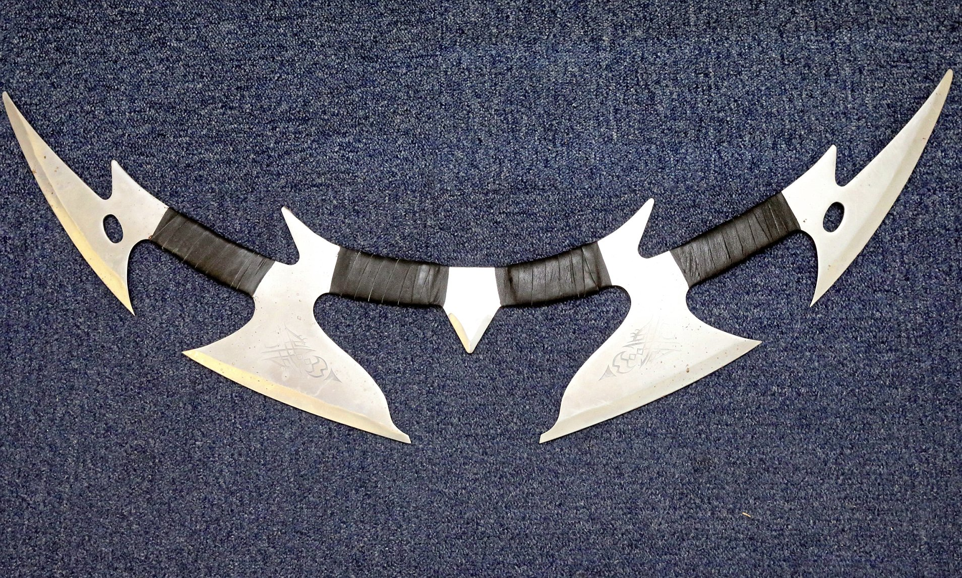

The Warrior’s Guide is designed to enhance and inspire all Klingons for the better enjoyment of Klingon Fandom and Culture. In this guide we will examine every facet of the Klingon Military, Commissioning ships and Commanding Ships, Awards, Ranks and so on.
The IKEF is a non-profit making Star Trek fan organization created for those who wanted greater freedom by taking the best and worst of organized fandom and creating an experience like no other, we portray the Klingon Empire side of the Gene Roddenberry universe; our mission is to provide a group wherein people can sample Klingon values such as Honor, Strength and Loyalty!
IKEF is an international organization that is supported by a large number of fan clubs, called groups, located in the USA, UK, Europe, Australia. Each of these groups is an autonomous fan club with specific meeting location's. We are willing to allow a lone member for the sake of their participation but, we want to try to get them aboard a ship. On the other hand, if they are more than 50 miles from the nearest vessel we do offer them the opportunity to run their own ship command, unless there is some reason they cannot or should not command. In that case, a lone warrior might be preferable. We don't like to see lone warriors because alone one can end up surrounded by your enemies, but it does seem to occur now and then, thankfully not very often.
So, what is required to form and run a ship within the Imperial Klingon Expeditionary Forces? A commanding officer and an executive officer – both having and wearing Klingon costume to local functions – along with another crew member (or more) to share in the fun! That's all it takes; well, that and keeping in contact with us when we ask for you to report or when you have something to share with us. Yes, it's really that simple. So, what are you waiting for, Brave Warrior! Do you wish to know more about our organization?

The High Council

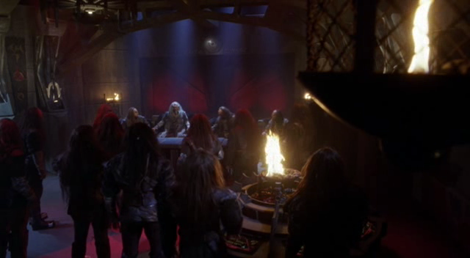

Standing together as 4 warriors, the High Council consists of the Thought Admiral, Chief of Fleet Operations, Q'onos Sector Commander and Mempa Sector Commander. Other positions are filled as needed. The CFO and Sector commanders vote on issues at hand, while the Thought Admiral advises, clarifies rules, and - on the rare occasion a member of the council abstains – offers a tie breaker vote. Each one also enforces a 'no drama or politics' policy.
Under the direction of the council, without assuming a voting role, sits the Council's Imperial Intelligence Officer, handling duties the Thought Admiral and Council need assistance with, and updating documentation as needed. The IIO is also responsible for the Honor Guard of the IKEF, ensuring their duties are noted to the council for review and potential reward.
On equal standing with the Imperial Intelligence Officer is the Marine Commandant, who oversees the warriors serving aboard ships of the fleet. A marine unit will consist of a minimum of 3 personal. Highest ranking marine is lead. Leads answer to the Captain of the ship. individual marines may serve on ship they answer to the captain. All marines answer to the Commandant. Marines will assist the Captain in running events help keep order and generally be helpful to the rest of the members of the Ship.
Motto: We are the hammer for the Empire!

