**ABSTRACT**

Scalp brain signals or Electroencephalogram (EEG) exhibit distinct attributes during different types of motor imagery (MI), the imagination of limb motor movement. The recording of EEG signals is detected using a multi-channel brain cap, and then classified by the Motor Imagery-Brain Computer Interface (MI-BCI), allowing subjects to control external devices by executing the appropriate motor movement corresponding to the EEG-specific movement. One possible application of the BCI is to provide a brain-controlled wheelchair for patients with motor neuron disease. Patients who are incapable of communication due to full body paralysis arising from medical conditions would benefit from such technology. Hence, with the aim of exiting the virtual conditions and applying MI-BCI in a real-world environment through the manipulation of hardware prototype, this paper investigates: first, the performance of the MI-BCI employing the Filter Bank Common Spatial Pattern (FBCSP) algorithm in classifying different types of MI through the detection and classification of EEG signals; and subsequently, a proposed brain-controlled miniature robot which mimics a wheelchair while providing a safe environment for the subject to navigate the vehicle through a real-world environment, which was developed to assess the real-time performance of the MI-BCI. To simulate a wheelchair’s point of view, the proposed robot includes features that allow a first-person view for the user’s navigation, and the ability to reverse when in contact with a front obstacle. Training results show that 3 types of motor imagery, namely left-hand, right-hand and foot MI could be classified with an accuracy of 76.39% and hence, employed in the controlling of robot. Experimental results on two healthy subjects showed that the FBCSP algorithm was able to distinguish between the 3 classes of motor imagery with an average accuracy of about 75.2%, and the subjects were able to navigate through the real environment in about 52 trials. Results from this study provide motivation to further investigate the potential of the MI-BCI in a larger-scale study, with the possibility of utilization in the operation of a brain-controlled wheelchair product.

**INTRODUCTION**

The transmission of signals from nerve cells in the brain requires motor neuron cells to direct signals to the particular muscles so as to produce movement. With severe disruption in the signal transmission, this renders patients unable to perform essential voluntary muscle movement [4]. In the U.S alone, approximately 6 million people face severe body paralysis due to various diseases like the Amyotrophic Lateral Sclerosis (ALS) [17], a kind of motor neuron disease which destroys motor neuron cells [24]. As a result, personal assistance is required to move around, and depression and anxiety are common psychosocial problems associated with patients with motor neuron diseases or other neurologically disabling illnesses following diagnosis [25]. Hence there is a need to help patients with lack of focused attention to perform their everyday activities in a less dependent manner [26], as it offers patients a greater sense of independence and an improved sense of well-being [28].

Despite the loss of motor movement, the intention to move his limbs can be detected by a BCI through the imagination of movement. During Motor Imagery, the subject imagines motor movement through a first-person perspective, but no movement is actually performed [1]. The mental thought of different motor movements by the subject leads to distinguishable changes and characteristics of the Electroencephalogram (EEG) signals [2], as different body parts have a spatially ordered layout in the primary motor cortex [3,9]. To capitalize on the patterns of EEG, studies have investigated methods to record and use EEG [20], attempting to provide a non-muscular channel for sending messages and commands to the external world [13]. With improvements in the field of neurotechnology, such studies have led to the development of the Brain-Computer Interface (BCI). The BCI changes the input of EEG signals from mere reflections of central nervous system (CNS) activity into the intended movements as output [5]. Hence, different types of motor imagery like the imagination of left hand movement and foot movement can be detected non-invasively from the EEG, using a Motor Imagery Brain-Computer Interface (MI-BCI), where a multi-channel brain cap with electrodes is positioned on the subject’s scalp. These different EEG signals can be recognized by the system and hence translated into different commands.

Different signal processing and machine learning approaches to differentiate brain states have been investigated [18,19] and developed to classify different types of motor imagery carried out by the subject, in an attempt to improve the accuracy of the MI-BCI in classification. The processing and interpretation of EEG data will then allow different commands corresponding to the EEG signals to be served for the MI-BCI. The MI-BCI has been used for communication and controlling movements such as a applications in modern computer games [14], virtual spelling bee [11] and thought translation devices [22], the manipulation of a robotic arm [5,16] and in prosthetics and control systems [15]. Studies have suggested that subject-specific frequency bands yield better results in the accuracy of the MI-BCI classification [6], hence one EEG-processing algorithm that is the Filter Back Common Spatial Pattern (FBCSP) algorithm, was proposed and developed to process the EEG signals for 2-class single-trial MI [12]. This algorithm selects temporal-spatial discriminative EEG characteristics [3] and through the features selected, it then computes and classifies trial-based EEG. The algorithm has shown its effectiveness on offline EEG data classification by performing the best relatively on multi-class MI data of the Left-hand, Right-hand, Foot and Tongue from 9 subjects during the international BCI Competition IV [10].

In one research conducted, “EEG-controlled Wheelchair for ALS Patients”, while there were no attempts to develop a brain-controlled wheelchair prototype or miniature robot, a custom EEG-based BCI was built with the aim to pave the way for improved facilitation and interaction between ALS patients and the environment [26]. The paper suggested future works can be done with a goal to enable patients to move the brain-controlled wheelchair itself, in a practical, real-life environment. In another previous study, “Interacting with the Computer using a Brain Computer Interface”, it has been demonstrated that it is possible for a subject to navigate himself through a virtual environment by employing a multi-class MI-BCI [21]. Hence, leading after the works of such studies where MI-BCI was explored in a virtual environment, this research aims to move towards the application of MI-BCI in hardware prototypes and real-world assistive technologies. As a next step from virtual reality to creating a hardware prototype towards the use of the Multi-class MI-BCI as a navigation tool for a brain-controlled wheelchair, we have developed a miniature robot prototype which simulates a wheelchair that will be controlled by a multi-class MI-BCI. The miniature robot is made using Lego Mindstorm building blocks, which is an inexpensive and easy set to utilize for robot building.

There are challenges to the use of BCI assistive devices in real-world environments. One key concern for brain-controlled wheelchairs is safety, as it transports a particularly vulnerable person [27]. In an attempt to address this issue, the final design of the miniature robot built in our research has been refined to include sensors which provide information of the surroundings and allow the robot to change directions when for a safe navigation. The wheelchair should also be ergonomic, providing intuitive and efficient navigation with a minimum of effort. Another concern is the increased costs of conducting tests in real environmental situations and complex procedures to optimize the BCI parameters. As such in our study, the effectiveness of the multi-class MI-BCI which employs the FBCSP algorithm that classifies Left-hand, Right-hand and Foot motor imagery has also been assessed, by having the wheelchair perform the navigation task when motor imagery is detected by the MI-BCI.

**METHODOLOGY**

*A. Filter Bank Common Spatial Pattern (FBCSP)*

Studies have suggested that subject-specific frequency bands yield better results in the accuracy of the MI-BCI classification [6], hence one EEG-processing algorithm that is the Filter Back Common Spatial Pattern (FBCSP) algorithm, was proposed and developed to process the EEG signals for 2-class single-trial MI [12]. This algorithm selects temporal-spatial discriminative EEG characteristics [3] and through the features selected, it then computes and classifies trial-based EEG. The algorithm has shown its effectiveness on offline EEG data classification by performing the best relatively on multi-class MI data of the Left-hand, Right-hand, Foot and Tongue from 9 subjects during the international BCI Competition IV [10].

*B. Hardware Lego Prototype*

The proposed design of the robot vehicle is shown in Figure 1. The diagram also shows how the user interacts with the robot vehicle.

Motor Imagery commands sent to robot vehicle

Neuroscan Quikcap

NXT Brick

Second part of interaction

First part of interaction

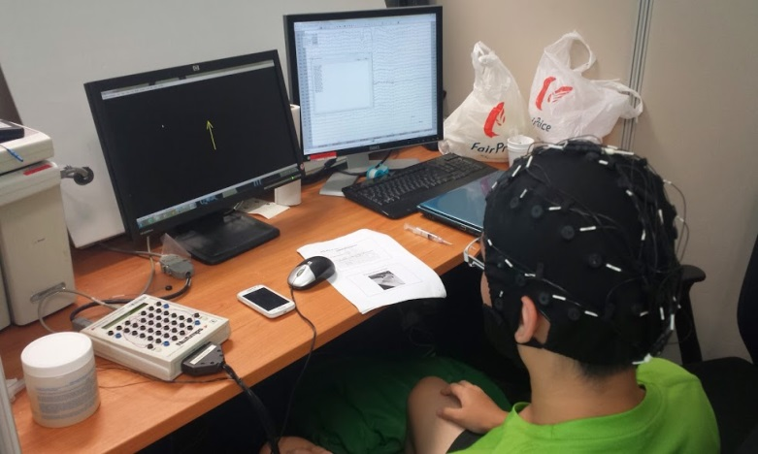 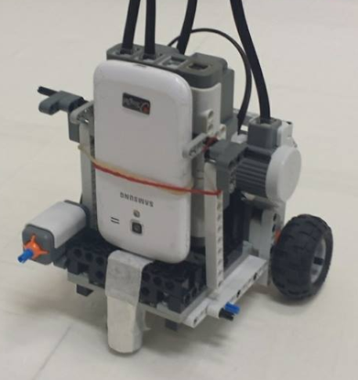

EEG Acquisition Device

Computer Monitor

Subject undergoing experiment

Touch Sensor

Phone

Phone Holder

Back Motor

Provides video feedback to computer monitor

Facing Forward

Front Wheel

**Figure 1: Flow of trial from subject to BCI to Robot Vehicle then back to the subject**

**(Left) Experiment set-up (Right) Robot Vehicle**

The robot vehicle is constructed from the Lego Mindstorms NXT which is a programmable robotics kit. The robot vehicle has two back wheels attached to Lego Mindstorms motors that will facilitate the movement of the robot vehicle, while the front wheel is a ball bearing taped to 2 Lego bricks. The ball bearing was used instead of 2 wheels so as to reduce friction and to allow for smoother turning. The robot vehicle also has a touch sensor at the front so that when it hits an obstacle in front of the robot vehicle, it will return to its original position when turning or move back when going forward. The NXT is fitted in the middle of the robot vehicle and connected by a single brick so as to allow for easier removal of the NXT brick for recharging the batteries. The NXT brick is connected to the desktop computer by Bluetooth. In front of the NXT brick is a holder to hold a phone. The phone uses its camera to project a first-person view of the environment to the computer monitor to aid the subject in navigating the environment by allowing the subject to know the location and position of the robot vehicle, while also giving a more realistic visual experience of operating a brain controlled wheelchair, as seen in Figure 2 below.

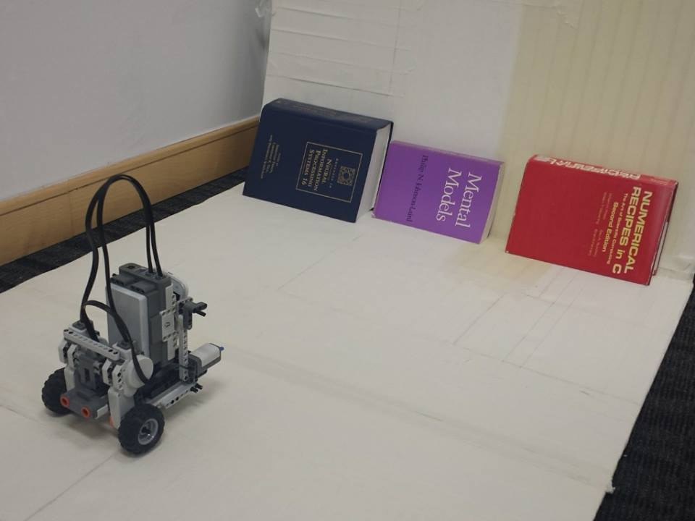 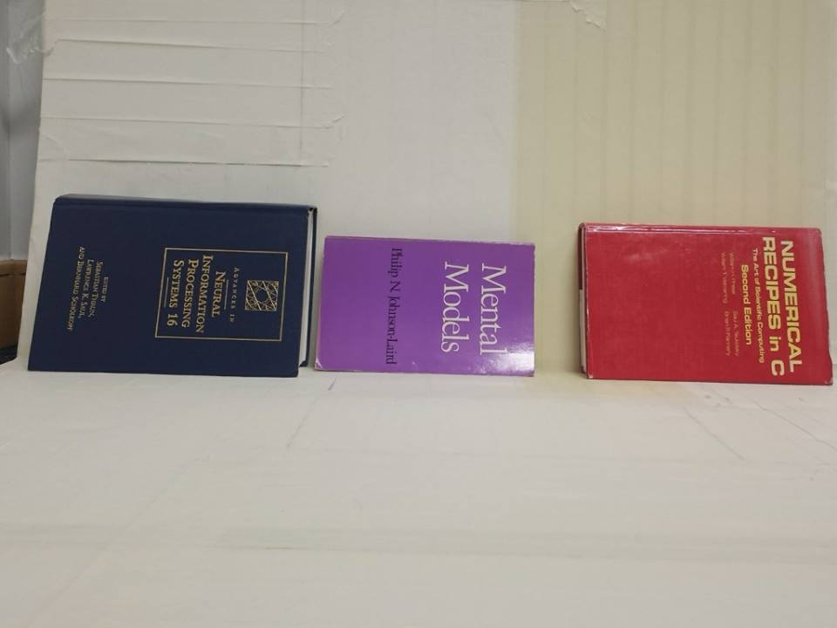

A

B

C

A

B

C

Robot Vehicle

**Figure 2: (Left) Third-Person View (Right) First-person view**

The MI-BCI translates the following MI into the following actions in Figure 3:



**Figure 3: Actions Corresponding to Specific Motor Imagery**

*C. Lego Robot Vehicle Remote Controller (Graphical User Interface)*

To control the movements of the robot vehicle, a remote controller software was designed and developed. The graphical user interface (GUI) is shown in Figure 4.

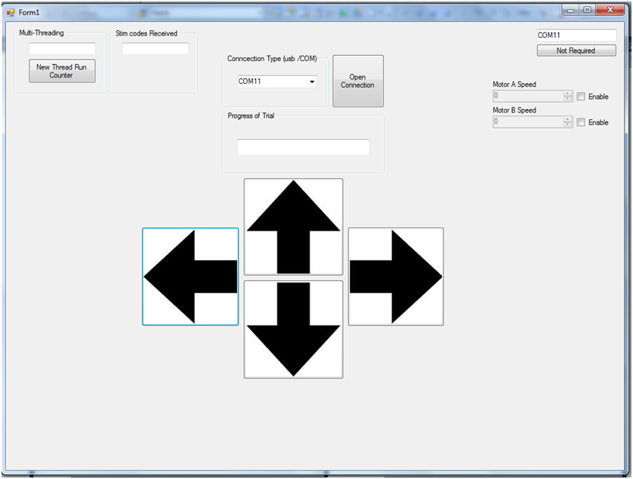

Change speed of motors

Activate touch sensor and to read value of sensor

Select Com port or USB and open connection to brick

Messages from BCI to subject

Arrows for manually controlling robot vehicle

**Figure 4: Interface Layout of Lego Robot Vehicle Remote Controller**

The Lego robot vehicle remote controller has the following features:

* Open connection to NXT brick on the robot vehicle: The NXT brick can be connected to the remote controller GUI through a USB cable or Bluetooth connection. Arrows for manual control of the robot vehicle: The four arrows allow for the robot vehicle to turn left, move forward, turn right and move backward. The arrows are used for manual control of the robot vehicle to find the number of the trials required when using mouse-control instead of brain-control to reach the target during the experiments. The arrows have same functions as shown in Figure 3 except that it is mouse-controlled. The only exception is the button to move backwards:
  + If the backward button is clicked, the robot vehicle will move backward by driving both motors backward.
* Progress of Trial: The BCI sends instructions to the subject to notify the start of trial, start of performing of motor imagery, and the end of trial.
* Sending commands to NXT brick: After the EEG signals are classified by the FBCSP algorithm, one of the following commands will be sent to the NXT brick:
  + Turn left.
  + Turn right.
  + Move forward.
* Change speed of motors: Although there is a default speed of 20 for the motors, the speed can be changed to suit different environments. The speed can range from -100 to 100.
* First-person view: The phone on the phone holder uses a third-party application called "SECuRET LiveStream" to stream live feed to a temporary website created by the application.

**EXPERIMENT**

The experiment with the MI-BCI was conducted on 4 healthy subjects, with the setup as shown in Figure 1. EEG signals were recorded from 25 electrodes placed around the sensorimotor cortex area using the Neuroscan Quikcap with a sampling rate of 250Hz as shown in Figure 5. There were 2 experiment sessions: Training Session and Testing Session with the robot vehicle.



**Figure 5: Neuroscan Quikcap**

*A. Training Session with MI-BCI*

To familiarize the subject with the BCI and to train the FBCSP algorithm, a training session is provided. The protocol is shown in Figure 6.

|  |  |  |  |  |
| --- | --- | --- | --- | --- |
| Break  1s | Fixation  Cross  1s | Visual  Cue  1s | Motor Imagery  4s | Break  3s |

0.5s - 2.5s

Beep Train time segment

**Figure 6: Timeline of training session for a single-trial**

1s before the start of the trial, there will be a beep to signify a trial is about to begin. A trial starts with a fixation cross at the center of the screen for 1s. Next, the fixation cross disappears and an arrow will be shown pointing in one of the four directions (left, right, up or down). Each different direction represents a specific motor imagery that the subject is suppose to perform, namely left-hand, right-hand, tongue and feet respectively. The subject will perform the motor imagery for 4s, followed by 3s of break between trials.

*.   
B. Testing Session with Navigation of Environment using Wheelchair Prototype*

During the testing session, the subject has to navigate the experimental setup as shown in Figure 2.

Three books of different colours were placed at the end of the board to mark targets A, B and C that the wheelchair prototype has to travel to and hit. The number of trials required to travel to the destination was taken, while manual control of the robot through the arrows on the GUI was done to find the number of the trials required when using mouse-control instead of brain-control to reach the target during the experiments.

The protocol for the testing session is shown in Figure 7 below:

|  |  |  |  |
| --- | --- | --- | --- |
| Break  1s | Fixation  Cross  1s | Motor Imagery  4s | Break with prototype  executing command  7s |

Beep

**Figure 7: Timeline of testing session for a single-trial**

For every trial, the subject will be cued by a beep 1s before the start of each trial. At the start of the trial, the user will be given 4s to perform one of the three types of motor imagery: left-hand, right-hand and foot, and the EEG data will be recorded. For the next 8 seconds of rest, the FBCSP will then be employed to classify the EEG data and select the most probable motor imagery action. The command will then be sent to the wheelchair prototype through the GUI. The wheelchair prototype will then perform the given command and the first-person view from the phone will change accordingly. During the 8s of rest, a beep will be given 1s before the start of the next trial. The cycle then repeats until the wheelchair prototype hits the target.

The flowchart in Figure 8 illustrates the use of the MI-BCI during the testing session:

Beep 1s before start of trial

Video feedback provided to subject

Robot vehicle executes action during 8 s of rest

Start

Command sent to robot vehicle

Fixation cross appears on the screen

FBCSP algorithm employed to classify EEG signals

Subject performs motor imagery for 4s

Most probable motor imagery action selected

**Figure 8: Flow Chart illustrating Usage of MI-BCI during Testing Session**

**RESULTS**

We performed cross-validation on the training data to get an estimate of the accuracy of the FBSCP algorithm. Cross-validation splits the data trials into n sets (for our project’s purposes, *n* = 10) by randomly sorting the 288 trials and placing fixed partitions. It then uses the first n-1 sets for the training of the classifier, and the remaining set to test the classifier, repeating for another 9 times in this case.. These results show that the FBCSP is quite accurate in classifying data into many different classes because if we had used a random classifier, the results would gravitate towards 25

The results of this session are shown in the form of four confusion matrices, as shown below. This shows the relationship between the output classes the user intended (the true classes) versus the actual output of the classifier (the predict class). The Tongue motor imagery was the least accurate out of the four classes.

**Table 9: Table showing 4-class cross-validation of testing session for 4 subjects**

**4-class cross-validation**



The analysis with 3-class cross validation of Left, Right and Foot imagery is shown in Table 10.

**Table 10: Table showing 3-class cross-validation of testing session for 4 subjects**

**3-class cross-validation**



Overall accuracy:

Overall accuracy: 82.871%

From the data, it is evident that out of the four subjects who took part in the MI-BCI trial, only two subjects (CZY & TK) had accuracy levels(70.134% and 74.999% respectively) satisfactory for 4-class analysis. The other two subjects (NL & OWS) had accuracy levels(40.559% and 36.111% respectively) closer to that of pure chance, and would be too inaccurate to continue to the second session of experiments.

The two subjects with satisfactory results went on to conduct the second experiment testing on the difficulty of controlling the robot by guiding them to different targets(Left, Middle, Right).



-WT denotes that the wrong target was reached and the experiment was restarted

-Experimental and empirical values represent the number of trials needed to reach the target using the BCI and by manual control respectively

From the data derived from the two subjects’ trials above, it can be seen that even with a high accuracy in the first session of experiments, it is much harder to guide the real-life prototype to a target than expected. There is a large discrepancy between the experimental and empirical values for the number of trials needed to arrive at a target.

**DISCUSSION**

To address the needs of paralyzed patients to move themselves independently, this paper proposes a BCI-controlled wheelchair, allowing the subject to send commands using his scalp brain signals or EEG signals. The proposed wheelchair is an extension of the past paper based on the subject of navigating a virtual environment. In this paper, the wheelchair has been simulated by a hardware prototype constructed out of Lego bricks, where the subject uses their EEG signals to control the prototype while viewing it from a first-person perspective from a camera on the prototype.

Four types of motor imagery were then investigated for use in the proposed virtual speller: Left hand (L), Right hand (R), Foot (F), and Tongue (T). During motor imagery, the subject performs imagination of movement of the appropriate body part from a first-person perspective without actually performing it. Experimental results show that L and R are consistently more accurate relative to the other classes. The FBCSP algorithm was originally designed for these two types of motor imagery which could explain why their performances are the best. In the experiment sessions, only one subject (CZY) was familiar with BCI usage, whereas the other three(NL, OWS, TK) were BCI-naïve, which might explain why their experimental results were worse. Results from the prototype show that the 4 types of motor imagery could be employed to help the wheelchair navigate, albeit not as accurately as projected by the initial trial.

During the first session of experiments, three of the subjects (NL, OWS, TK) were BCI-naive and found it a daunting task to conduct the experiment properly and under the right conditions. Moreover, due to the largely repetitive and tedious tasks involved, some of the subjects became bored and had difficulty paying proper attention. During the second session of experiments, both subjects (CZY, TK) found it difficult to guide the robot into the specified target due to the algorithm’s misinterpretation of the EEG signals. A large number of trials were needed to reach a target, and both subjects were exhausted after the end of this session of experiments.

One limitation with the experiments is that the time taken to navigate the robot to a target was long, as such identifying the ergonomics of the system as a potential area for refinement. The subject should receive greater and better training and preparation, and the turning of the robot should be standardized as much as possible. This would be beneficial in case many mistaken turnings result in the robot not aligning itself properly with the targets, caused by non-90o turns, possibly since in practical environment, the motors on both sides of the robot may not be identical and turn by a slightly uneven magnitude. One limitation with the use of EEG-based BCI is that EEG signals are easily contaminated by other signals, especially in initial training sessions with BCI-naïve subjects, which may reduce the effectiveness of trials and commands interpreted. One solution to enhance the effectiveness would be to increase the number of sessions for better training, as it has been shown that signal contamination reduced as number of sessions progressed [23], and as such, reducing the number of trials needed to arrive at a specific target. Also, due to the inaccuracy of the prototype’s movements, it occasionally travelled over the boundary of the region designated for its movements. This had to be remedied by an observer manually placing the robot back into the area. Another limitation of our current prototype was the narrow range of view of the camera. A phone camera was mounted on the front of the prototype, but its range of view was narrow, and maneuvering without peripheral vision was challenging. Hence it is possible for an addition of another phone camera for greater viewing range.

In conclusion, the initial performance of the system encourages further improvements to the training and performance of the wheelchair. To improve the time taken to navigate to a target, a subject should receive greater and better training and preparation, and results have shown the number of commands the MI-BCI can process. With this research, having identified the various limitations and problems faced by the miniature robot hardware in a real-world environment and the effectiveness of the MI-BCI, it would be a step closer towards the application of MI-BCI in real world assistive technologies.

**ACKNOWLEDGEMENTS**

We would like to thank our mentor for the technical advice and guidance throughout the course of our project.

**REFERENCES**

[1] H. H. Ehrsson, S. Geyer, and E. Naito, "Imagery of Voluntary Movement of Fingers, Toes, and Tongue Activates Corresponding Body-Part-Specific Motor Representations," *J Neurophysiol,* vol. 90, pp. 3304-3316, November 1, 2003 2003

[2] G. Dornhege, B. Blankertz, G. Curio, and K. R. Muller, "Boosting bit rates in noninvasive EEG single-trial classifications by feature combination and multiclass paradigms," *IEEE Trans. Biomed. Eng.,* vol. 51, pp. 993-1002, 2004.

[3] Z. Y. Chin, K. K. Ang, C. Wang, C. Guan and H. Zhang, "Multi-class Filter Bank Common Spatial Pattern for Four-Class Motor Imagery BCI" Institute of Infocomm Research, Agency for Sci., Technol. & Res. (A*STAR), Singapore

[4] H. Ramoser, J. Muller-Gerking, and G. Pfurtscheller, "Optimal spatial filtering of single trial EEG during imagined hand movement," IEEE Trans Rehabil Eng., vol. 8, pp. 441-446, 2000.

[5] J. R. Wolpaw, N. Birbaumer, D. J. McFarland, et al., "Brain Computer interfaces for communication and control," Clin Neurophysiol., vol. 113, 2002.

[6] B. Blankertz, R. Tomioka, S. Lemm, M. Kawanabe, and K. R. Muller, "Optimizing Spatial filters for Robust EEG Single-Trial Analysis," IEEE Signal Process. Mag., vol. 25, pp. 41-56, 2008.

[7] T. D’Albis, "A predictive speller for a brain-computer interface based on motor-imagery," 2009.

[8] K.-R. Müller, M. Tangermann, G. Dornhege, et al., "Machine learning for real-time single-trial EEG-analysis: From brain-computer interfacing to mental state monitoring," Journal of Neuroscience Methods, vol. 167, pp. 82-90, 2008.

[9] W. Penfield and T. Rasmussen, The Cerebral Cortex of Man. New York, N.Y: The Macmillan Company, 1950.

[10] B. Blankertz, BCI Competition IV, 2008, http://ida.first.fraunhofer.de/projects/bci/competition_iv/

[11] Yap L.H., Liu J.N., Tan S.Y, Chin Z.Y., and Wang C., “Think and Type: Decoding EEG Signals for a Brain-Computer Interface Virtual Speller”, Institute for Infocomm Research Singapore, 2011

[12] K. K. Ang, Z. Y. Chin, H. Zhang, et al., "Filter Bank Common Spatial Pattern (FBCSP) in Brain-Computer Interface," in *Proc*. *IJCNN'08*, 2008, pp. 2390-2397

[13] Crespel, A., Gelisse, P. “Atlas of Electroencephalography: EEG Awake and Sleep EEG Activation Procedures and Artifacts”, Volume 1, John Libbey Eurotext, (2005).  
  
[14] R. Mendez, G. Dunwell, I., et al. “Assessing the Usability of a Brain-Computer Interface (BCI) that Detects Attention Levels in an Assessment Exercise”, Proc. of the 13th Int’l Conference on Human-Computer Interaction, Springer Berlin/Heidelberg Lecture Notes In Computer Science, Volume 5610/2009, San Diego, California, USA, 19-24 July, 149-158, (2009).

[15] Loudin, J.D., et al. “Optoelectronic retinal prosthesis: system design and performance”, Journal of Neural Engineering, 4, 72-84, (2007).

[16] Ranky, G.N. Adamovich, S. “Analysis of a commercial EEG device for the control of a robot arm”, Proc. of the IEEE 36th Annual Northeast Bioengineering Conference, New York, USA, 1-2, (2010).

[17] Christopher and Dana Reeve Foundation. (2009). One Degree of Separation: Paralysis and Spinal Cord Injury in the United States. Retrieved from http://www.christopherreeve.org/atf/cf/%7B3d83418f-b967-4c18-8ada-adc2e5355071%7D/8112REPTFINAL.PDF on 14th July 2014.

[18] C. Bishop, Pattern Recognition and Machine Learning. Springer, 2006.

[19] U. Hoffmann, Bayesian Machine Learning Applied in a Brain-Computer Interface for Disabled Subjects. PhD thesis, Ecole Polytechnique Federale de Lausanne, Switzerland, 2007.

[20] Sanei, S., Chambers, J.A. “EEG Signal Processing”, Wiley, July, 2007.

[21] Gan W.L., Bay W.H., Chin Z.Y., and Wang C., “Interacting with the Computer using a Brain Computer Interface”, Institute for Infocomm Research Singapore, 2010

[22] Birbaumer, N.; Cohen, L.G. Brain-computer interfaces: Communication and restoration of movement in paralysis. J. Physiol. 2007, 579, 621–636.

[23] McFarland D.J.1., Sarnacki W.A., Vaughan T.M., Wolpaw J.R..”Brain-computer interface (BCI) operation: signal and noise during early training sessions.” Clin Neurophysiol 116(1): 56-62. 2005.

[24] P. N. Leigh and K. R. Chaudhuri. “Motor Neuron Disease” J. Neurol Neurosurg Psychiatry, vol. 57(8), pp. 886-896, 1994.

[25] B.M. Tedman, C.A. Young, I.R. Williams. “Assessment of depression in patients with motor neuron disease and other neurologically disabling illness.” J. Neurol Sci., vol. 152(1), pp. s75-s79, 1997.

[26] A. Kodj, D. Kumar, D. Kodali, I.A. Pasha. “EEG-controlled wheelchair for ALS Patients.” Communication Systems and Network Technologies (CNST) 2013 International Conference., pp. 879-883, 2013

[27] R. Brice. “A Brain Controlled Wheelchair to navigate in familiar environments.” National University of Singapore, 2008.

[28] M. Trail, N. Nelson, J.N. Van, S.H Appel, E.C. Lai. “Wheelchair use by patients with amyotrophic lateral sclerosis: A survey of user characteristics and selection preferences.” Archives of Physical Medicine and Rehabiliation, vol. 82(1), pp. 98-102, 2001