Jesse Wolgamott
Senior Technology Executive

AGILE SOFTWARE DEVELOPER

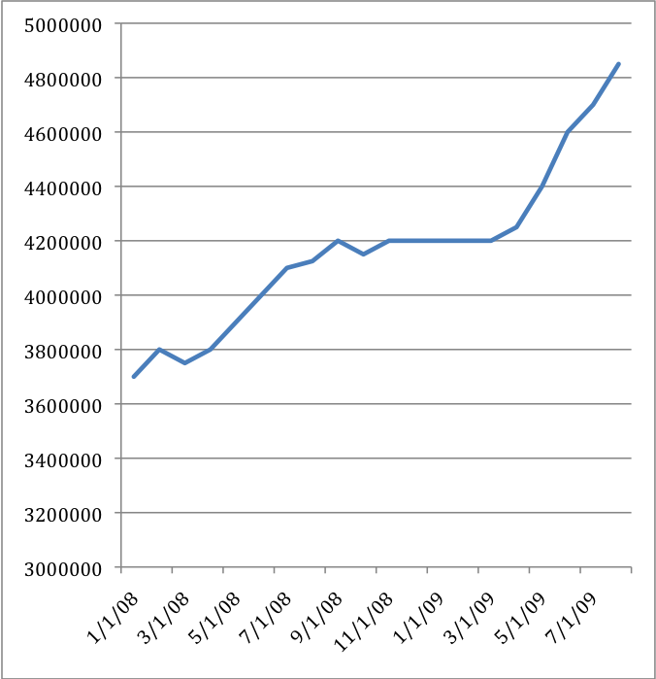
Grew revenues 60% in 3 years of executive management, delivering 99.99% system availability. Software architect and business leader for flagship product, WebCOBRA, representing 75% of sales.

Accountable for IT strategy, product management, internal systems, customer support, financial reporting, and order fulfillment. 7 direct, 14 indirect reports. $2.2M budget.

Partner relationships with largest insurance companies: United Healthcare (now Optum), BlueCross/BlueShield, WageWorks, UniCare.

Agile Software Developer with 10 years experience developing high available systems.

Travis yearly revenue track (above) since
assuming executive management role.

How to learn more about me:
http://jessewolgamott.com
www.linkedin.com/in/jessewolgamott
jesse.wolgamott@gmail.com

RECOMMENDATIONS

“Jesse is one of the few programmers that I have worked with who not only is a whiz on the tech side but also has a fantastic personality and sense of humor. This was integral to our business since we were better able to communicate our client's needs for the system and he translated them faster to the other programmers.” - Joe Holland, Director Sales and Marketing, promoOrder (colleague)

EXPERIENCE and ACHIEVEMENTS

Travis Software Corp. Houston, TX, 2002–Present
Benefits administration software company serving insurance industry. 22 employees. $5M in revenue.

PRESIDENT / COO (2009–September 2009)
SENIOR VICE PRESIDENT (2008)
VICE PRESIDENT, TECHNICAL SERVICES (2007–2008)
DIRECTOR, SOFTWARE DEVELOPMENT (2003-2006)
SENIOR SYSTEMS ENGINEER (2002-2003)

Travis Software Corp., continued

Creating Revenue

- Grew revenue $2M by building WebCOBRA, a cost-effective web-based version of 16-year-old desktop software.
- Generated 30% additional revenue and strengthened customer loyalty, identifying and quickly responding to a need for training on new legislation. Expanded online classroom capacity from 5 students to hundreds of students, enabling timely fulfillment of overwhelming demand.
- Spurred add-on sales and increased daily web traffic from 20 to 3500 with up-to-the-minute blogs communicating key regulatory information.
- Drove sales by giving customers a voice in product development process, creating community website that delivered instantaneous feedback and increased consumer loyalty and satisfaction.

Conserving Costs

- Saved $175K in customer service expenses, added revenue stream, and slashed project timetables by creating consulting division to address complex customer-initiated issues.
- Increased sales leads 40% at no additional cost by strategically reworking online advertising keywords. Established spending parameters by creating keyword ROI metrics.
- Saved $30K in annual labor costs by upgrading hybrid network to Windows system, enabling broader applicant pool.
- Cut per-computer cost 20%, negotiating preferred vendor contracts with Dell and CDW.

Fostering Agility in Technology and Business

- Promoted innovation by implementing a new-project incubator program.
- Streamlined development and fostered IT flexibility, employing Agile processes (XP and SCRUM).
- Advanced informed decision-making and improved customer satisfaction by designing management reporting system to capture key business metrics.
- Doubled revenue per employee by improving technology / infrastructure design and motivating team environment to meet higher expectations.

Delivering Quality and Performance

- Maintained 99.9%+ uptime of WebCOBRA since inception, 3+ years.
- Decreased dropped customer support cases 90%, paring 5 scattered Help Desk case intake procedures to 2 focused methods.
- Bolstered business continuity capabilities, implementing $1.2M project to add vital second fault tolerant data center.

- Completed 3-year build of WebCOBRA on-time and under-budget.
- Expedited launch by adding functionality incrementally.
- Increased agility, replacing master database with distributed database structure.
- Made job queuing scalable by migrating to Amazon’s SQS and S3.

promoOrder.com (purchased by eBlox) Austin, TX, 2000–2002
Startup organization delivering customized online company stores selling corporate logowear. 50 employees.

SOFTWARE DEVELOPER / USER INTERFACE ENGINEER
As first internal developer, adapted small-load legacy system to meet high-growth needs with minimal resources. Designed customizable website skins to integrate client website with back-end technology.

Early career:

ENTREPRENUER
Owner of small business website creation, InnerGrafix Management. At peak, company took in $30K in annual revenue, paying for college tuition holding roles of sole salesperson and developer.

TECHNOLOGY FORERUNNER
Pioneering entrepreneur in Internet and website technology, named Entrepreneur of the Month by Duck Head, Inc.

PROFESSIONAL PROFILE

University of Texas at Austin
BBA, Management / Information Systems, Austin, TX

National Deans List

Co-Founder and sole developer of WeEatt.com, a recipe-sharing social network.

