1. Window→Preferences→Code Style→Code Templates
2. Expand option: Comments→Files
3. In window Patter file comment header is visible:

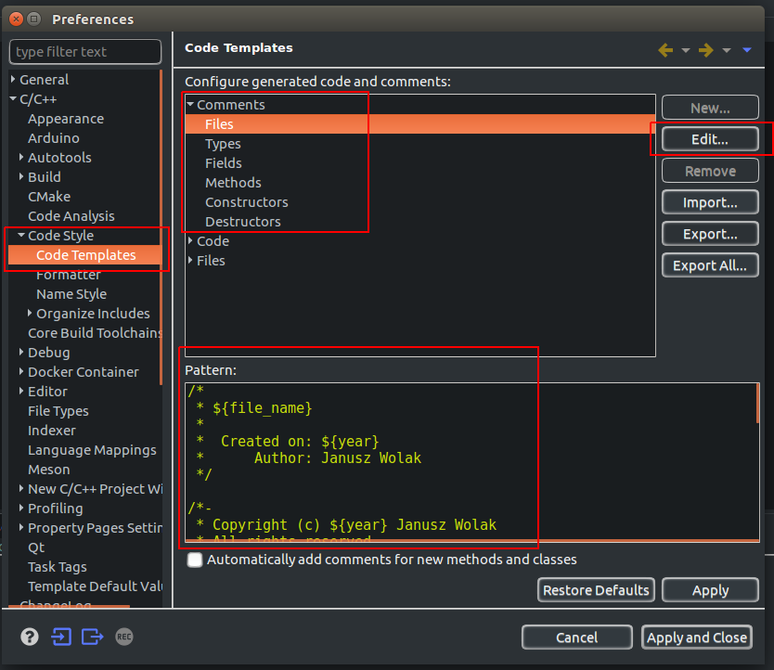

4. Click Edit and paste or paste file comment header:
- include ${year} to “Created On:”
- include ${year} to “Copyright”

