1. Open Project->Properties->C/C++ Build and set the Build Location (where is placed Your makefile)

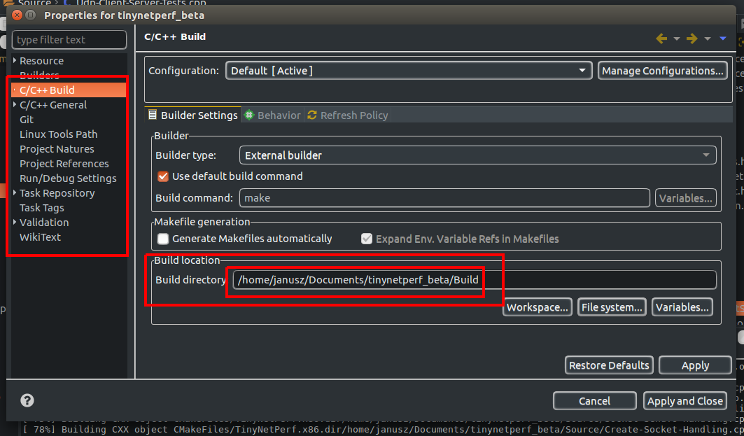
NOTE: In TinyNetPerf Make file is located in Build direcory

2. Now is possible to build directly from Eclipse menu (Build All, Clean… etc)

