1. Version:

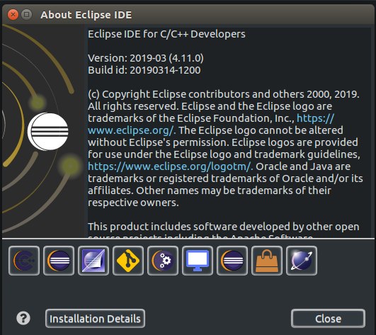

2. Go to: File→New→Makefile Project With Existing Code
3. Select location of project TinyNetPerf : {your directory}/tinynetperf_beta/TinyNetPerf

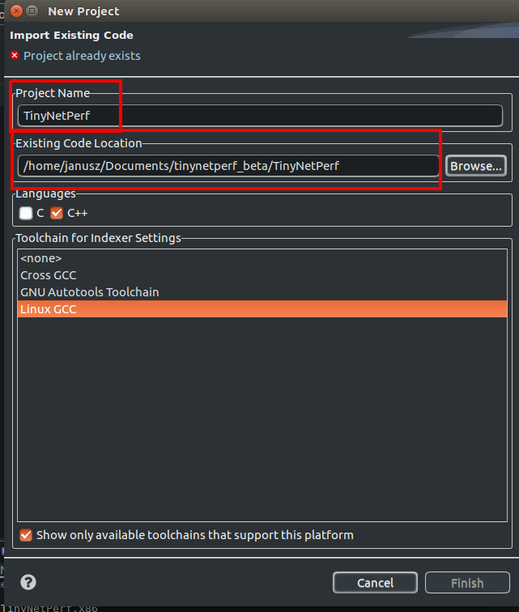
4. Select location of project UnitTests :
{your directory}/tinynetperf_beta/UnitTests

5. Select location of make file for TinyNetPerf:
{your directory}/tinynetperf_beta/TinyNetPerf/Build

6. Select location of make file for UnitTests:
{your directory}/tinynetperf_beta/UnitTests/Build

