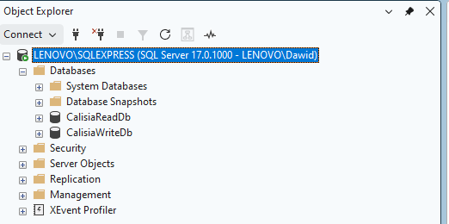

Utworzenie dwóch baz danych:
- CalisiaWriteDb
- CalisiaReadDb

CalisiaWriteDb - Tabele
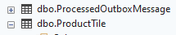

dbo.ProcessedOutboxMessage | 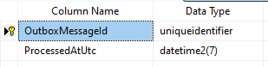
dbo.ProductTile | 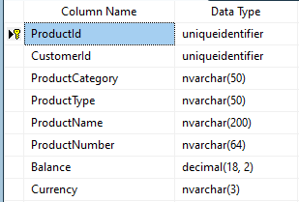
dbo.TimelineEvent | 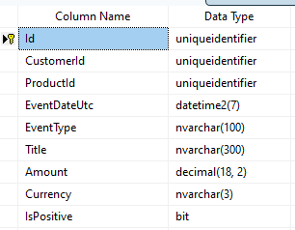

CalisiaReadDb - Tabele
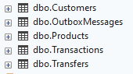

dbo.Customers | 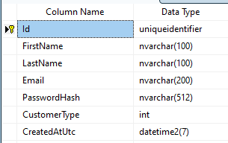
dbo.OutboxMessages | 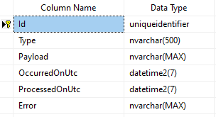
dbo.Products | 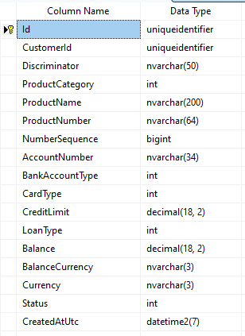
dbo.Transactions | 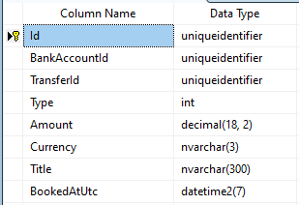
dbo.Transfers | 