Creating PDF cover pages using LibreOffice

This guide describes how you can create PDF cover pages for YajHFC.

To enable PDF cover page support in YajHFC, you will first have to install the YajHFC pdf plugin (it is already included in the default Windows installation for YajHFC 0.5.2 and up).

Due to limitations of the PDF format, you will have to create PDF forms where the cover page values are put into the form fields.

In this guide the cover page is created using LibreOffice / OpenOffice because it has built-in PDF support and is freely available for all platforms YajHFC supports from http://www.libreoffice.org/

Nevertheless, PDF forms created using other utilities (with MS Office for example) should work well, too.

Step-by-step guide
- Start LibreOffice Writer
- Enter and format the static text (i.e. the text that should not be replaced with cover page information) as you would normally do:
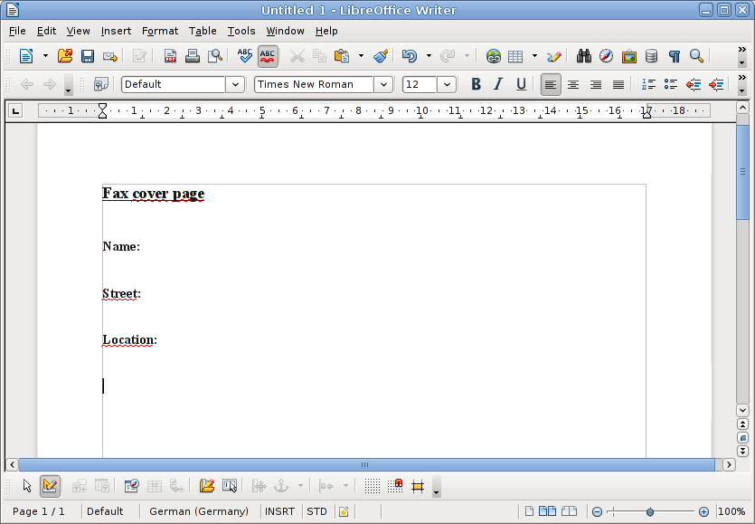
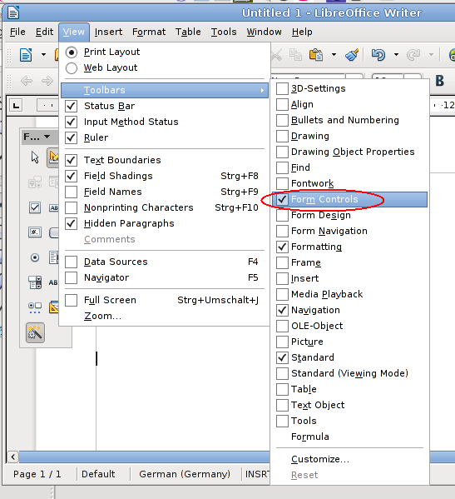
- If not already visible, display the Form Controls toolbar:
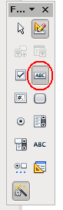
- In the Form Controls toolbar, select the Text Box tool:

- Draw a text box for each field you want to add (Name, Street and Location in the example):
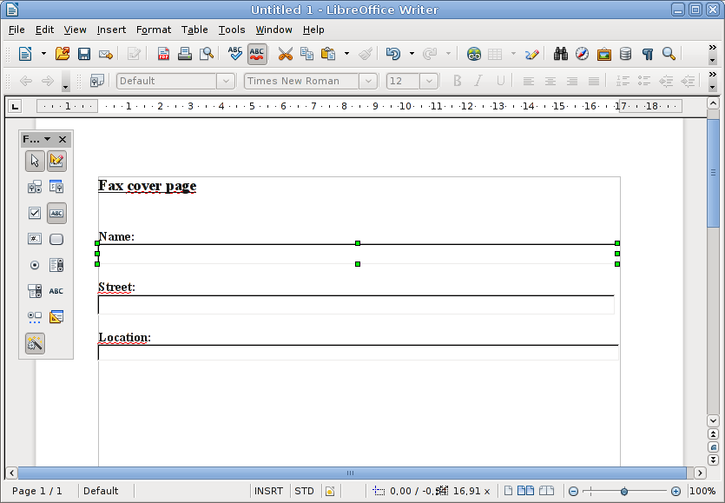
- For each text box, modify its properties:
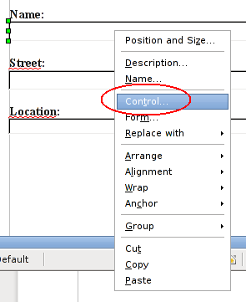
  - From the right-click context-menu, select Control...

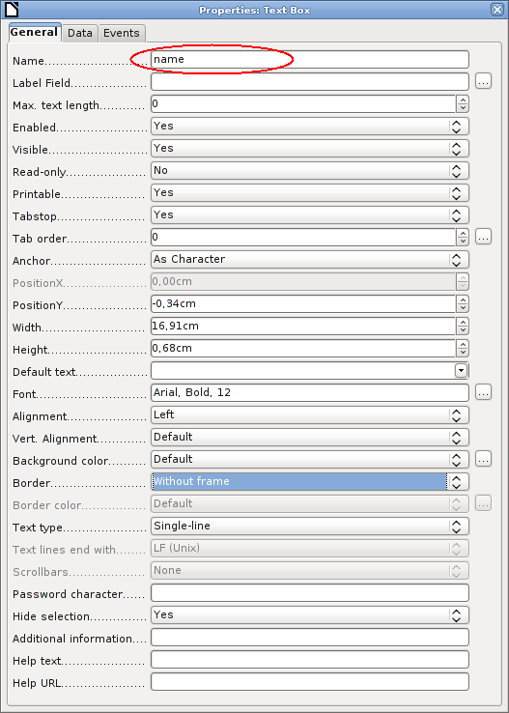
  - Set the property Name to the name of the desired cover page field.
In the example:
  - set the Name of the “Name” field to name
  - set the Name of the “Street” field to street
  - set the Name of the “Location” field to location
For a list of available cover page fields, please see the table at the end of this document
It is probably also a good idea to set the Border to Without Frame and the Font to the font you would like to use, although this is not required for the cover page to work

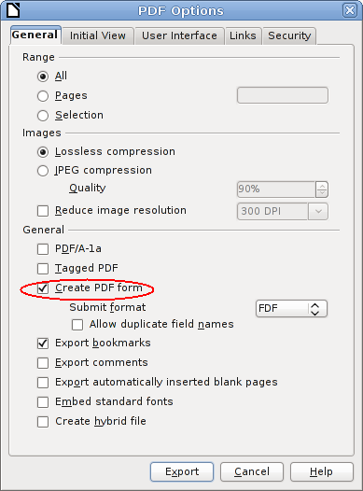
- When you are done with modifying the control properties, select File→ Export as PDF.
In the export dialog make sure the Create PDF form option is checked.
The rest of the options are not important and can be set as you prefer.

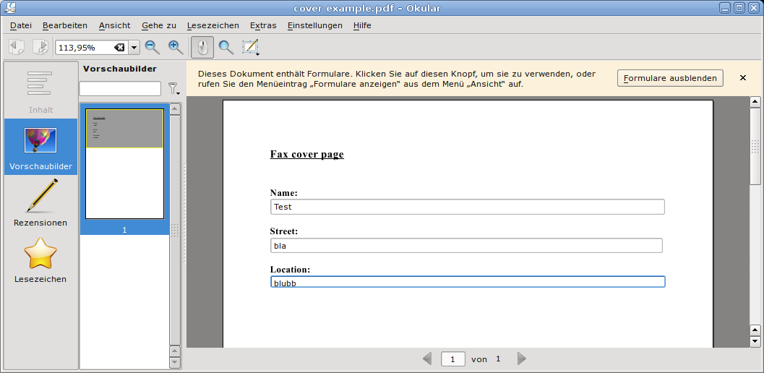
- If you want, you can verify that the form works as intended using a PDF reader:
- Test the cover page in YajHFC:
  - Open the send dialog
  - Add an recipient
  - Check Use cover page
  - Check Use custom cover page, click the browse button and select the PDF file you created in step 8
  - Click Preview. In the launched PDF viewer you should be able to see the filled out cover page.
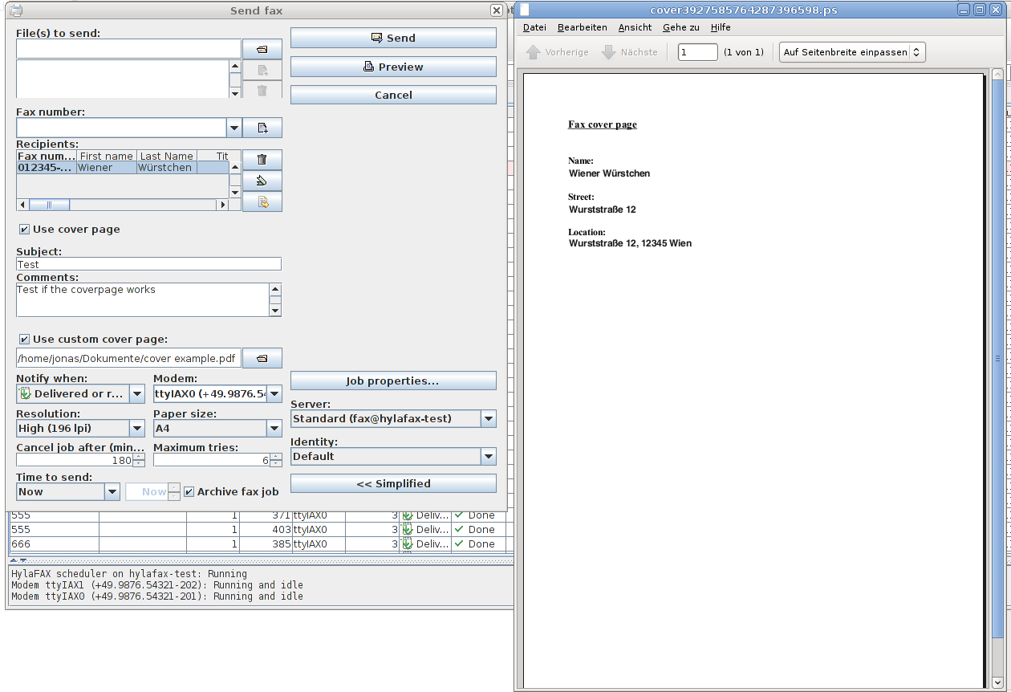
- If the cover page looks as you want, you are ready. Else repeat the steps until it looks right.

You can find a larger example with more fields as cover-src.odt and cover.pdf in the examples subdirectory of the YajHFC distribution or at the following locations:
http://files.yajhfc.de/doc/examples/cover-src.odt
http://files.yajhfc.de/doc/examples/cover.pdf

Available cover page fields
The following form field names are recognized by YajHFC (case insensitively). Fields with names not in this table will be ignored.

Field | Meaning
Name | The recipient's name
Company | The recipient's company
Location | The recipient's location
Faxnumber | The recipient's fax number
Voicenumber | The recipient's voice number
FromName | The sender's name
FromCompany | The sender's company
FromLocation | The sender's location
FromFaxnumber | The sender's fax number
FromVoicenumber | The sender's voice number
FromEMail | The sender's e-mail address
Subject | The fax's subject
Date | Today's date
PageCount | The number of pages excluding the cover page
Comments | The comments entered for this fax
Surname | The recipient's surname (resent faxes: the same as Name)
GivenName | The recipient's given name
Title | The recipient's title
Position | The recipient's position
Department | The recipient's department
CompanyName | The recipient's company name (without department) (resent faxes: the same as Company)
Street | The recipient's street name
Place | The recipient's location (without street or ZIP code) (resent faxes: the same as Location)
ZIPCode | The recipient's ZIP Code
State | The recipient's state
Country | The recipient's country
EMail | The recipient's e-mail address
WebSite | The recipient's website
FromSurname | The sender's surname
FromGivenName | The sender's given name
FromTitle | The sender's title
FromPosition | The sender's position
FromDepartment | The sender's department
FromCompanyName | The sender's company name (without department)
FromStreet | The sender's street name
FromPlace | The sender's location (without street or ZIP code)
FromZIPCode | The sender's ZIP Code
FromState | The sender's state
FromCountry | The sender's country
FromEMail | The sender's e-mail address
FromWebSite | The sender's website
TotalPageCount | The number of pages including the cover page
CCNameAndFax | The names and fax numbers of the other recipients of this fax in the format Name1 <faxnumber1>; Name2 <faxnumber2>; ...

